Mass events in 2023
In 2023, 6.3 thousand mass events were organised, of which 2.9 thousand artistic and entertainment events. The events gathered a total of 26.9 million participants, of which 10.3 million participants of artistic and entertainment events.
20.3%
Increase in the number of organised mass events in comparison to 2022
Compared to 2022, the number of organised mass events increased by 20.3%, of which artistic and entertainment events – by 19.5% and sports events – by 21.0%. Most of mass events were organised in Śląskie Voivodship (907). Many mass events were also organised in: Mazowieckie (707), Wielkopolskie (573), Dolnośląskie (550), Małopolskie (500) and Kujawsko-Pomorskie Voivodships (500). The fewest mass events were organised in Podlaskie Voivodship (116).

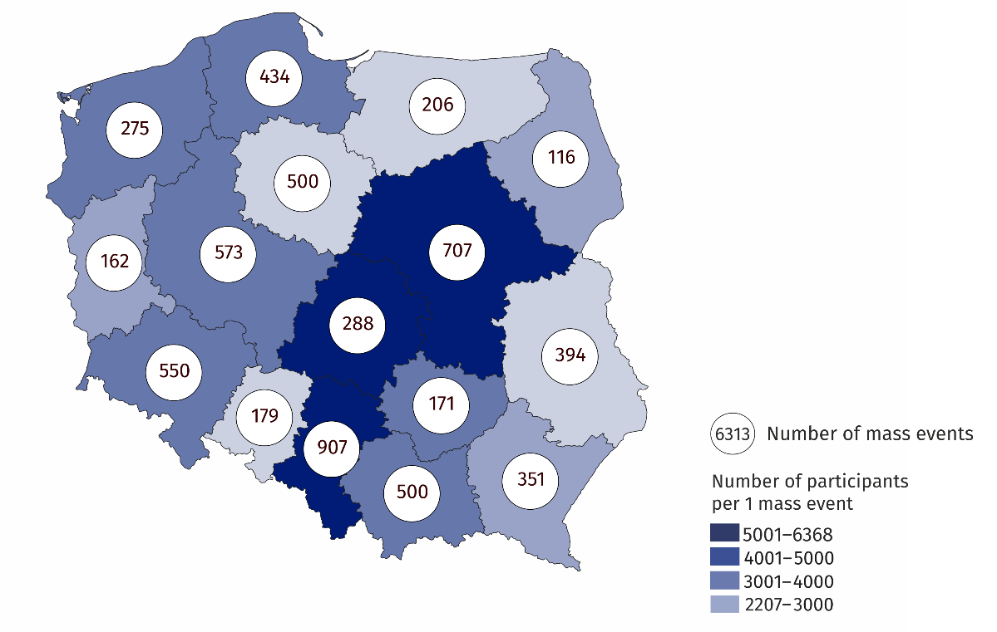
Map 1. Mass events in 2023
The majority of mass events were sports events (54.2%), most of which were organised in Śląskie Voivodship (614), and the fewest in Podlaskie Voivodship (43). The remaining part of mass events were artistic and entertainment events, within which concerts constituted the majority (68.0% of all artistic and entertainment events). The largest number of artistic and entertainment events took place in Mazowieckie Voivodship (384), and the fewest in Opolskie Voivodship (65).
Compared to 2022, the number of participants in mass events increased by 17.0% (i.e. by 3.9 million people), while the number of participants in artistic and entertainment events increased by 8.2% (i.e. by 0.8 million people), and sports events by 23.2% (i.e. by 3.1 million people). The vast majority of mass events participants took part in paid events (84.2%). Paid participation concerned mainly sports events (97.7%). 62.4% of participants of mass artistic and entertainment events took part in paid events.
Most of mass events (4.0 thousand) were organised in closed facilities (25.8% more than in 2022). 2.4 thousand events (12.1% more) were organised outdoor.
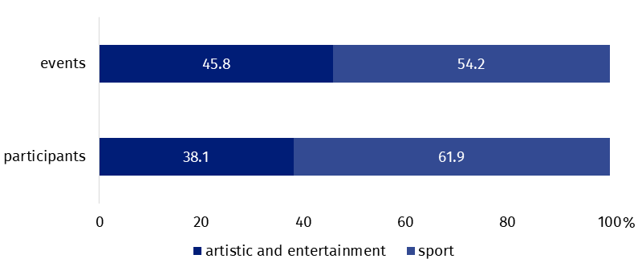
Chart 1. Mass events and their participants by type in 2023
The majority of mass events were organised by legal entities (92.8% of the total number of mass events).
In the case of quoting data from the Statistics Poland, please provide information: "Statistics Poland data source", and in the case of publishing calculations made on data published by the Statistics Poland, please provide information: "Own study based on Statistics Poland data".
Prepared by:  Statistical Office in Kraków  Director Agnieszka Szlubowska  Phone: (+48 12) 420 40 50 | Issued by:  Press Office  Mobile: (+48) 695 255 032  Phone: (+48 22) 608 38 04, (+48 22) 449 41 45,  (+48 22) 608 30 09  e-mail: obslugaprasowa@stat.gov.pl

stat.gov.pl/en/

@StatPoland

@GlownyUrzadStatystyczny

gus_stat

glownyurzadstatystycznygus

glownyurzadstatystyczny
Related information
Culture and national heritage in 2022
Mass events in 2022
Terms used in the official statistics
Mass event
Event participant

