Activity of centres of culture, cultural centres and establishments, clubs and community centres in 2023
As of the end of 2023, there were 3,961 centres of culture, cultural establishments, cultural centres, clubs and community centres. During the year these entities organised 258.8 thousand events, in which 33.5 million participants took part.
13.8%
Increase in the number of events organised by centres of culture, cultural centres and establishments, clubs and community centres in comparison to 2022

Most centres of culture, cultural centres and establishments, clubs and community centres were operating in Małopolskie Voivodship (431), and the least in Lubuskie Voivodship (76). Among discussed entities, cultural centres dominated, accounting for 32.9% of the total number of entities, whereas clubs constituted the smallest group (7.3%). Most of the entities (61.0%) were located in the countryside.

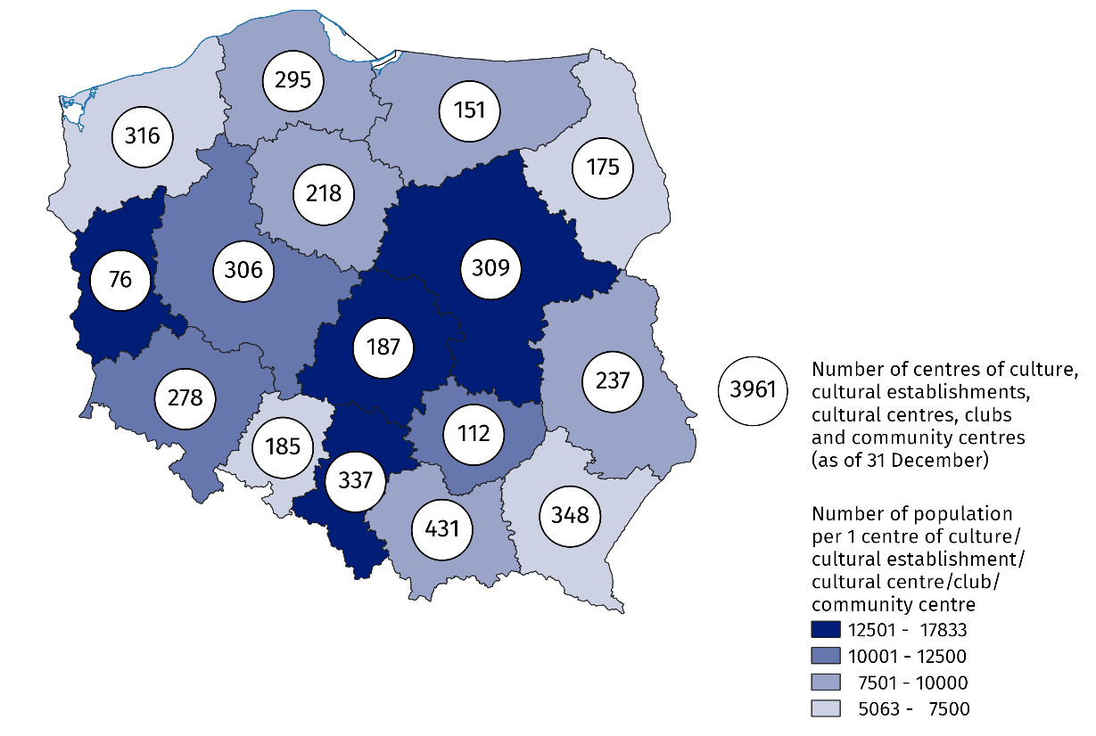
Map 1. Centres of culture, cultural centres and establishments, clubs and community centres in 2023
11.7% of the total number of entities were operating in Małopolskie Voivodship
The prevalent part, i.e. 92.9% of centres of culture, cultural centres and establishments, clubs and community centres belonged to the public sector, of which 90.5% were entities of local government units at the level of gmina.
Centres of culture, cultural centres and establishments, clubs and community centres organised a total of 258.8 thousand events, in which 33.5 million people took part. The largest number of events (101.0 thousand) was organised by cultural centres, and the fewest – by community centres (17.8 thousand). Compared to 2022, both the number of organised events and the number of their participants increased (by 13.8% and 22.6%, respectively).
Workshops were most frequently organised (29.5% of the total number of events). On average 129 people took part in one event. In festivals and artistic reviews this average was 631 people per one event.
6.3% of centres of culture, cultural centres and establishments, clubs and community centres conducted online cultural activities and shared 1.6 thousand events and 0.1 thousand courses.
As of the end of 2023, 25.0 thousand various types of groups (clubs/sections) were operating in centres of culture, cultural centres and establishments, clubs and community centres, to which 504.8 thousand members belonged. Art and technical classes (6.8 thousand) were mostly organised within the activity of groups (clubs/sections). They were also most numerous in terms of participants (116.1 thousand).
Centres of culture, cultural centres and establishments, clubs and community centres conducted a total of 5.2 thousand courses. 73.3 thousand people obtained the graduated status of the course (an increase by 18.1% in comparison to 2022). The most popular courses were foreign languages courses (22.5% of the total number of courses) and learning to play the instruments (17.7%).
Chart 1. Groups (clubs, sections) and their participants in the centres of culture, cultural centres and establishments, clubs and community centres by type in 2023
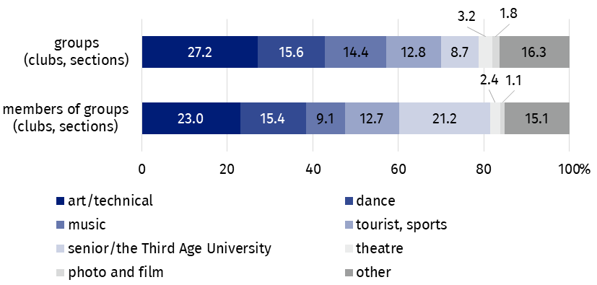
As of 31 December
As of the end of 2023, 14.3 thousand artistic groups were operating in centres of culture, cultural centres and establishments, clubs and community centres, among which the most numerous were dance groups – 3.7 thousand. From the total number of 250.3 thousand artistic groups participants – 63.8% were school children and youth. Every fifth artistic groups participant was person above 60 years old (20.6%).

Chart 2. Artistic groups and their participants in the centres of culture, cultural centres and establishments, clubs and community centres by type in 2023
As of 31 December
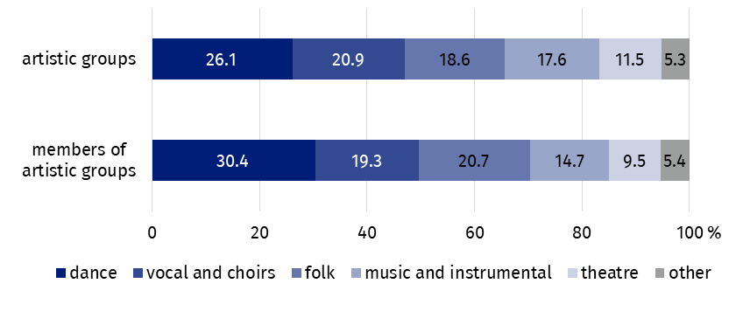
In the case of quoting data from the Statistics Poland, please provide information: "Statistics Poland data source", and in the case of publishing calculations made on data published by the Statistics Poland, please provide information: "Own study based on Statistics Poland data".
Prepared by:  Statistical Office in Kraków  Director Agnieszka Szlubowska  Phone: (+48 12) 420 40 50 | Issued by:  Press Office  Mobile: (+48) 695 255 032  Phone: (+48 22) 608 38 04, (+48 22) 449 41 45,  (+48 22) 608 30 09  e-mail: obslugaprasowa@stat.gov.pl

stat.gov.pl/en/

@StatPoland

@GlownyUrzadStatystyczny

gus_stat

glownyurzadstatystycznygus

glownyurzadstatystyczny
Related information
Culture and national heritage in 2022
Activity of centres of culture, cultural centres and establishments, clubs and community centres in 2022
Terms used in the official statistics
Cultural establishment
Show (event)
Club
Group in cultural institution
Unit’s organiser
Cultural centre
Performance hall
Community centre
Event participant

