Activity of art galleries in 2023
In 2023, 317 art galleries were operating in Poland, which organised 3.7 thousand exhibitions for 4.0 million visitors. In comparison to the previous year, the number of exhibitions increased by 5.2%, and the number of visitors – by 34.9%.
5.2%
An increase in the number of organised exhibitions in Poland in comparison to 2022
Most of galleries were located in Małopolskie Voivodship (58) and in Mazowieckie (51), and the fewest in Opolskie Voivodship (2). More than half of all visitors (54.6%) visited art galleries in Małopolskie and Mazowieckie Voivodship (1.2 million and 1.0 million people, respectively). The fewest visitors were recorded in Lubuskie Voivodship (32.0 thousand people). Public art galleries attracted 91.9% of visitors. Of the total number of visitors, 32.7% were people, who visited open-air exhibitions.
More than half (54.6%) of visitors visited art galleries in Małopolskie and Mazowieckie Voivodship

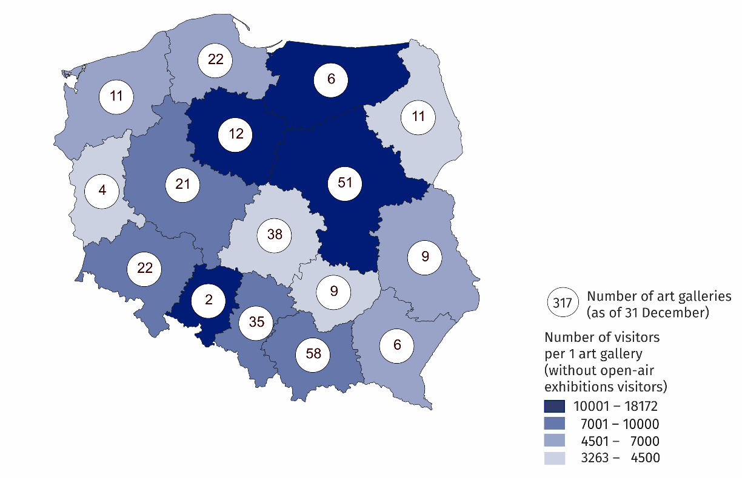
Map 1. Art galleries in 2023
Art galleries organised 3,731 exhibitions of which: national exhibitions (3,353), international (237) and exhibitions from abroad (141). In addition, Polish art galleries organised 55 exhibitions abroad.

Chart 1. The structure of public art galleries own collections in 2023
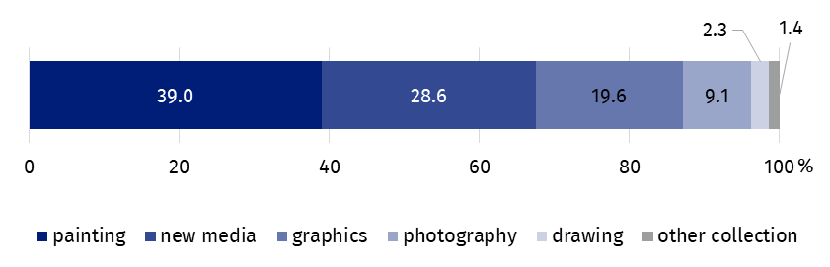
As of 31 December
State and local government art galleries had 1.1 million own collections (3.3% more than in 2022), the largest part of which was painting (39.0%). Objects from the category of new media, graphics and photography together constituted more than half of the own collections of public galleries (57.3%).
Most of art galleries conducting exhibition activities in Poland belonged to the public sector (63.1%), of which 87.0% of art galleries were organised by local government units.
In the case of quoting data from the Statistics Poland, please provide information: "Statistics Poland data source", and in the case of publishing calculations made on data published by the Statistics Poland, please provide information: "Own study based on Statistics Poland data".
Prepared by:  Statistical Office in Kraków  Director Agnieszka Szlubowska  Phone: (+48 12) 420 40 50 | Issued by:  The Spokesperson for the President of Statistics Poland  Karolina Banaszek  Phone: (+48) 695 255 011
Press Office  Phone: (+48 22) 608 38 04  e-mail: obslugaprasowa@stat.gov.pl |   stat.gov.pl/en/

@StatPoland

@GlownyUrzadStatystyczny

gus_stat

glownyurzadstatystycznygus

glownyurzadstatystyczny
Related information
Culture and national heritage in 2022
Activity of art galleries in 2022
Terms used in the official statistics
Art gallery
Unit’s organiser
Exhibition
Open-air exhibition in the galleries
Exposition
Visitor

