Activity of museums in 2023
In 2023, there were 974 museums and museum branches, visited by 42.3 million people. Museums presented 2.7 thousand permanent exhibitions and organised 4.6 thousand temporary exhibitions in Poland.
15.3%
Increase in the number of visitors in museums and museum branches in comparison to 2022
In terms of the number of museums and museum branches, in 2023 two Voivodships dominated – Mazowieckie and Małopolskie, with 140 and 111 units operating, respectively. In these Voivodships, visitors accounted for 59.3% of the total number of visitors to museums and museum branches. The fewest museums and visitors were recorded in Lubuskie Voivodship (17 museums and 281.6 thousand visitors). The number of museum visitors in Poland per 1,000 population was 1,123.

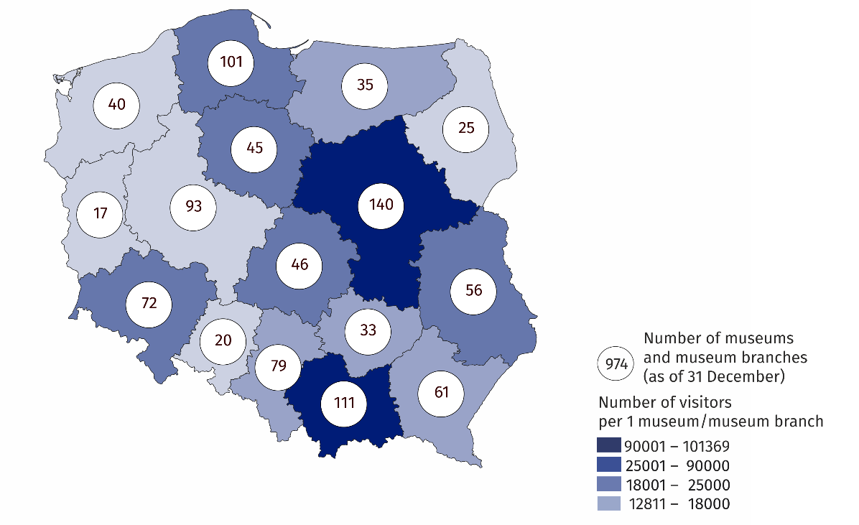
Map 1. Museums and museum branches in 2023
71.9% of museums belonged to the public sector, the vast majority of which were organised by local government units (83.9%). Whereas, within the private sector, museum organisers were most often natural persons (52.2% of private museums).
71.9% of museums and museum branches belonged to the public sector
25.8% of the total number of museums operated in Mazowieckie and Małopolskie Voivodships
Museums and museum branches were visited by 42.3 million people, including 12.8 million free of charge, and 7.9 million visitors with reduced-price tickets. Organised groups of school youth accounted for 9.0% of all visitors (in 2022 – 10.7%). Art museums were the most popular among all visitors, visited by 15.7 million people (37.1% of the total number of visitors).
Museums and museum branches were visited by 42.3 million people, including 12.8 million free of charge
The “Night of Museums” was attended by 762.4 thousand visitors (in 2022 – 619.6 thousand). Historical museums were the most popular during this event, with 290.2 thousand visitors (in 2022 – 231.8 thousand).
Of the total number of museums and museum branches, 39.2% presented outdoor exhibitions, and 38.2% had adjacent areas (gardens, parks, green areas) available to visitors. Historical museums accounted for half of the museums offering both outdoor exhibitions and adjacent areas (48.4% and 50.0%, respectively).
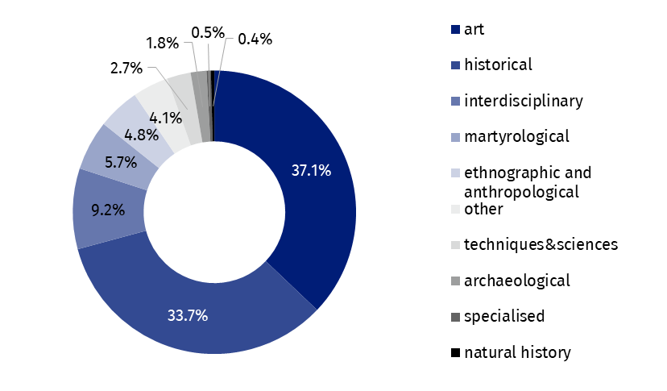
Chart 1. Visitors to museums and museum branches by type in 2023
As of the end of 2023, the total number of museum collections amounted to 21.4 million items, i.e. 2.6% more than in 2022.
Museums presented 2.7 thousand permanent exhibitions (3.4% more than in 2022) and 4.6 thousand temporary exhibitions (4.2% more). The largest number of temporary exhibitions was organised by historical museums (2.3 thousand).
In addition to the primary exhibition activity, 144.2 thousand events were organised by museums and museum branches in 2023, attended by 6.9 million people. Most of the events were museum classes and workshops – 107.8 thousand, attended by 2.2 million people. Museums and museum branches organised also 11.1 thousand curatorial tours – 258.0 thousand people took advantage of this form of sightseeing.
The number of cultural and educational events increased by 8.7% compared to the previous year
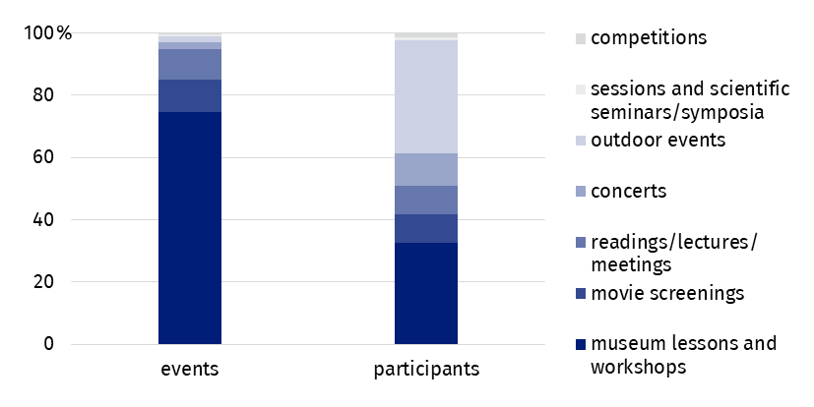
Chart 2. Cultural and educational activity of museums and museum branches in 2023
In the case of quoting data from the Statistics Poland, please provide information: "Statistics Poland data source", and in the case of publishing calculations made on data published by the Statistics Poland, please provide information: "Own study based on Statistics Poland data".
Prepared by:  Statistical Office in Kraków  Director Agnieszka Szlubowska  Phone: (+48 12) 420 40 50 | Issued by:  Press Office  Mobile: (+48) 695 255 032  Phone: (+48 22) 608 38 04, (+48 22) 449 41 45,  (+48 22) 608 30 09  e-mail: obslugaprasowa@stat.gov.pl

stat.gov.pl/en/

@StatPoland

@GlownyUrzadStatystyczny

gus_stat

glownyurzadstatystycznygus

glownyurzadstatystyczny
Related information
Culture and national heritage in 2022
Activity of museums in 2022
Terms used in the official statistics
Museum
Museum branch
Unit’s organiser
Museum lesson
Exhibits
Temporary exhibitions
Permanent exhibitions
Visitor

Visiting the exhibition with a researcher.

