Activity of theatres and music institutions in 2023
In 2023 theatres and music institutions presented 59.0 thousand performances and concerts, with 12.3 million audience. 798 premieres took place. Theatres and music institutions had 5.0 thousand performances and concerts in their repertoire.
31.7%
An increase in the number of audience in theatres and music institutions in comparison to 2022
Stage activities were conducted by 207 theatres and music institutions, of which 182 had their own artistic ensemble. The largest number of theatres and music institutions operated in Voivodships: Mazowieckie (41) and Małopolskie (29), and the fewest - in Lubuskie, Opolskie, Podkarpackie and Świętokrzyskie Voivodships (4 each). A total of 59.0 thousand performances/concerts were staged on 369 stages in Poland.
83.6% of theatres and musical institutions belonged to the public sector. Local government units were organisers for 93.1% of public entities.
Of the total number of audience 32.3% took part in performances and concerts organised by theatres and music institutions in Mazowieckie Voivodship

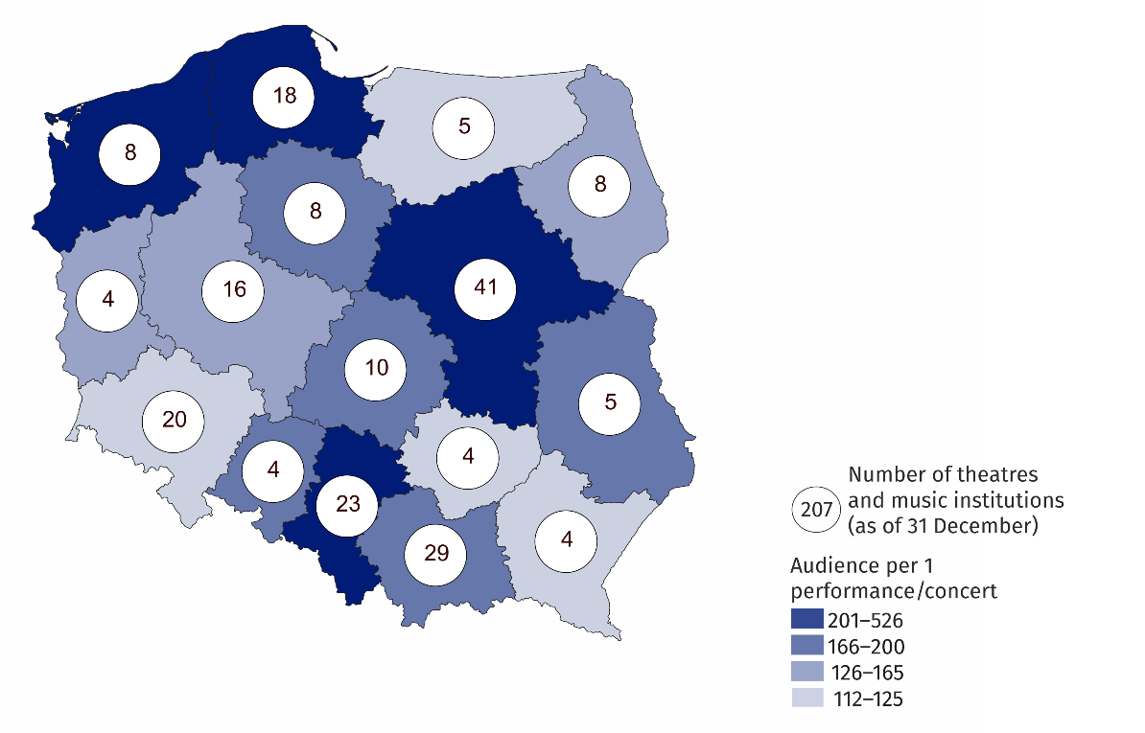
Map 1. Theatres and music institutions in 2023
Performances and concerts organised by theatres and musical institutions were attended by 12.3 million audience (31.7% more than in 2022). The largest number of audience was recorded in the theatres and music institutions in Mazowieckie Voivodship – 4.0 million people (three times more than in Małopolskie Voivodship, which was next in terms of the number of audience). The smallest number of audience attended performances and concerts in the theatres and music institutions in Lubelskie Voivodship (144.4 thousand).
Chart 1. The structure of theatres and music institutions by type in 2023
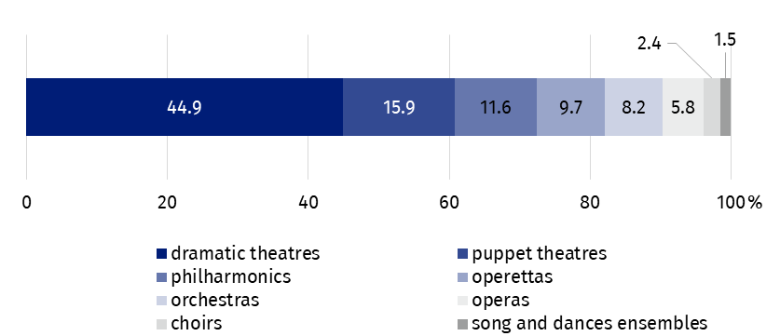
As of 31 December
Theatres and music institutions had 5.0 thousand performances and concerts in their repertoire, of which 798 were premiere shows (645 in dramatic and puppet theatres and 153 in music theatres).
Almost 1/3 of total performances and concerts were addressed to children and youth. Most of them (55.6%) were school music broadcasts.
In the case of quoting data from the Statistics Poland, please provide information: "Statistics Poland data source", and in the case of publishing calculations made on data published by the Statistics Poland, please provide information: "Own study based on Statistics Poland data".
Prepared by:  Statistical Office in Kraków  Director Agnieszka Szlubowska  Phone: (+48 12) 420 40 50 | Issued by:  Press Office  Mobile: (+48) 695 255 032  Phone: (+48 22) 608 38 04, (+48 22) 449 41 45,  (+48 22) 608 30 09  e-mail: obslugaprasowa@stat.gov.pl

stat.gov.pl/en/

@StatPoland

@GlownyUrzadStatystyczny

gus_stat

glownyurzadstatystycznygus

glownyurzadstatystyczny
Related information
Culture and national heritage in 2022
Activity of theatres and music institutions in 2022
Terms used in the official statistics
Choir
Artistic activities and entertainment
Philharmonic
Music institution
Concert
Orchestra
Premiere
Performance
Scene
Theatre
Audience
Own artistic team
Song and dance ensemble

