Financial results of cultural institutions in 2023 – preliminary data
In 2023, the financial results of cultural institutions were higher in comparison to the previous year. Total revenues increased by 16.2%, total costs by 15.7% and investment outlays by 13.5%.
16.2%
Total revenue increase y/y
Total revenues of cultural institutions in 2023 amounted to PLN 14,396.7 million. In the structure of revenues, 91.5% were net revenues from sale of products, goods and materials, 8.2% - other operating revenues and 0.3% - financial revenues. More than 26.0% of revenues were the total revenues of cultural institutions from Mazowieckie Voivodship.
Total revenues of local government cultural institutions in 2023 amounted to PLN 11,542.2 million
Average total revenues per one cultural institution amounted to PLN 3,056.6 thousand. The highest total revenues per one institution were achieved by cultural institutions in Mazowieckie Voivodship – PLN 5,754.6 thousand, and the lowest in Lubelskie Voivodship – PLN 1,476.3 thousand. In 2023 national cultural institutions achieved revenues of PLN 2,854.5 million, while revenues of local government cultural institutions amounted to PLN 11,542.2 million. In the total revenues of cultural institutions the largest share was held by entities operating arts facilities - 40.7%.
Total costs were higher by 15.7% than in the previous year and amounted to PLN 14,198.2 million. The structure of costs was composed of: operating costs (98.6%), other operating costs (1.3%) and financial costs (0.1%). As in the case of revenues, over 26.0% of total costs were the costs of cultural institutions in Mazowieckie Voivodship. In the total costs of cultural institutions, the largest share was held by entities operating arts facilities - 40.8%.
Net financial result of cultural institution in 2023 amounted to PLN 196.6 million
Gross financial result amounted to PLN 198.6 million (gross profit PLN 303.0 million, gross loss PLN 104.4 million). Net financial result amounted to PLN 196.6 million (PLN 117.3 million in the previous year), with an increase in net profit (by 19.8%) and decrease in net loss (by 21.9%).

Table 1. Financial results of cultural institutions
Specification | 01–12 2022 | 01–12 2023 | 01–12 2022=100
Specification | in PLN million |  | 01–12 2022=100
Total revenues | 12,394.2 | 14,396.7 | 116.2
Total costs | 12,274.9 | 14,198.2 | 115.7
Gross financial result | 119.2 | 198.6 | 166.6
Net financial result | 117.3 | 196.6 | 167.6
Net profit | 251.7 | 301.6 | 119.8
Net loss | 134.4 | 105.0 | 78.1
Investment outlays | 1,921.9 | 2,181.0 | 113.5
Outlays on intangible fixed assets | 33.6 | 51.9 | 154.2
In 2023 the investment outlays of cultural institutions were higher by 13.5% than in the previous year and amounted to PLN 2,181.0 million. Over 33.0% of investment outlays had cultural institutions from Mazowieckie voivodship.
Investment outlays incurred by local government cultural institutions amounted to PLN 1,316.9 million, i.e. 60.4% of the total amount of investment outlays.

Chart 1. The structure of investment outlays of cultural institutions by legal forms in 2023

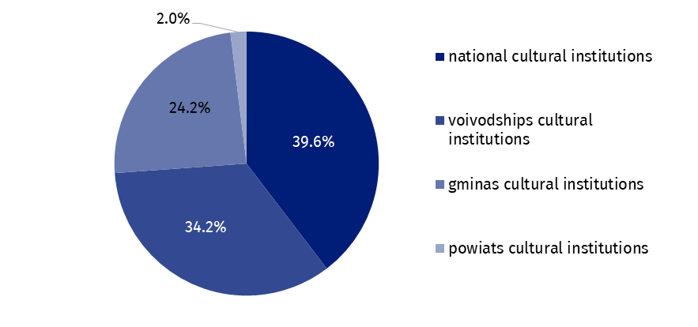
In 2023 outlays of cultural institutions on intangible fixed assets were 54.2% higher in comparison to the previous year and amounted to PLN 51.9 million. The largest share of outlays on intangible fixed assets had cultural institutions from Mazowieckie Voivodship (48.0%).

Table 2. Total revenues and total costs of cultural institutions by selected divisions and classes of PKD classification in 2023
Specification | Number of cultural institutions | Total revenues | Total costs
Specification | Number of cultural institutions | in PLN million
Grand total | 4,710 | 14,396.7 | 14,198.2
local government units property | 4,633 | 11,542.2 | 11,430.5
government property | 77 | 2,854.5 | 2,767.7
of which:
creative, arts and entertainment activities | 2,336 | 8,682.7 | 8,590.6
of which:
performing arts activities | 152 | 2,657.2 | 2,626.7
operation of arts facilities | 2,173 | 5,858.8 | 5,798.1
libraries, archives, museums and other cultural activities | 2,368 | 5,492.3 | 5,392.8
of which:
library and archives activities | 1,969 | 2,317.7 | 2,309.5
museums activities | 391 | 3,082.0 | 2,994.8
The data presented in this study were prepared on the basis of the form with the symbol F-01/dk Quarterly report on the finances of cultural institutions.
In the case of quoting data from the Statistics Poland, please provide information: “Statistics Poland data source”, and in the case of publishing calculations made on data published by the Statistics Poland, please provide information: “Own study based on Statistics Poland data”.
Prepared by:  Statistical Office in Kraków  Director Agnieszka Szlubowska  Phone: (+48 12) 420 40 50 | Issued by:  The Spokesperson for the President of Statistics Poland  Karolina Banaszek  Phone: (+48) 695 255 011
Press Office  Phone: (+48 22) 608 38 04  e-mail: obslugaprasowa@stat.gov.pl |   stat.gov.pl/en/

@StatPoland

@GlownyUrzadStatystyczny

gus_stat

glownyurzadstatystycznygus

glownyurzadstatystyczny
Related information
Financial results of cultural institutions in the period January-September 2023
Methodological report. Non-financial enterprises surveys 2019
Terms used inn official statistics
Total revenues
Total costs
Gross financial result
Net financial result
Investment outlays
Outlays on intangible fixed assets
Cultural institution

