Financial results of cultural institutions in 2023
Assets (liabilities) of the surveyed cultural institutions as of 31 December 2023 amounted to PLN 26,117.0 million. Total revenues were higher by 17.3%. Also total costs increased – by 17.2% in comparison to 2022.
Assets (liabilities) of cultural institutions at the end of 2023 were 11.9% higher than at the end of 2022

17.3%
Increase of the total revenues in comparison to the previous year
Assets (liabilities) amounted to PLN 26,117.0 million. Half (50.9%) of total value of assets (liabilities) belonged to entities employing between 50 to 249 people (319 entities), 25.1% belonged to entities employing between 10 to 49 people (1,611 entities), 20.0% belonged to entities employing 250 and more people (28 entities) and 4.0% – entities employing less than 10 people (2,750 entities).
The highest value of assets (liabilities) was recorded in libraries, archives, museums and in institutions conducting other activity in the field of culture – PLN 15,881.1 million (60.8% of the total value).

Table 1. Basic data on the finances of cultural institutions
Specification | 2022 | 2023 | 2022=100
Specification | in PLN million |  | 2022=100
Assets (liabilities) | 23,334.9 | 26,117.0 | 111.9
Total revenues | 12,476.3 | 14,632.6 | 117.3
Total costs | 12,395.8 | 14,526.1 | 117.2
Gross financial result | 80.5 | 106.6 | 132.4
Net financial result | 78.5 | 104.7 | 133.3
At the end of 2023 total fixed assets of cultural institutions amounted to PLN 23,868.5 and were 11.1% higher in comparison to the previous year. As in the previous year, tangible fixed assets had the largest share in their structure (98.6%), of which fixed assets constituted 85.8% and fixed assets under construction – 13.6%.

Current assets of cultural institutions amounted to PLN 2,248.5 million and were 22.1% higher in comparison to the end of 2022. Short-term investments constituted 65.3% of current assets.

Chart 1. Current assets of cultural institutions in 2023
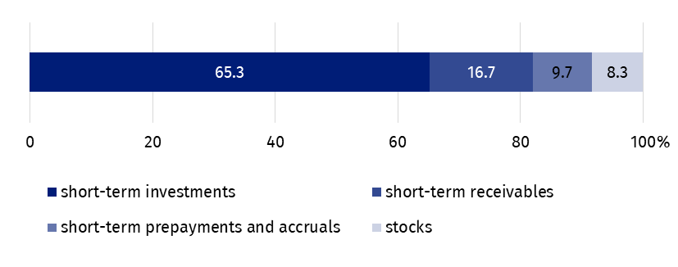
As of 31 December
Equities amounted to PLN 8,288.6 million and increased by 9.9% in comparison to the end of 2022. Equities constituted 31.7% of total liabilities. The share of liabilities and provisions for liabilities in total liabilities constituted 68.3%.
Liabilities and provisions for liabilities at the end of 2023 amounted to PLN 17,828.4 million (increase by 12.9% in comparison to the end of 2022). In their structure prepayments and accruals constituted 92.4%, short-term liabilities 4.5%, reserves for liabilities 2.6% and long-term liabilities 0.5%.
Chart 2. Liabilities of cultural institutions in 2023
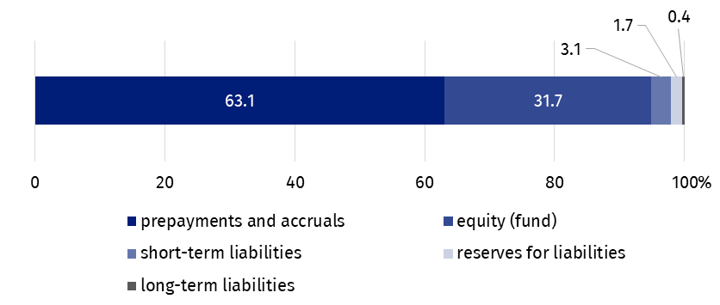
As of 31 December
The total revenue generated by cultural institutions amounted to PLN 14,632.6 million and increased by 17.3% in comparison to 2022. The highest value of revenues was reported in cultural institutions employing between 50 to 249 people (38.7% of the total value of revenues). In the structure of total revenues, the largest share had subsidies to basic activity (74.7%).
Total revenues were 17.3% higher than in 2022
More than 26% of the total value of revenues of cultural institutions were revenues of entities located in Mazowieckie Voivodship.
The revenues of local government cultural institutions amounted to PLN 11,655.4 million (79.7%) and that of state cultural institutions amounted to PLN 2,977.2 million (20.3%).
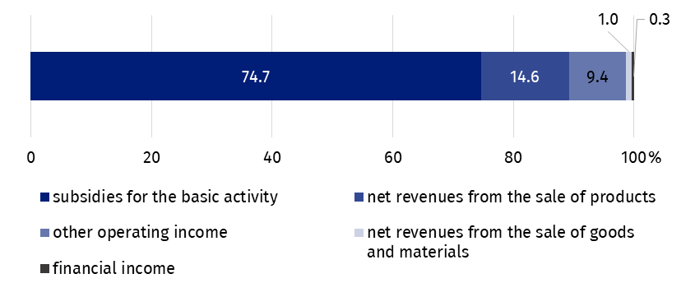
Chart 3. Total revenues of cultural institutions in 2023
In 2023 total costs incurred by cultural institutions amounted to PLN 14,526.1 million and were 17.2% higher than in previous year. The highest share had own costs of products, goods and materials sold (97.8%).
Total costs were 17.2% higher than in 2022
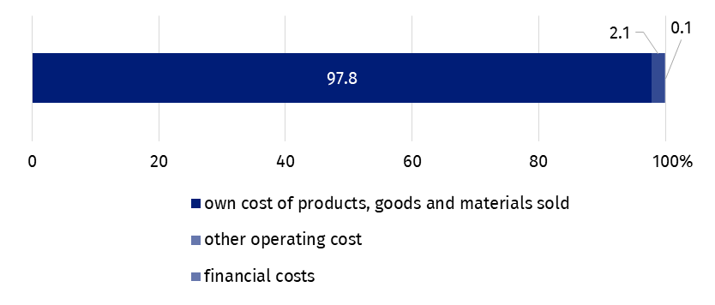
Chart 4. Total costs of cultural institutions in 2023
More than 26% of the total value of costs were incurred by cultural institutions from Mazowieckie Voivodship.
The highest share in total revenues and total costs was generated by institutions conducting creative arts and entertainment activity, i.e. PLN 8,750.9 million respectively (59.8% of the total value of revenues) and PLN 8,706.9 million (59.9% of the total value of costs).
The gross financial result of cultural institutions increased from PLN 80.5 million in 2022 to PLN 106.6 million in 2023 (gross profit PLN 245.4 million, gross loss PLN 138.8 million).
Obligatory encumbrances on gross financial result due to income taxes decreased in relation to 2022 by 3.5% and amounted to PLN 1.9 million.
The net financial result of cultural institutions amounted to PLN 104.7 million (compared to PLN 78.5 million in 2022), with an increase in net profit (by 3.6%) and a decrease in net loss (by 11.2%). From the total number of cultural institutions examined, 41.7% achieved a net profit and 40.5% recorded a net loss.
As of 31 December 2023, 87.2 thousand people worked in cultural institutions, of which 12.6% in state-owned and 87.4% in local government ones. Among the institutions surveyed, small entities employing less than 10 people predominated, constituting 58.4% of the total number of units. Similarly to previous years, most people worked in cultural institutions conducting creative arts and entertainment activities (55.6% of the total number of employees).

Table 2. Total revenues and total costs according to selected divisions and classes of PKD classification in 2023
Specification | Total | Of which
Specification | Total | creative, arts and enterta-inment activi-ties | of which |  | libraries, archives, muse-ums and other cultural activities | of which
Specification | Total | creative, arts and enterta-inment activi-ties | perfor-ming arts | opera-tion of arts facilities | libraries, archives, muse-ums and other cultural activities | library and  archives active-ties | muse-ums activi-ties
Number of cultural institutions | 4,708 | 2,335 | 152 | 2,172 | 2,367 | 1,968 | 391
Total revenues in PLN million | 14,632.6 | 8,750.9 | 2,681.6 | 5,901.9 | 5,637.5 | 2,337.8 | 3,207.1
of which:
net revenues from the sale of products | 2,143.1 | 1,464.0 | 543.1 | 897.1 | 558.7 | 29.5 | 520.3
subsidies for the basic activity | 10,927.3 | 6,481.1 | 1,920.7 | 4,426.2 | 4,352.6 | 2,154.2 | 2,127.4
of which:
state budget | 2,291.6 | 1,087.2 | 461.0 | 600.6 | 1,130.1 | 197.8 | 874.1
local government units | 8,510.1 | 5,333.6 | 1,451.5 | 3,776.9 | 3,170.5 | 1,943.4 | 1,215.9
Total costs in PLN million | 14,526.1 | 8,706.9 | 2,666.5 | 5,873.0 | 5,580.5 | 2,341.8 | 3,150.1
of which:
depreciation | 1,007.6 | 481.6 | 163.6 | 313.0 | 502.1 | 153.6 | 344.2
usage of materials and energy | 1,374.1 | 833.2 | 159.3 | 666.3 | 523.0 | 241.4 | 275.7
external services | 2,914.6 | 1,918.7 | 385.5 | 1,476.4 | 923.0 | 264.8 | 639.7
remuneration | 6,826.0 | 4,071.3 | 1,476.5 | 2,524.8 | 2,686.9 | 1,307.7 | 1,340.1
social insurance and other benefits | 1,359.5 | 782.1 | 284.9 | 485.4 | 564.5 | 273.8 | 282.4

The balance sheet and profit and loss account for 2023 were obtained from 4,708 cultural institutions with legal personality: 77 state organisational units and 4,631 self-government units.
The data presented in this study were prepared on the basis of the form with the symbol
F-02/dk Annual report on the finances of cultural institutions.
In the case of quoting data from the Statistics Poland, please provide information: "Statistics Poland data source", and in the case of publishing calculations made on data published by the Statistics Poland, please provide information: "Own study based on Statistics Poland data".

Prepared by:  Statistical Office in Kraków  Director Agnieszka Szlubowska  Office: tel. (+48 12) 420 40 50 | Issued by:  Press Office  Mobile: (+48) 695 255 032  Phone: (+48 22) 608 38 04, (+48 22) 449 41 45,  (+48 22) 608 30 09  e-mail: obslugaprasowa@stat.gov.pl

stat.gov.pl/en

@StatPoland

@GlownyUrzadStatystyczny

gus_stat

glownyurzadstatystycznygus

glownyurzadstatystyczny
Related information
Financial results of cultural institutions in 2023 – preliminary data
Financial results of cultural institutions in 2022
Methodological report. Non-financial enterprises surveys 2019
Terms used in official statistics
Total revenues
Total costs
Gross financial result
Net financial result
Investment outlays
Outlays on intangible fixed assets
Cultural institution

