Outpatient health care in 2023
8.0%
Increase in the number of specialised doctors consultations compared to 2022

At the end of 2023, outpatient health care was carried out by 23.5 thousand outpatient departments and 3.2 thousand doctors and dentists practises providing services funded by public sources. During the year, 312.3 million doctors consultations and 34.9 million stomatological consultations were provided. Almost 9.5% of total doctors consultations in primary health care were provided via telephone.

Outpatient departments and medical practices
At the end of 2023, outpatient consultations were provided by 23.5 thousand outpatient departments and 3.2 thousand doctors and dentists practices providing services funded by public sources
At the end of 2023, 26.6 thousand providers of ambulatory health care were operating – 23.5 thousand outpatient departments and 0.6 thousand doctors’ practices and 2.6 thousand dentists practices providing services funded by public sources. 21.2 thousand providers of ambulatory health care were located in urban areas, and 5.4 thousand in rural areas.
The most outpatient departments were operating in Mazowieckie Voivodship (3 570), and the lowest – in Opolskie Voivodship (579). The highest number of practices providing health services funded by public sources was in Wielkopolskie Voivodship (369), while the lowest – in Lubuskie Voivodship (116).
Chart 1. Outpatient departments by class of locality and voivodships in 2023
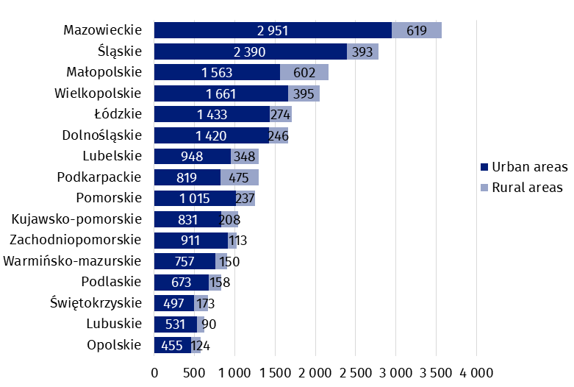
As of 31 December

Chart 2. Doctors and dentists practises providing health services funded by public sources by class of locality and voivodships in 2023
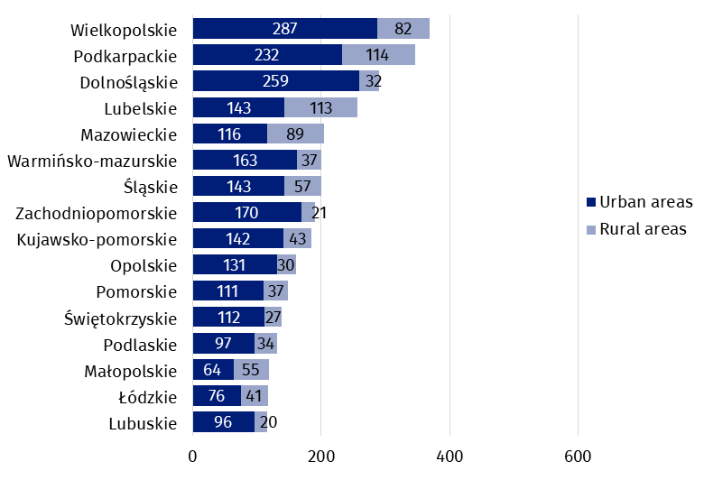
As of 31 December
The number of population per one provider of ambulatory health care amounted to 1 413 persons (by 35 less than in the previous year). The highest value was recorded in Pomorskie Voivodship (1 685 persons), while the lowest – in Podlaskie Voivodship (1 183).

Map 1. The number of population per 1 provider of ambulatory health care by voivodships in 2023
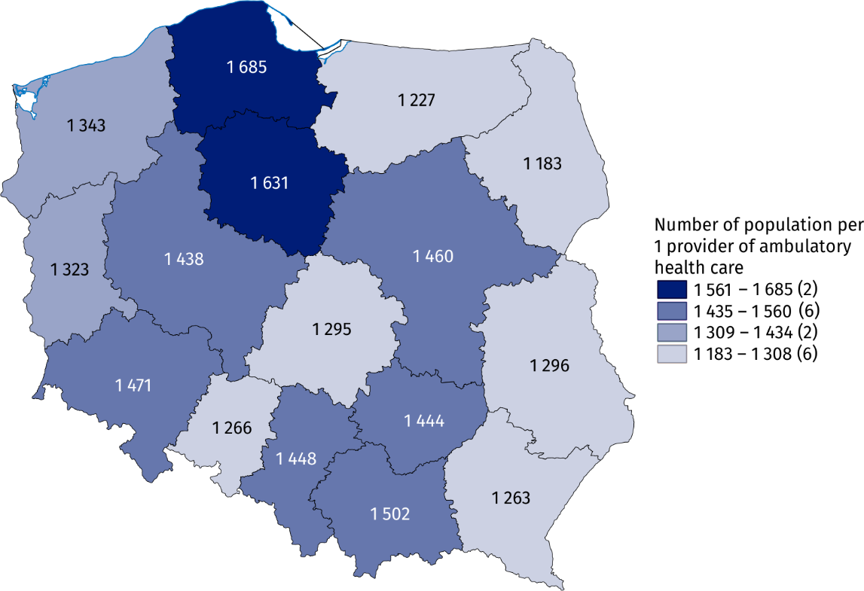
As of 31 December

Outpatient consultations
In 2023, there were provided 312.3 million doctors consultations and 34.9 stomatological consultations in outpatient health care
In 2023, there were 347.3 million outpatient consultations – 312.3 million doctors consultations (increase of 4.9% compare to the previous year) and 34.9 million stomatological consultations (by 5.3% more than a year earlier). 181.1 million doctors consultations were in primary health care (by 2.8% more than in 2022), and 131.2 million in specialised health care (increase of 8.0% compared to the previous year).
In primary health care children and youth in age up to 18 years had 36.9 million consultations (decrease of 0.5% compared to previous year), while people aged 65 years and more – 63.4 million (by 6.0% more than a year earlier). There were 16.9 million specialised consultations provided to children and youth in age up to 18 years (increase of 7.7% compared to 2022) and 39.7 million consultations provided to people aged 65 years and more (by 10.3% more than in previous year).

Chart 3. Outpatient consultations by type of consultation and patients’ age in 2023
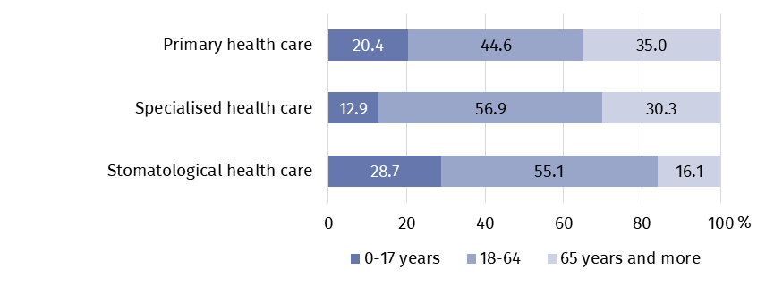
In 2023, 17.1 million doctors consultations in primary health care and 9.7 million in specialised health care were provided via telephone (by 27.2% and 8.5% respectively less than in previous year). 55.0 thousand stomatological consultations were provided remotely.
In specialised health care, the highest share of consultations was in surgical clinics (17.7%). A large number of consultations were also recorded in gynecological and obstetrical clinics (10.5%) and ophthalmology clinics (8.6%).
Most doctors consultations in specialised outpatient health care were provided in surgical clinics (over 23 million)

Chart 4. Selected specialised doctors consultations by type of clinic in 2023
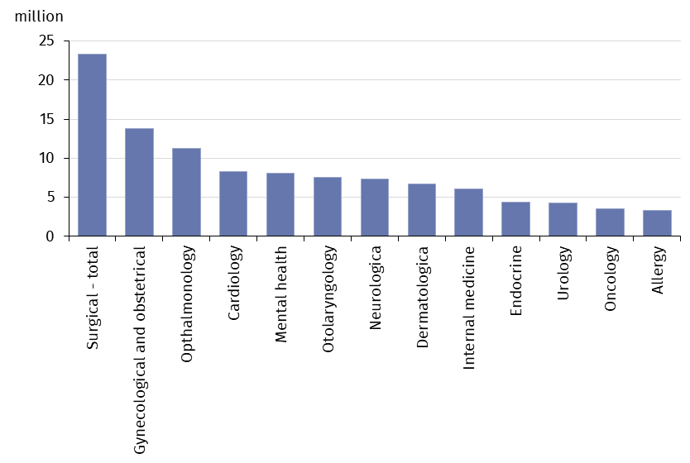
In 2023, the average number of outpatient consultations per capita was 9.2
In review year, the average number of outpatient consultations per capita was 9.2. The highest value was recorded in Mazowieckie Voivodship (10.2), while the lowest – in Opolskie Voivodship (7.6).

Map 2. Outpatient consultations per capita by voivodships in 2023
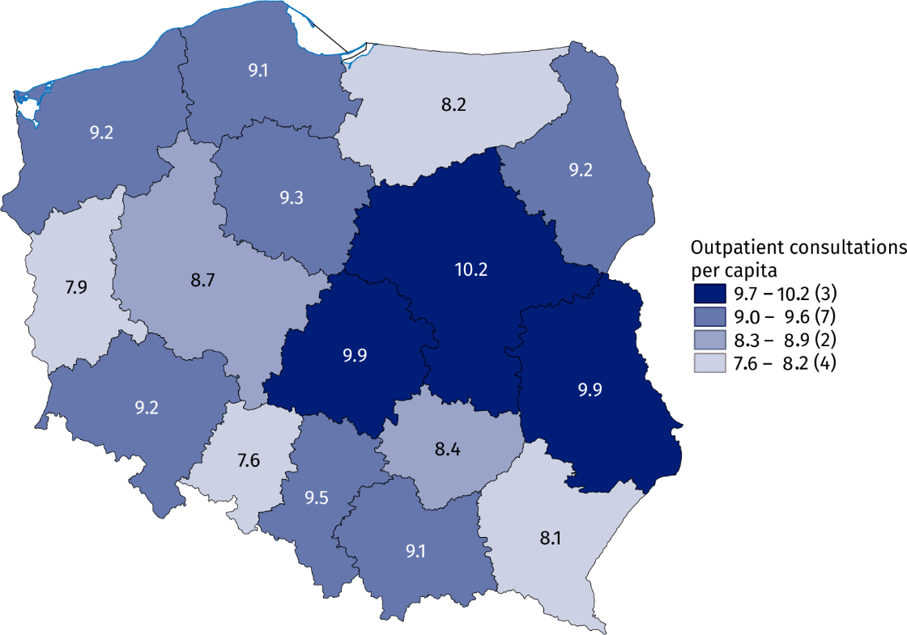

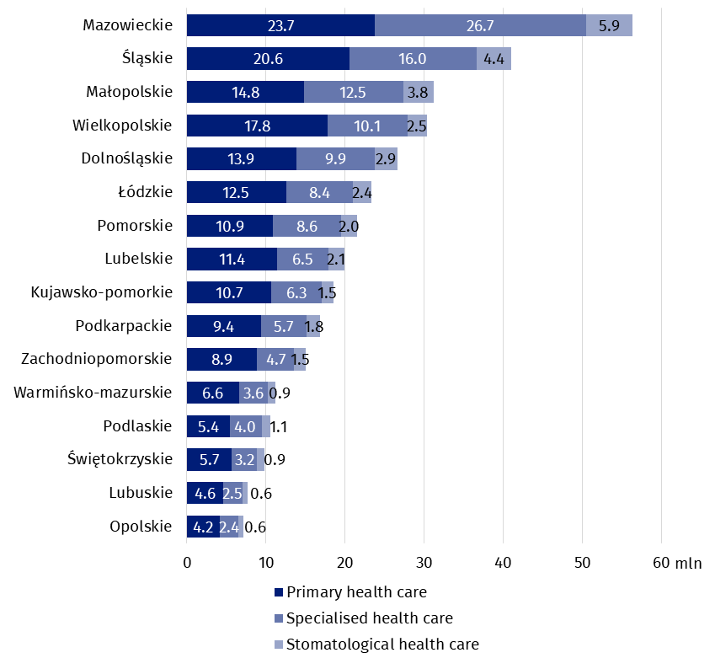
Chart 5. Outpatient consultations by type of consultation and voivodships in 2023
In the case of quoting data from the Statistics Poland, please provide information: "Statistics Poland data source", and in the case of publishing calculations made on data published by the Statistics Poland, please provide information: "Own study based on Statistics Poland data".

Prepared by:  Statistical Office in Kraków  Director Agnieszka Szlubowska  Phone: (+48 12) 420 40 50 | Issued by:  Press Office  Mobile: (+48) 695 255 032  Phone: (+48 22) 608 38 04, (+48 22) 449 41 45,  (+48 22) 608 30 09  e-mail: obslugaprasowa@stat.gov.pl

stat.gov.pl/en/

@StatPoland

@GlownyUrzadStatystyczny

gus_stat

glownyurzadstatystycznygus

glownyurzadstatystyczny
Related information
Health and health care in 2022
Methodological report. Health and health care statistics – Statistics Poland’s reports

Data available in databases
Local Data Bank -> Health care, social welfare and benefits to the family
Knowledge Databases -> Society -> Health and health care

Terms used inn official statistics
Specialised out-patient services
Out-patient health care services
Primary health care
Consultation
Medical practice
An out-patient department
Teleconsultation

Including holiday and night time medical services. There are health care benefits in primary health care, provided from 6 pm to 8 am on the following day and 24 hours on public holidays. Including also holiday and night time medical services given as a subcontract with a hospital.

