Pharmacies and pharmaceutical outlets in 2023
At the end of 2023, there were operating 11.5 thousand pharmacies (generally available and dispensaries) and 1.1 thousand pharmaceutical outlets in which 57.8 thousand pharmacists and pharmaceutical technicians were employed.
1.6%
Decrease in the number of generally available pharmacies compared to 2022

Pharmacies and pharmaceutical outlets
At the end of 2023, there were operating 11.5 thousand generally available pharmacies (decrease of 1.6% in comparison with the previous year) and 1.1 thousand pharmaceutical outlets (by 2.5% less than a year earlier). Additionally, there were 24 dispensaries (as in 2022).
The night duties were fulfilled permanently by 2.2% generally available pharmacies, temporarily – by 15.3% pharmacies. The sales of medical products by mail order using the website (via e-pharmacies) were carried out by 197 pharmacies and 6 pharmaceutical outlets.
The number of population per one generally available pharmacy and pharmaceutical outlet amounted to 2 996 persons
There were on average 2 996 persons per one generally available pharmacy and pharmaceutical outlet (by 40 more than in the previous year). The highest number of inhabitants per one generally available pharmacy and pharmaceutical outlet was recorded in Pomorskie Voivodship (3 425), while the lowest – in Lubelskie Voivodship (2 615).
Map 1. Generally available pharmacies and pharmaceutical outlets by voivodships in 2023
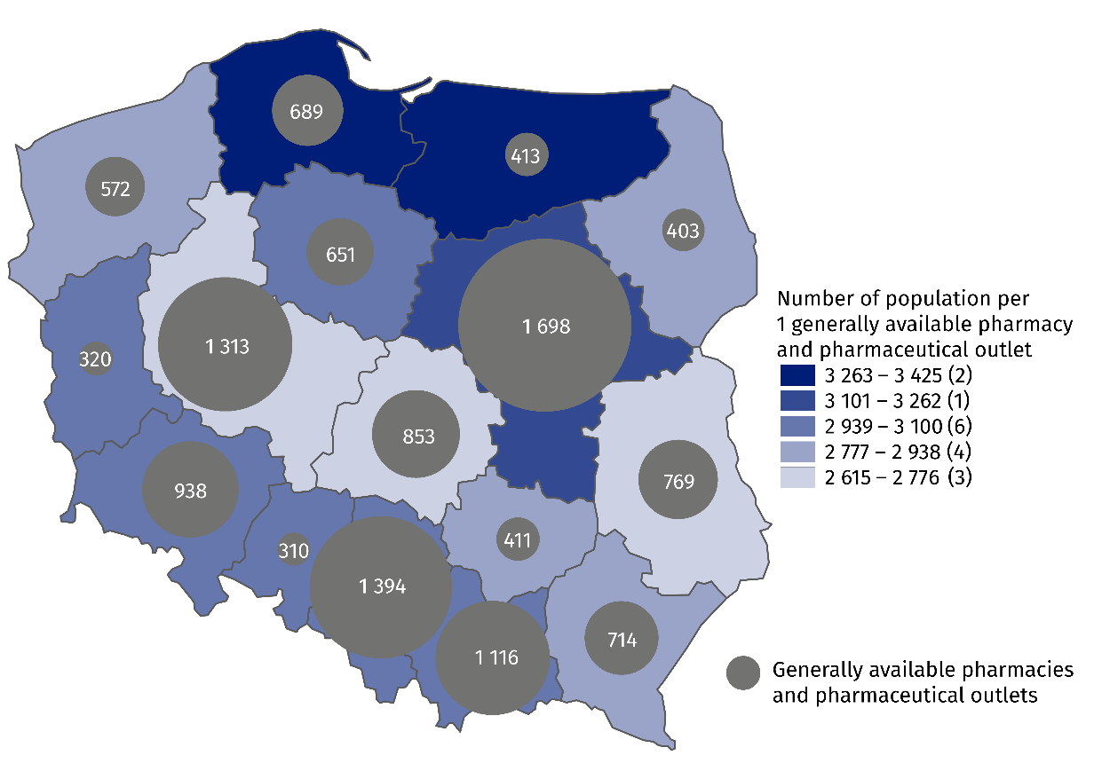
As of 31 December

Employed in pharmacies and pharmaceutical outlets
Pharmacies and pharmaceutical outlets employed 25.9 thousand pharmacists and 31.9 thousand pharmaceutical technicians
As of 31 December 2023, generally available pharmacies, dispensaries and pharmaceutical outlets employed 63.2 thousand employees, of which 25.9 thousand pharmacists and 31.9 thousand pharmaceutical technicians (compared to 2022 respectively increase by 0.4% and decrease by 0.3%). Like a year earlier, the vast majority of employees were females (83.4% of pharmacists and 94.6% of pharmaceutical technicians).
Table 1. Employed in pharmacies and pharmaceutical outlets in 2023
Specification | Total | Of which
Specification | Total | pharmacists | pharmaceutical technicians
Generally available pharmacies | 61358 | 25701 | 30379
Dispensaries | 209 | 91 | 53
Pharmaceutical outlets | 1655 | 130 | 1450
Map 2. Employed in generally available pharmacies and pharmaceutical outlets by voivodships in 2023
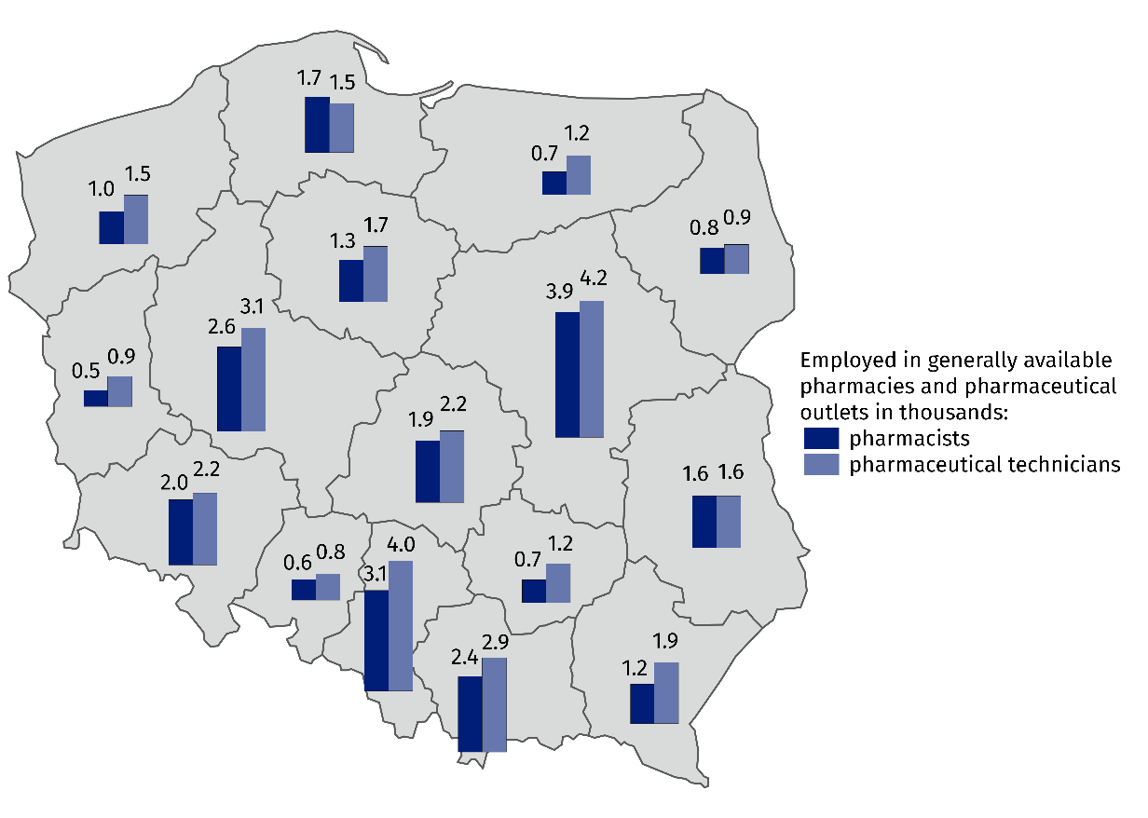
As of 31 December
In the case of quoting data from the Statistics Poland, please provide information: "Statistics Poland data source", and in the case of publishing calculations made on data published by the Statistics Poland, please provide information: "Own study based on Statistics Poland data".

Prepared by:  Statistical Office in Kraków  Director Agnieszka Szlubowska  Phone: (+48 12) 420 40 50 | Issued by:  Press Office  Mobile: (+48) 695 255 032  Phone: (+48 22) 608 38 04, (+48 22) 449 41 45,  (+48 22) 608 30 09  e-mail: obslugaprasowa@stat.gov.pl

stat.gov.pl/en/

@StatPoland

@GlownyUrzadStatystyczny

gus_stat

glownyurzadstatystycznygus

glownyurzadstatystyczny
Related information
Health and health care in 2022
Methodological report. Health and health care statistics − Statistics Poland’s reports
Data available in databases
Local Data Bank -> Health care, social welfare and benefits to the family
Knowledge Databases -> Society -> Health and Health care
Terms used inn official statistics
Generally available pharmacy
Dispensary
Pharmaceutical outlet
The main workplace

Concerns employed persons for whom this is the main workplace. Total number of employed covers all employees in an establishment, including non-medical staff (e.g. cashiers, manual workers) as well as owners and co-owners of pharmacies.

