Emergency rescue services activity in 2023
20.2% Decrease in the number of interventions of fire brigades in 2023 compared to 2022
In 2023, fire brigades intervened in 486.1 thousand events. Interventions concerned 99.3 thousand fire events, 340.0 thousand local threats, and 46.9 thousand false alarms. 490 drowning accidents, of which 450 persons died, including 50 women, were reported to the Police. Water life rescue services carried out 1 412 rescue actions.

Events involving fire brigades
In 2023, throughout the country, fire brigades intervened in 486.1 thousand events (decrease by 20.2% in comparison with 2022). Most of the interventions of fire brigades were recorded in Mazowieckie Voivodeship (70.3 thousand), the lowest number was in Opolskie Voivodeship (12.2 thousand). Indicator of the number of events requiring intervention of fire brigades per thousand persons, reached the highest level in Lubuskie Voivodeship (14.9), and the lowest one in Lubelskie Voivodeship (10.7).
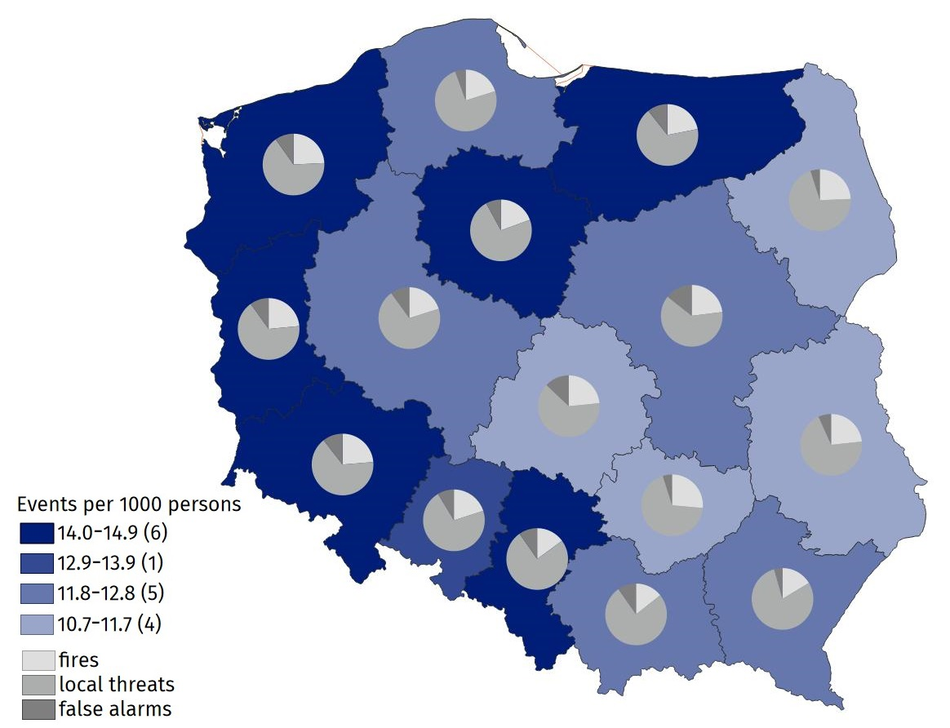
Map 1. Events requiring intervention of fire brigades in 2023
Source: National Headquarters of the State Fire Service.
Interventions concerned 340.0 thousand local threats (by 20.0% less than in 2022), 99.3 thousand fires (less by 27.0%) and 46.9 thousand false alarms (less by 2.2%).
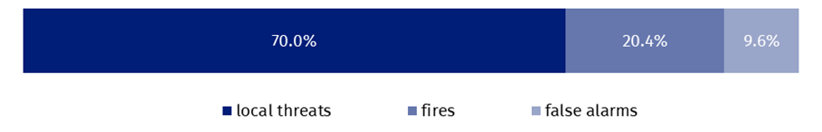
Chart 1. Events involving fire brigades in 2023
Source: National Headquarters of the State Fire Service.
In case of local threats per thousand persons, requiring the participation of fire brigades, the highest value of the indicator was in Śląskie Voivodeship (11.0), while the lowest value was in Łódzkie Voivodeship (7.0). The most local threats requiring the intervention of fire brigades were windstorms (64.4 thousand), which number in comparison with 2022, decreased by 48.6%.
In 2023, 96.1% of all fires were classified as small fires
Most of the fires were small - 95.4 thousand (96.1% of total number), and the number of very big fires was the smallest - 73 (0.1%).
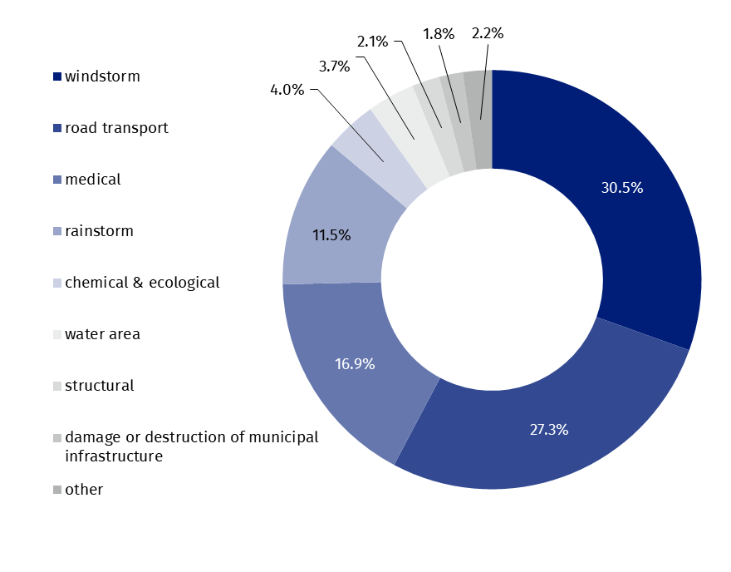
Chart 2. Local threats by type in 2023
Windstorms were the largest local threats requiring the intervention of fire brigades (30.5% cases)
Source: National Headquarters of the State Fire Service.
As in previous years, more than a half of all false alarms i.e. 23 850 (50.9%) were reported in good faith.
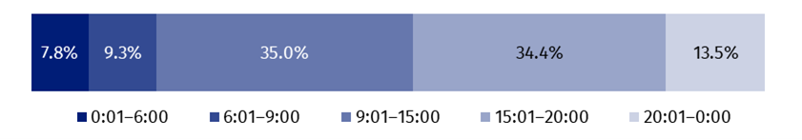
Chart 3. Events requiring intervention of fire brigades by time of spotting in 2023
Source: National Headquarters of the State Fire Service.
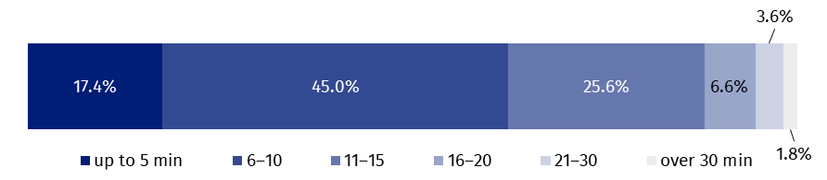
Chart 4. Events requiring intervention of fire brigades by drive time in 2023
In 45% of incidents, the drive time of arrival at the location of the accident was between 6 and 10 minutes
Source: National Headquarters of the State Fire Service.
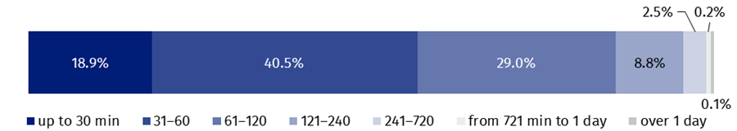
Chart 5. Events requiring intervention of fire brigades by duration of intervention in 2023
In more than 40% of incidents, the duration of the intervention of the fire protection units was between 31 and 60 minutes

Source: National Headquarters of the State Fire Service.
3 503.0 thousand firefighters were involved in interventions of fire brigades, including 1 766.3 thousand volunteer firefighters, 8 097.5 thousand vehicles were used in rescue actions, of which 677.1 thousand fire engines. As a result of fires and local threats, 11.0 thousand persons died (including five firefighters) and 55.5 thousand were injured (including 432 firefighters).

Table 1. Events involving fire brigades by voivodeships in w 2023
Specification | Total | Fires | Local threats | False alarms
POLAND | 486 124 | 99 275 | 339 986 | 46 863
Dolnośląskie | 40 724 | 9 665 | 26 757 | 4 302
Kujawsko-pomorskie | 28 781 | 5 594 | 20 893 | 2 294
Lubelskie | 21 465 | 5 004 | 15 013 | 1 448
Lubuskie | 14 551 | 3 420 | 9 696 | 1 435
Łódzkie | 26 034 | 6 101 | 16 563 | 3 370
Małopolskie | 42 613 | 6 106 | 32 376 | 4 131
Mazowieckie | 70 295 | 16 218 | 43 992 | 10 085
Opolskie | 12 176 | 2 441 | 8 683 | 1 052
Podkarpackie | 24 796 | 4 057 | 19 649 | 1 090
Podlaskie | 12 761 | 3 109 | 9 022 | 630
Pomorskie | 29 783 | 6 002 | 22 134 | 1 647
Śląskie | 62 961 | 9 411 | 47 467 | 6 083
Świętokrzyskie | 13 244 | 3 495 | 9 101 | 648
Warmińsko-mazurskie | 20 093 | 4 402 | 13 552 | 2 139
Wielkopolskie | 41 680 | 8 386 | 29 146 | 4 148
Zachodniopomorskie | 24 167 | 5 864 | 15 942 | 2 361
Source: National Headquarters of the State Fire Service.

Drowning events
In 2023, 450 persons drowned, that is 28 persons more than in the previous year

In 2023, 490 drowning events were reported to the Police (by 9.6% more than in 2022), resulting in 450 deaths (by 6.6% more), including 50 women (6.4% more than in the previous year).
Most victims of drowning events were recorded in Pomorskie Voivodeship (60), the smallest number of them in Podlaskie Voivodeship (11).
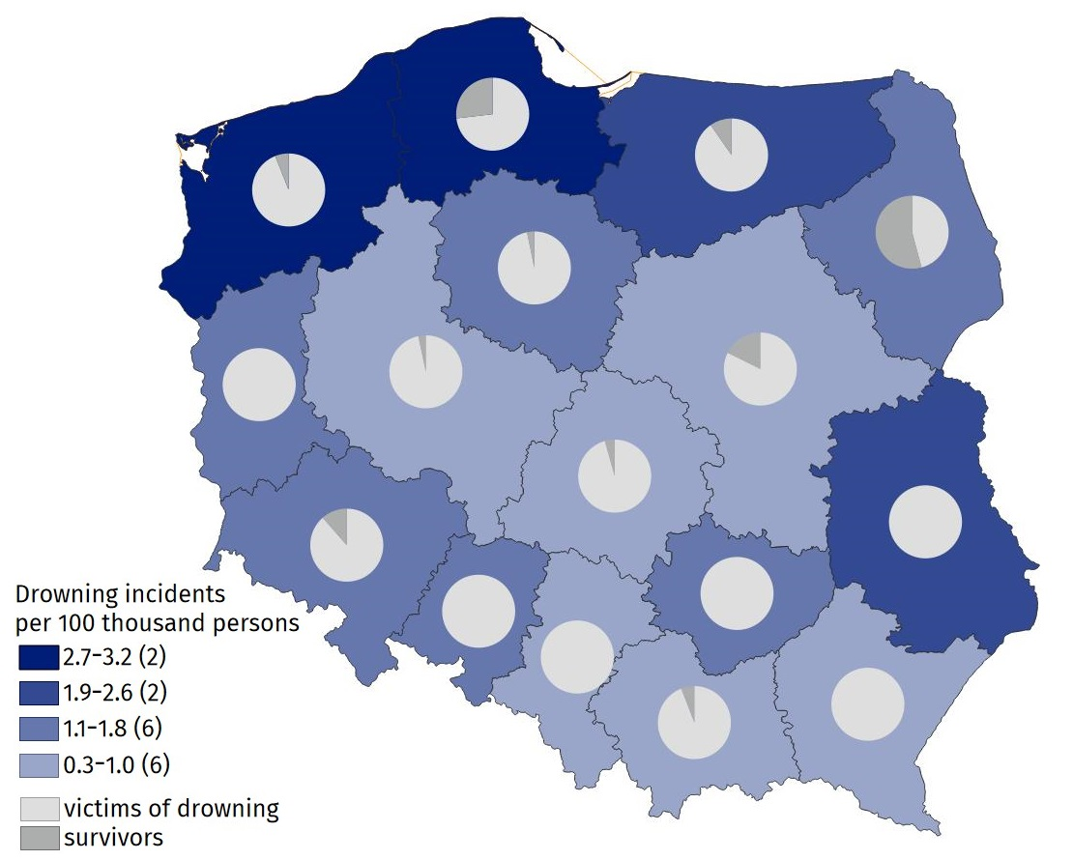
Map 2. Drowning incidents by voivodeships in 2023
Source: data on the basis of data from registered proceedings by Police offices.
Persons over 50 years of age were the largest group of drowning victims (224 persons), while children under 7 years of age were the smallest (one person).
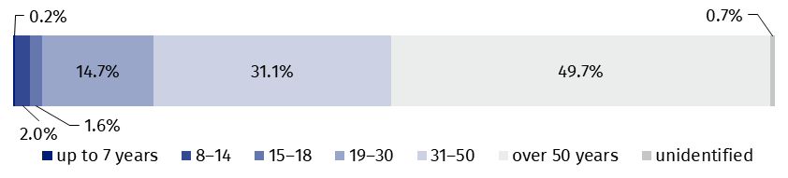
Chart 6. Victims of drowning by age in 2023
Among the drowning victims, 224 were over 50 years old (49.8% of all victims)
Source: National Headquarters of Police.
The highest numbers of drowning accidents were recorded on Sundays (101), while the lowest numbers of them were recorded on Mondays (44).
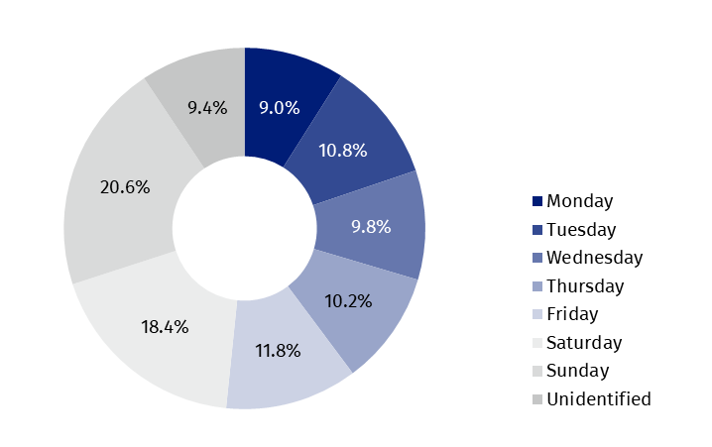
Chart 7. Drowning incidents by days of the week in 2023
Source: National Headquarters of Police.
Most of victims drowned in the rivers (121 cases)
Most of victims drowned in rivers (121), of which the biggest number in Małopolskie Voivodeship (14) and the least in Śląskie (2). 111 persons drowned in lakes. The biggest number of victims of drowning in lakes was recorded in Pomorskie Voivodeship (30), while the smallest number of such victims was in the Dolnośląskie, Świętokrzyskie and Podlaskie Voivodeships (one person in each). No victim of drowning in the lakes in Podkarpackie Voivodeship was recorded. 18 persons drowned in the sea, i.e. two more than in 2022 (12 in the Pomorskie Voivodeship and 6 in the Zachodniopomorskie Voivodeship).
At the time of the incident, 82 drowning victims were intoxicated whereas 30 were sober. In 336 events of drowning (74.7%) state of consciousness (i.e. sober, intoxicated or under influence of drugs) could not be determined.

Table 2. Drowning incidents by voivodeships in 2023 r.
59 persons were rescued from drowning
Specification | Drowning incidents | Victims of drowning | Survivors
POLAND | 490 | 450 | 59
Dolnośląskie | 35 | 31 | 4
Kujawsko-pomorskie | 31 | 30 | 1
Lubelskie | 39 | 40 | –
Lubuskie | 13 | 13 | –
Łódzkie | 22 | 22 | 1
Małopolskie | 33 | 32 | 2
Mazowieckie | 50 | 42 | 9
Opolskie | 14 | 14 | –
Podkarpackie | 19 | 19 | –
Podlaskie | 19 | 11 | 13
Pomorskie | 75 | 60 | 22
Śląskie | 12 | 12 | –
Świętokrzyskie | 19 | 20 | –
Warmińsko-mazurskie | 31 | 28 | 3
Wielkopolskie | 29 | 29 | 1
Zachodniopomorskie | 49 | 47 | 3
Note: There can be more than one person per incident.
Source: data on the basis of data from registered proceedings by Police stations.

Actions of water rescue services
In 2023, 118 entities were eligible to water rescue
As of 31 December 2023, 118 entities received permission to water rescue service and they employed 14 027 water lifeguards.
Water lifeguards carried out 1 412 rescue operations
Water lifeguards carried out 1 412 rescue operations, most of them in inland and coastal water area (857) and least in places occasionally used for bathing (34).
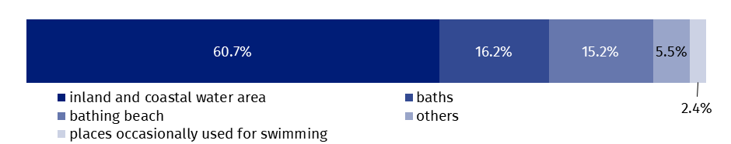
Chart 8. Rescue operations to save drowning people by place of rescue in 2023
Source: Ministry of Interior and Administration.
Water lifeguards carried out 6 482 actions requiring professional first aid. Most rescue actions occurred in the baths (2 180), such interventions were the least in places occasionally used for swimming (27).
In the analysed period 779 actions dealt with transporting victims of the incidents or in danger of losing health or life in water area to a location where it was possible to perform medical rescue actions by the units of the State Medical Emergency.
Water lifeguards saved lives of 1 226 drowning persons
Water lifeguards took part in 581 actions of searching for missing people. They saved 1 226 persons.
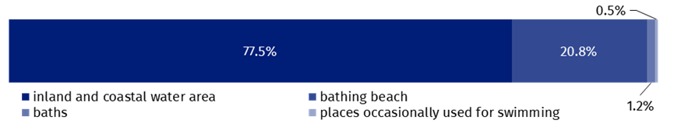
Chart 9. Actions of searching for missing persons in water area by place of rescue in 2023
Source: Ministry of Interior and Administration.
Entities, eligible to water rescue, were carrying out training activities in the area of water rescue. In 2023 they delivered 501 training courses, including 484 training courses dedicated to water lifeguards. 17 courses were delivered for instructors of water rescue. 4 977 persons were awarded with the certificate of acquired qualifications.
In the case of quoting data from the Statistics Poland, please provide information: “Statistics Poland data source”, and in the case of publishing calculations made on data published by the Statistics Poland, please provide information: “Own study based on Statistics Poland data”.

Prepared by:  Statistical Office in Kraków  Director Agnieszka Szlubowska  Phone: (+48 12) 420 40 50 | Issued by:  Press Office  Mobile: (+48) 695 255 032  Phone: (+48 22) 608 38 04, (+48 22) 449 41 45,  (+48 22) 608 30 09  e-mail: obslugaprasowa@stat.gov.pl

stat.gov.pl/en/

@StatPoland

@GlownyUrzadStatystyczny

gus_stat

glownyurzadstatystycznygus

glownyurzadstatystyczny
Related information
Emergency rescue services activity in 2022
Fire brigade activity in 2022
Emergency rescue services activity in 2021
Data available in databases
Database Local Data Bank – organisation of the state and justice

Data based on events reported to the Police.
Data based on reports of services entitled to water life savings reported to the Ministry of Interior and Administration.
Reference to Article 32(1) Act of 8 September 2006 on Medical State Emergency. Journal of Laws 2024, pos. 652 and further amendments.

