Stationary social welfare facilities in 2023
In the country there were 2 138 stationary social welfare facilities, which had 132.6 thousand places in total. 121.9 thousand residents stayed in stationary social welfare facilities, including 60.5 thousand women.
132.6 thousand
The number of places in stationary social welfare facilities in 2023

Facilities
Social assistance houses accounted for over 42% of all stationary social welfare facilities

Social assistance houses accounted for 42.3% of all stationary social welfare facilities operating at the end of 2023. Establishments ensuring 24–hour care for disabled persons, chronic patients or elderly persons within the scope of economic activity or their statutory activity accounted for 30.5% and hostels for homeless persons for 14.2%. Family–based assistance houses, community self–help centres (with round–the–clock available places), houses for mothers with children under age and pregnant women, night shelters and other centres jointly accounted for 13.0% of all facilities.

Chart 1. Stationary social welfare facilities by type in 2023
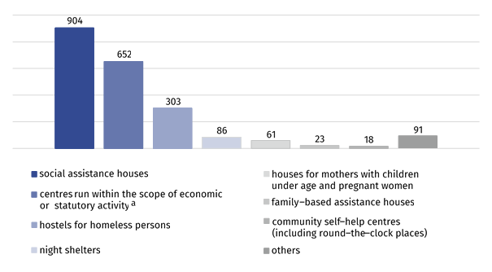
As of 31 December
a Establishments ensuring 24–hour care for disabled persons, chronic patients or elderly persons within the scope of economic activity or their statutory activity. c Including round–the–clock places.
Local government was a governing body for 35.8% stationary social welfare facilities. Legal and natural persons, associations, churches and religious unions, foundations and other organisations managed the rest of facilities.
Over 89% of the objects were equipped with amenities for the disabled persons. The most of the facilities (over 71%) was equipped with bathrooms for persons with disabilities. Ramps, ascents and platforms easing the entrance were present in 66.2% facilities and lifts in 63.6% of them. Remaining facilities, predominantly hostels for homeless persons and night shelters, did not have any conveniences for persons with disabilities.

Places
About 64% of all places in stationary social welfare facilities are located in social assistance houses

At the end of 2023, the places in social assistance houses accounted for 63.8% of all places in stationary social welfare facilities, 20.4% for establishments ensuring 24–hour care for disabled persons, chronic patients or elderly persons within the scope of economic activity or their statutory activity and 11.1% for hostels for homeless persons. Family–based assistance houses, community self–help centres (with round–the–clock available places), houses for mothers with children under age and pregnant women, night shelters and others accounted jointly for 4.7% of all places.
The biggest number of places in stationary social welfare facilities was in Mazowieckie Voivodship and the smallest one in Lubuskie Voivodship. The biggest number of places in stationary social welfare facilities per 10 thousand persons was in Opolskie Voivodship (52.5) and the smallest one in Wielkopolskie Voivodship (28.8). The index for Poland amounted to 35.2.

Map 1. Places in stationary social welfare facilities per 10 thousand persons in 2023
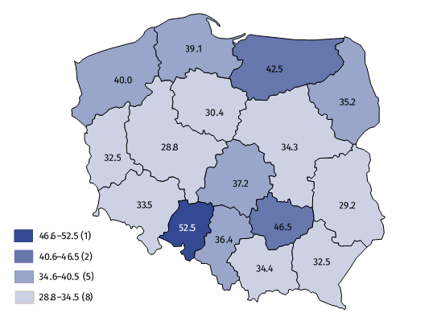
As of 31 December

Residents
Nearly 67% residents of social welfare facilities stayed in social assistance houses
In stationary social welfare facilities, there were 121.9 thousand residents. Out of all residents, 66.9% stayed in social assistance houses. 19.6% of all residents stayed in establishments ensuring 24–hour care for disabled persons, chronic patients or elderly persons within the scope of economic activity or their statutory activity, 10.0% residents were in hostels for homeless persons, 1.6% in night shelters, 0.8% in houses for mothers with children under age and pregnant women and 0.2% in community self–help centres (with round–the–clock available places). The residents in family–based assistance houses accounted only for 0.1% of all residents.

Chart 2. Residents in stationary social welfare facilities by age groups in 2023
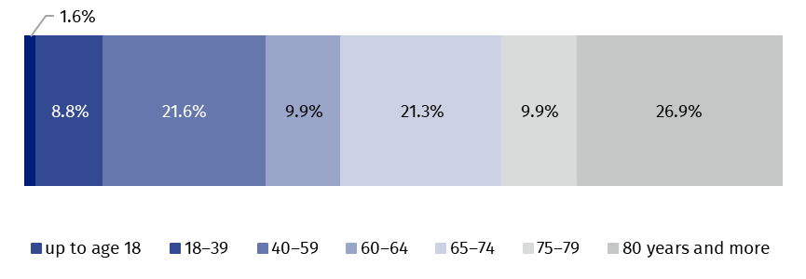
As of 31 December
More than a half of the residents in stationary social welfare facilities was over 65 years old
The persons over 65 years old amounted to over a half of all residents in stationary social welfare facilities. Every fifth of the residents was a person at age of 40–59. The residents at age of 17 and less constituted the smallest age group (2.0 thousand).

Chart 3. Residents in stationary social welfare facilities by groups of residents in 2023
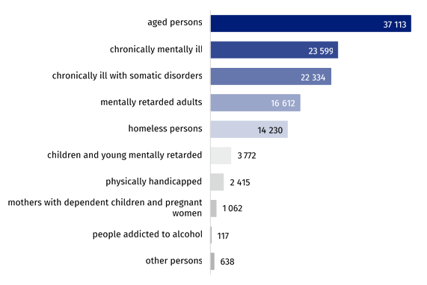
As of 31 December

Out of all residents of the stationary social welfare facilities the most of persons stayed in the centres for the aged people (30.4% of total number of the residents). The smallest share of the residents referred to people addicted to alcohol (0.1%).
The most of residents of stationary social welfare facilities (84.1%) financed, at least partly, their stay from own income, e.g. old age pension, disability pension, periodical allowance. The cost of accommodation for 8.0% of residents was incurred completely by their families, while the accommodation for 6.3% was paid entirely by the local government or by the state. About 2% of the residents were exempted from the payment.

Table 1. Stationary social welfare facilities by voivodshipsª in 2023
As of 31 December
SPECIFICATION | Centres | Places | Residents
POLAND | 2 138 | 132 634 | 121 892
Dolnośląskie | 145 | 9 648 | 9 006
Kujawsko-pomorskie | 97 | 6 058 | 5 606
Lubelskie | 89 | 5 867 | 5 355
Lubuskie | 55 | 3 165 | 2 997
Łódzkie | 122 | 8 796 | 8 069
Małopolskie | 180 | 11 790 | 11 179
Mazowieckie | 321 | 18 904 | 17 042
Opolskie | 76 | 4 914 | 4 485
Podkarpackie | 99 | 6 742 | 5 920
Podlaskie | 69 | 4 001 | 3 578
Pomorskie | 161 | 9 216 | 8 602
Śląskie | 268 | 15 738 | 14 549
Świętokrzyskie | 88 | 5 433 | 4 960
Warmińsko-mazurskie | 105 | 5 777 | 5 324
Wielkopolskie | 169 | 10 051 | 9 253
Zachodniopomorskie | 94 | 6 534 | 5 967
a Centres excluding branches. Places and residents including branches.
In the case of quoting data from the Statistics Poland, please provide information: “Statistics Poland data source”, and in the case of publishing calculations made on data published by the Statistics Poland, please provide information: “Own study based on Statistics Poland data”.

Prepared by:  Statistical Office in Kraków  Director Agnieszka Szlubowska  Phone: (+48 12) 420 40 50 | Issued by:  Press Office  Mobile: (+48) 695 255 032  Phone: (+48 22) 608 38 04, (+48 22) 449 41 45,  (+48 22) 608 30 09  e-mail: obslugaprasowa@stat.gov.pl

stat.gov.pl/en/

@StatPoland

@GlownyUrzadStatystyczny

gus_stat

glownyurzadstatystycznygus

glownyurzadstatystyczny
Related information
Social assistance, child and family services in 2022
Data available in databases
Database Local Data Bank – health care, social welfare and benefits to the family
Terms used in official statistics
Community self-help centre
Establishment ensuring 24-hour care for disabled persons, chronic patients, or elderly persons within the scope of economic activity or their statutory activity
Family-based assistance house
Hostel for homeless persons
House for mothers with children under age and pregnant women
Night shelter
Social assistance house

