Disabled persons in 2023
4.0 million
Persons with a certificate of disability, level of disability or level of incapacity to work

As of December 2023 in Poland, there were 4,006.4 thousand persons who had a valid certificate of disability or level of disability issued by the medical examination committee or a certificate of the level of incapacity to work issued by the Social Insurance Institution.

Persons with a certificate of disability, level of disability or level of incapacity to work (disabled persons with legal confirmation)
Of the 4,006.4 thousand persons with a certificate of disability, level of disability or level of incapacity to work, 2,321.1 thousand had only a certificate issued by the medical examination committee, while 922.6 thousand had only a certificate issued by the Social Security Institution. The others held both certificates (762.7 thousand).

Chart 1. Persons by type of held certificate of disability in 2023

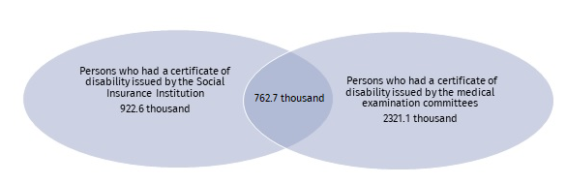
As of 31 December
Source: datasets of powiat and city disability assessment teams (PZON), dataset from the Social Insurance Institution's pension systems (ZUS EMIR and RENTIER).
The structure of disabled persons with legal confirmation was the following: 41.3% with a moderate level, followed by 27.4% with a severe level and 25.2% with a mild level. Those with a disability certificate without a specified level due to age (up to 16 years old) accounted for 5.8%. In the other cases the level of disability could not be determined.
Out of all disabled persons with legal confirmation, 53.1% were women
In the studied population of legally disabled persons, women predominated, constituting 53.1%. The majority of women were in the age group of 70–74 (292.0 thousand), while the majority of men were in the age group of 65–69 (275.2 thousand).

Chart 2. Disabled persons with legal confirmation by sex and age groups in 2023

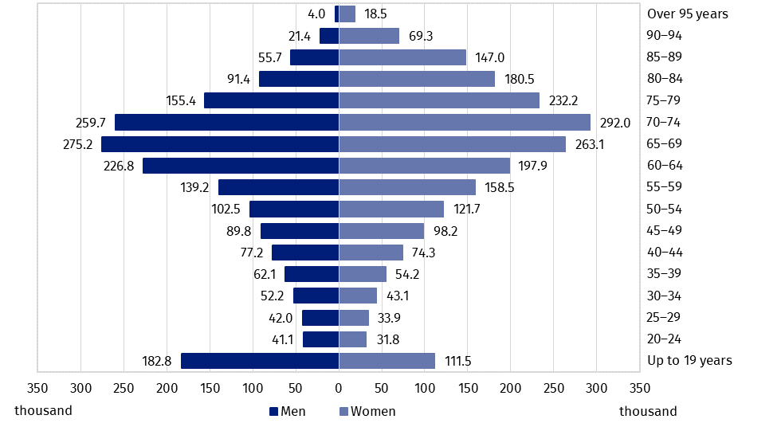
As of 31 December
The biggest value of the index of the number of disabled persons with legal confirmation per 1,000 population was recorded in Lubuskie Voivodship (165)
Source: datasets of PZON, ZUS EMIR and RENTIER.
Of disabled persons with legal confirmation the biggest number of women (239.1 thousand) and men (215.5 thousand) lived in Śląskie Voivodship and the smallest one in Opolskie Voivodship (44.6 thousand women and 40.9 thousand men). Per 1,000 population, the largest number of persons was recorded in Lubuskie Voivodship (165), and the smallest one in Mazowieckie Voivodship (75).

Map 1. Disabled persons with legal confirmation per 1,000 population by voivodships in 2023

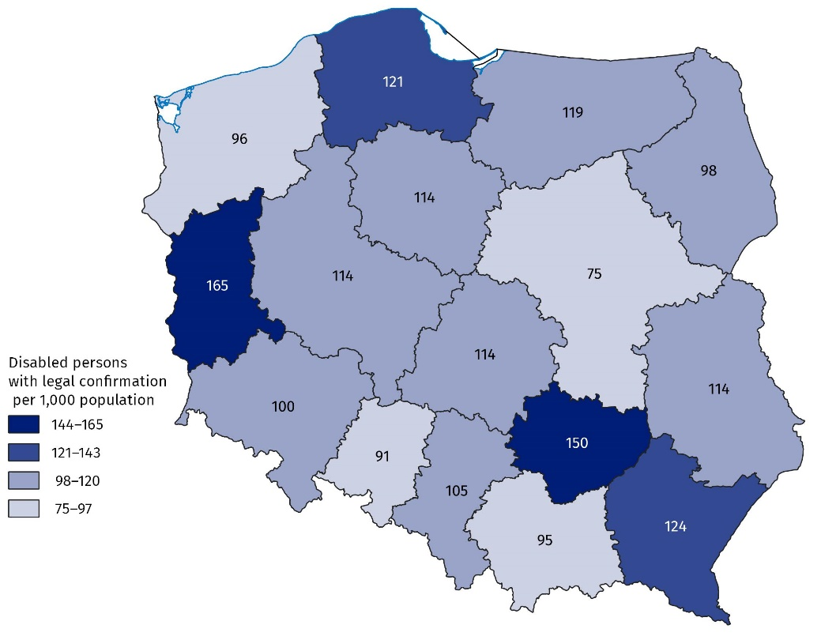
As of 31 December
Source: datasets of PZON, ZUS EMIR and RENTIER.
By gmina, the largest number of disabled persons with legal confirmation (106.0 thousand) lived in Warsaw. They accounted for 2.7% of the total number of such persons in Poland. Per 1,000 population, the largest number of persons lived in the gmina of Ostrowiec Świętokrzyski (257), and the smallest one in the gminas of Długołęka and Czernica (29 persons in each).

Map 2. Disabled persons with legal confirmation per 1,000 population by gminas in 2023
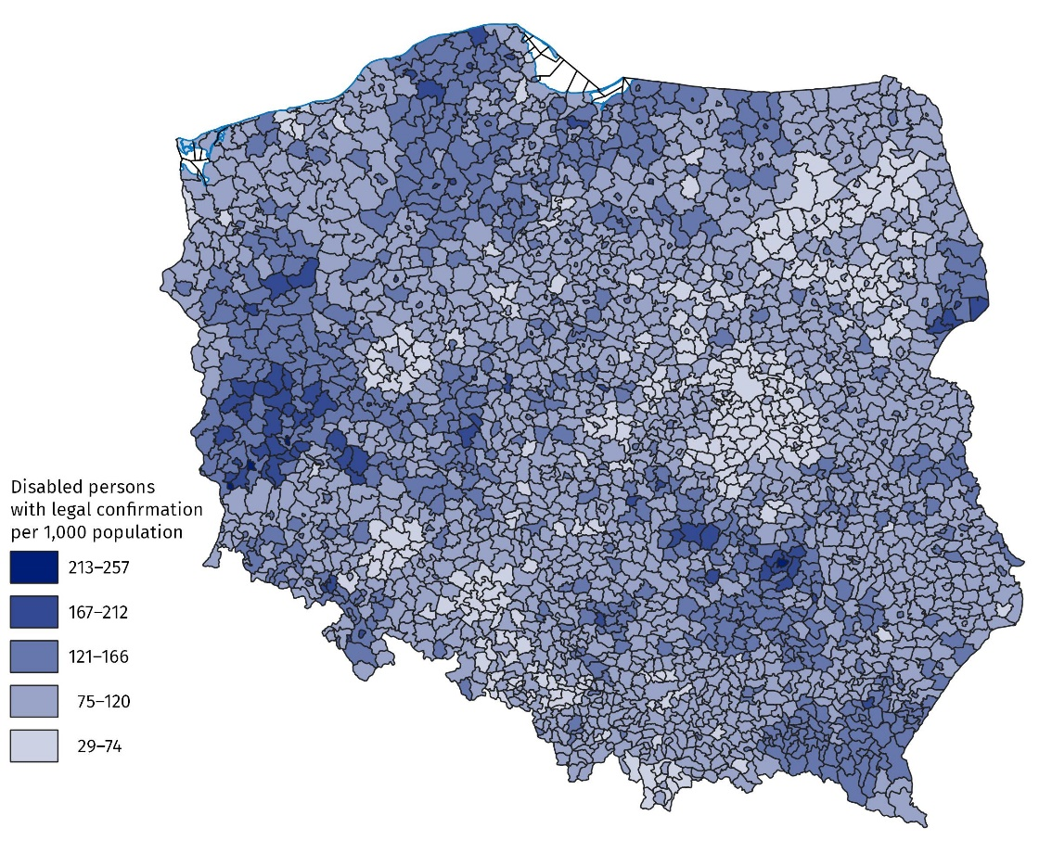
As of 31 December
Source: datasets of PZON, ZUS EMIR and RENTIER.

Persons with a certificate of disability or a level of disability issued by the medical examination committee
As of 31 December 2023, 3,083.8 thousand persons held a certificate of disability or level of disability issued by the medical examination committee. The certificate may contain no more than three symbols of causes of disability. Each symbol represents an individual reason for disability or its level. More than half of persons held a certificate with one cause, and nearly 40% with two causes of disability.
The biggest number of persons held a certificate issued for motor impairment (1,393.1 thousand), and the smallest one for epilepsy (74.2 thousand).

Chart 3. Persons with certificate of disability or level of disability by its causes in 2023

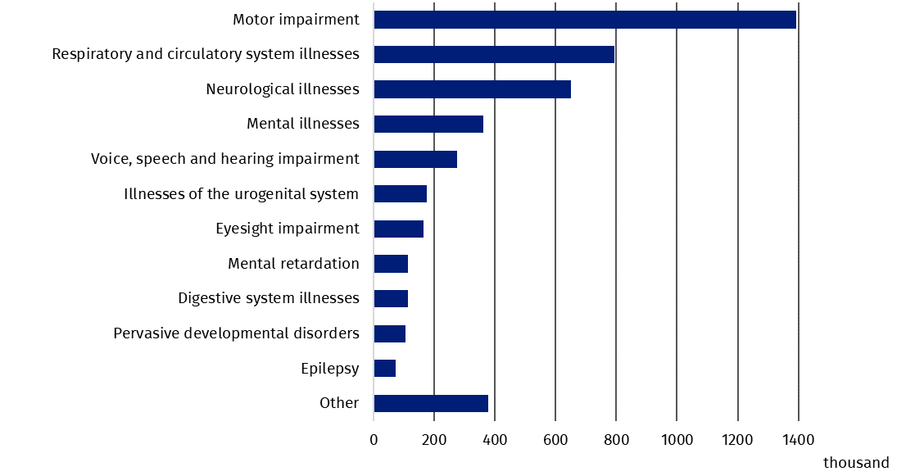
As of 31 December
Source: datasets of PZON.
703.3 thousand persons with a disability or level of disability held a valid parking card
As of 31 December 2023, there were 703.3 thousand persons with a certificate of disability or level of disability holding valid parking card. The most such persons per 1,000 population was recorded in Lubuskie Voivodship (31.3), and the least in Mazowieckie Voivodship (11.9).

Chart 4. Persons with a certificate of disability or level of disability with a valid parking card per 1,000 population in 2023

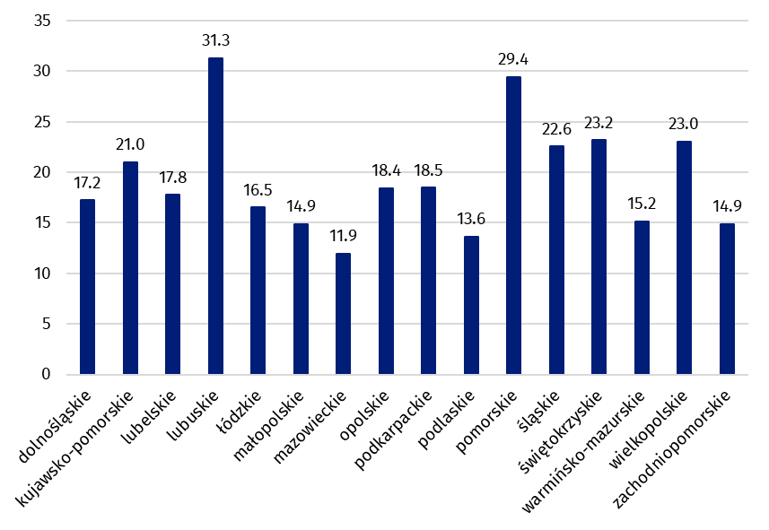
As of 31 December
Source: datasets of PZON.

Persons reported to Social Insurance Institution by contributors who informed the contributor that they held a certificate of disability or level of disability or certificate of incapacity to work
Nearly 754 thousand persons reported to the Social Insurance Institution by contributors informed the payer of contributions that they had a disability certificate or level of disability (issued by the medical examination committee) or a certificate of incapacity to work (issued by the Social Insurance Institution). The structure of such persons by level of disability was the following: 11.2% with a severe level, followed by 59.0% with a moderate level and 29.4% with a mild level. The others held a certificate of disability without specified level due to their age (up to 16 years old).
The most men reported to the Social Insurance Institution by contributors who informed the payer of contributions that they had a certificate of disability or level of disability or a certificate of incapacity to work lived in Mazowieckie Voivodship (43.6 thousand), while the most women lived in Śląskie Voivodship (35.6 thousand). The least persons lived in Opolskie Voivodship (6.4 thousand women and 9.6 thousand men). The most persons per 1,000 population lived in Lubuskie Voivodship (34.5), and the least – in Mazowieckie Voivodship (13.8).
The indicator of the number of people who presented the payer of contributions with a certificate of disability, degree of disability or degree of incapacity for work per 1,000 thousand population was the highest in Lubuskie Voivodship (34.5).

Map 3. Persons reported to Social Insurance Institution by contributors who informed the payer of contributions that they had a certificate of disability or level of disability or certificate of incapacity to work per 1,000 population by voivodships in 2023
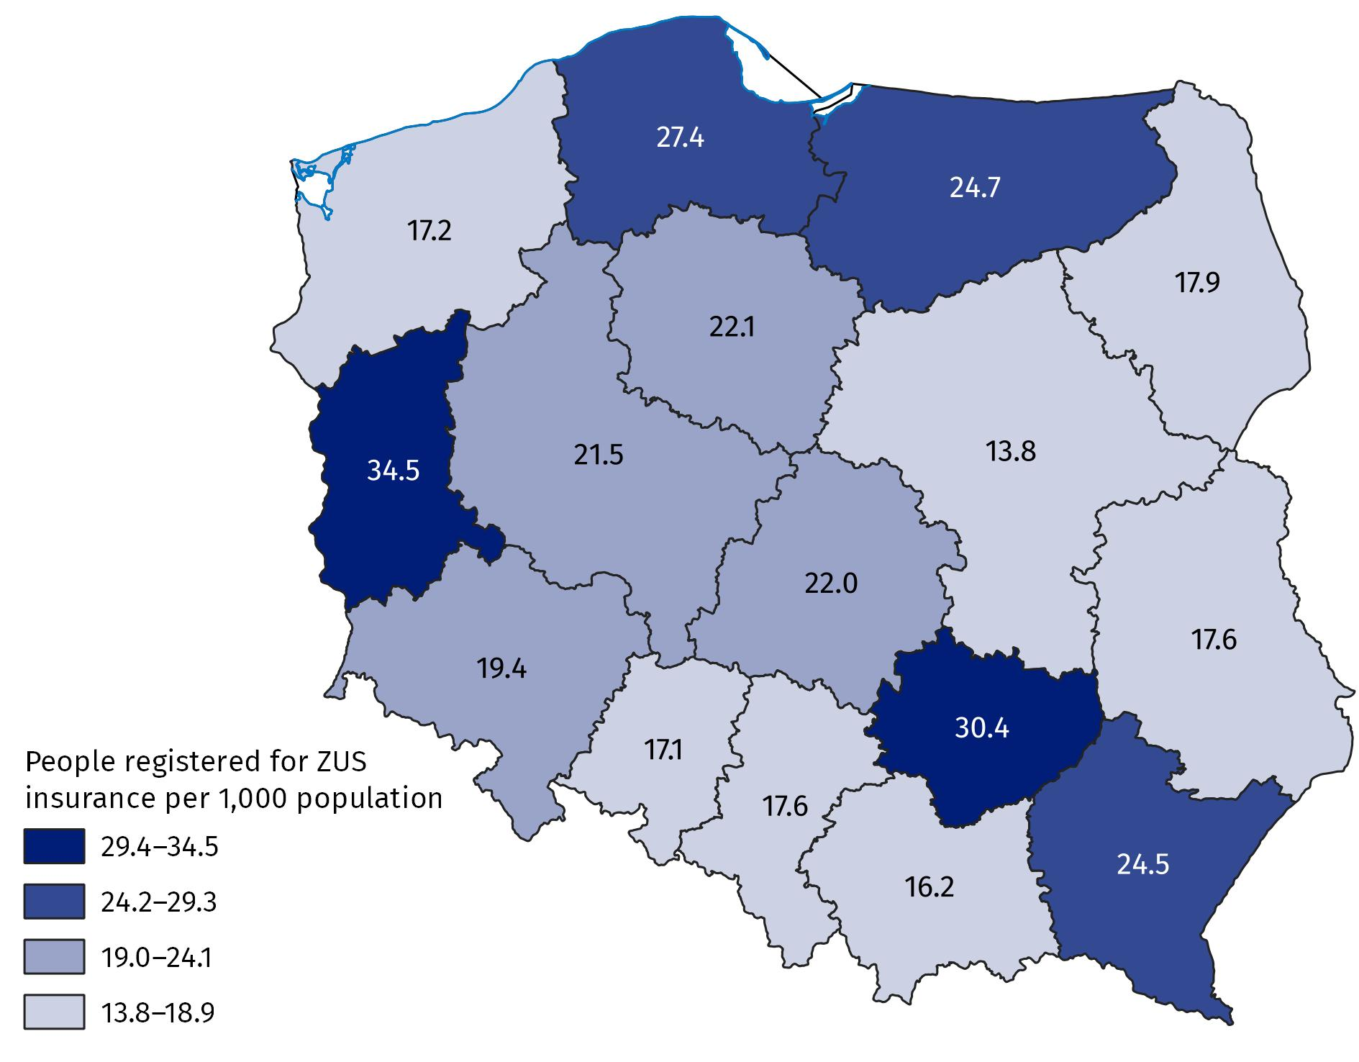
As of 31 December
Source: Information System of the Social Insurance Institution.
The surveyed population was dominated by persons at age of 50 and more (60.1%). The most men were in the 60–64 age group (19.9%), while the most women were in the 55–59 age group (20.1%).

Chart 5. Persons reported to Social Insurance Institution by contributors who informed the payer of contributions that they had a certificate of disability or level of disability or certificate of incapacity to work by sex and by age group in 2023
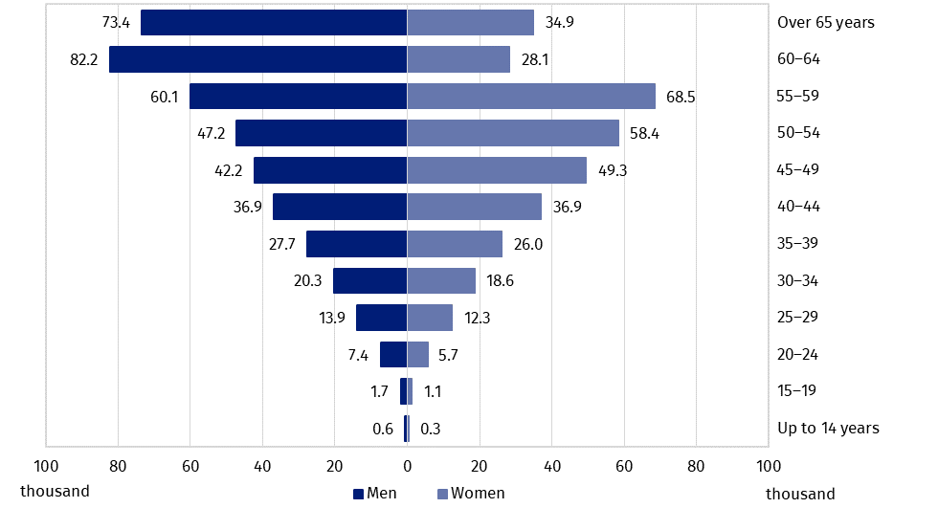
As of 31 December
Source: Information System of the Social Insurance Institution.
Among persons with a certificate, 18.5% were entitled to disability pension, and 12.2% were entitled to retirement pension.
More than half of persons (54.5%) were employed under an employment contract. In case of 14.7% of persons, insurance contributions were paid by a social assistance organisational unit or by the village mayor, the mayor or the city president. In addition, 6.8% of insured persons performed an agency contract, contract of mandate or service contract. Moreover, 6.6% were unemployed persons who received neither allowances nor stipends.

Persons who held a valid disability group certificate issued by medical examination committee subordinate to the Minister of Internal Affairs and the Minister of Defense before 1 January 1998
As of December 2023, 144 persons held valid certificate of disability group issued before 1 January 1998 by a medical examination committee subordinate to the Minister of Internal Affairs. Out of this population, 16 persons held a disability certificate of group I, 53 persons held a disability certificate of group II and 75 persons held a disability certificate of group III. Among persons with a certificate, men predominated – 83 persons.
The most persons lived in Mazowieckie Voivodship (37 men and 35 women). No person with a certificate of disability group lived in Podlaskie Voivodship.
More than 91% of those persons were 70 and more years old, while the others belonged to the 56–69 age group. The youngest man was 56, and the youngest woman was 66.
As of December 2023, 6 899 persons held a valid certificate of disability group issued before 1 January 1998 by medical examination committee subordinate to the Minister of Defence. Out of that group, 15.0% persons held a disability certificate of group I, 26.4% held a disability certificate of group II and 58.6% held a disability certificate of group III. Only two women were in the group with certificates. Every certificate was issued for indefinite period. Among persons with a certificate of disability of any group, 65.0% were receiving retirement pension benefits, 27.2% were receiving disability pension, there is no information on pension entitlement for 7.8% of persons.
More than 96% of certified persons were 65 years old and more, while the others were in 48–64 age group. The youngest man was 48 and the oldest was 102. Women were from 92 years old (the youngest) to 101 years old (the oldest).

Recipients of incapacity to work pension granted on the basis of a verdict on incapacity to work on an agricultural holding issued by the Agricultural Social Insurance Fund
As of December 2023, 166.8 thousand persons were receiving incapacity to work pension granted on the basis of a verdict on incapacity to work on an agricultural holding, issued by the Agricultural Social Insurance Fund (KRUS). The structure of beneficiaries was the following: 14.7% with confirmed complete incapacity to work on an agricultural holding jointly with certified incapacity to live independent life, 85.3% with confirmed complete incapacity to work on an agricultural holding without certified incapacity to live independent life. In the surveyed population, 63.0% of persons held a permanent incapacity (indefinite) certificate, and 37.0% had confirmed temporary incapacity to work on an agricultural holding. For 19.8% of persons, the certificate was issued before 1 January 1998.
The most men receiving incapacity to work pension granted on the basis of a verdict on incapacity to work on an agricultural holding, issued by KRUS lived in Lubelskie Voivodship (11.7 thousand), while the most women lived in Małopolskie Voivodship (11.6 thousand). The least persons lived in Opolskie Voivodship (1.1 thousand men and 0.9 thousand women). The most such persons per 1,000 population lived in Lubelskie Voivodship (10.8), and the least – in Śląskie Voivodship (1.0).

Map 4. Recipients of incapacity to work pension granted on the basis of a certificate of incapacity to work on agricultural holding issued by the Agricultural Social Insurance Fund per 1,000 population by voivodships in 2023
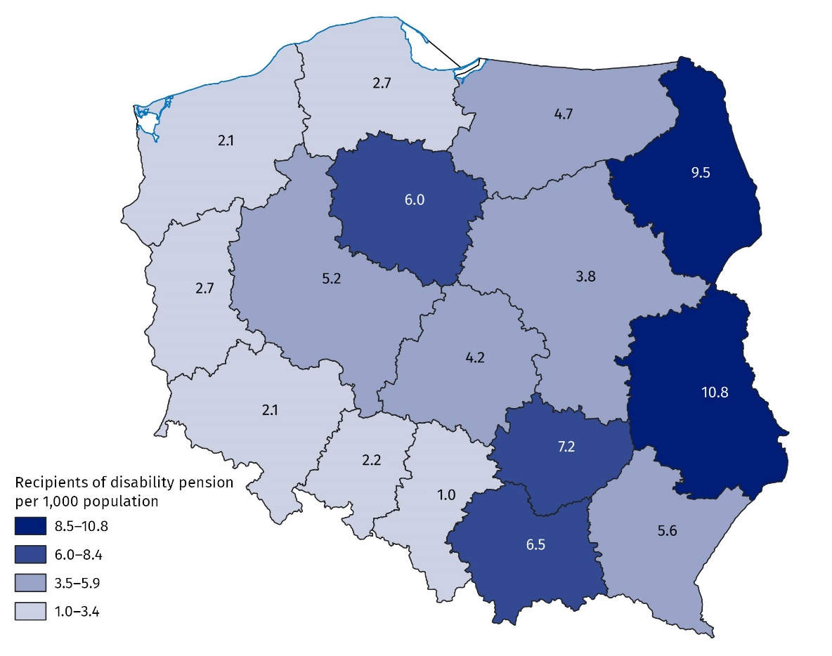
As of 31 December
Source: Information system of pension benefit management of the Agricultural Social Insurance Fund.
Persons aged 50 and more dominated in the surveyed population (90.1%). The most men belonged to 60–64 age group (36.2%), while the most women – to 55–59 age group (22.0%).

Chart 6. Recipients of incapacity to work pension granted on the basis of a certificate of incapacity to work on agricultural holding issued by the Agricultural Social Insurance Fund by sex and age group in 2023
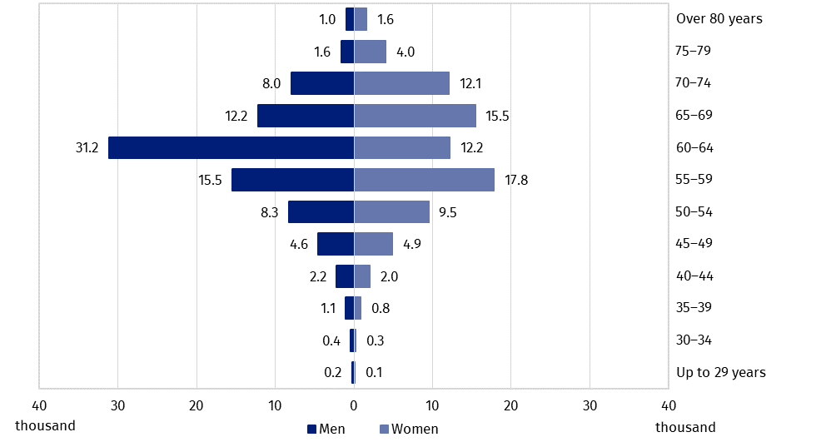
As of 31 December
Source: Information system of pension benefit management of the Agricultural Social Insurance Fund.

Educating persons with disabilities and persons with special educational needs
In the 2023/24 school year, there were 360 special nursery schools, attended by 8.1 thousand children with disabilities. The largest number of children who attended special nursery schools were over 7 years old (27.8%). Boys predominated in the group of children in special nursery schools (71.7%). Other nursery schools and remaining pre-primary education establishments were attended by 55.9 thousand children with disabilities, who accounted for 3.7% of the total number of children. The majority of children with disabilities attended regular nursery schools (79.0%), including the ones with integrated sections (10.6%) and integrated nursery schools (11.6%).
In the 2023/24 school year, 244.9 thousand children and youth with special educational needs (excluding schools for adults) attended schools, i.e. 4.7% of the total number of students
Table 1. Pre-primary education establishments in the 2023/24 school year
As of 30 September
Specification | Units | Sections | Children
Specification | Units | Sections | total | of which with disabilitiesª
Total | 22 505 | 76 276 | 1 512 017 | 55 857
Nursery schools | 13 888 | 60 788 | 1 228 695 | 44 108
special | 360 | 1 724 | 8 069 | .
integrated | 462 | 1 727 | . | 6 461
with integrated sections | 523 | 3 530 | . | 5 902
a Excluding children in special units.
Table 1. Pre-primary education establishments in the 2023/24 school year (cont.)
As of 30 September
Specification | Units | Sections | Children
Specification | Units | Sections | total | of which with disabilitiesª
with special sections | 98 | 634 | . | 1 943
with integrated and special sections | 118 | 892 | . | 3 492
other pre-primary schools | 12 327 | 52 281 | . | 26 310
Pre-primary education units | 37 | 37 | 522 | 16
Pre-primary sections | 1 362 | 1 362 | 22 774 | 5 433
Pre-primary sections at primary schools | 7 218 | 14 089 | 260 026 | 6 300
a Excluding children in special units.
There were 53.5 thousand children in special primary schools. Moreover, 126.4 thousand children with special educational needs attended sections at regular primary schools. The total number of children with disabilities who received special education at primary level was 179.9 thousand (6.0% of the total number of children), 68.8% of whom were boys. Among 3.4 thousand children who were taught individually, there were 45.4% children with special educational needs.
Special care and education centres and special education units were assigned for children with special education certificate issued due to their disability, but could not attend kindergarten or school in their place of residence because of their disability. In the 2023/24 school year, there were 350 such facilities. Among 22.5 thousand available places, 45.0% were used. Persons intellectually retarded accounted for 54.3% of pupils. Moreover, the units provided care for children and youth with combined disabilities (28.5%), deaf or hearing impaired (5.1%) and blind or visually impaired (3.6%).
Rehabilitation and educational centres are facilities that enable the implementation of the annual obligation of pre-school preparation, the obligation to attend school and the obligation to learn for children and young people with profound intellectual disabilities, who have a decision on the need for rehabilitation and educational activities, and with multiple disabilities, one of which was an intellectual disability, who have a decision on the need for special education. As of 30 September 2023, 192 rehabilitation and educational centre provided 8.3 thousand places, of which 75.2% were used. The facilities provided participation in classes for children with multiple disabilities (3.4 thousand) and those with profound intellectual disabilities (2.6 thousand).
Education of young people with special educational needs at the secondary level was provided primarily in special schools. The largest proportion of special schools were those that offered preparation for a specific profession: special schools for vocational training and special vocational schools of the first level. All special schools educated 29.8 thousand persons. Moreover, 35.0 thousand students with special educational needs were educated in sections, including 44.5% of those in sections at general secondary schools, 33.2% of those in sections at technical secondary schools and 21.7% of persons in sections at stage I sectoral vocational schools. The total number of children and youth covered by special education at the secondary level was 64.8 thousand, accounting for 3.4% of their total number.
Post-secondary schools were attended by 282 students with special educational needs. Mainly there were special schools (251 students).
In the 2023/24 academic year, 21.9 thousand persons holding the certificate of the level of disability were studying at higher education institutions (1.8% of total number of students), and 5.3 thousand persons graduated them (1.8% of total number of graduates). Among doctoral students, 15.4% held a certificate of disability (0.5 thousand persons).

Adaptation of infrastructure in the area of health care and culture to the needs of disabled persons
Most outpatient departments and individual medical practices had bathrooms adapted for the needs of disabled persons (77.8%) and ramps or platforms facilitating entrance to the building (65.9%). Most pharmacies and pharmacy outlets had ramps or platforms facilitating entrance to the building (55.9%). Adaptations for the hearing impaired and the deaf persons were the least common in the institutions operating in field of the health care.
Table 2. Adaptations to the needs of disabled persons in the institutions operating in the field of health care in 2023
As of 31 December
Over 94% of centres of culture, cultural centres and establishments, clubs and community centres was adapted for the needs of disabled persons
Specification | Outpatient departments and individual medical practices | Pharmacies and pharmaceutical outlets
Total | 26 634 | 12 564
Ramps/platforms facilitating entry into the building | 17 553 | 7 018
Automatically opening doors to the building | 2 455 | 834
Lift(s) | 7 821 | 214
of which adapted for wheelchair users | 5 632 | .
Bathrooms adapted for disabled persons | 20 713 | .
Adaptations for the visually impaired and the blind | 1 220 | 164
Adaptations for the hearing-impaired and the deaf | 919 | 97
Non-slip floors | 9 206 | 3 493
Other | 3 512 | 2 067
No amenities | 2 255 | 2 725
Among cultural institutions, the most adaptations for disabled persons were in centres of culture, cultural centres and establishments, clubs and community centres (94.3%). More than 92% of institutions had amenities close to the entrance and nearly 71% was equipped with adaptations inside the building. Nearly 49% of public libraries was appropriately adapted for disabled persons.
Table 3. Adaptations to the needs of disabled persons in institutions of culture in 2023
As of 31 December
Specification | Total | Of total the facilities adapted to the needs of disabled persons
Specification | Total | total adapted facilities | entrance to the building | adaptations inside the building
Cinemas | 535 | 483 | 481 | 453
Theatres and musical institutions | 207 | 173 | 169 | 166
Art galleries and art exhibitions | 317 | 189 | 182 | 160
Museums and museum branches | 974 | 533 | 510 | 468
Centres of culture, cultural centres and establishments, clubs and community centres | 3 961 | 3 734 | 3 650 | 2 793
Public libraries | 7 570 | 3 727 | 3 660 | 2 424

Passenger road transport
Urban transport in Poland had 12,466 buses and 3,042 trams. The percentage of buses adapted to transport disabled people was 95.0%, and trams 54.4%. The highest percentage of buses adapted to transport disabled persons was recorded in Kujawsko-Pomorskie Voivodship (nearly 100%) and the smallest one in Opolskie Voivodship (80.4%).
The number of operating bus stations owned or managed by the carrier amounted to 125, of which 67 were adapted for disabled persons (53.6%).

Methodological notes
- The disability certification system in Poland is not uniform. It is defined by two fundamental legal acts:
- The Act of 27 August 1997 on Vocational and Social Rehabilitation and Employment of Disabled Persons, abridged: the Act on Rehabilitation (uniform text, Journal of Laws of 2024, item 44, as amended) – in Art. 2, disability is defined as permanent or temporary inability to fulfil social roles due to permanent or long-term impairment of the overall efficiency, in particular resulting in incapacity to work. Art. 3 defines the level of disability: severe, moderate and mild, while Art. 4a mentions children up to 16 years of age who are certified without determining their level of disability. Disability adjudication institutions are powiat (first instance) and voivodship (second instance) disability adjudication units. The final instance consists of labour and social security courts;
- The Act of 17 December 1998 on Retirement and Other Pensions from the Social Insurance Fund (uniform text, Journal of Laws of 2023, item 1251, as amended) – Art. 12 defines person incapable to work as one who has completely or partially lost the ability to work for paid employment due to a deterioration of the physical or psychical health and is not expected to regain the ability to work after retraining. Decisions on: incapacity to work, incapacity to live independent life and on rationale of retraining, issued by the Social Insurance Institution, are converted into verdicts on the level of disability in accordance with Art. 5 of the aforementioned Act on Rehabilitation.
- In compliance with Art. 1, Art. 2 and Art. 63 of the Act on Rehabilitation, valid verdicts on assigning to one of the disability groups, issued before 1 January 1998 by medical examination committees subordinated to the minister of competent for internal affairs and the Minister of National Defence on the basis of separate regulations on the assessment of capability to military service - the Act of 10 December 1993 on Retirement Provision for Professional Soldiers and Their Families (uniform text, Journal of Laws of 2024, item 242, as amended) and the Act of 18 February 1994 on Retirement Provision for Officers of the Police, Internal Security Agency, Intelligence Agency, Military Counterintelligence Agency, Military Intelligence Service, Central Anti–Corruption Office, Border Guard, Marshal Guard, State Protection Service, State Fire Service, Customs and Tax Service, Prison Service and their families (uniform text, Journal of Laws of 2024, item 1121, as amended) – are converted into the following levels of disability:
- certificate assigning for group I of disability is equal to certificate of severe disability,
- certificate assigning for group II of disability is equal to certificate of moderate disability,
- certificate assigning for group III of disability is equal to certificate of mild disability.
The verdicts of medical examination committees issued after 31 December 1997 are not equal to the assessments of disability within the meaning of the Act on Rehabilitation. In compliance to Art. 5a of the Act on Rehabilitation, individuals may apply to the examination committees to determine the level of disability.
- According to Art. 62(3) and Art. 63 of the Act on Rehabilitation, persons certified as complete incapable to work on an agricultural holding are disabled if the certificates were issued before 1 January 1998, and are still valid, except that:
  - persons who are entitled to care allowance are determined as the ones with severe level of disability,
  - other persons are determined as the ones with mild level of disability.
Complete incapacity to work has been defined as permanent or temporary. The explanation of those notions can be traced to the Act of 20 December 1990 on Social Insurance of Farmers (uniform text, Journal of Laws of 2024, item 90, as amended), where in Art. 21 it is evoked that complete incapacity to work on an agricultural holding is recognised as permanent if insured person is not likely to regain capabilities to personally perform works on an agricultural holding. Complete incapacity to work is treated as temporary if insured person is likely to regain capabilities to personally perform works on an agricultural holding. In case of permanent incapability the verdicts were issued for indefinite period, while in case of temporary inability the final date of legally recognised incapability was determined.
Along with a certificate of total incapacity to work on an agricultural holding, the beneficiaries are entitled to receive a certificate of inability to live independent life. In such case, farmers are entitled to nursing supplement. The benefit can be granted automatically – to persons who are more than 75, years old or upon submitting the application, with certificates on health enclosed – to adults who are completely incapable to work and to live independent life. In principle, entitlement to nursing supplement excludes its beneficiary from the right to nursing allowance, since beneficiaries are entitled to just one of those benefits. The benefits, though similar, differ in that:
  - nursing supplement is paid by the Agricultural Social Insurance Fund, while the allowance by the local government executive organ – the village mayor, the mayor or the president of the city – competent in consideration of beneficiary’s home address,
  - nursing supplement is paid jointly with retirement and other pension, while nursing allowance is paid regardless of other granted benefits.
In accordance with the Act on Social Insurance for Farmers, verdicts on permanent or temporary complete incapacity to work on an agricultural holding, which constitute one of the prerequisites for the entitlement to incapacity to work pension, are issued by medical expert (first instance) or medical examination committee (second instance).
Certificates of incapacity to work issued by medical expert or a medical examination committee of the Agricultural Social Insurance Fund after 1 January 1998 are not convertible into the levels of disability. Persons who have been issued a certificate of incapacity to work on an agricultural holding in the adjudication system of the Agricultural Social Insurance Fund after 1 January 1998 may apply to the examination committee to determine the level of disability.
- The release news takes advantage from the data sets of:
- medical examination committees on persons holding valid verdict on disability or the level of disability (PZON);
- Social Insurance Institution on the recipients of retirement and other pensions with the verdict on the level of incapacity to work (ZUS EMIR and RENTIER);
- Social Insurance Institution on persons reported for social and health insurance by contributors who have presented a certificate on disability, level of disability or level of incapacity to work, issued by a relevant authority;
- Pension Institution of the Ministry of Internal Affairs and Administration on persons holding valid verdict on disability group, issued before 1 January 1998 by the medical committee subordinate to the minister competent for internal affairs;
- Ministry of National Defence on persons holding valid verdict on disability group, issued before 1 January 1998 by the medical committee subordinate to the Minister of National Defence;
- Agricultural Social Insurance Fund on recipients of disability benefits;
Information on decisions on complete incapacity to work on an agricultural holding has been stored in the Agricultural Social Insurance Fund system since 2000. The analysed data does not refer to persons who, after 25 years of employment record, had their disability pension converted into retirement benefit (unless it is more favourable to the beneficiary);
- Ministry of National Education on children and youth with the verdict of the public psychological and educational counselling centre (including public specialist outpatient clinic) on the need for special education or for individual education;
Special education is organised for children and youth with disabilities, socially maladjusted and at risk of social maladjustment, requiring special forms of learning and methods of work. It may be organised in the general school system or individually. School children with the certificate of special educational needs are not necessarily disabled in compliance with the provisions of the Act on Rehabilitation, likewise disabled school children do not need a verdict on the need of special education.
- Ministry of Science and Higher Education on students and doctoral students with a verdict on the level of disability issued by the relevant authority;
- from the reporting of Statistics Poland.
- The data presented in this release news on persons holding the valid certificate of disability or the level of disability issued by the Disability Assessment Committee are different from the data included in the quarterly information of the Office of the Government Plenipotentiary for Disabled Persons. The age of individuals was determined as of 31 December 2023, not as of the date of the verdict. The data may not record all decisions of organs of appeal.
In the case of quoting data from the Statistics Poland, please provide information: "Statistics Poland data source", and in the case of publishing calculations made on data published by the Statistics Poland, please provide information: "Own study based on Statistics Poland data".

Prepared by:  Statistical Office in Kraków  Director Agnieszka Szlubowska  Phone: +48 12 420 40 50 | Issued by:  Press Office  Mobile: (+48) 695 255 032  Phone: (+48 22) 608 38 04, (+48 22) 449 41 45,  (+48 22) 608 30 09  e-mail: obslugaprasowa@stat.gov.pl

stat.gov.pl

@GUS_STAT

@GlownyUrzadStatystyczny

gus_stat

glownyurzadstatystycznygus

glownyurzadstatystyczny
Related information
Social assistance, child and family services in 2022
Disabled people in 2022
Disabled persons with legal confirmation in Małopolskie Voivodship in 2022
Terms used inn official statistics
Disabled person
Disabled person with legal confirmation
Level of disability

In compliance with Art 5 of the Act of 27 August 1997 on vocational and social rehabilitation and employment of the disabled persons (consolidated text, Journal of Laws 2024, item 44, as amended), the Social Insurance Institution (ZUS) medical expert decisions on incapacity to work, inability to live an independent life and the rationale for retraining are subject to conversion into the verdict on the level of disability.
Determined by home address. When home address was unknown, determined by the mailing address, and when both addresses were unknown, by registered address.
Listed only once by predominating type of disability.
Graduates of the 2022/23 academic year.

