Foster care in 2023
09.05.2024
3.5%
Increase in the number of children in foster care compared to 2022

At the end of 2023, in foster care there were 75.3 thousand children, including 58.2 thousand in family foster care and 17.1 thousand in institutional foster care. In comparison to 2022, the number of children in foster care increased by 3.5%.

Family foster care
Related families accounted for over a half of all foster families
At the end of 2023 family foster care functioned in the form of related, not professional and professional families which amounted to 35 978 and in the form of foster homes – 834 units. Among foster families, related families accounted for 63.8%, not professional families –30.4%, and professional families – 5.8%.
53.1% of persons performing the function of foster family were at age of 51–70
The function of foster family was fulfilled by 18 675 married couples and by 17 303 lone persons. The families which admitted one child accounted for 72.3%, two children – 18.1%, three children – 5.4%, and four or more children 4.1% of all foster families. Over a half of persons performing the role of foster family were persons at age of 51–70. Foster homes were run by 707 married couples and by 127 lone persons. Most persons (77.5%) performing the function of a family foster home were in the 41–60 age group.

Children in family foster care
Among children who were provided with family types of foster care, 7 105 had legal confirmation of disability or of the level of disability
There were 58 210 children in family foster care, including 6 226 children in foster homes. Among all children who were provided with foster care 7 105 had legal confirmation of disability, moderate disability or severe disability and 2 659 were orphans. There were 28 839 girls in family foster care. Children at age of 7–13 constituted the major group (20 179) both in foster families and in foster homes, while children at age under 1 were in the smallest group (1 004). In 2023 there were 10 756 children who were admitted for the first time in family foster care. In 2023, 8 062 children up to age of 18 left family foster care. The largest number of children were placed in another form of family foster care (2 522). There were 1 351 children went to adoption families, and 2 488 children returned to their natural families. Family foster care was left by 961 children because they were moved to institutional foster care and 47 children left family foster care, because of transferring them to social assistance house. Out of 4 022 adult residents who left foster care in 2023, 2 174 set up their own households, and 127 returned to their own families or relatives. Among the residents who left foster care at age over 18, 1 440 did not start to lead independent life.

Chart 1. Structure of children in family foster care by age group in 2023
As of 31 December 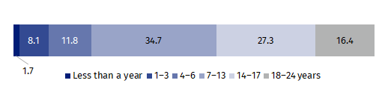

Institutional foster care centres
Socialisation centres accounted for 61.6% of all institutional foster care centres
At the end of 2023 in Poland there were 1 318 institutional foster care centres, including 1 305 care and education centres, 10 regional care and therapy centres and 3 intervention pre-adoptive centres. The care and education centres encompass socialisation centres (812), family centres (204), intervention centres (61), specialist therapy centres (37) and tasks combining centres (191).

Places in institutional foster care
There were 16 630 places in institutional foster care centres, including 10 834 places in socialisation centres, 2 681 places in task combining centres and in family, intervention and specialist therapy centres 1 499, 788 and 456 respectively. In other centres there were 372 places in total.

Chart 2. Structure of places in institutional foster care centres by type of centre in 2023
As of 31 December
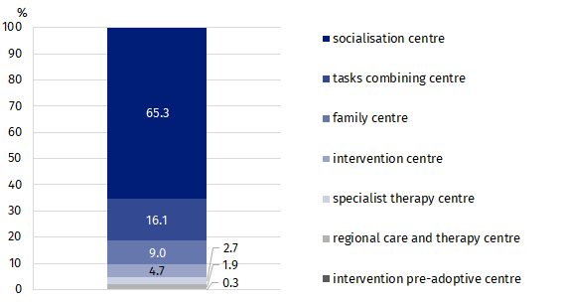

Residents in institutional foster care
Children at age of 14–17 constituted the major group of residents in institutional foster care (47.2%)
At the end of 2023, there were 17 128 residents in institutional foster care. Residents at age of 14–17 constituted the major group (8 079 children). The second biggest group (4 367 persons) were children at age of 10–13. The smallest was the youngest age group under age of 1 (142 residents). In institutional foster care centres there were 1 292 adult residents who continued their education.

Chart 3. Structure of residents in institutional foster care by age group in 2023
As of 31 December 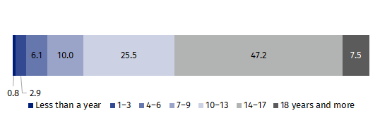
Throughout the year 2023, 4 468 residents up to age of 18 left institutional foster care centres. The major group (39.7%) were residents who returned to their own family. Transfer to other type of institutional foster care was the reason for leaving the centres for 25.1% of children. In family foster care 21.0% of residents were placed, while 5.8% went to adoption families. Out of 2 061 residents at age over 18 who left the centres, 1 199 set up their own household and 681 returned to their own family.

Volunteers in institutional foster care
In 2023, 1 240 volunteers did charity work in institutional foster care. The works of education and care centres were attended by 1 177 persons, 34 persons worked for regional care and therapy centres and 29 volunteers were involved in the works of pre-adoptive intervention centres. Among care and education centres most volunteers supported the activities of socialisation centres (68.6%) and the smallest group worked in family centres (6.5%).

Legally disabled persons in institutional foster care
Among all residents of institutional foster care the disabled persons accounted for 12.9%
By the end of 2023 there were 2 210 disabled residents of institutional foster care. In care and education centres there were 1 982 persons certified as disabled while in regional care and therapy centres 227 persons. In socialisation centres the disabled persons accounted for 58.9% of total of disabled residents in care and education centres, 17.3% in tasks combining centres, 10.0% in specialist therapy centres, 9.9% in family centres and 3.9% in intervention centres.

Table 1. Foster care by voivodships in 2023
As of 31 December
SPECIFICATION | Family care |  | Institutional care
SPECIFICATION | families | children | centres | residents
POLSKA | 36 812 | 58 210 | 1 318 | 17 128
Dolnośląskie | 3 965 | 6 035 | 162 | 2 070
Kujawsko-pomorskie | 2 188 | 3 541 | 90 | 1 246
Lubelskie | 1 776 | 2 782 | 93 | 1 022
Lubuskie | 1 338 | 2 110 | 41 | 527
Łódzkie | 2 737 | 3 970 | 85 | 1 213
Małopolskie | 2 053 | 3 151 | 97 | 1 099
Mazowieckie | 4 102 | 6 249 | 140 | 1 786
Opolskie | 995 | 1 590 | 29 | 412
Podkarpackie | 1 150 | 1 748 | 47 | 691
Podlaskie | 901 | 1 394 | 30 | 384
Pomorskie | 2 420 | 4 596 | 81 | 1 113
Śląskie | 4 898 | 7 761 | 178 | 2 307
Świętokrzyskie | 935 | 1 361 | 46 | 612
Warmińsko-mazurskie | 1 735 | 2 830 | 66 | 900
Wielkopolskie | 3 309 | 5 190 | 70 | 911
Zachodniopomorskie | 2 310 | 3 902 | 63 | 835
In the case of quoting data from the Statistics Poland, please provide information: “Statistics Poland data source”, and in the case of publishing calculations made on data published by the Statistics Poland, please provide information: “Own study based on Statistics Poland data”.
Prepared by:  Statistical Office in Kraków  Director Agnieszka Szlubowska  Phone: (+48 12) 420 40 50 | Issued by:  Press Office  Mobile: (+48) 695 255 032  Phone: (+48 22) 608 38 04, (+48 22) 449 41 45,  (+48 22) 608 30 09  e-mail: obslugaprasowa@stat.gov.pl

stat.gov.pl/en/

@StatPoland

@GlownyUrzadStatystyczny

gus_stat

glownyurzadstatystycznygus

glownyurzadstatystyczny
Related information
Social assistance, child and family services in 2022
Data available in databases
Database Local Data Bank – health care and social welfare
Terms used in official statistics
Pre-adoptive intervention centre
Family foster care coordinator
The organiser of family foster care
Foster care
Centres combining tasks of the centres
Care and education centre for children and young people
Intervention centre
Family centre
Socialization centre
Specialist therapy centre
Poviat centre for family support
Regional care and therapy centre

