Family benefits in 2023
In 2023, PLN 12.3 billion was allocated to support families in the form of family benefits. PLN 1.6 billion was spent on social security and health insurance contributions. Moreover, PLN 2.2 billion was paid out from the family care capital, and PLN 1.4 billion under the "Good Start" programme. The Large Family Card was held by 1.8 million families. The total amount of alimony fund benefits paid was nearly PLN 0.9 billion.
8.2%
Increase in the amount of family benefits paid y/y

Total family benefits
PLN 12.3 billion was transferred to the beneficiaries of family benefits to support families with children or with disabled persons

In 2023, 12.3 billion zlotys were allocated for family benefits, aimed at financially supporting families with children or persons with disabilities, i.e. by PLN 931.8 million (by 8.2%) more than in 2022. These benefits were used by an average of 1.4 million beneficiaries per month, and on average 2.9 million benefits were paid per month. The largest amount of funds, as in 2022, was spent on assistance directed to people with disabilities, i.e. on attendance benefits, which accounted for 76.7% of the total amount of expenditures. Expenses on aid directed to families with children, i.e. family allowances with supplements, childbirth benefits, parental benefits and other family benefits paid from gminas’ own resources accounted for 23.3% of the total amount of expenditures.

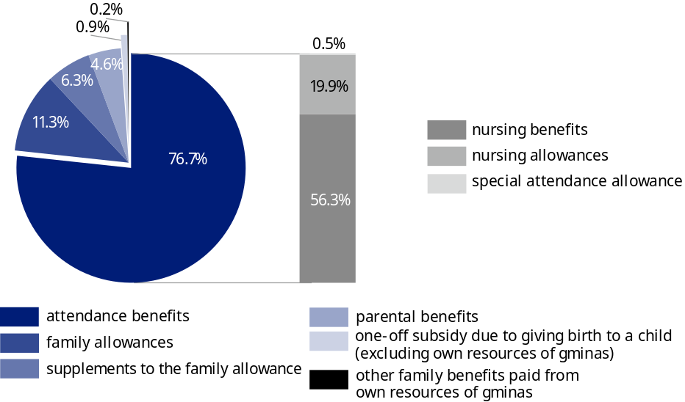
Chart 1. Expenditures on family benefits in 2023
Source: National Family Benefits Monitoring System, Ministry of Family, Labour and Social Policy.
In addition, Ukrainian citizens who came to Poland due to ongoing war operations and whose stay was recognized as legal are entitled to family benefits provided by gminas. In 2023, PLN 79.6 million more was allocated for family benefits for Ukrainian citizens than in 2022. The amount of benefits paid was PLN 210.1 million, which was 1.7% of the total amount of family benefits. On average, 65.6 thousand benefits were paid monthly.
Among family benefits paid to Ukrainian citizens, the largest share was held by attendance benefits, i.e. those addressed to disabled people. Their value amounted to PLN 92.1 million, which constituted 43.8% of the value of family benefits paid to Ukrainian citizens. Family allowances with supplements (PLN 74.2 million) and parental benefits (PLN 41.4 million) constituted 35.3% and 19.7% of the total amount of benefits paid, respectively. The smallest amount was allocated to subsidies due to giving birth to a child – PLN 2.4 million, i.e. 1.2%.

Total attendance benefits
PLN 9.5 billion was allocated to attendance benefits
Of the total amount of family benefits paid in 2023, 76.7% (PLN 9.5 billion) were benefits addressed to disabled people, i.e. attendance benefits. These are: nursing benefits, nursing allowances and special attendance allowance. Compared to 2022, the amount of attendance benefits increased by 18.9% (PLN 1.5 billion). PLN 6.9 billion was allocated for attendance benefits, which accounted for 73.3% of the total amount of attendance benefits paid. The remaining part consists of nursing allowances (PLN 2.5 billion) and special attendance allowances (PLN 65.2 million). Nursing allowances were paid monthly to an average of 948.6 thousand people, compared to 923.5 thousand people in 2022. In the structure of nursing allowances, the highest share – 71.5% – was paid to people aged 16–74. Allowances for disabled children under 16 years of age accounted for 26.7%, while those for people aged 75 and over – 1.8%. In the year under review, monthly nursing allowance was paid on average to 253.3 thousand children under the age of 16, which accounted for 4.1% of the total number of children of that age. In 2023, monthly nursing benefit was granted to 238.1 thousand people, and special attendance allowance to 8.8 thousand people.

Family benefits and supplements to family allowances
Family allowance was received on average by 452.9 thousand families per month

In 2023, family benefits of PLN 1.4 billion were paid, i.e. PLN 286.0 million (by 17.0%) less than in 2022. On average, family benefits were collected monthly by 452.9 thousand families, i.e. 99.8 thousand (by 18.1%) less families than in 2022. Benefits for one or two children were collected by 306.7 thousand families, which accounted for 67.7% of families collecting family benefits. Among families collecting family allowances, full families accounted for 74.4% (337.0 thousand families). In 2023, 79.9 thousand families with a child with disabilities benefited from family benefits, accounting for 17.6% of all families collecting family benefits. Among families collecting family benefits, 53.0% (240.3 thousand families) had a per capita income of no more than PLN 400, and 39.4% (178.3 thousand families) had a per capita income between PLN 400 and the income criterion level. Income above the income criterion level was achieved by 7.6% of families receiving family benefits (34.3 thousand).
Family benefits were paid monthly to an average of 1 019.3 thousand children, with the largest group being children aged 6–12 (396.0 thousand – 38.9%). The percentage of children under the age of 6 (295.9 thousand) was 29.0%, children aged 13–17 – 26.3%, and those aged 18 and over who were dependent mainly due to education – 5.8%.
Parents received family benefits for 13.9% of children under the age of 18

The share of children under the age of 18 for whom parents received family benefits in the total number of children of that age amounted to 13.9% and was lower by 2.6 pp compared to 2022. This indicator reached its lowest value in Dolnośląskie Voivodship (9.9%) and the highest one in Lubelskie Voivodship (18.5%).

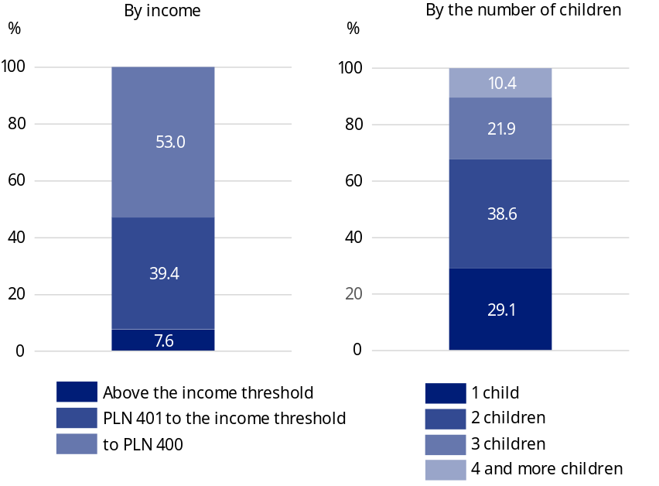
Chart 2. Families receiving the family allowance in 2023
Source: National Family Benefits Monitoring System, Ministry of Family, Labour and Social Policy.

In 2023, family benefit recipients received supplements to allowances in the amount of PLN 777.0 million, which accounted for 6.3% of the total amount of family benefits. On average, 619.7 thousand supplements to family allowances were paid monthly, i.e. by 91.1 thousand (by 12.8%) less than in 2022. Expenditures on supplements to family allowances were financed from the state budget, and moreover, gminas spent PLN 8.4 million from their own funds to increase these amounts.
31.4% of expenses on supplements to family allowances were supplements for raising a child in a multi-
-children family
The largest amount of expenses on supplements to family allowances – PLN 243.7 million (31.4%) was paid for raising a child in a multi-children family, and the smallest one – PLN 36.4 million (4.7%) was paid for the birth of a child.

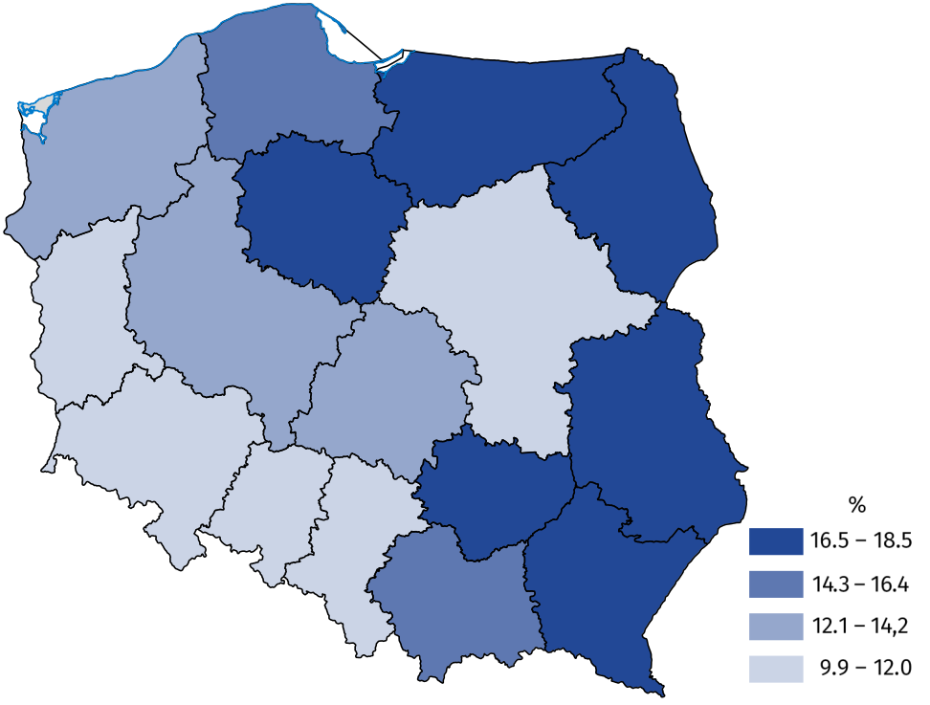
Map 1. Share of children under the age of 18 for whom parents received the family allowance in the total number of children at this age in 2023
Source: National Family Benefits Monitoring System, Ministry of Family, Labour and Social Policy.

Parental benefits
Introduced on 1 January 2016, parental benefits are available to women who have given birth to a child and who do not receive maternity benefits or allowances. In 2023, expenditures on parental benefits amounted to PLN 566.7 million and accounted for 4.6% of all expenses on family benefits. On average, 51.8 thousand eligible persons received them monthly. Compared to the previous year, both the amount and the monthly average number of parental benefits paid decreased (by 16.5% and 16.9%, respectively).
On average 51.8 thousand people collected parental benefits monthly

Childbirth benefits
In 2023, one-off childbirth benefits, the so-called "baby bonus", were directed to parents of 113.7 thousand children, which was 39.3 thousand less (25.7%) than in the previous year.
Parents of 113.7 thousand children received subsidies due to giving birth to a child ("baby bonus")
Expenditures on "baby bonus" payments financed from the state budget amounted to PLN 113.7 million, which accounted for 0.9% of total expenditures on family benefits. Among families receiving one-off childbirth benefits – 34.7% were families with one child, and families with two children – 39.1%, while large families (with three children and more) – 26.3% of the population in question. In 2023, an additional 6.9 thousand childbirth benefits were paid from own resources of gminas for a total amount of PLN 4.8 million.

Social security and health insurance contributions
In 2023, PLN 1.3 billion was spent on retirement and other pension contributions for people receiving nursing benefits or a special attendance allowance. Monthly contributions were paid on average for 173.8 thousand beneficiaries. Health insurance contributions were also paid for recipients of the aforementioned benefits on a monthly average for 110.0 thousand eligible persons. PLN 272.8 million was paid out on this account.

Family care capital
Family care capital (RKO), introduced on 1 January 2023, is available for every second and subsequent child in the family aged 12 to 35 months, in the maximum amount of PLN 12 000 per child. When submitting the application, the child's parent/person who has taken the child in for upbringing decides on the form of payment of the benefit, i.e. whether they want to receive a benefit of PLN 500 for 24 months or PLN 1 000 for 12 months. In 2023, capitals worth a total of PLN 2.2 billion were paid out, an average of 198.4 thousand capitals per month. Among the capitals paid out, benefits paid in the amount of PLN 1 000 predominated (80.8%).
PLN 2.2 billion was paid within the framework of family care capital

Benefits from the "Good Start" programme
Since 2018, assistance for families with children has been expanded to include a payment once a year (PLN 300) of benefits for school supplies for each school child starting the school year. The benefit is paid under the "Good Start" programme and is independent of earned income. In 2023, support under the programme was received by 4.6 million students, and the value of this support was PLN 1.4 billion, just like in 2022.
Families of students received PLN 1.4 billion from the “Good Start” programme

The Large Family Card
The Large Family Card is a system of discounts and additional entitlements for large families with a minimum of three children. It is granted regardless of the amount of income per person in the family and supports the budgets of families with many children and facilitates access to many goods and services. Among other things, holders of the Large Family Card can enjoy discounts on train travel, free admission to national parks, lower passport fees, as well as discounts on the purchase of food, clothing, cosmetics, books or fuel. In 2023, nearly 1.8 million families had the Large Family Card, towards almost 1.5 million a year earlier (21.7% increase).
Nearly 1.8 million families had the Large Family Card

Alimony fund benefits
The value of benefits paid from the alimony fund amounted to PLN 870.4 million
The alimony fund may be used by a person entitled to alimony in the case of ineffective enforcement of alimony from the debtor. In 2023, 2.0 million alimony fund benefits were paid (in 2022 – 2.3 million). These benefits were paid for a total amount of PLN 870.4 million, 8.6% less than in the previous year. An average of 170.0 thousand benefits were paid monthly, with an average amount of PLN 426.6, compared to an average of 189.4 thousand benefits with an average amount of PLN 419.0 paid monthly in 2022.

Child-raising benefits
A PLN 500 child-raising benefit paid under the government programme "Family 500 plus" was due for every child up to 18 years of age, regardless of the amount of income per capita earned in the family. In 2023, expenditures on child-raising benefits amounted to PLN 41.6 billion. On average, the benefit was paid monthly to 7.4 million children.
PLN 41.6 billion was paid under the government programme "Family 500 plus"

Table 1. Amounts of family benefits paid by voivodships in 2023
Specification | Amount of family benefits paid | Amount of benefits paid from the alimony fund |  | Amount of child-  -raising benefits paid from the “Family 500 plus” programme
Specification | in million PLN
Poland | 12329.37 |  | 870.44 |  | 41646.93
Dolnośląskie | 742.00 |  | 73.35 |  | 3069.98
Kujawsko-pomorskie | 820.52 |  | 62.65 |  | 2151.61
Lubelskie | 746.58 |  | 54.13 |  | 2106.25
Lubuskie | 401.59 |  | 27.14 |  | 1074.29
Łódzkie | 701.36 |  | 50.88 |  | 2492.82

Table 1. Amounts of family benefits paid by voivodships in 2023 (cont.)
Specification | Amount of family benefits paid | Amount of benefits paid from the alimony fund |  | Amount of child-  -raising benefits paid from the “Family 500 plus” programme
Specification | in million PLN
Małopolskie | 880.05 |  | 50.68 |  | 3959.24
Mazowieckie | 1398.05 |  | 100.28 |  | 6590.70
Opolskie | 245.05 |  | 19.53 |  | 924.49
Podkarpackie | 982.59 |  | 36.81 |  | 2229.19
Podlaskie | 408.15 |  | 24.71 |  | 1210.22
Pomorskie | 948.37 |  | 66.45 |  | 2824.59
Śląskie | 1209.13 |  | 98.80 |  | 4573.59
Świętokrzyskie | 552.26 |  | 27.29 |  | 1147.04
Warmińsko-mazurskie | 557.74 |  | 49.55 |  | 1440.89
Wielkopolskie | 1236.13 |  | 76.17 |  | 4149.04
Zachodniopomorskie | 499.79 |  | 52.02 |  | 1682.32
Applicant with a foreign address | – |  | – |  | 13.33
Source: National Family Benefits Monitoring System, Ministry of Family, Labour and Social Policy and Central Statistical Application – the area of Child-raising Benefit of the Ministry of Family, Labour and Social Policy, data of the Social Insurance Institution.
In the case of quoting data from the Statistics Poland, please provide information: "Statistics Poland data source", and in the case of publishing calculations made on data published by the Statistics Poland, please provide information: "Own study based on Statistics Poland data".

Prepared by:  Statistical Office in Kraków  Director Agnieszka Szlubowska  Phone: (+48 12) 420 40 50 | Issued by:  Press Office  Mobile: (+48) 695 255 032  Phone: (+48 22) 608 38 04, (+48 22) 449 41 45,  (+48 22) 608 30 09  e-mail: obslugaprasowa@stat.gov.pl

stat.gov.pl/en/

@StatPoland

@GlownyUrzadStatystyczny

gus_stat

glownyurzadstatystycznygus

glownyurzadstatystyczny
Related information
Link to the Statistics Poland publication "Social assistance, child and family services in 2022"
Data available in databases
Local Data Bank – HEALTH ATTENDANCE, SOCIAL WELFARE AND BENEFITS TO THE FAMILY
Terms used inn official statistics
Beneficiaries from family benefits
Alimony fund benefits
Benefits within the "Family 500+" Programme

Beneficiaries of family benefits are families receiving family benefits for dependent children and adults entitled to benefits for themselves.
Pursuant to the Act of 12 March 2022 on Assistance to Citizens of Ukraine in Connection with the Armed Conflict on the Territory of that Country (Journal of Laws of 2022, item 583).
The income criterion determining the payment of family benefits is PLN 674 of the average monthly family income per capita or PLN 764 for families with a disabled child.
Pursuant to Art. 17c of the Act of 28 November 2003 on Family Benefits (Journal of Laws of 2023 item 390), the parental benefit apart from the child's mother is also granted to the father, actual guardian, foster family in cases specified in the Act.
Act of 17 November 2021, Journal of Laws of 2023 item 883.
Benefits paid abroad are not included (PLN 115.0 thousand).
The value of paid child-raising benefits is given together with benefits paid for children in foster care and for children who came from Ukraine in connection with the armed conflict.
Due to rounding, data do not sum up to the total.
It also contains data that could not be assigned to individual voivodships due to incorrect or missing data about the voivodship.
See footnote 7 p. 5.

