Gross domestic product and gross value added
in regional breakdown in 2022
In 2022, more than 1/2 of the national value
of gross domestic product was generated in the
5 regions: Warszawski stołeczny, Śląskie, Wielkopolskie, Dolnośląskie and Małopolskie.
56.1%
Percentage of GDP value generated in the 5 regions in 2022

Gross domestic product
In 2022, value of the generated gross domestic product amounted to 3 074 798 million PLN.
In comparison to 2021, it grew by 16.9% at current prices.
In 2022, all regions recorded an increase in GDP at current prices compared to the previous year
The increase in gross domestic product at current prices compared to 2021 was recorded
in all regions, the largest in Mazowiecki regionalny region – by 22.3%, and the smallest in Świętokrzyskie region – by 11.3%.
In 2022, the shares of individual regions in the generation of GDP ranged from 2.0% in Opolskie region to 17.6% in Warszawski stołeczny region. Value of GDP generated in Warszawski stołeczny region in 2022 was almost 9 times higher than in Opolskie region (in 2021 more than 8 times higher).
In the group of regions with high shares in the generation of GDP in 2022, apart from Warszawski stołeczny region, there were also the following regions: Śląskie, Wielkopolskie, Dolnośląskie and Małopolskie. Entities acting in the 5 above-mentioned regions, in which 51.3% of total employed persons in the national economy worked, jointly generated 56.1%
of the national value of GDP.
Graph 1. Share of regions in the generation of gross domestic product in 2022 (current prices)
Podlaskie 2.2%
Opolskie 2.0%
Świętokrzyskie 2.2%
Lubuskie 2.1%
Warszawski stołeczny 17.6%
Warmińsko-mazurskie 2.5%
Zachodniopomorskie 3.6%
Lubelskie 3.6%
Podkarpackie 3.7%
Kujawsko-pomorskie 4.3%
Łódzkie 6.0%
Pomorskie 6.2%
Mazowiecki regionalny 5.5%
Wielkopolskie 9.8%
Dolnośląskie 8.6%
Małopolskie 8.0%
POLAND
3 074.8 billion PLN
Śląskie 12.1%
In 2022, the following regions were in the group of regions with low shares in the GDP generation (less than 3% each): Lubuskie, Opolskie, Podlaskie, Świętokrzyskie and Warmińsko-mazurskie. Their total share in the GDP generation amounted to 11.0% and employment in these regions constituted 13.0% of the total employed persons in the national economy.
In 2022, the average level of gross domestic product per capita in Poland amounted to
81 286 PLN. In comparison with 2021, it was higher by 17.4% at current prices. The increase
in GDP per capita at current prices compared to 2021 was recorded in all regions – from 12.4% in Świętokrzyskie region to 23.2% in Mazowiecki regionalny region.
In the regional breakdown, the level of GDP per capita in 2022 was differentiated. Indicator
of dispersion of GDP per capita, calculated at the regions’ level for Poland in 2022 amounted to 22.0%. In comparison to 2021, an increase of this indicator by 0.7 pp was noted.
Level of GDP per capita exceeding the national average was obtained in 4 regions: Warszawski stołeczny, Dolnośląskie, Wielkopolskie and Śląskie
The highest level of GDP per capita in 2022 was noted for Warszawski stołeczny region –
166 446 PLN, exceeding more than twice the national average. In 2022 the level of GDP per capita above the national average was also observed in Dolnośląskie region – by 11.8%, Wielkopolskie region – by 5.6% and Śląskie region – by 5.0%.
The highest level of GDP per capita, obtained in 2022 in Warszawski stołeczny region, exceeded 3 times the value of GDP per capita of Lubelskie region, in which the lowest level
of GDP per capita was recorded.
All regions of Eastern Poland recorded a GDP per capita level below 75% of the national average
Low level of GDP per capita (less than 75% of the national average) in 2022 was observed
in the regions of Eastern Poland: Lubelskie, Podkarpackie, Warmińsko-mazurskie, Świętokrzyskie and Podlaskie. In 2022, the value of GDP per capita in these regions varied from 67.6% to 73.4% of the national average.
The lowest level of GDP per capita in 2022, noted in Lubelskie region, represented 33.0%
of the level of this indicator for the best in this regard Warszawski stołeczny region.
Map 1. Gross domestic product per capita by regions in 2022 (current prices)

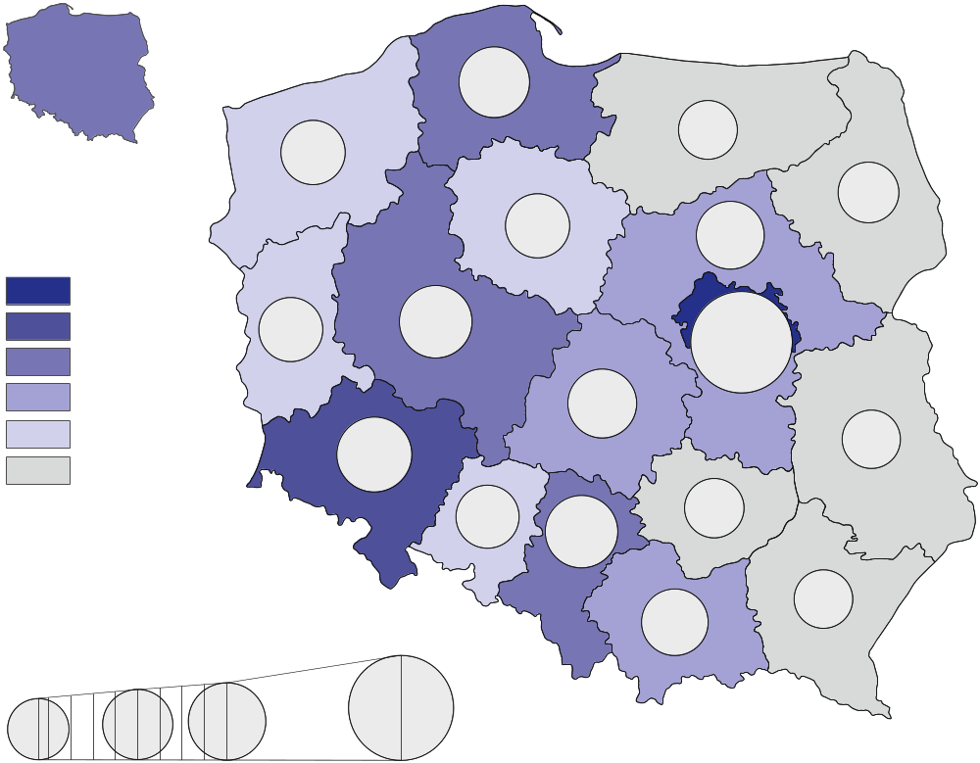
54.9-60.0
67.6%
90.0%
110.0%
81.7%
81.6%
99.6%
69.0%
81.8%
73.4%
92.3%
105.6%
204.8%
94.6%
67.6%
81.3
thousand
PLN

90.1-100.0
100.1-166.4
80.1-90.0
70.1-80.0
60.1-70.0
111.8%
70.0%
204.8%
In thousand PLN
79.5%
105.0%
67.9%
88.4%
Poland=100

Table 1. Gross domestic product by regions in 2022 (current prices)
Regions | Total |  |  | Per capita
Regions | in million PLN | in percent | previous year=100 | in PLN | Poland=100 | previous year=100
POLAND | 3 074 798 | 100.0 | 116.9 | 81 286 | 100.0 | 117.4
Dolnośląskie | 262 933 | 8.6 | 118.1 | 90 915 | 111.8 | 118.5
Kujawsko-pomorskie | 133 570 | 4.3 | 116.2 | 66 398 | 81.7 | 117.0
Lubelskie | 111 576 | 3.6 | 114.4 | 54 950 | 67.6 | 115.4
Lubuskie | 65 150 | 2.1 | 116.1 | 66 300 | 81.6 | 116.9
Łódzkie | 183 413 | 6.0 | 114.9 | 76 883 | 94.6 | 115.8
Małopolskie | 246 319 | 8.0 | 114.1 | 71 836 | 88.4 | 114.2
Mazowiecki regionalny | 169 337 | 5.5 | 122.3 | 75 027 | 92.3 | 123.2
Opolskie | 61 059 | 2.0 | 113.1 | 64 600 | 79.5 | 114.0
Podkarpackie | 114 810 | 3.7 | 113.1 | 55 155 | 67.9 | 113.6
Podlaskie | 68 369 | 2.2 | 117.1 | 59 667 | 73.4 | 117.9
Pomorskie | 191 032 | 6.2 | 121.1 | 80 999 | 99.6 | 121.0
Śląskie | 371 976 | 12.1 | 118.3 | 85 316 | 105.0 | 119.2
Świętokrzyskie | 67 218 | 2.2 | 111.3 | 56 860 | 70.0 | 112.4
Warmińsko-mazurskie | 76 859 | 2.5 | 113.4 | 56 106 | 69.0 | 114.3
Warszawski stołeczny | 541 693 | 17.6 | 119.0 | 166 446 | 204.8 | 118.4
Wielkopolskie | 300 126 | 9.8 | 115.5 | 85 841 | 105.6 | 115.7
Zachodniopomorskie | 109 357 | 3.6 | 113.3 | 66 476 | 81.8 | 114.0
Gross value added by kind of activity
In 2022, 28.7% of the national gross value added was generated by the entities engaged in activities in the area of services covering trade; repair of motor vehicles; transportation and storage; accommodation and catering; information and communication. In the individual
regions, the shares of these entities in the generation of gross value added in 2022 ranged between 20.6% in Mazowiecki regionalny region and 36.4% in Warszawski stołeczny region.
In 2022, 11 regions recorded the largest share of industry
in creating GVA
In 2022, entities engaged in industry generated 27.4% of the national gross value added.
In the regions’ breakdown, in 2022 significant variation of the shares of industry was observed – from 13.9% in Warszawski stołeczny region to 39.4% in Mazowiecki regionalny region.
In 2022, entities engaged in other services (including public administration and defence; compulsory social security) generated 24.2% of the national gross value added. In 2022, Małopolskie region was characterised by the highest share of other services – 28.4% while Mazowiecki regionalny region was marked by the smallest share – 17.4%.

Entities engaged in financial and insurance activities; real estate activities in 2022 generated 10.1% of the national gross value added. In the individual regions, the shares of entities acting in the field of financial and insurance activities; real estate activities in the generation
of gross value added in 2022 ranged between 5.9% in Mazowiecki regionalny region and 16.1% in Warszawski stołeczny region.
In 2022, entities active in construction generated 6.5% of the national gross value added.
In the regions’ breakdown in 2022, the shares of units engaged in construction in the generation of gross value added ranged from 5.4% in Łódzkie region to 7.8% in Małopolskie region.
The share of agriculture, forestry and fishing in the generation of the national gross value added in 2022 amounted to 3.1%. In the individual regions, in 2022 the shares of entities conducting activity in the range of agriculture, forestry and fishing were significantly differentiated – from 0.7% in Warszawski stołeczny region to 10.6% in Mazowiecki regionalny region.
Graph 2. Gross value added by kind of activity and regions in 2022 (current prices)
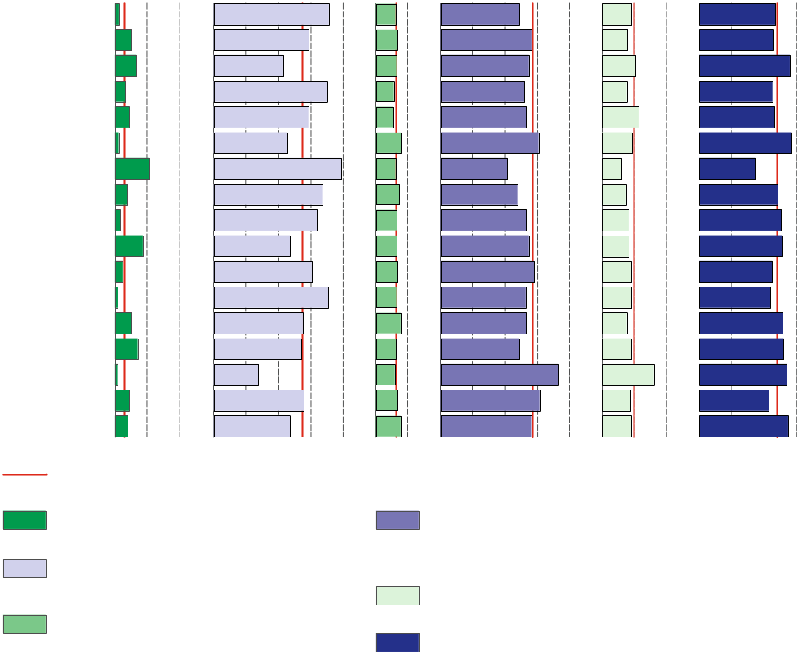
Table 2. Gross value added by kind of activity and regions in 2022 (current prices)
Construction
Industry
Poland
Trade; repair of motor vehicles^{Δ};
transportation and storage; accommodation and catering^{Δ}; information and communication
Agriculture, forestry and fishing
Financial and insurance activities; real estate activities^{Δ}
Other services
Dolnośląskie
Kujawsko-pomorskie
Lubelskie
Lubuskie
Łódzkie
Małopolskie
Mazowiecki regionalny
Opolskie
Podkarpackie
Podlaskie
Pomorskie
Śląskie
Świętokrzyskie
Warmińsko-mazurskie
Warszawski stołeczny
Wielkopolskie
Zachodniopomorskie
In % of total
0 10 20 0 10 20 30 40 0 10 0 10 20 30 40 0 10 20 0 10 20 30
REGIONS  a – in million PLN  b – in % of total  c – previous year=100 |  | Total | Agriculture, forestry  and fishing | Industry | Construction | Trade; repair of motor vehicles^{Δ};  transportation and storage;  accommodation and catering^{Δ};  information and communication | Financial and insurance activities;  real estate activities^{Δ} | Other services
POLAND | a | 2 740 195 | 85 438 | 750 970 | 177 816 | 785 904 | 276 678 | 663 390
 | b | 100.0 | 3.1 | 27.4 | 6.5 | 28.7 | 10.1 | 24.2
 | c | 119.7 | 146.4 | 122.8 | 115.5 | 119.8 | 133.9 | 110.0
Dolnośląskie | a | 234 320 | 3 040 | 83 506 | 14 344 | 57 069 | 21 235 | 55 127
 | b | 100.0 | 1.3 | 35.6 | 6.1 | 24.4 | 9.1 | 23.5
 | c | 120.9 | 139.0 | 127.0 | 116.1 | 120.3 | 133.6 | 109.9
Kujawsko-pomorskie | a | 119 035 | 5 940 | 35 008 | 8 022 | 33 574 | 9 262 | 27 230
 | b | 100.0 | 5.0 | 29.4 | 6.7 | 28.2 | 7.8 | 22.9
 | c | 119.0 | 154.8 | 118.0 | 114.1 | 122.2 | 127.0 | 110.3
Lubelskie | a | 99 434 | 6 490 | 21 294 | 6 365 | 27 277 | 10 210 | 27 798
 | b | 100.0 | 6.5 | 21.4 | 6.4 | 27.4 | 10.3 | 28.0
 | c | 117.2 | 139.2 | 114.0 | 114.5 | 119.5 | 131.4 | 109.5
Lubuskie | a | 58 060 | 1 845 | 20 297 | 3 276 | 15 109 | 4 403 | 13 130
 | b | 100.0 | 3.2 | 35.0 | 5.6 | 26.0 | 7.6 | 22.6
 | c | 118.9 | 124.8 | 125.2 | 112.6 | 118.8 | 125.1 | 109.6
Łódzkie | a | 163 454 | 7 185 | 47 653 | 8 851 | 43 363 | 18 403 | 37 999
 | b | 100.0 | 4.4 | 29.2 | 5.4 | 26.5 | 11.3 | 23.2
 | c | 117.6 | 156.7 | 114.5 | 115.6 | 116.8 | 137.5 | 109.9
Małopolskie | a | 219 514 | 2 647 | 50 054 | 17 061 | 66 818 | 20 515 | 62 419
 | b | 100.0 | 1.2 | 22.8 | 7.8 | 30.4 | 9.3 | 28.4
 | c | 116.9 | 136.1 | 114.1 | 112.6 | 120.8 | 134.4 | 110.9
Mazowiecki regionalny | a | 150 910 | 16 005 | 59 389 | 9 269 | 31 076 | 8 930 | 26 243
 | b | 100.0 | 10.6 | 39.4 | 6.1 | 20.6 | 5.9 | 17.4
 | c | 125.3 | 145.5 | 136.6 | 113.0 | 118.5 | 120.6 | 108.6
Opolskie | a | 54 414 | 2 014 | 18 219 | 3 976 | 12 944 | 4 017 | 13 243
 | b | 100.0 | 3.7 | 33.5 | 7.3 | 23.8 | 7.4 | 24.3
 | c | 115.8 | 149.9 | 113.0 | 114.3 | 120.0 | 123.3 | 110.4
Podkarpackie | a | 102 316 | 1 683 | 32 666 | 6 715 | 27 063 | 8 350 | 25 839
 | b | 100.0 | 1.6 | 31.9 | 6.6 | 26.5 | 8.2 | 25.3
 | c | 115.8 | 131.9 | 117.2 | 114.9 | 117.4 | 126.6 | 109.2
Podlaskie | a | 60 929 | 5 317 | 14 369 | 3 938 | 16 719 | 5 043 | 15 543
 | b | 100.0 | 8.7 | 23.6 | 6.5 | 27.4 | 8.3 | 25.5
 | c | 120.0 | 144.4 | 118.6 | 116.7 | 123.0 | 128.0 | 110.3
Pomorskie | a | 170 244 | 3 928 | 51 652 | 11 530 | 49 402 | 15 389 | 38 343
 | b | 100.0 | 2.3 | 30.3 | 6.8 | 29.0 | 9.0 | 22.5
 | c | 124.0 | 147.6 | 138.3 | 115.0 | 122.4 | 130.5 | 109.3

Table 2. Gross value added by kind of activity and regions in 2022 (cont.)
REGIONS  a – in million PLN  b – in % of total  c – previous year=100 |  | Total | Agriculture. forestry  and fishing | Industry | Construction | Trade; repair of motor vehicles^{Δ};  transportation and storage;  accommodation and catering^{Δ};  information and communication | Financial and insurance activities;  real estate activities^{Δ} | Other services
Śląskie | a | 331 497 | 2 515 | 117 303 | 21 330 | 87 679 | 30 100 | 72 570
 | b | 100.0 | 0.8 | 35.4 | 6.4 | 26.4 | 9.1 | 21.9
 | c | 121.1 | 135.9 | 129.2 | 113.3 | 119.5 | 137.0 | 108.5
Świętokrzyskie | a | 59 903 | 2 980 | 16 446 | 4 635 | 15 853 | 4 539 | 15 451
 | b | 100.0 | 5.0 | 27.5 | 7.7 | 26.5 | 7.6 | 25.8
 | c | 114.0 | 135.4 | 112.6 | 113.8 | 114.5 | 122.6 | 109.5
Warmińsko-mazurskie | a | 68 495 | 4 894 | 18 591 | 4 219 | 16 687 | 6 240 | 17 864
 | b | 100.0 | 7.1 | 27.1 | 6.2 | 24.4 | 9.1 | 26.1
 | c | 116.2 | 145.4 | 112.9 | 113.6 | 118.0 | 127.7 | 109.0
Warszawski stołeczny | a | 482 745 | 3 208 | 67 028 | 28 465 | 175 741 | 77 753 | 130 551
 | b | 100.0 | 0.7 | 13.9 | 5.9 | 36.4 | 16.1 | 27.0
 | c | 121.8 | 145.3 | 129.3 | 120.7 | 120.2 | 140.0 | 111.7
Wielkopolskie | a | 267 466 | 11 895 | 74 475 | 18 272 | 82 110 | 23 508 | 57 205
 | b | 100.0 | 4.4 | 27.8 | 6.8 | 30.7 | 8.8 | 21.4
 | c | 118.2 | 157.7 | 114.3 | 117.3 | 120.5 | 135.2 | 109.2
Zachodniopomorskie | a | 97 457 | 3 853 | 23 020 | 7 548 | 27 420 | 8 781 | 26 835
 | b | 100.0 | 4.0 | 23.6 | 7.7 | 28.1 | 9.0 | 27.5
 | c | 116.0 | 151.0 | 116.5 | 113.4 | 116.2 | 125.0 | 110.0

Symbol (∆) — categories of applied PKD 2007 classification (link) are presented in abbreviated form.
Data from regional accounts included in this note have been revised in relation to those published on 29 December 2023 and balanced with annual national accounts data included
in the publication “National accounts by institutional sectors and sub-sectors 2019-2022”. Data will be subject to further revision, in accordance to the revision policy applied in national and regional accounts (link). Complete range of data for the year 2022 will be available in November of the current year.
In case of quoting Statistics Poland data, please provide information: “Source of data: Statistics Poland”, and in case of publishing calculations made on data published by Statistics Poland, please include the following disclaimer: “Own study based on figures from Statistics Poland”.
Prepared by:  Statistical Office in Katowice  Director Grażyna Witkowska  Phone: (+48 32) 779 12 48 | Issued by:  Press Office  Mobile: (+48) 695 255 032  Phone: (+48 22) 608 38 04, (+48 22) 449 41 45,  (+48 22) 608 30 09  e-mail: obslugaprasowa@stat.gov.pl


stat.gov.pl/en/
 | @StatPoland

@GlownyUrzadStatystyczny

gus_stat

glownyurzadstatystycznygus

glownyurzadstatystyczny
Related information
Gross domestic product - regional accounts in the years 2019-2021
Methodological report. Gross domestic product and its elements in the regional breakdown
Most EU regions record an increase in real GDP in 2022
National accounts by institutional sectors and sub-sectors 2019-2022
Provisional estimates of gross domestic product in regional breakdown in 2022
Data available in databases
Knowledge Databases -> National and regional accounts -> Regional accounts
Local Data Bank -> Regional accounts
Terms used in official statistics
Gross domestic product
Regional accounts
Value added, gross

