Higher education in the 2023/2024 academic year
As of 31 December 2023, there were
1,245.2 thousand people enrolled in higher education institutions in Poland, by 21.5 thousand more than in 2022. 292.1 thousand graduates received diplomas in the 2022/23 academic year, by 0.5 thousand fewer than in 2021/22.
1.8%
Increase in the number of students compared to the 2022/23 academic year
According to the POL-on register, 354 higher education institutions operated in Poland
in the 2023/24 academic year. This study covers 342 HEIs which filed statistical reports.
The number of students decreased from 1,405.1 thousand to 1,204.0 thousand in the
2015/16-2019/20 academic years, then it began increasing to reach 1,245.2 thousand people in the 2023/24 academic year. A steady decline, from 364.6 thousand people in the 2015/16 academic year to 292.1 thousand in 2022/23, was recorded in the number of graduates
(a slight increase was recorded only in the 2016/17 and 2020/21 academic years).

Chart 1. Students and graduates of higher education institutions (including foreigners)
Compared to the 2015/16 academic year, the number of students decreased by 11.4%, while the number of graduates fell by 19.9%

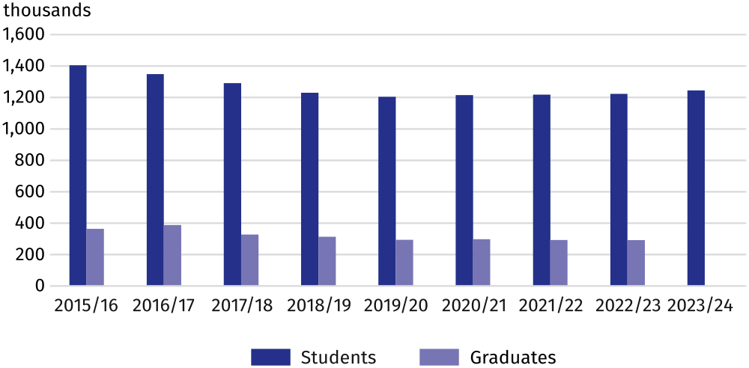

Students
Women accounted for 58.5% of students in the 2023/24 academic year. 790.4 thousand people were enrolled in full-time programmes (63.5% of students), while 454.7 thousand people studied part-time. First-cycle studies were chosen by 60.8% of all students
(756.5 thousand people), whereas second-cycle programmes concentrated 19.7% and
long-cycle programmes 19.2% of students. The most (285.5 thousand) people studied in Mazowieckie Voivodship, while the fewest (11.0 thousand) in Lubuskie Voivodship.
63.5% of students were enrolled in full-time programmes
Business, administration and law with 22.6% of all students was the most frequently chosen broad field, followed by Social sciences, journalism and information (14.0% respectively), Health and welfare (13.7%) and Engineering, manufacturing and construction (12.5%).
107.1 thousand foreigners, including 52.3 thousand women, studied in Poland, by 1.6% more than in the previous year (this applies to people studying in Poland for at least one academic year). Most of the foreigners came from European countries, primarily from Ukraine (46.2 thousand, 43.1% of all foreigners), Belarus (12.7 thousand – 11.8%) and Türkiye (4.8 thousand – 4.4%). Full-time studies were undertaken by 93.2 thousand foreigners (87.0%). Nearly a third (32.8 thousand) of all foreign students studied at higher education institutions in Mazowieckie Voivodship.
Higher education institutions in Mazowieckie Voivodship were the most popular with foreign students

Table 1. Students by voivodships in the 2023/24 academic year
SPECIFICATION | Total | Of which females | In |  | Of total number  – foreigners
SPECIFICATION | Total | Of which females | full-time programmes | part-time programmes | Of total number  – foreigners
POLAND | 1245153 | 728464 | 790428 | 454725 | 107130
Dolnośląskie | 115157 | 64707 | 72316 | 42841 | 9519
Kujawsko-Pomorskie | 58389 | 36958 | 32264 | 26125 | 3936
Lubelskie | 64547 | 38798 | 49266 | 15281 | 9461
Lubuskie | 10989 | 6127 | 7151 | 3838 | 381
Łódzkie | 74269 | 45011 | 43731 | 30538 | 8074
Małopolskie | 148433 | 87904 | 108865 | 39568 | 9010
Mazowieckie | 285465 | 166043 | 164089 | 121376 | 32789
Opolskie | 17389 | 9671 | 13138 | 4251 | 2344
Podkarpackie | 41908 | 23518 | 30287 | 11621 | 2867
Podlaskie | 28830 | 17472 | 20921 | 7909 | 1748
Pomorskie | 88543 | 52534 | 53200 | 35343 | 5594
Śląskie | 106604 | 61660 | 70514 | 36090 | 7607
Świętokrzyskie | 19765 | 12106 | 12676 | 7089 | 1192
Warmińsko-Mazurskie | 21290 | 12387 | 15826 | 5464 | 565
Wielkopolskie | 131033 | 75190 | 72356 | 58677 | 9643
Zachodniopomorskie | 32542 | 18378 | 23828 | 8714 | 2400

Graduates
292.1 thousand people, including 183.0 thousand (62.6%) women, obtained higher education diplomas in the 2022/23 academic year. Most graduates (183.4 thousand) completed
long-cycle and first-cycle programmes, while graduates of second-cycle studies accounted for 37.2%.
183.2 thousand graduates completed full-time programmes (62.7%), while 108.9 thousand – part-time programmes
Graduates most often completed their studies in the following broad fields: Business, administration and law (24.3%), Engineering, manufacturing and construction (13.9%), Health and welfare (13.4%) and Social sciences, journalism and information (11.1%).
The most of 17.3 thousand foreign graduates came from Ukraine (39.5%), Belarus (12.4%) and India (3.1%). Women represented more than half of foreign graduates (56.0%). 87.4% of foreigners completed full-time studies, mostly Business, administration and law (33.5% of the total number of foreign graduates).

Table 2. HEI graduates by broad fields of education in the 2022/23 academic year
SPECIFICATION | Total | Of which females
Total | 292120 | 183000
Education | 19768 | 16524
Arts and humanities | 26966 | 19405
Social sciences, journalism and information | 32535 | 22177
Business, administration and law | 71080 | 46076
Natural sciences, mathematics and statistics | 10729 | 7275
Information and Communication Technologies (ICTs) | 14411 | 2261
Engineering, manufacturing and construction | 40750 | 15885
Agriculture, forestry, fisheries and veterinary | 4949 | 3012
Health and welfare | 39001 | 31975
Services | 24427 | 15067
Individual inter-field studies | 7504 | 3343
When quoting Statistics Poland data, please provide the information: "Source of data: Statistics Poland", and when publishing calculations made on data published by Statistics Poland, please include the following disclaimer: "Own study based on figures from Statistics Poland".
Prepared by:  Statistical Office in Gdańsk  Director Jerzy Auksztol  Phone (+48 58) 76 83 130 | Issued by:  Press Office  Mobile: (+48) 695 255 032  Phone: (+48 22) 608 38 04, (+48 22) 449 41 45,  (+48 22) 608 30 09  e-mail: obslugaprasowa@stat.gov.pl

stat.gov.pl/en/

@StatPoland

@GlownyUrzadStatystyczny

gus_stat

glownyurzadstatystycznygus

glownyurzadstatystyczny
Related information
Higher education and its finances in 2022
Data available in databases
Local Data Bank - Higher education
Terms used in official statistics
Student
Degree programmes
Full-time programmes
Part-time programmes

