Employed persons in the national economy in Poland in February 2024
As at the last day of February 2024 in the national economy there were
15 081.5 thousand employed persons.
The mean age was 42.7 years, the median age was 42.0 years.
The mean age and median age of employed persons in the national economy were similar for men and women.
15 081.5 thousand
number of employed persons
in the national economy
as at 29 February2024
The data refer to employed persons in national economy entities based in Poland who live in Poland or abroad.
Among the total number of employed persons in the national economy in Poland, men had a larger share. At the end of February 2024, their share was 52.8%. However, the sex structure of the employed varied according to their age. There was a predominance of men at essentially all ages, this was particularly evident at the threshold and end of working life. In contrast, the share of women among employed persons in the national economy was higher only between the ages of 47-59.
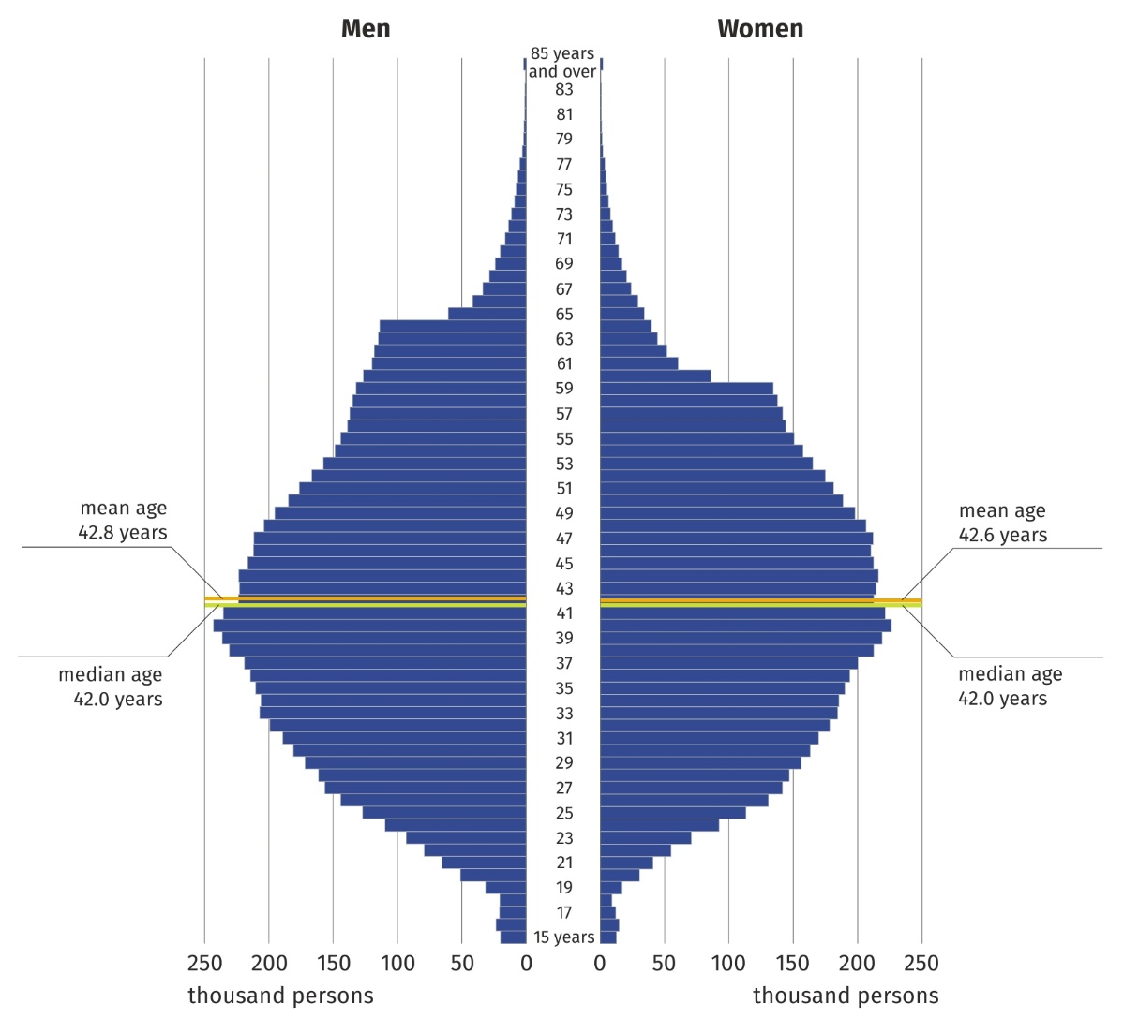
Chart 1. Employed persons in the national economy by sex and age in 2024
As at 29 February
The sex structure of the employed also varied according to their place of residence. The predominance of women among employed persons occurred mainly in Poland's largest cities. As at 29 February 2024, the highest share of women – 56.1% – was recorded in the Małopolskie Voivodship, in the border gmina of Lipnica Wielka, and the smallest in the rural gmina of Lelkowo in the Warmińsko-Mazurskie Voivodship – 33.0%.

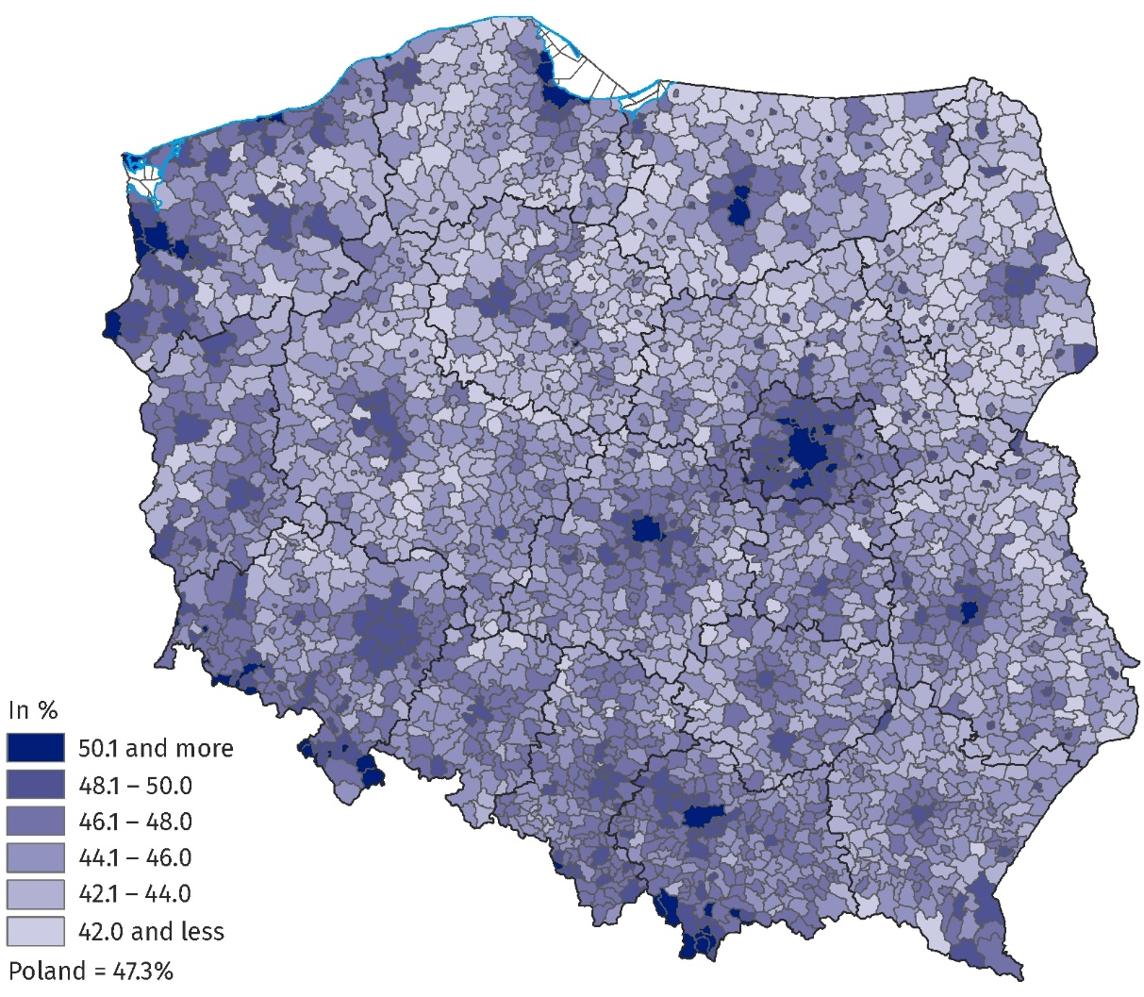
Map 1. Share of women in the total number of employed persons in the national economy
by gmina of residence in 2024
As at 29 February
The share of women and men in the total number of employed persons in the national economy also varied according to the kind of activity of the entity in which they worked. As at 29 February 2024, the largest number of employed persons in the national economy, i.e. 2 781.5 thousand, were concentrated in Manufacturing, i.e. 18.5% of the total number of employed persons. In this section, women accounted for 34.6%. The second section in terms of the number of employed persons – Trade; repair of motor vehicles∆ concentrated 14.7% of the total number of employed persons, and the share of women was over 53%. As at the end of February 2024, the Human health and social work activities and Education sections were most feminised. Women accounted for 82.0% and 79.6% of employed persons in these sections, respectively. The most masculinised sections were Construction and Mining and quarrying, where the share of men was over 89%.
At the end of February 2024, the largest number of employed persons was in the Manufacturing section

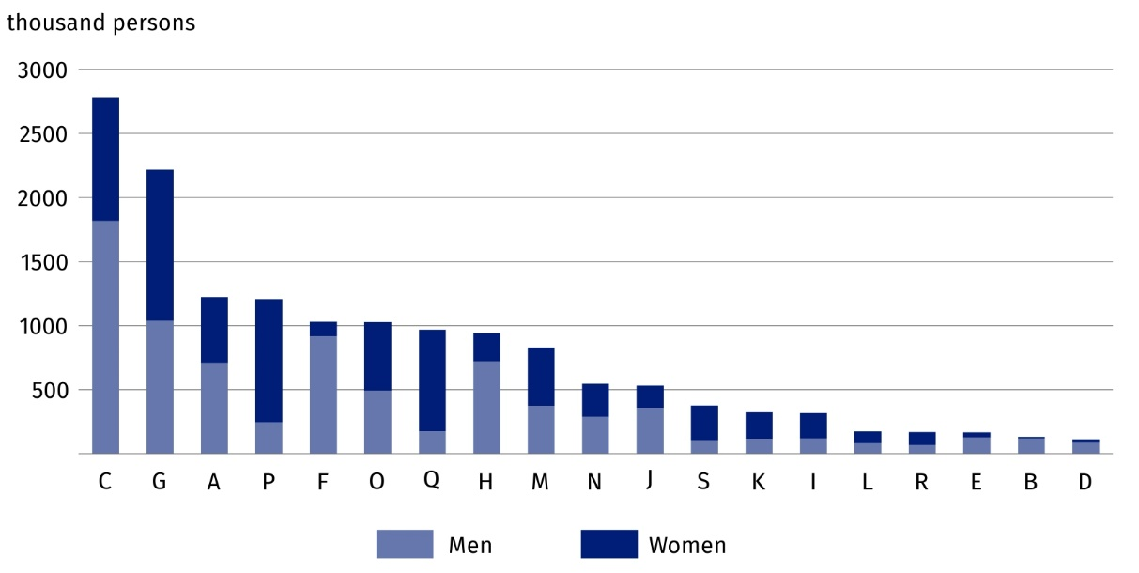
Chart 2. Employed persons in the national economy by sex and PKD/NACE section in 2024
As at 29 February
Both male and female employment was dominated by paid work. At the end of February 2024, 79.0% of all employed persons in the national economy were in paid employment.

Table 1. Employed persons in the national economy by sex in 2024
On the last day of February 2024, men accounted for 62% of the self-employed including contributing family workers

As at 29 February
Specification | Total | Men | Women
Specification | thousand persons
Total | 15 081.5 | 7 957.8 | 7 123.8
Of which
employees | 11 918.6 | 5 986.7 | 5 932.0
self-employed persons including contributing family workers | 3 131.1 | 1 945.5 | 1 185.6
The next largest grouping of employed persons in the national economy were self-employed persons including contributing family workers. As at 29 February 2024, there were 3 131.1 thousand of them and they accounted for 20.8% of the total number of employed persons in the national economy. In all PKD/NACE sections, self-employed persons including contributing family workers were dominated by those without employees.

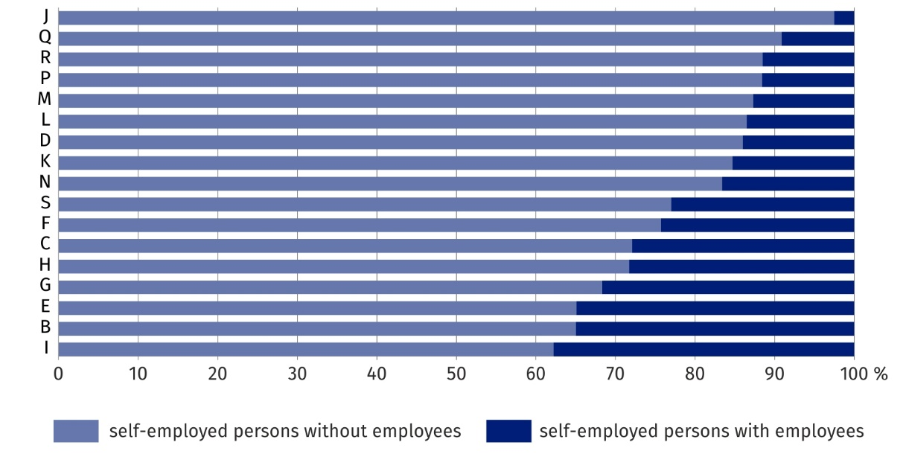
Chart 3. Structure of self-employed persons including contributing family workers in selected PKD/NACE sections in 2024
As at 29 February
Due to the rounding of data, sums of components may differ from the amount given in the item ‘total’.
***
There is a wider range of data on employed persons in the national economy in the publication tables.
***
In this news release abbreviated names of NACE, Rev. 2 sections were used. Abbreviations are marked with a ‘Δ’ symbol. Full names are listed below.
PKD/NACE section symbols:
A – Agriculture, forestry and fishing;
B – Mining and quarrying;
C – Manufacturing;
D – Electricity, gas, steam and air conditioning supply;
E – Water supply; sewerage, waste management and remediation activities;
F – Construction;
G – Wholesale and retail trade; repair of motor vehicles and motorcycles;
H – Transportation and storage;
I – Accommodation and food service activities;
J – Information and communication;
K – Financial and insurance activities;
L – Real estate activities;
M – Professional, scientific and technical activities;
N – Administrative and support service activities;
O – Public administration and defence; compulsory social security;
P – Education;
Q – Human health and social work activities;
R – Arts, entertainment and recreation;
S – Other service activities.

In the case of quoting Statistics Poland data, please provide information: ‘Source of data: Statistics Poland’, and in the case of publishing calculations made on data published by Statistics Poland, please provide information: ‘Own work based on Statistics Poland data.’
Prepared by:  Statistical Office in Bydgoszcz  Director Wiesława Gierańczyk, Ph.D.  Phone: (+48 52) 366 93 90 | Issued by:  Press Office  Mobile phone: (+48) 695 255 032  Landline phones: (+48 22) 608 38 04, (+48 22) 449 41 45,  (+48 22) 608 30 09  e-mail: obslugaprasowa@stat.gov.pl

stat.gov.pl/en/

@StatPoland

@GlownyUrzadStatystyczny

gus_stat

glownyurzadstatystycznygus

glownyurzadstatystyczny
Related information
Methodological report Employment in the national economy
Methodological report Employment in the national economy according to administrative data sources

