Financial results of investment fund companies
in the first half of 2024
The value of total assets acumulated by investment fund companies at the end of first half of 2024 amounted to PLN 3.0 billion and was by 21.7% higher compared to the end of the first half of 2023.
⇧ 21.7%
Increase in the value of assets of investment fund companies

As of the end of June 2024, 56 investment fund companies were in operation
At the end of June 2024, 56 investment fund companies (TFI) were in operation. They managed a total of 471 investment funds (excluding funds in liquidation). In comparison, at the end of June 2023, there were 55 fund companies that managed a total of 522 investment funds.
Balance sheets of investment fund companies
Assets of investment fund companies amounted to PLN 3,047.7 million (21.7% more than at the end of June 2023), including current assets which reached PLN 2,207.6 million (increased by 23.1%) and accounted for 72.4% of total assets. Current assets mainly consisted of short-term financial investments, which increased to PLN 1,748.3 million (by 25.0%) and short-term credits in amount PLN 415.4 million (increased by 17.8%).
Cash and other cash assets had the largest share in the structure of financial assets (77.0%). Five investment fund companies with the highest assets owned 40.0% of the total value of assets (35.8% a year earlier).
In the liabilities of investment fund companies, equity (funds) amounted to PLN 2,051.3 million (increase of 12.1% compared to the first half of 2023) and represented 67.3% of the total liabilities. The value of share capital was PLN 691.1 million (an increase of 3.8% compared to first half of 2023).
The value of foreign capital in the total share capital of TFI decreased to PLN 182.2 million (the share of foreign investors decreased by 2.4 percentage points to 26.4%). In 10 investment fund companies, the share of foreign capital exceeded 50%.

Table 1. Selected items of the balance sheets of investment fund companies
Specification | First half of 2023 | First half of 2024
Specification | in PLN milion |  | First half of 2023=100
Total assets, of which: | 2,504.6 | 3,047.7 | 121.7
Fixed assets, of which: | 692.9 | 809.1 | 116.8
long-term investments | 471.1 | 556.3 | 118.1
Current assets, of which: | 1,793.8 | 2,207.6 | 123.1
short-term investments | 1,398.5 | 1,748.3 | 125.0
Total equity and liabilities, of which: | 2,504.6 | 3,047.7 | 121.7
Equity capital, of which: | 1,829.5 | 2,051.3 | 112.1
share capital | 666.0 | 691.1 | 103.8
supplementary capital | 907.2 | 969.5 | 106.9
Liabilities and provisions for liabilities | 675.1 | 996.4 | 147.6
Profit and loss account of investment fund companies
TFI's net operating result in the first half of 2024 amounted to PLN 0.4 billion
In the first half of 2024, revenues from TFI's operating activities amounted to PLN 1,841.6 million and were by 18.2% higher than the value recorded in the previous year. The increase was mainly influenced by the change in revenue from the management of investment funds, which amounted to PLN 1,823.5 million and was higher by 22.6%. The operating costs of TFI at the end of first half of 2024 amounted to PLN 1,409.4 million and were higher by 10.3% compared to the first half of the previous year. In the cost structure, the main items were external services (52.7% of the value of operating costs), which increased by 17.0% and remuneration with other related expenses (17.9%), which grew annually by 0.9%. The operating result of TFI in the first half of 2024 amounted to PLN 433.4 million and was 55.8% higher than in the first half of the previous year.

Chart 1. Selected financial data of investment fund companies for the first half of the year from 2020 to 2024
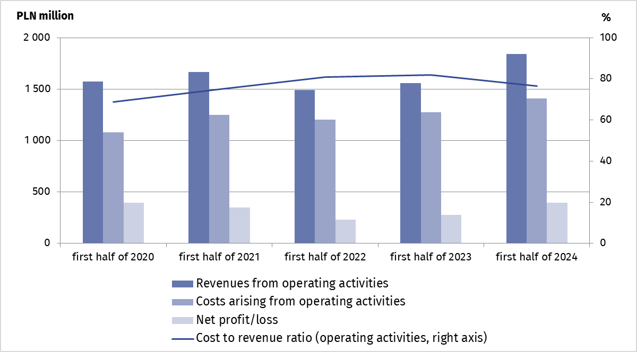
The gross financial result of TFI in the first half of 2024 amounted to PLN 491.0 million and was higher by 44.5% compared to the first half of the previous year. The net financial result of PLN 395.6 million was made up of the profits of 42 investment fund companies with a total value of PLN 410.5 million and of the loss of 14 investment fund companies in the amount of PLN 14.9 million.

Table 2. Selected items of the profit and loss account of investment fund companies
TFI's net profit in the first half of 2024 amounted to PLN 0.4 billion and was 43.8% higher than the result at the end of the same period in 2023
Specification | First half of 2023 | First half of 2024
Specification | in milion PLN |  | First half of 2023=100
Revenues from operating activities, of which: | 1,558.4 | 1,841.6 | 118.2
remunerations for managing the funds | 1,487.3 | 1,823.1 | 122.6
Costs arising from operating activities, of which: | 1,277.3 | 1,409.4 | 110.3
external services | 634.8 | 742.8 | 117.0
Gross profit | 339.8 | 491.0 | 144.5
Net profit | 275.1 | 395.6 | 143.8

When quoting Statistics Poland data, please provide the information: “Source of data: Statistics Poland”, and when publishing calculations made on data published by Statistics Poland, please include the following disclaimer: “Own study based on figures from Statistics Poland”.

Prepared by:  Macroeconomic Studies and  Finance Department  Director Mirosław Błażej  Phone: (+48 22) 608 37 73 | Issued by:  Press Office  Mobile: (+48) 695 255 032  Phone: (+48 22) 608 38 04, (+48 22) 449 41 45,  (+48 22) 608 30 09  e-mail: obslugaprasowa@stat.gov.pl

stat.gov.pl/en/

@StatPoland

@GlownyUrzadStatystyczny

gus_stat

glownyurzadstatystycznygus

glownyurzadstatystyczny
Related information
Financial results of financial funds

Data available in databases
Macroeconomic Data Bank

Terms used in official statistics
Investment fund
Investment fund company

According to the data provided by the Polish Financial Supervision Authority on 27.08.2024. The total number of investment funds at the end of June 2024 (including funds in liquidation) was 625, compared to 660 funds at the end of June 2023. The decrease in the number of funds resulted mainly from the liquidation of closed-end investment funds.

