Financial results of investment fund companies
in 2023
The value of total assets acumulated by investment fund companies at the end of 2023 amounted to PLN 3.2 billion and was by 18.7% higher than at the end of the previous year.
⇧ 18.7%
Increase in the value of assets of investment fund companies

As of the end of 2023, 56 investment fund companies were in operation, compared to 55 companies year earlier

At the end of December 2023, 56 investment fund companies (TFI) were in operation, compared to 55 investment fund companies operating at the end of 2022. They managed a total of 497 investment funds (excluding funds in liquidation). In 2023, one new company received permission from the Financial Supervision Commission to perform activities, and there were no companies that would discontinue their operations. In comparison, at the end of December 2022, there were 55 fund companies that managed a total of 533 investment funds.
The investment fund companies most frequently indicated that the subject of their activity was the management of a collective securities portfolio – 39 responses. The least frequently mentioned subject of activity was acting as a representative of foreign funds – 7 responses. The remaining indications included the management of alternative investment funds, management of portfolios that included one or more financial instruments, investment consultancy and accepting and transmitting orders to purchase or sell financial instruments.
Balance sheets of investment fund companies
Assets of investment fund companies amounted to PLN 3,193.3 million (18.7% more than at the end of December 2022), including current assets which reached PLN 2,350.3 million (increased by 19.9%) and accounted for 73.6% of total assets. Current assets mainly consisted of short-term financial investments, which increased to PLN 1,575.1 million (by 1.7%) and short-term credits in amount PLN 735.9 million (increased by 90.0%).
Cash and other cash assets had the largest share in the structure of financial assets (75.3%). Five investment fund companies with the highest assets owned 39.7% of the total value of assets.
In the liabilities of investment fund companies, equity (funds) amounted to PLN 2,357.9 million (increase of 15.1% compared to 2022) and represented 73.8% of the total liabilities. The value of share capital was PLN 676.0 million (increase by 0.1% compared to 2022).
The value of foreign capital in the basic capital of TFI decreased to PLN 167.2 million (the share of foreign investors decreased by 0.2 percentage points to 24.7%). In 9 investment fund companies, the share of foreign capital exceeded 50%.

Table 1. Selected items of the balance sheets of investment fund companies
Specification | 2022 | 2023
Specification | in milion PLN |  | 2022=100
Total assets, of which: | 2,689.4 | 3,193.3 | 118.7
Fixed assets, of which: | 715.8 | 841.0 | 117.5
long-term investments | 495.2 | 584.4 | 118.0
Current assets, of which: | 1,960.7 | 2,350.3 | 119.9
short-term investments | 1,549.2 | 1,575.1 | 101.7
Total equity and liabilities, of which: | 2,689.4 | 3,193.3 | 118.7
Equity capital, of which: | 2,047.8 | 2,357.9 | 115.1
share capital | 675.1 | 676.0 | 100.1
supplementary capital | 919.9 | 971.6 | 105.6
Liabilities and provisions for liabilities | 641.6 | 835.4 | 130.2
Profit and loss account of investment fund companies
TFI's net operating income in 2023 amounted to PLN 0.9 billion
In 2023, revenues from TFI's operating activities amounted to PLN 3,514.7 million and were by 20.9% higher than the value recorded in the previous year. The increase was mainly influenced by the change in revenue from the management of investment funds, which amounted to PLN 3,464.5 million and was higher by 20.7%. The operating costs of TFI at the end of 2023 amounted to PLN 2,630.2 million and were higher by 12.0% compared to the previous year. In the cost structure, the main items were external services (56.0% of the value of operating costs), which increased by 6.1% and remuneration with other related expenses (19.5%), which increased by 16.2% in 2023. The operating result of TFI in 2023 amounted to PLN 866.8 million and was 51.0% higher than in the previous year.
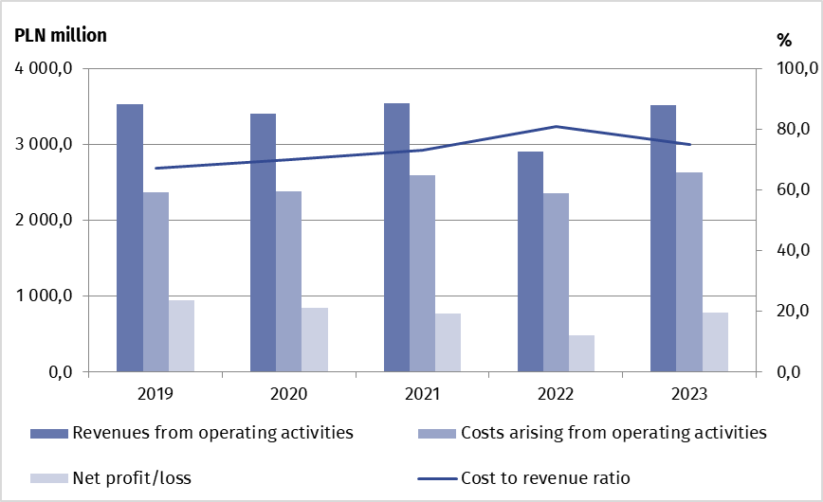
Chart 1. Selected financial data of investment fund companies
The gross financial result of TFI in 2023 amounted to 977.62 million PLN and was higher by 61.6% compared to the previous year. The net financial result of PLN 787.0 million was made up of the profits of 41 investment fund companies with a total value of PLN 817.5 million and of the loss of 15 investment fund companies (PLN 30.5 million).

Table 2. Selected items of the profit and loss account of investment fund companies
TFI's net profit in 2023 amounted to PLN 0.8 billion and was the highest since 2020
Specification | 2022 | 2023
Specification | in milion PLN |  | 2022=100
Revenues from operating activities, of which: | 2,907.0 | 3,514.7 | 120.9
remunerations for managing the funds | 2,871.2 | 3,464.5 | 120.7
Costs arising from operating activities, of which: | 2,349.3 | 2,630.2 | 112.0
external services | 1,377.5 | 1,461.4 | 106.1
Gross profit | 604.6 | 977.2 | 161.6
Net profit | 478.9 | 787.0 | 164.3

When quoting Statistics Poland data, please provide the information: “Source of data: Statistics Poland”, and when publishing calculations made on data published by Statistics Poland, please include the following disclaimer: “Own study based on figures from Statistics Poland”.

Prepared by:  Macroeconomic Studies and  Finance Department  Director Mirosław Błażej  Phone: (+48 22) 608 37 73 | Issued by:  Press Office  Mobile: (+48) 695 255 032  Phone: (+48 22) 608 38 04, (+48 22) 449 41 45,  (+48 22) 608 30 09  e-mail: obslugaprasowa@stat.gov.pl

stat.gov.pl/en/

@StatPoland

@GlownyUrzadStatystyczny

gus_stat

glownyurzadstatystycznygus

glownyurzadstatystyczny
Related information
Financial results of financial funds

Data available in databases
Macroeconomic Data Bank

Terms used in official statistics
Investment fund
Investment fund company

According to the data provided by the Polish Financial Supervision Authority on 27.03.2024. The total number of investment funds at the end of 2023 (including funds in liquidation) was 651, compared to 672 funds at the end of 2022. The decrease in the number of funds resulted mainly from the liquidation of closed-end investment funds.

