Financial results of insurance companies in 2023
109.1
Gross written premiums growth rate in 2023
Total gross written premium amounted to PLN 78.9 billion
The overall net financial result of insurance companies in 2023 was more favorable than a year ago and amounted to PLN 9.5 billion. This was due to a better result obtained by both life insurance companies (Branch I) and non-life insurance companies (Branch II).

Incomes and costs
Total gross claims paid amounted to PLN 44.2 billion
Earned premium was the dominant item in the total income structure. In 2023, the total gross written premium amounted to PLN 78 889.0 million (an increase of 9.1% compared to 2022), of which PLN 22 847.8 million was the premium of life insurance companies, and
PLN 56 041.2 million of non-life insurance. Claims incurred constituted the dominant position in the total cost structure. Total gross claims paid in 2023 amounted to PLN 44 239.4 million and decreased by 0.3% compared to 2022; in Branch I they decreased to PLN 16 229.3 million (by 14.0% y/y), and in Branch II their value increased to PLN 28 010.1 million (by 9.8% y/y).

Chart 1. Life insurers financial results (Branch I)

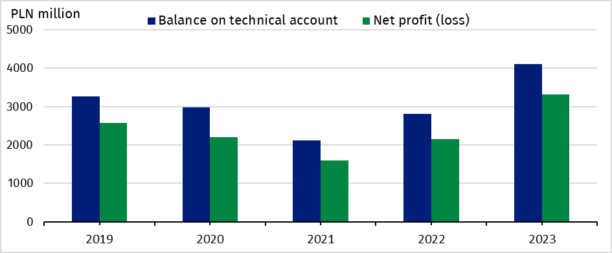

Chart 2. Non-life insurers financial results (Branch II)

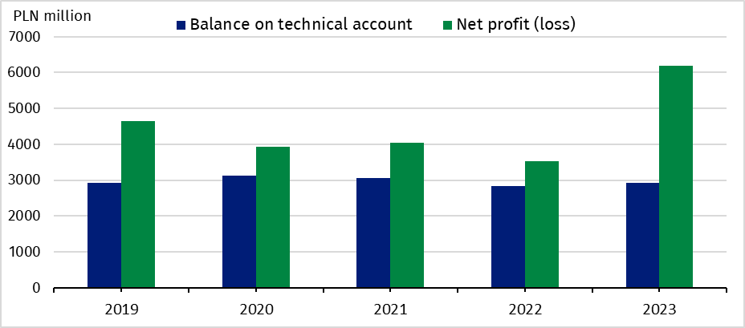

Fianncial results and balance on technical account
Net financial result
amounted to PLN 3.3 billion in the life sector,
and PLN 6.2 billion
in non-life sector
The total net financial result of insurance companies amounted to PLN 9 499.2 million and was higher by 66.9% compared to 2022. Life insurance companies generated a result of PLN 3 318.6 million (an increase of 53.9% y/y), and non-life insurance companies profit amounted to PLN 6 180.7 million (an increase of 74.9% y/y).
The technical result (in aggregate) amounted to PLN 7 033.4 million and was 24.8% higher than in 2022. The technical result in life insurance (branch I) increased to PLN 4 109.0 million (by 46.3%), which was mostly due to the technical results generated in the insurance class 5: “Accident and sickness insurance if they are supplementary to insurance from classes 1-4” (PLN 2,010.6 million) and in the class 1: “Life insurance” (PLN 1 426.0 million). The technical result in non-life insurance (branch II) increased to PLN 2 924.4 million (by 3.5%), which was mostly due to technical results generated in the insurance class 3: “Casco insurance of land vehicles, except for rail vehicles” (PLN 941.2 million) and in the class 9: “Insurance of other damage to property (where not included in classes 3, 4, 5, 6 or 7) caused by hail or frost and other causes (such as theft) where those causes are not included in class 8” (PLN 629.7 million).

Table 1. Income, costs and balance on technical life and non-life insurance account
Specification | Life (Branch I) |  |  | Non-life (Branch II)
Specification | 2022 | 2023 | 2022=100 | 2022 | 2023 | 2022=100
Specification | million PLN |  | 2022=100 | million PLN
Total income | 25 048.5 | 32 059.6 | 128.0 | 44 226.9 | 51 154.6 | 115.7

of which:
Earned premiums | 21 162.7 | 22 274.4 | 105.3 | 38 754.7 | 42 683.4 | 110.1
Investment incomeª | 3 742.1 | 9 622.1 | 257.1 | 4 418.4 | 7 191.9 | 162.8
Total costs | 22 892.6 | 28 741.0 | 125.5 | 40 692.0 | 44 973.9 | 110.5
of which:
Claims incurred  including change in provisions - net of reinsurance | 18 769.3 | 16 068.4 | 85.6 | 23 695.0 | 26 188.2 | 110.5
Change in other technical provisions - net of reinsurance | - 8 633.2 | 4 273.1 | x | 10.4 | 8.0 | 76.9
Net operating  expenses | 5 787.3 | 6 086.3 | 105.2 | 12 027.5 | 13 518.1 | 112.4
Investment charges | 5 959.4 | 867.2 | 14.6 | 1 641.7 | 1 454.0 | 88.6
Net financial account | 2 155.9 | 3 318.6 | 153.9 | 3 535.0 | 6 180.7 | 174.9
***
Balance on technical account | 2 808.3 | 4 109.0 | 146.3 | 2 826.0 | 2 924.4 | 103.5

a Including unrealised gains on investments

Gross written premiums and gross claims paid in direct activities
Gross written premiums
collected from
motor insurance amounted to PLN 28.3 billion

In the structure of gross premiums written from total direct activities, the premiums of life insurers accounted for 29.0% and premiums of non-life insurers for 71.0% of the total value. As in the previous year, the dominant position in Branch I, in terms of gross premiums collected, was achieved by class 1: “Life insurance”. This was followed by the insurance class 5: “Accident and sickness insurance where it is complementary to the insurance listed in classes 1 to 4”. The share of these two classes of life insurance amounted to 45.6% and 36.3% of the value of gross premiums written, respectively.
In Branch II, the largest item (50.4%) was the gross insurance premium collected from motor insurances. These premiums increased by 8.5% compared to 2022 and amounted to PLN 28 265.3 million. Class 3 “Casco insurance for land vehicles, except rail vehicles” accounted for 22.4% of Branch II gross premiums and class 10 “Liability insurance of all kinds arising out of the ownership and use of self-propelled land vehicles, including carrier's liability insurance” for 28.0%.

Table 2. Gross written premiums and gross claims paid by selected types of insurance from direct activities
Specification | Gross written premiums |  |  | Gross claims paid
Specification | 2022 | 2023 | 2022= =100 | 2022 | 2023 | 2022= =100
Specification | million PLN |  | 2022= =100 | million PLN |  | 2022= =100
LIFE
Total | 21 541.1 | 22 847.8 | 106.1 | 18 873.9 | 16 229.3 | 86.0

of which:
Life insurance (Class 1) | 9 726.2 | 10 407.4 | 107.0 | 6 759.0 | 6 314.8 | 93.4
Life insurance linked to investment fund (Class 3) | 4 049.7 | 3 907.7 | 96.5 | 8 916.7 | 6 279.6 | 70.4
Accident and sickness insurance (Class 5) | 7 520.8 | 8 291.0 | 110.2 | 2 967.6 | 3 413.2 | 115.0
NON-LIFE
Total | 50 771.0 | 56 041.2 | 110.4 | 25 515.7 | 28 010.1 | 109.8
of which:
Accident and sickness insurance (Class 1 and 2) | 2 799.1 | 3 107.4 | 111.0 | 737.5 | 928.5 | 125.9
Casco insurance of land vehicles (Class 3) | 11 005.1 | 12 567.8 | 114.2 | 6 412.4 | 7 251.3 | 113.1
Insurance against fire and natural forces (Class 8) | 5 103.3 | 5 812.5 | 113.9 | 2 364.1 | 2 258.8 | 95.5
Insurance against other damage and loss of property (Class 9) | 5 374.0 | 5 736.8 | 106.8 | 1 827.1 | 1 917.8 | 105.0
Motor vehicle liability  arising out of the possession  of land vehicles (Class 10) | 15 046.3 | 15 697.5 | 104.3 | 9 851.5 | 10 661.4 | 108.2
of which compulsory third-party liability insurance of owners of motor vehicle | 14 549.6 | 15 156.8 | 104.2 | 9 608.2 | 10 399.3 | 108.2
General third-party liability  insurance (Class 13) | 3 114.0 | 3 588.9 | 115.3 | 1 265.0 | 1 335.9 | 105.6

Assets and liabilities
The total assets of insurance companies increased by 11.0% year-on-year
The total assets of insurance companies for the year ended 31 December 2023 amounted to PLN 218 093.0 million (an increase of 11,0% y/y), of which PLN 89 368.4 million was
allocated to life insurance companies, and PLN 128 724.6 million to non-life insurance
companies.

Table 3. Assets and liabilities of insurance companies (as of 31st December)
Specification | Life |  |  | Non-life
Specification | 2022 | 2023 | 2022=100 | 2022 | 2023 | 2022=100
Specification | million PLN |  | 2022=100 | million PLN |  | 2022=100
Total assets | 82 744.6 | 89 368.4 | 108.0 | 113 746.7 | 128 724.6 | 113.2

of which:
Investments | 39 807.3 | 43 839.2 | 110.1 | 88 707.6 | 102 577.6 | 115.6

of which:
Shares, participating interests and other variable-yield securities, units and investment certificates in investment funds | 5 101.1 | 5 730.2 | 112.3 | 12 189.5 | 12 170.4 | 99.8
Debt securities and other fixed-income securities | 27 606.5 | 31 947.6 | 115.7 | 55 770.3 | 64 409.6 | 115.5
Net assets for  life assuranceª | 37 397.3 | 40 330.9 | 107.8 | x | x | x
Total liabilities | 82 744.6 | 89 368.4 | 108.0 | 113 746.7 | 128 724.6 | 113.2

of which:
Capital and reserves | 10 141.0 | 11 949.5 | 117.8 | 28 277.5 | 37 021.2 | 130.9
Technical provisions | 69 129.8 | 73 482.8 | 106.3 | 86 211.9 | 93 698.3 | 108.7
a Where the investment risk is borne by the policyholders.

This information has been compiled on the basis of preliminary data for 2023 provided to the GUS by the UKNF as they stood on 12.03.2024. Comparative values for 2022 have been provided on the basis of data provided by insurance companies to the UKNF after their prior verification by auditors, as they stood 28.08.2023.
In case of quoting Statistics Poland data, please provide information: “Source of data: Statistics Poland”, and in case of publishing calculations made on data published by Statistics Poland, please include the following disclaimer: “Own study based on figures from Statistics Poland”.

Prepared by:  Macroeconomics Studies  and Finance Department  Director Miroslaw Blazej  Phone: (+48 22) 608 37 73 | Issued by:  The Spokesperson for the President  of Statistics Poland  Karolina Banaszek  Phone: (+48) 695 255 011
Press Office  Phone: (+48 22) 608 38 04  e-mail: obslugaprasowa@stat.gov.pl |   stat.gov.pl/en/

@StatPoland

@GlownyUrzadStatystyczny

gus_stat

glownyurzadstatystycznygus

glownyurzadstatystyczny
Related information
Polish insurance market 2018

Data available in databases
Financial Results of Insurance Companies
Quarterly bulletin. Insurance market

Terms used inn official statistics
Insurance undertaking
Gross written premium

