Factoring activity of financial enterprises in 2023
In 2023, the study covered 46 entities conducting factoring activity. During the year, these companies purchased 27.1 million invoices worth PLN 500.0 billion. Factoring services of the surveyed entities were used by 24.8 thousand clients in 2023.
6.8%
Increase in the value of purchased receivables

Basic data on factoring companies
In 2023, factoring companies purchased 27.1 million invoices, 13.5% more than in the previous year
In the group of 46 surveyed entities conducting factoring activity in 2023, there were 39 non-banking enterprises conducting this type of activity and 7 commercial banks that dealt with factoring alongside statutory banking activity.
Table 1. Activities of the surveyed entities
SPECIFICATION | Total | Non-banking factoring enterprises | Factoring activity in banks
SPECIFICATION | Number of entities
Total entities surveyed | 46 | 39 | 7
Factoring – only activity | 29 | 29 | -
Factoring – dominant activity | 3 | 3 | -
Factoring – secondary activity | 14 | 7 | 7
Among the non-banking factoring enterprises, 21 belonged to capital groups, of which 19 were subsidiaries and two were dominating and subsidiaryentities simultaneously.
In non-banking factoring enterprises, domestic capital dominated in 26 enterprises, in 13 foreign capital. In the group of non-banking factoring enterprises, joint-stock companies (21 units) and limited liability companies (17 units) dominated. One enterprise had a different organizational form.
Non-banking factoring companies employed 1,582 persons on the basis of an employment contract, 105 based on a mandate contract, agency contract or specific work contract, and 155 self-employed persons. The distribution network of the surveyed non-banking factoring companies consisted of 150 branches, representative offices and affiliates.

Characteristics of factoring services
22.5 thousand customers used factoring services in non-banking factoring enterprises in 2023, while 2.4 thousand customers used factoring services in banks
In 2023, factoring services were used by 24,822 clients, 1.4% less than in the previous year.
The number of purchased invoices by the surveyed factoring companies increased by 13.5%, from 23,868 thousand in 2022 to 27,082 thousand in 2023.
Table 2. Basic information on the activities of factoring companies
SPECIFICATION | Total |  | Non-banking factoring enterprises |  | Factoring activity in banks
SPECIFICATION | 2022 | 2023 | 2022 | 2023 | 2022 | 2023
Number of customers (factorers) | 25 166 | 24 822 | 22 656 | 22 454 | 2 510 | 2 368
Number of purchased invoices  in thousand | 23 868 | 27 082 | 21 005 | 24 113 | 2 863 | 2 969
Value of purchased receivables  in PLN million | 468 236 | 499 995 | 390 068 | 412 515 | 78 168 | 87 481
The value of receivables purchased by the surveyed factoring companies (in total) increased by 6.8%, from PLN 468,236 million in 2022 to PLN 499,995 million in 2023. In domestic factoring, the value of purchased receivables increased by 8.2%, while in foreign factoring it decreased by 3.7%. Domestic factoring accounted for 89.5% of the total value of purchased receivables, and foreign factoring for 10.5%. In domestic factoring, the most frequently used factoring was non recourse factoring (53.1%), recourse factoring (22.0%) and reverse factoring (22.6%).
Chart 1. Value of purchased receivables in domestic factoring
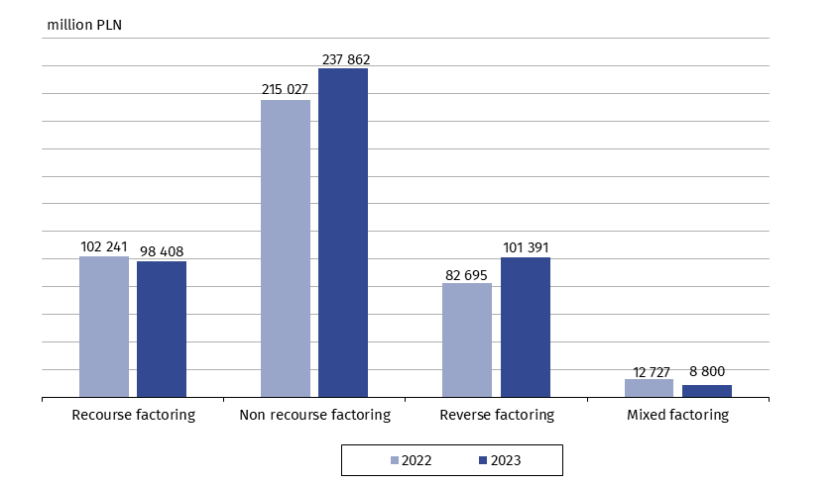
In the group of non-banking factoring companies, the value of purchased receivables increased by 5.8% and amounted to PLN 412,515 million. Domestic factoring accounted for 89.0% of the total value of purchased receivables, and factoring in foreign trade for 11.0%.
In commercial banks that conducted factoring activity, the value of purchased receivables increased by 11.9% to PLN 87,481 million. Domestic factoring accounted for 92.2% of purchased receivables and factoring in foreign trade accounted for 7.8%.
The value of funds engaged by enterprises dealing with factoring activity (in total) at the end of 2023 increased by 23.3% to the amount of PLN 63,529 million. The total financial resources were involved in 94.8% in domestic factoring and in 5.2% in foreign factoring.
Non-banking factoring companies committed funds worth PLN 46,052 million, of which 95.8% in domestic factoring and 4.2% in foreign factoring.
Funds committed by banks to conduct factoring activity amounted to PLN 17,477 million, of which 92.0% was allocated to domestic factoring and 8.0% to foreign factoring.
The factoring activity of the surveyed entities in total was financed in 62.2% from bank credits and loans, and in 23.4% from own funds.
In non-banking enterprises, factoring activity was financed in 82.1% from bank credits and loans, and in 13.3% by corporate bonds. Factoring activity in banks was financed in 84.2% from own funds.
Financial situation of surveyed factoring companies
From among the surveyed group of non-banking enterprises for which factoring activity was the only or dominant type of activity, 31 companies kept full accounting, and one kept the book of revenues and expenses.
The value of assets of 31 companies conducting full accounting in 2023 increased from PLN 39,878 million to PLN 43,870 million. The dominant item of assets were current assets - PLN 43,040 million. The share of short-term receivables in current assets amounted to 70.3% and reached PLN 30,248 million. The second largest item of current assets were short-term investments - PLN 12,746 million (29.6%), which mainly consisted of short-term financial assets (74.0%).
The value of assets of enterprises, in which factoring was the only or dominant type of activity, increased by 9.8% during the year
The liabilities of the 31 enterprises described above were dominated by liabilities and provisions for liabilities, the value of which amounted to PLN 42,260 million (96.5% of the total value of liabilities).
Revenues from the total activity of these 31 companies amounted to PLN 4,055 million and increased by 48.8%, of which sales revenues accounted for 83.2%. Total operating costs increased by 41.6% and amounted to PLN 3,327 million.
The net financial result of 31 non-banking enterprises with full accounting, for which factoring was the only or dominant type of activity, amounted to PLN 641 million. From among this group of enterprises, 23 companies generated a positive net financial result of PLN 668,9 million, the remaining 8 suffered losses of minus PLN 27,7 million.

In case of quoting Statistics Poland data, please provide information: “Source of data: Statistics Poland”, and in case of publishing calculations made on data published by Statistics Poland, please include the following disclaimer: “Own study based on figures from Statistics Poland”

Prepared by:  Macroeconomic Studies and Finance Statistics Department  Director Mirosław Błażej  Phone: (+48 22) 608 37 73 | Issued by:  Press Office  Mobile +48 695 255 032  Phone +48 22 608 38 04, +48 22 449 41 45,  +48 22 608 30 09  e-mail: obslugaprasowa@stat.gov.pl
Press Office  Phone: (+48 22) 608 38 04  e-mail: obslugaprasowa@stat.gov.pl |   www.stat.gov.pl/en/

@StatPoland

@GlownyUrzadStatystyczny

gus_stat

glownyurzadstatystycznygus

glownyurzadstatystyczny

Related information
Specialized segments of financial market 2022
Macroeconomic situation in Poland in the context of the world economic processes in 2022

Terms used in official statistics
Factoring
Recourse factoring
Non recourse (traditional) factoring

It is possible to link the financial situation with the company's operations only for entities for which factoring activity is the only or dominant, and for entities that at the same time, keep full accounting. The requirement for the surveyed enterprises to maintain full accounting results from the necessity to use uniform and comparable accounting categories for the purposes of the conducted analyzes.

