Economic aspects of environmental protection 2023

The amount of outlays on fixed assets for environmental protection in 2023 amounted to approx. PLN 18.2 billion (compared to PLN 13.9 billion in 2022), and outlays on fixed assets for water management reached the level of approx. PLN 4.3 billion (PLN 4.0 billion in 2022). In 2023, outlays on environmental protection and water management accounted for 0.53% and 0.13% of GDP, respectively (0.45% and 0.13% in 2022, respectively).
25,8%
Outlays on fixed assets for environmental protection and water management in relation to 2022.

Outlays on fixed assets for environmental protection and water management, similarly to the previous year trend were rising. The biggest year to year growth in investments in 2023 was seen in relation to wastewater management and water protection (by 1.9 billion PLN), air and climate protection (by 0.9 billion PLN), waste management (by 0.8 billion PLN)
and on investments related to central heating, hot water supply and thermal insulation of buildings (by 0.8 billion PLN).
As in previous years, enterprises are the main investor in outlays on fixed assets for environmental protection, followed by gminas, and then budgetary units. The group of investors with the highest share of outlays in the field of water management were gminas, then enterprises and budgetary units.
In 2023, outlays on fixed assets for environmental protection amounted to approx. PLN 18.2 billion, and on water management to approx. PLN 4.3 billion
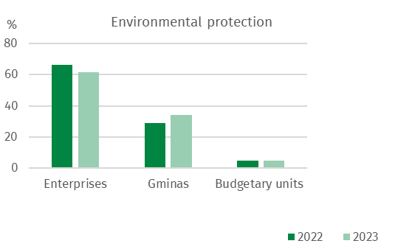
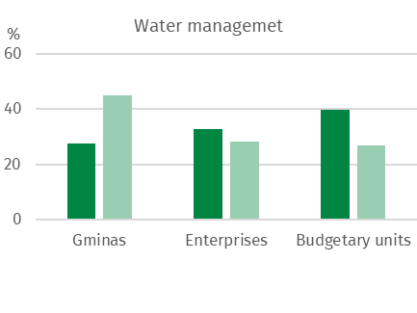
Chart 1. Structure of outlays on fixed assets for environmental protection and water management by groups of investors

The highest outlays on fixed assets for environmental protection were incurred in the following voivodships: Mazowieckie (18.4% of total outlays on fixed assets for environmental protection), Wielkopolskie (11.8%) and Śląskie (11.3%) while the lowest in Podlaskie (2.3%) as well as Zachodniopomorskie and Lubuskie (2.5%).
In water management, the highest outlays were incurred in the following voivodships: Mazowieckie (16.4% of total expenditure), Opolskie (11.5%), as well as Wielkopolskie (9.0%), while the lowest in Świętokrzyskie (2.2%), Podlaskie (2.5%) and Zachodniopomorskie (2.9%).

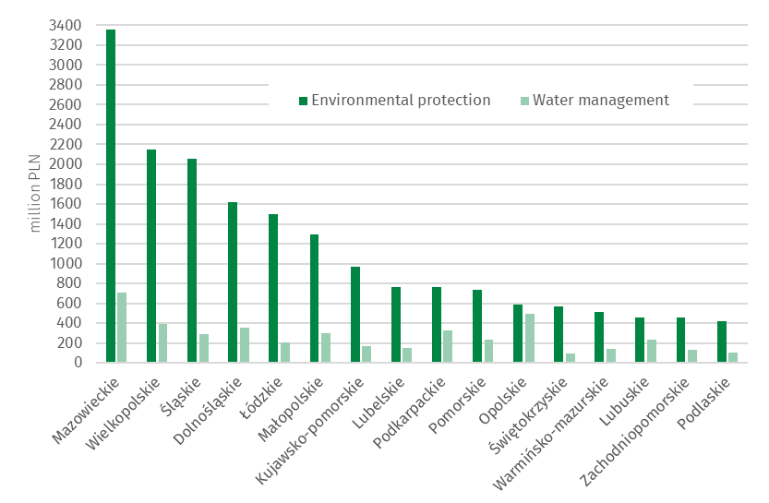
Chart 2. Outlays on fixed assets for environmental protection and water management by voivodship in 2023

Outlays on fixed assets for environmental protection

Outlays on fixed assets for environmental protection are classified according to 9 areas of environmental protection: 1. air and climate protection; 2. wastewater management and protection of water; 3. waste management; 4. protection and restoration of the utility value of soils and protection of groundwater and surface waters; 5. noise and vibration reduction; 6. protection of biodiversity and landscape; 7. protection against ionising radiation; 8. research and development activities and 9. other environmental protection activities.
The structure of outlays on fixed assets for environmental protection in Poland in 2023 was dominated by outlays on wastewater management and protection of water, as well as on air and climate protection, with a share of 46.1% and 29.6%, respectively. The remaining 24.3% of outlays are outlays on waste management (10.6%), protection of biodiversity and landscape (1.0%), noise and vibration reduction (0.9%), protection of soil and ground and surface waters (0.7%) and other environmental protection activities (11.2%), respectively.
In 2023, outlays on fixed assets for wastewater management and protection of water amounted to PLN 8.4 billion
In 2023, outlays on fixed assets for wastewater management and protection of water amounted to PLN 8.4 billion. The highest outlays for this purpose were incurred in the following voivodships: Mazowieckie (18.2%), Śląskie (11.6%) and Wielkopolskie (9.7%), the lowest in Opolskie (2.2%), Warmińsko-Mazurskie (2.4%) and Lubuskie (2.7%).
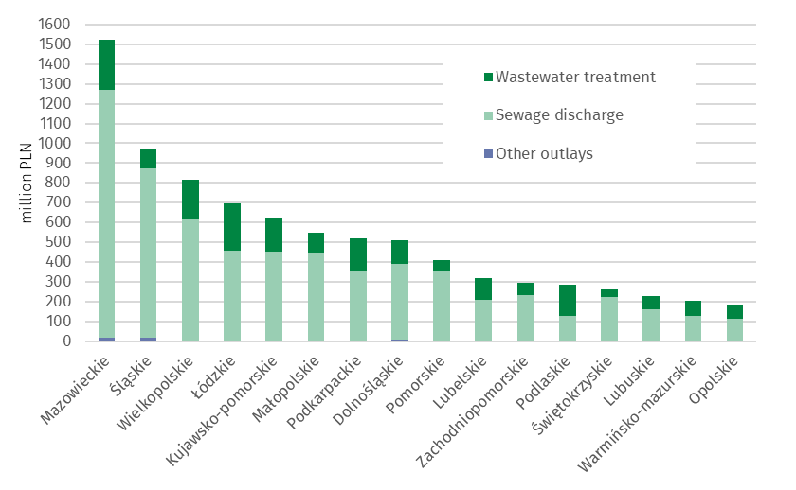
Chart 3. Outlays on fixed assets for wastewater management and protection of water by amount and voivodship in 2023
In 2023, outlays on fixed assets for air and climate protection amounted to PLN 5.4 billion
Outlays on fixed assets for the protection of air and climate amounted to PLN 5.4 billion. The highest outlays were incurred in the following voivodships: Wielkopolskie (14.1%), Dolnośląskie (13.9%) and Mazowieckie (13.8%), the lowest in Zachodniopomorskie (0.6%), Podlaskie (1.0%) and Lubuskie (1.9%).
The largest part of outlays on air and climate protection were outlays on pollution prevention equipment (78.6% of the total expenditure), including modern fuel combustion technologies along with the modernisation of boiler and thermal energy plants (38.3%), unconventional energy sources (27.8%) and pollution reduction equipment (20.5%)
The highest outlays on unconventional energy sources were in Łódzkie (PLN 272 million) and Wielkopolskie (PLN 207 million), the lowest in Lubuskie and Świętokrzyskie (PLN 18 million each).

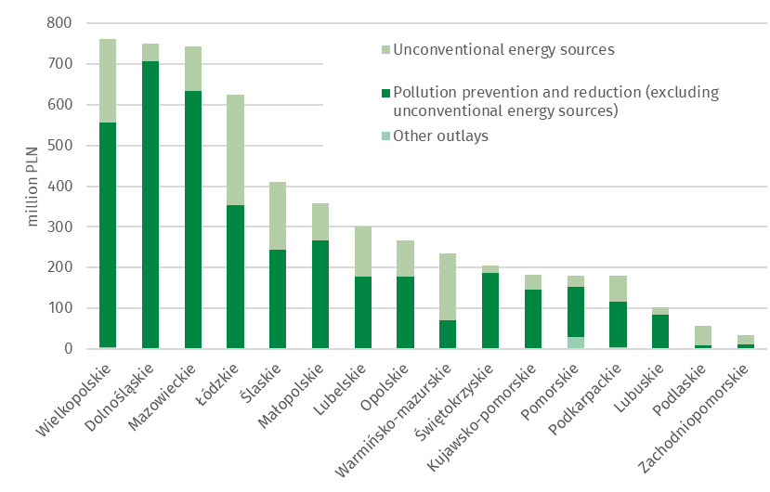
Chart 4. Outlays on fixed assets for air and climate protection by voivodship in 2023

Outlays on waste management amounted to PLN 1.9 billion, on biodiversity and landscape protection PLN 0.2 billion, on noise and vibration reduction PLN 0.2 billion, on soil, ground and surface water protection PLN 0.1 billion, and on other activities PLN 2.0 billion was spent in total.
The highest outlays on waste management were in the following voivodships: Mazowieckie and Małopolskie (PLN 974 million summed) and Dolnośląskie (PLN 199 million), as well as on soil, ground and surface water protection in Mazowieckie and Lubelskie (PLN 71 million summed). The lowest outlays on waste management were in Świętokrzyskie (PLN 18 million) as well as Warmińsko-mazurskie (PLN 30 million), and on soil, ground and surface water protection in Kujawsko-pomorskie and Wielkopolskie (PLN 0,8 million summed).
In 2023 the Łódzkie and Małopolskie voivodships were characterized amongst other voivodships by the highest outlays on noise and vibration reduction (PLN 51 million
and PLN 28 million, respectively), and in Śląskie and Lubuskie on biodiversity and landscape protection (PLN 105 million summed). The lowest outlays on noise and vibration reduction were in Warmińsko-Mazurskie (PLN 0,4 million), and in the Pomorskie voivodeship there was no outlays incurred. The lowest outlays on the protection of biodiversity and landscape were in Lubelskie and Małopolskie (PLN 1,0 million summed).

Outlays on fixed assets for water management
Investments related to water management include water intakes and systems (including the main and distribution water network and construction of water quality control laboratories, including automatic water quality measurement stations), construction and modernization of water treatment plants, construction of water reservoirs (except fire and daily equalisation reservoirs), water, sailing and energy falls, as well as locks and weirs, regulation and management of rivers and mountain streams, construction of flood embankments and construction of pump stations behind embankments and in depression areas.
In 2023, the amount of outlays on water management amounted to approximately
PLN 4.3 billion. The main stream of outlays were directed to the construction of drinking water infrastructure. Investments in water intakes and systems accounted for 50.0% of all outlays in water management.

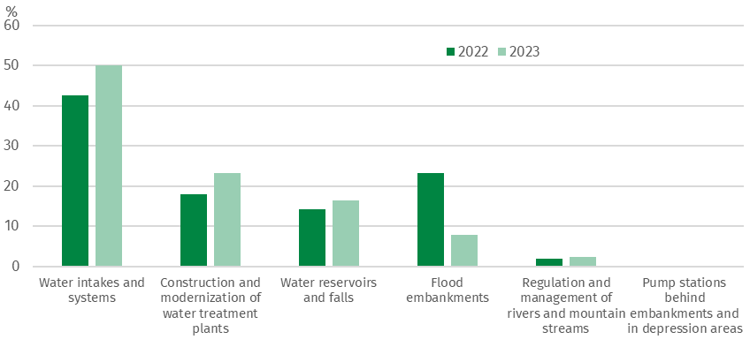
Chart 5. Structure of outlays on fixed assets for water management

The largest outlays on water intakes and systems were incurred in Mazowieckie
(PLN 404 million) and Śląskie (PLN 249 million) voivodships. On the other hand, on water reservoirs and falls as well as flood embankments in Opolskie (PLN 447 million) and Dolnośląskie (PLN 185 million) voivodships. For the construction and modernization of water treatment plants, the greatest amount of funds was allocated in the Mazowieckie voivodship (PLN 263 million).

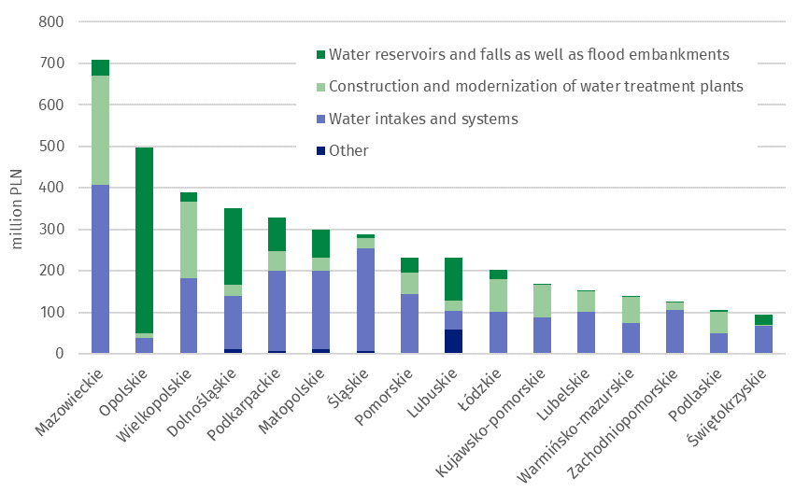
Chart 6. Outlays on fixed assets for water management by investment directions and voivodship in 2023

Tangible effects of investments in environmental protection and water management
In 2023, as a result of the implementation of environmental protection investments,
55 wastewater treatment plants with a total capacity of 47 thousand m³/day (including
48 municipal wastewater treatment plants with a total capacity of 38 thousand m³/day) were completed. 3.9 thousand km of sewage network discharging wastewater and approx. 0.7 thousand km of sewage network discharging precipitation water were completed.
In the field of air protection, devices for reducing gaseous pollutants with a capacity of approx. 234 thousand tons/year and equipment for neutralisation of particulates pollutants with a capacity of approx. 5 thousand tons/year were completed.
In 2023, waste neutralisation equipment and installations with a total capacity of approx. 451 thousand tons/year were completed.
In 2023, in terms of the tangible effects of water management investments, the capacity of newly completed water supply devices amounted to approx. 86 thousand m³/day for water treatment plants, and approx. 75 thousand m³/day for water intakes. Thirteen water reservoirs were built with a total capacity of approx. 14.9 million m³. In addition, 3 thousand km of the water supply network were built, 47.4 km of rivers and mountain streams were regulated and management, and 85.9 km of flood embankments were built or modernised.

When quoting Statistics Poland data, please provide the information: “Source of data: Statistics Poland”, and when publishing calculations made on data published by Statistics Poland, please include the following disclaimer: “Own study based on figures from Statistics Poland”.

Prepared by:  Agriculture and Environment  Department  Director Marta Wojciechowska  Phone: (+48 22) 608 31 28 | Issued by:  Press Office  Mobile: (+48) 695 255 032  Phone: (+48 22) 608 38 04, (+48 22) 449 41 45,  (+48 22) 608 30 09  e-mail: obslugaprasowa@stat.gov.pl


stat.gov.pl/en/

@StatPoland

@GlownyUrzadStatystyczny

gus_stat

glownyurzadstatystycznygus

glownyurzadstatystyczny
Related information
Infographic - Economic aspects of environmental protection
Economic aspects of environmental protection 2023
Data available in databases
Local Data Bank Environmental protection
Terms used inn official statistics
Tangible effects of environmental protection and water management investments

In accordance with the Polish Statistical Classification of Activities and Facilities Related to Environmental Protection, introduced by the Regulation of the Council of Ministers of March 2, 1999 (Journal of Laws 1999, No. 25, pos. 218).

