Value chains of domestic enterprises in 2022

At the end of 2022, most (78.7%) of the surveyed enterprises with 10 or morepersons employed performed business functions only internally and did not source them outside. The phenomenon of external sourcing concerned 21.3% of the surveyed enterprises, most of which (88.0%) contracted out functions only to other domestic enterprises. Business functions abroad were contracted out mainly to European Union countries.
21.3%
of enterprises outsourced business functions at the end of 2022

Place of performance of business functions
In 2022, functions were outsourced more often by large enterprises, i.e. with 250 or more persons employed – 29.9% of entities in this size class compared to 21.3% for the total
At the end of 2022, four-fifths (47,753) of the surveyed enterprises (legal entities) employing 10 or more persons performed business functions entirely within the enterprise, and one-fifth (12,895) sourced functions externally to be performed completely or partially to others units.

Chart 1. Structure of the surveyed enterprises by size class and place of function performance in 2022
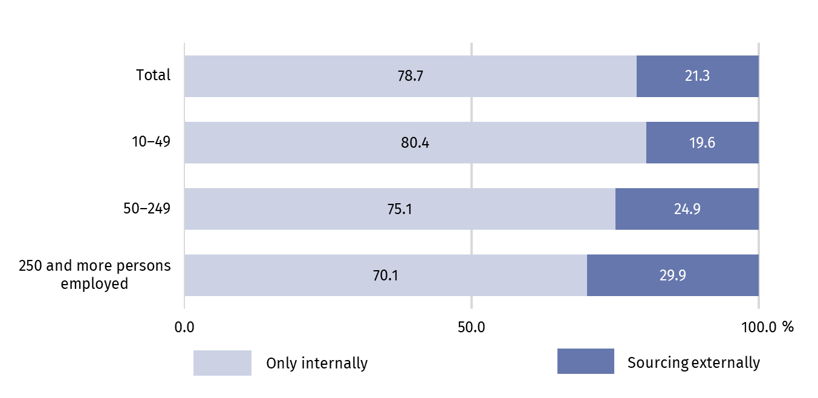 In 2022, functions were sourced externally more often by large enterprises (with 250 or more persons employed) – 29.9% of entities belonging to this size class, and less frequently by medium-sized enterprises (with 50−249 persons employed) – 24, 9% and small (with 10−49 employed persons) – 19.6%.
Depending on legal form of enterprises, legal persons and organizational units without legal personality sourced functions externally more often (22.8%) than entities belonging to natural persons (18.1%).
Enterprises owned by domestic capital sourced functions externally less frequently (20.0%) than enterprises with the share of foreign capital (28.8%).
Chart 2. Share of enterprises sourcing externally business functions by NACE sections in 2022
In 2022, the implementation of business functions was most often entrusted to external entities by enterprises from construction and information and communication sections
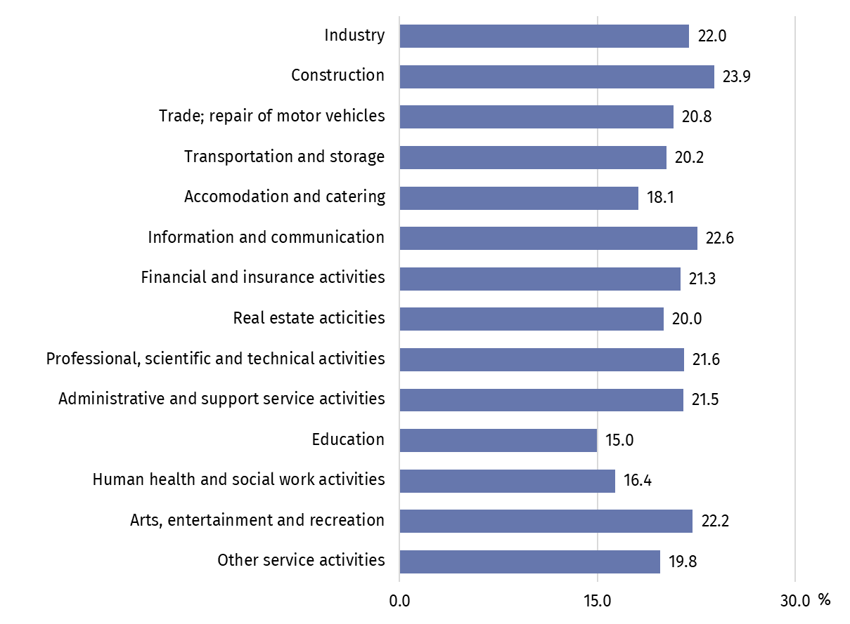
In terms of location of the surveyed enterprises, the share of enterprises sourcing functions externally differed slightly in particular voivodships. The performance of functions was sourced externally in 2022 more often by enterprises located in the following voivodships: Mazowieckie (23.7%), Lubuskie (23.5%), Dolnośląskie (23.4%). Enterprises from the Lubelskie and Podkarpackie Voivodships performed all functions entirely on their own more often than entities from other voivodships (83.0% and 82.4% respectively).

Activities performed by surveyed enterprises
At the end of 2022, the most frequently performed function within enterprises was marketing, sales and after-sales services - it was performed by 58.0% of the surveyed entities
At the end of 2022, the surveyed enterprises employing 10 or more persons most often performed functions related to marketing, sales and after-sales services (in 58.0% of the surveyed enterprises), management and administration (57.7%), production (47.1%) and other business functions (45.4%). In total, four-fifths (4,422.4 thousand people) of the total number of persons employed in the surveyed enterprises were involved in the implementation of these functions. The least frequently performed internally functions by the surveyed units were engineering and related technical services (in 10.8% of the surveyed enterprises) and research and development (4.5%). These functions also involved the smallest number of persons employed.

Table 1. Enterprises and persons employed by business function (as of 31 December 2022)
Business functions | Number of enterprisesª | Number of persons employed
Business functions | Number of enterprisesª | In absolute number | in %
Total | 60 648 | 5 441 630 | 100.0
Production | 28 545 | 1 802 219 | 33.1
Management and administration | 35 004 | 589 471 | 10.8
Engineering and related technical services | 6 537 | 143 887 | 2.6
Research and development | 2 724 | 54 051 | 1.0
Information technologies | 8 882 | 214 641 | 3.9
Marketing, sales, and after-sales service | 35 193 | 1 061 583 | 19.5
Transport, logistics and storage | 19 429 | 606 607 | 11.1
Other business functions^{b} | 27 546 | 969 171 | 17.8
a Due to the possibility of performing many functions within the enterprise, the functions do not add up to the "total" value. b Includes inter alia facility management, repair and maintenance services and other services.

Large enterprises (with 250 and more persons employed) were characterized by a slightly different structure – the most frequently performed function by them was management and administration (in 82.5% of the surveyed enterprises). In addition, enterprises of this size class almost four times more often than all surveyed enterprises indicated the independent implementation of the information technologies function (52.9% against 14.6% in total) and almost five times the research and development function (22.0% against 4.5% in total).

Chart 3. Percentage of surveyed enterprises in each size class by type of functions performed by them in 2022.
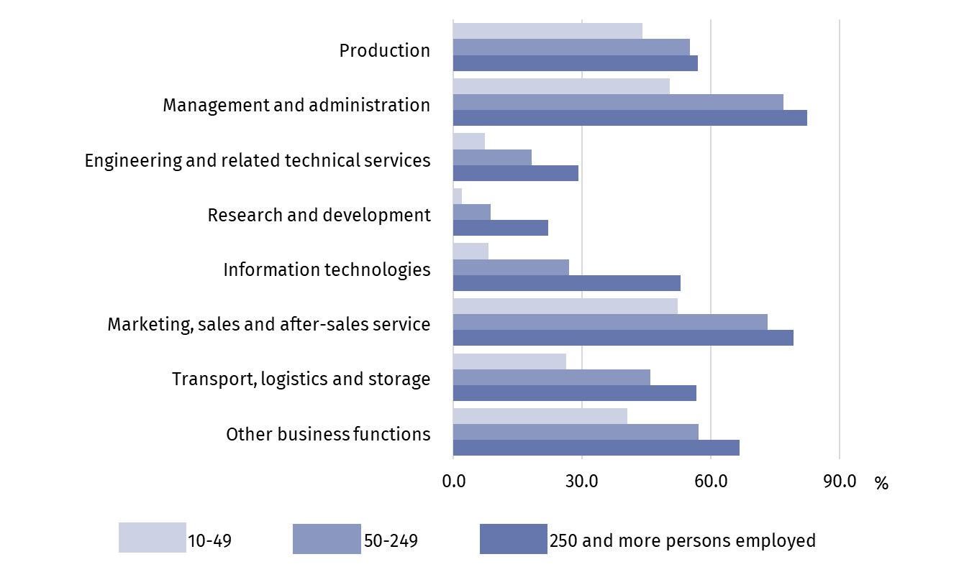
Enterprises with the share of foreign capital accounted for 14.0% of all surveyed enterprises and for 37.9% of all persons employed. Taking into account the capital ownership structure in individual business functions, enterprises with foreign capital accounted for from 13.2% in production function to 33.2% in the information technologies function. In the function related to information technologies as well as research and development, persons employed in enterprises with foreign capital dominated in the total number of persons employed there (63.2% and 57.9% respectively).

Directions of ordering selected activities
Among enterprises outsourcing business functions at the end of 2022, the majority (88.0%) performed them only in other domestic enterprises
Out of 12,895 surveyed enterprises with 10 or more persons employed, which sourced functions externally completely or partially at the end of 2022, the majority (88.0%) indicated only other domestic enterprises as the place of performing the functions, 9.1% both domestic and foreign enterprises, and 2.9% only foreign enterprises.

Chart 4. Structure of enterprises sourcing functions externally by size class and place of sourcing in 2022
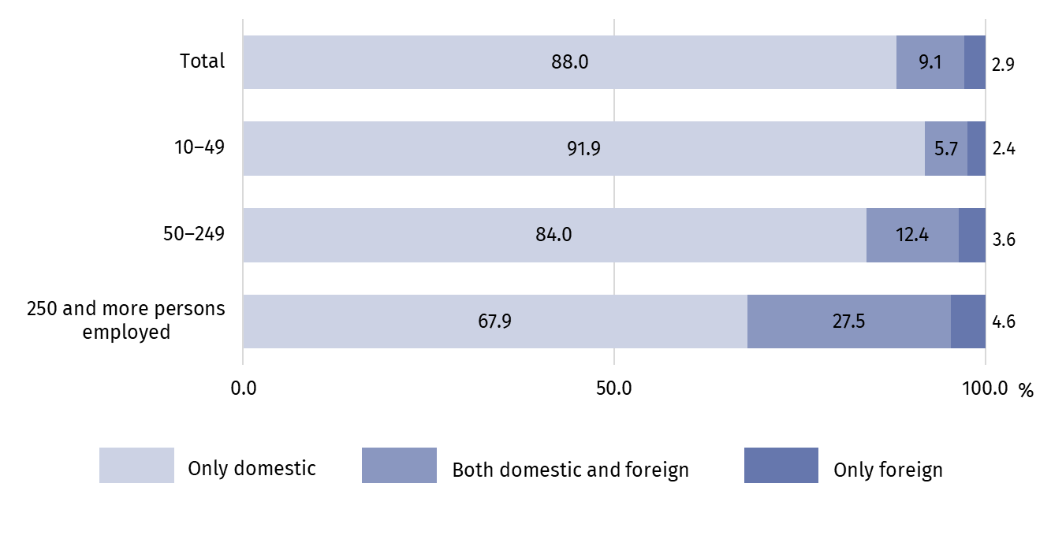
Large enterprises (with 250 and more persons employed) more often than entities from other size classes contracted functions to foreign entities, i.e. both in Poland and abroad or only abroad (a total of 32.1% of entities within this size class). A similar situation occurred in the case of legal persons, which sourced functions externally to foreign entities more than three times more often than natural persons (14.9% compared to 4.3%).
Enterprises with the share of foreign capital accounted for 64.4% of all enterprises commissioning functions abroad.
Activities abroad were more often commissioned by enterprises from the information and communication section (22.6% of entities within this section), mining and quarrying (20.4%) and transport and storage (17.6%).
The place of performance of business functions outside Poland was most often chosen by enterprises located in the Mazowieckie Voivodship (a total of 17.4% of enterprises from this voivodship), Zachodniopomorskie (14.4%) and Opolskie (13.8%), and the least frequently enterprises from the Podlaskie (6.9%) and Kujawsko-Pomorskie (7.6%) voivodships.

Chart 5. Percentage of enterprises sourcing business functions externally by type of function and place of sourcing 2022
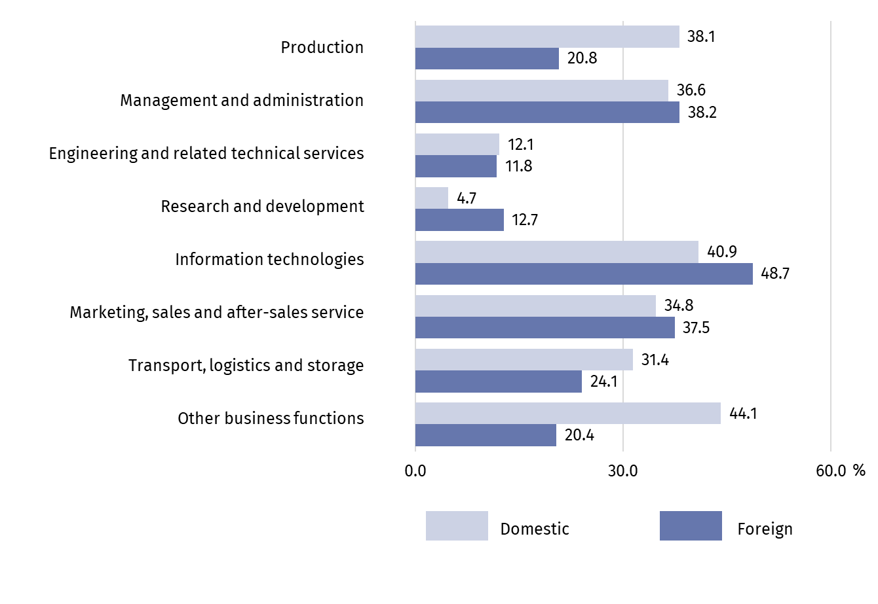
The majority (87.8%) of enterprises commissioning business functions abroad at the end of 2022 indicated enterprises from the European Union as the place of performance of the function
Taking into account the type of business function, in 2022 other domestic enterprises were most often contracted out with tasks related to other business functions and information technologies. Functions outsourced within the country were performed slightly more often by unrelated enterprises, i.e. outside the same enterprise group.
Outside Poland, tasks related to information technology were mainly performed, as well as (to a lesser extent) activities in the field of management and administration as well as marketing, sales and after-sales services. Functions sourced externally abroad were mostly performed by other related enterprises, i.e. belonging to the same enterprise group.
Among the total of 1,546 enterprises commissioning business functions abroad at the end of 2022, the largest percentage of enterprises (95.2%) indicated European enterprises as the place of performance of functions, including 87.8% enterprises from the European Union.

Chart 6. Percentage of enterprises sourcing business functions externally in the European Union countries in 2022
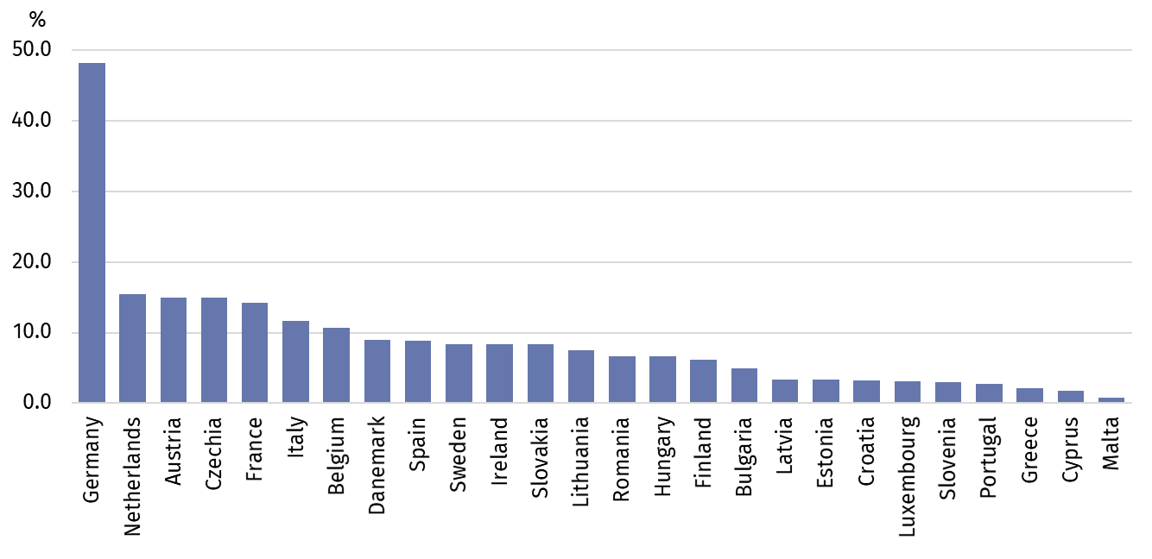

Germany (48.2%) was the most frequently chosen country of performing functions abroad. Among European countries not belonging to the European Union, the most frequently chosen country was United Kingdom (15.5%), while among countries outside Europe, most functions were performed in the United States and Canada (13.8%). In the countries of the Visegrad Group, functions were performed by 19.7% of all enterprises commissioning activities abroad (15.0% in the Czechia, 8.3% in Slovakia, 6.7% in Hungary).

Table 2. Percentage of enterprises sourcing business functions externally abroad by selected areas in 2021
Business functions | Total | Europe | United States and Canada | China | India
Business functions | in %
Production | 100.0 | 92.5 | 5.0 | 6.2 | 0.6
Management and administration | 100.0 | 93.4 | 14.7 | 0.8 | 4.2
Engineering and related technical services | 100.0 | 92.3 | 16.5 | 2.2 | 1.6
Research and development | 100.0 | 90.9 | 13.2 | 2.5 | 1.5
Information technologies | 100.0 | 93.0 | 15.3 | 0.5 | 4.2
Marketing, sales and after-sales service | 100.0 | 95.2 | 10.2 | 1.4 | 1.2
Transport, logistics and storage | 100.0 | 98.1 | 4.3 | 3.2 | 0.8
Other business functions | 100.0 | 96.2 | 9.8 | 2.5 | 2.5

The data presented in this news release concern 60,648 legal entities with 10 or more persons employed, organised in the form of civil law partnerships, partnerships, capital companies, branches of foreign entrepreneurs, state enterprises and natural persons performing economic activity, whose predominant type of activity is classified into the following sections according to the Polish Classification of Activities (PKD 2007): B, C, D, E, F, G, H, I, J (excluding cultural institutions with legal personality), K (excluding banks, cooperative savings and credit unions, insurance institutions offices and brokerage houses, investment companies and funds as well as pension companies and funds), L, M, N, P (excluding universities), Q (excluding independent public health care institutions), R (excluding other cultural institutions with legal personality), S (excluding section 94).
The study of global value chains has been conducted at the Statistics Poland since 2021. The first results of the study so far have allowed for a preliminary analysis of the value chains of domestic enterprises. The study for 2022 covered an additional group of natural persons conducting a business activity, which made it possible to enrich the analysis with an additional criterion according to the legal form of enterprises.
If the study refers to a group of natural persons, it should be understood that it is presented together with persons who operated within the framework of companies established under an agreement concluded on the basis of the Civil Code (civil partnerships). It was also assumed that the group of entities with legal personality (legal entities) is presented together with organizational units without legal personality.
An enterprise with the share of foreign capital is an enterprise, that has foreign unit among its shareholders (also minor).
The study uses a classification of business functions (link), according to which the following functions are distinguished:
- Production (covers agriculture and fishing, manufacturing and assembly, production of energy and extraction of raw materials, construction);
- Management and administration;
- Engineering and related technical services;
- Research and development;
- Information technology (covers information technology services, software programming, IT system installation, maintenance, help desk services, telecommunication);
- Marketing, sales and after-sales services;
- Transportation, logistics and storage;
- Other business functions (covers facility management, maintenance and repair services and other services).
For the purposes of this publication, additional groupings were made in relation to the applicable classification division, including the following sections within the term “Industry”: B (Mining and quarrying), C (Manufacturing), D (Electricity, gas steam and air conditioning supply), E (Water supply; sewerage, waste management and remediation activities).
In the case of quoting data from Statistics Poland, please include the information: "GUS data source", and in the case of publishing calculations made on the basis of data published by Statistics Poland, please include the information: "Own study based on the data of Statistics Poland".

Prepared by:  Enterprises Department  Director Katarzyna Walkowska  Phone: (+48 22) 608 35 66 | Issued by:  Press Office  Mobile: (+48) 695 255 032  Phone: (+48 22) 608 38 04, (+48 22) 449 41 45,  (+48 22) 608 30 09  e-mail: obslugaprasowa@stat.gov.pl

stat.gov.pl/en/

@StatPoland

@GlownyUrzadStatystyczny

gus_stat

glownyurzadstatystycznygus

glownyurzadstatystyczny
Related publications
Value chains of national enterprises in 2021
Terms used in official statistics
Business function
An enterprise group
Foreign capital

Business function is a set of tasks that an enterprise must carry out on a regular basis in order to bring goods or services to market. These tasks may be performed internally by an enterprise or sourced externally.

