Financial results of non-financial enterprises
in the 1st quarter of 2024
In the 1st quarter of 2024 financial results of the surveyed non-financial enterprises were lower comparing to those obtained a year earlier. The economic and financial indicators deteriorated. Investment outlays were lower by 2.2% than those recorded in the 1st quarter of 2023 (when there was an increase by 7.2%).
6.2%
Decrease in total revenues y/y
Total revenues were lower by 6.2% comparing to the previous year and total costs of obtaining the revenues decreased by 4.5%. The cost level indicator deteriorated from 94.5% in the previous year to 96.3%. Net revenues from sale of products, goods and materials decreased by 6.2% and the costs of obtaining them – by 4.6%.
The financial result from the sale of products, goods and materials amounted to 47.9 bn PLN and was by 33.4% lower than in the 1st quarter of 2023. The financial result from other operating activity amounted to 3.3 bn PLN and was lower by 3.1 bn PLN over the year. There was an improvement observed in the result on financial activities (minus 4.3 bn PLN compared to minus 5.3 bn PLN in the 1st quarter of 2023).
In the 1st quarter of 2024 net financial result of non-financial enterprises was by 39.9% lower than the year before
Gross financial result amounted to 46.9 bn PLN compared to 73.0 bn PLN a year ago and its obligatory encumbrances amounted to 11.5 bn PLN (compared to 14.2 bn PLN a year ago). Net financial result amounted to 35.3 bn PLN and was by 39.9% lower than the year before. Net profit amounted to 63.0 bn PLN and was lower by 19.4 bn PLN than in the 1st quarter of 2023 while net loss was 27.7 bn PLN and increased by 4.0 bn PLN over the year. Net profit was recorded by 65.2% of all enterprises (compared to 70.5% a year ago) and the revenues obtained by them constituted 74.4% of total revenues of the surveyed enterprises (compared to 77.0% the year before). In manufacturing, net profit was recorded by 67.8% of all enterprises (it was 76.2% a year ago) and the share of the total revenues generated by these enterprises in the total revenues of all enterprises in this section was 78.1% (compared to 79.2% a year ago).
Chart 1. Profitability indicators in the 1st quarter of from 2005 to 2024
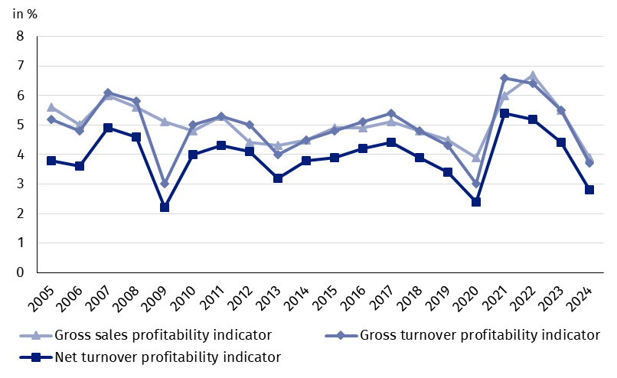
Table 1. Basic financial data of surveyed non-financial enterprises
SPECIFICATION | Jan.-March 2023 | Jan.-March 2024 | Jan.-March 2023 = 100
SPECIFICATION | in million PLN |  | Jan.-March 2023 = 100
Total revenues | 1,333,911.9 | 1,251,051.5 | 93.8
of which net revenues from sale  of products, goods and materials | 1,295,460.1 | 1,215,500.6 | 93.8
Total costs | 1,260,926.0 | 1,204,197.4 | 95.5
of which cost of products,  goods and materials sold | 1,223,600.2 | 1,167,631.1 | 95.4
Financial result from the sale of products,  goods and materials | 71,859.9 | 47,869.5 | 66.6
Financial result from other  operating activity | 6,424.4 | 3,284.6 | 51.1
Result on financial activity | -5,298.4 | -4,300.1 | x
Gross financial result | 72,985.9 | 46,854.1 | 64.2
Net financial result | 58,785.9 | 35,344.3 | 60.1
Net profit | 82,443.2 | 63,045.5 | 76.5
Net loss | 23,657.3 | 27,701.2 | 117.1
 | %
Cost level indicator | 94.5 | 96.3 | x
Gross sales profitability indicator | 5.5 | 3.9 | x
Gross turnover profitability indicator | 5.5 | 3.7 | x
Net turnover profitability indicator | 4.4 | 2.8 | x
First degree financial liquidity indicator | 37.5 | 42.0 | x
Second degree financial liquidity indicator | 107.5 | 107.9 | x
Cost level indicator for all surveyed enterprises was 96.3% (compared to 94.5% a year ago). Gross sales profitability indicator decreased from 5.5% to 3.9%, gross turnover profitability indicator – from 5.5% to 3.7% as well as net turnover profitability indicator – from 4.4% to 2.8%.
The most significant decrease in net turnover profitability indicator was recorded in mining and quarrying (by 15.9 pp.)

A decrease in net turnover profitability indicator was recorded i.a. in mining and quarrying (from 15.6% to minus 0.3%), real estate activities (from 10.4% to 5.1%), transportation and storage (from 4.4% to 2.0%), professional, scientific and technical activities (from 4.8% to 2.7%), construction (from 4.9% to 3.0%), trade; repair of motor vehicles (from 3.1% to 1.2%), electricity, gas, steam and air conditioning supply (from 4.6% to 3.4%), manufacturing (from 4.6% to 3.6%) as well as administrative and support service activities (from 6.1% to 5.6%). An increase in net turnover profitability indicator was recorded i.a. in information and communication (from 5.1% to 7.2%), other service activities (from 6.0% to 7.7%), accommodation and catering (from 3.8% to 4.8%) as welle as water supply; sewerage, waste management and remediation activities (from 5.3% to 6.1%).
First degree financial liquidity indicator was 42.0% (compared to 37.5% a year ago) and second degree financial liquidity indicator was 107.9% (compared to 107.5% in the previous year). First degree financial liquidity indicator at the level over 20% was achieved by 57.0% of the surveyed enterprises (compared to 54.3% a year ago). Second degree financial liquidity indicator, which ranged from 100% to 130%, was recorded by 11.5% of the surveyed enterprises (compared to 12.5% a year ago).
Chart 2. Net turnover profitability indicator
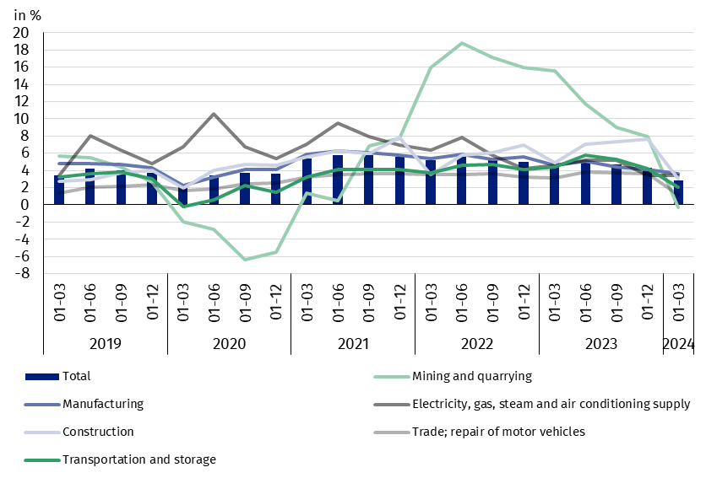

In the structure of total costs, there was an increase in the share of wages and salaries (by 2.5 pp.), external services (by 2.0 pp.), depreciation and other costs by kind (by 0.7 pp. each) as well as taxes and fees and insurances and other benefits and other costs by kind (by 0.6 pp. each). There was a decrease in the share of consumption of materials (by 6.5 pp.) as well as comsumption of energy (by 0.6 pp.).

Chart 3. Structure of costs by type in the 1st quarter of 2024

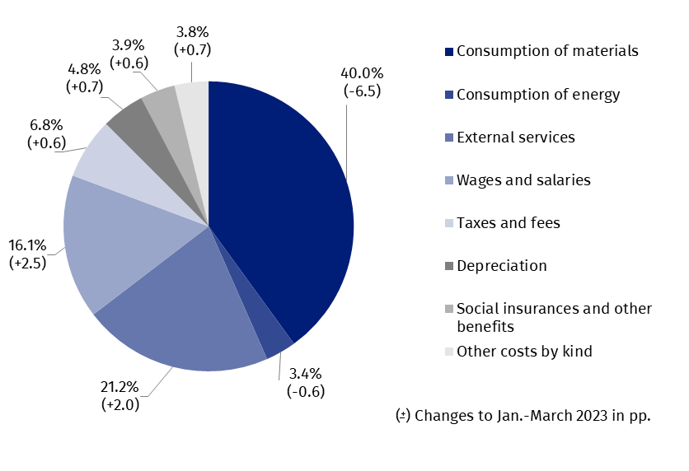

52.5% of the surveyed enterprises reported net revenues from sale of products, goods and materials for export in the 1st quarter of 2024 (compared to 52.3% in the previous year). The revenues from export sales were by 10.3% lower than a year before. The share of export in total sales revenues of all surveyed enterprises decreased from 24.9% to 23.8%. The share of the exporting enterprises which reported net profit was 67.3% (compared to 75.3% in the previous year). The basic economic and financial relations of the exporting enterprises deteriorated and these relations were similar to those of total surveyed enterprises.
There was a decrease in investment outlays of the surveyed enterprises by 2.2% compared to the 1st quarter of 2023
In the 1st quarter of 2024 investment outlays of the surveyed enterprises amounted to 39.9 bn PLN and were (in constant prices) by 2.2% lower than in the previous year (when an increase by 7.2% was recorded). The expenditures on buildings and structures decreased by 14.2% (in the previous year they increased by 4.9%). Expenditures on purchases increased by 4.5%, including increase of outlays on transport equipment – by 8.7% (in comparison to the increase in the previous year – 15.1%), while outlays on machinery, technical equipment and tools – by 2.8% (in comparison to the increase in the previous year – 5.9%).
The increase in investment outlays (in current prices) was recorded in sections, i.a. construction (by 53.2% compared to the increase by 20.1% the year before), administrative and support service activities (by 21.7% compared to the increase by 12.0% the year before), mining and quarrying (by 12.9% compared to the increase by 55.0% the year before), accommodation and catering (by 3.9% compared to the increase by 30.4% the year before). The decrease in investment outlays was noticed for transportation and storage (by 20.4% compared to the decrease of 1.9% the year before), information and communication (by 17.6% compared to the increase by 4.5% the year before), water supply; sewerage, waste management and remediation activities (by 16.4% compared to the increase by 19.8% the year before), real estate activities (by 14.1% compared to the decrease by 33.6% the year before), electricity, gas, steam and air conditioning supply (by 10.5% compared to the increase of 59.4% the year before), trade; repair of motor vehicles (by 2.9% compared to the increase of 12.8% the year before), manufacturing (by 2.0% compared to the increase of 17.7% the year before).
Chart 4. Dynamics of investment outlays - increase/decrease compared to the corresponding period of the previous year
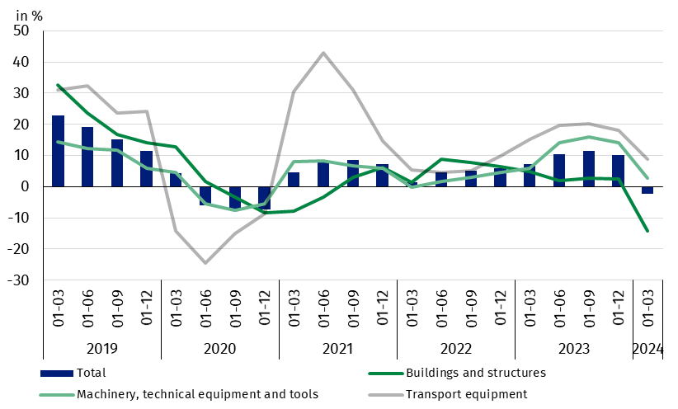

The data refer to 16 938 non-financial enterprises (legal units) with 50 and more persons employed keeping accounting ledgers. The data do not include agriculture, forestry, hunting and fishing (section A according to NACE rev. 2); financial and insurance activities (section K according to NACE rev. 2); higher education institutions; independent public health care facilities; cultural institutions with legal personality; trade unions, religious and political organisations.
In case of quoting Statistics Poland data, please provide information: “Source of data: Statistics Poland” and in case of publishing calculations made on data published by Statistics Poland, please include the following disclaimer: “Own study based on figures from Statistics Poland”.
Prepared by:  Enterprise Department  Director Katarzyna Walkowska  Phone: (+48 22) 608 31 25 | Issued by:  Press Office  Mobile: (+48) 695 255 032  Phone: (+48 22) 608 38 04, (+48 22) 449 41 45,  (+48 22) 608 30 09  e-mail: obslugaprasowa@stat.gov.pl

stat.gov.pl/en/

@StatPoland

@GlownyUrzadStatystyczny

gus_stat

glownyurzadstatystycznygus

glownyurzadstatystyczny
Related information
Statistical Bulletin
Information on the socio-economic situation of the country
News releases. Financial results of non-financial enterprises
Methodological report. Non-financial enterprises surveys
Data available in databases
Local Data Bank
Knowledge Database Non-financial Enterprises
Macroeconomic Data Bank
Terms used in official statistics
Total revenues
Total costs
Gross financial result
Net financial result
Cost level indicator
Gross turnover profitability indicator
Net turnover profitability indicator
First degree financial liquidity indicator
Second degree financial liquidity indicator
Investment outlays

