Financial results of non-financial enterprises
in 2023
In 2023 financial results of the surveyed non-financial enterprises were lower comparing to those obtained a year earlier. The economic and financial indicators deteriorated. Investment outlays were higher by 10.2% than those recorded in 2022 (when there was an increase by 5.9%).
4.8%
Increase in total revenues y/y
Total revenues were higher by 4.8% comparing to the previous year and total costs of obtaining the revenues increased by 5.5%. The cost level indicator deteriorated from 94.0% in the previous year to 94.6%. Net revenues from sale of products, goods and materials increased by 4.7% and the costs of obtaining them – by 5.3%.
The financial result from the sale of products, goods and materials amounted to 280.4 bn PLN and was by 4.5% lower than in 2022. The financial result from other operating activity amounted to 11.2 bn PLN and was lower by 5.8 bn PLN over the year. There was a deterioration observed in the result on financial activities (minus 7.6 bn PLN compared to minus 5.7 bn PLN in the previous year).
In 2023 net financial result of non-financial enterprises was by 9.1% lower than the year before
Gross financial result amounted to 284.1 bn PLN compared to 305.0 bn PLN a year ago and its obligatory encumbrances amounted to 55.5 bn PLN (compared to 53.5 bn PLN a year ago). Net financial result amounted to 228.6 bn PLN and was by 9.1% lower than the year before. Net profit amounted to 284.5 bn PLN and was higher by 0.2 bn PLN than in 2022 while net loss was 56.0 bn PLN and increased by 23.1 bn PLN over the year. Net profit was recorded by 80.8% of all enterprises (compared to 83.1% a year ago) and the revenues obtained by them constituted 83.3% of total revenues of the surveyed enterprises (compared to 89.7% the year before). In manufacturing, net profit was recorded by 80.1% of all enterprises (it was 84.2% a year ago) and the share of the total revenues generated by these enterprises in the total revenues of all enterprises in this section was 84.7% (compared to 91.3% a year ago).
Chart 1. Profitability indicators from 2004 to 2023
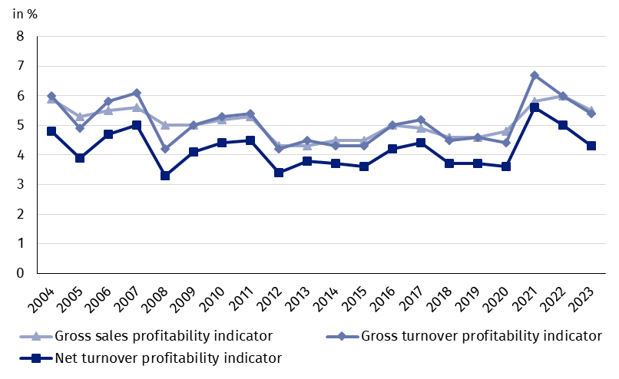
Table 1. Basic financial data of surveyed non-financial enterprises
SPECIFICATION | Jan.-Dec. 2022 | Jan.-Dec. 2023 | Jan.-Dec. 2022  = 100
SPECIFICATION | in million PLN |  | Jan.-Dec. 2022  = 100
Total revenues | 5,046,969.6 | 5,289,216.3 | 104.8
of which net revenues from sale  of products, goods and materials | 4,882,295.9 | 5,110,498.2 | 104.7
Total costs | 4,742,003.3 | 5,005,122.7 | 105.5
of which cost of products,  goods and materials sold | 4,588,574.3 | 4,830,058.9 | 105.3
Financial result from the sale of products,  goods and materials | 293,721.6 | 280,439.3 | 95.5
Financial result from other  operating activity | 16,977.0 | 11,234.2 | 66.2
Result on financial activity | -5,732.3 | -7,579.8 | 132.2
Gross financial result | 304,966.2 | 284,093.6 | 93.2
Net financial result | 251,429.1 | 228,567.9 | 90.9
Net profit | 284,317.8 | 284,520.9 | 100.1
Net loss | 32,888.7 | 55,953.0 | 170.1
 | %
Cost level indicator | 94.0 | 94.6 | x
Gross sales profitability indicator | 6.0 | 5.5 | x
Gross turnover profitability indicator | 6.0 | 5.4 | x
Net turnover profitability indicator | 5.0 | 4.3 | x
First degree financial liquidity indicator | 39.0 | 39.7 | x
Second degree financial liquidity indicator | 105.4 | 107.2 | x
Cost level indicator for all surveyed enterprises was 94.0% (compared to 94.6% a year ago). Gross sales profitability indicator decreased from 6.0% to 5.5%, gross turnover profitability indicator – from 6.0% to 5.4% as well as net turnover profitability indicator – from 5.0% to 4.3%.
The most significant decrease in net turnover profitability indicator was recorded in mining and quarrying (by 8.1 pp.)

A decrease in net turnover profitability indicator was recorded i.a. in mining and quarrying (from 16.0% to 7.9%), water supply; sewerage, waste management and remediation activities (from 6.5% to 4.8%), manufacturing (from 5.6% to 4.1%), professional, scientific and technical activities (from 8.7% to 7.8%) as well as electricity, gas, steam and air conditioning supply (from 4.2% to 3.4%). An increase in net turnover profitability indicator was recorded i.a. in real estate activities (from 5.4% to 7.8%), construction (from 6.9% to 7.6%), accommodation and catering (from 9.1% to 9.6%), administrative and support service activities (from 5.6% to 6.0%), trade; repair of motor vehicles (from 3.2% to 3.6%), information and communication (from 7.4% to 7.7%) as well as transportation and storage (from 4.1% to 4.2%). In other service activities the net turnover profitability indicator remained at the level recorded a year earlier (6.6%).
First degree financial liquidity indicator was 39.7% (compared to 39.0% a year ago) and second degree financial liquidity indicator was 107.2% (compared to 105.4% in the previous year). First degree financial liquidity indicator at the level over 20% was achieved by 58.7% of the surveyed enterprises (compared to 55.0% a year ago). Second degree financial liquidity indicator, which ranged from 100% to 130%, was recorded by 11.8% of the surveyed enterprises (compared to 12.0% a year ago).
Chart 2. Net turnover profitability indicator
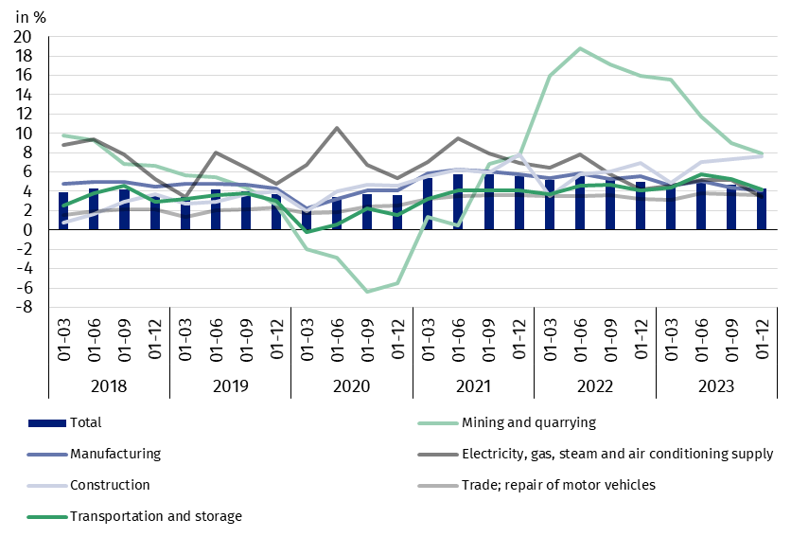

In the structure of total costs, there was an increase in the share of wages and salaries and taxes and fees (by 1.1 pp. each), external services (by 0.9 pp.), depreciation, social insurances and other benefits and other costs by kind (by 0.4 pp. each) as well as comsumption of energy (by 0.3 pp.). There was a decrease in the share of consumption of materials (by 4.6 pp.).

Chart 3. Structure of costs by type in 2023
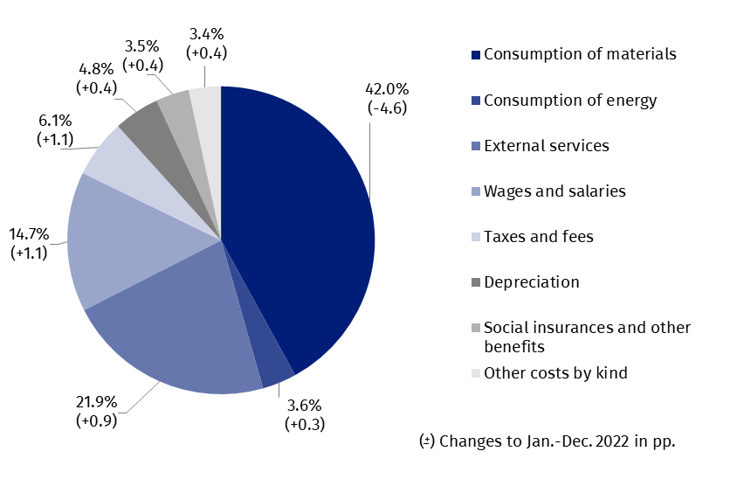

55.1% of the surveyed enterprises reported net revenues from sale of products, goods and materials for export in 2023 (compared to 54.9% in the previous year). The revenues from export sales were by 1.2% lower than a year before. The share of export in total sales revenues of all surveyed enterprises decreased from 25.6% to 24.2%. The share of the exporting enterprises which reported net profit was 80.8% (compared to 85.3% in the previous year). The basic economic and financial relations of the exporting enterprises deteriorated and were lower than the relations of total surveyed enterprises.
There was an increase in investment outlays of the surveyed enterprises by 10.2% compared to January-September of 2022
In 2023 investment outlays of the surveyed enterprises amounted to 225.0 bn PLN and were (in constant prices) by 10.2% higher than in 2022 when an increase by 5.9% was recorded. The expenditures on buildings and structures increased by 2.5% (in the previous year they increased by 6.4%). Expenditures on purchases increased by 15.1% (in comparison to the increase in the previous year – 5.8%), including increase of outlays on transport equipment – by 18.0% (in comparison to the increase in 2022 – 9.9%), while outlays on machinery, technical equipment and tools – by 14.2% (in comparison to the increased in the previous year – 4.5%).
The increase in investment outlays (in current prices) was recorded in sections, i.a. for real estate activities (by 47.3% compared to the increase of 23.9% the year before), mining and quarrying (by 46.7% compared to the increase by 28.4% the year before), construction (by 35.9% compared to the decrease by 9.0% the year earlier), electricity, gas, steam and air conditioning supply (by 35.1% compared to the increase of 6.3% in the previous year), transportation and storage (by 11,5% compared to the increase of 8.4% in the previous year), manufacturing (by 9.9% compared to the increase of 26.2% in the previous year). The decrease in investment outlays was noiced for trade; repair of motor vehicles (by 0.1% compared to the increase of 28.1% in the year earlier).
Chart 4. Dynamics of investment outlays - increase/decrease compared to the corresponding period of the previous year
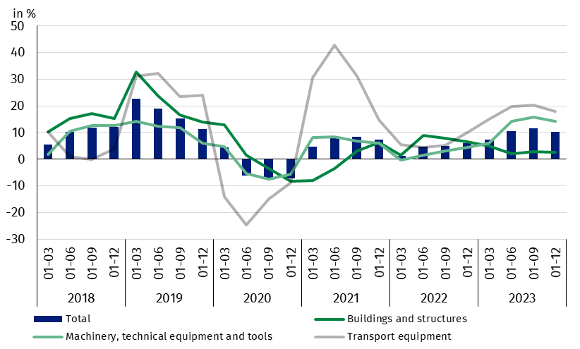

The data refer to 17 808 non-financial enterprises (legal units) with 50 and more persons employed keeping accounting ledgers. The data do not include agriculture, forestry, hunting and fishing (section A according to NACE rev. 2); financial and insurance activities (section K according to NACE rev. 2); higher education institutions; independent public health care facilities; cultural institutions with legal personality; trade unions, religious and political organisations.
In case of quoting Statistics Poland data, please provide information: “Source of data: Statistics Poland” and in case of publishing calculations made on data published by Statistics Poland, please include the following disclaimer: “Own study based on figures from Statistics Poland”.
Prepared by:  Enterprise Department  Director Katarzyna Walkowska  Phone: (+48 22) 608 31 25 | Issued by:  The Spokesperson for the President  of Statistics Poland  Karolina Banaszek  Phone: (+48) 695 255 011
Press Office  Phone: (+48 22) 608 38 04  e-mail: obslugaprasowa@stat.gov.pl |   stat.gov.pl/en/

@StatPoland

@GlownyUrzadStatystyczny

gus_stat

glownyurzadstatystycznygus

glownyurzadstatystyczny
Related information
Statistical Bulletin
Information on the socio-economic situation of the country
News releases. Financial results of non-financial enterprises
Methodological report. Non-financial enterprises surveys
Data available in databases
Local Data Bank
Knowledge Database Non-financial Enterprises
Macroeconomic Data Bank
Terms used in official statistics
Total revenues
Total costs
Gross financial result
Net financial result
Cost level indicator
Gross turnover profitability indicator
Net turnover profitability indicator
First degree financial liquidity indicator
Second degree financial liquidity indicator
Investment outlays

