Real estate sales in 2023

In 2023, 510.9 thousand notarial deeds of real estate trading were signed (a year-on-year decrease
of 3.8%). Compared to the previous year, the number of notarial deeds concerning the sale of real estate to the State Treasury or local government units increased (by 7.0%), the sale of perpetual usufruct rights (by 4.7%), the sale of cooperative ownership rights to premises (by 4.0%) and the sale of premises (by 1.9%). On the other hand, the largest decrease was recorded in the number of notarial deeds concerning the sale of undeveloped plots (by 13.1%).
3.8%
A decrease in the number
of notarial deeds of real estate sales compared to 2022

Table 1. Notarial deeds related to real estate sales concluded in 2023
In 2023, compared to the previous year, the highest increase in the number of notarial deeds was recorded in the sale of real estate to the State Treasury
or local government units
(by 7.0%)
Specification | 2023 | 2022=100
Total | 510 903 | 96.2
Sale of premises | 212 004 | 101.9
Sale of undeveloped plots | 105 984 | 86.9
Sale of agricultural real estate | 58 989 | 93.2
Sale of plots with a residential building | 49 648 | 92.7
Sale of cooperative ownership right to premises | 41 486 | 104.0
Sale of other properties | 18 855 | 92.3
Sale of plots with a building for other purposes | 14 931 | 97.2
Sale of perpetual usufruct rights | 5 388 | 104.7
Sale of real estate to the State Treasury or local  government units | 3 472 | 107.0
Granting perpetual usufruct by the State Treasury or local government units along with the sale of the building | 146 | 98.0
Source: the Ministry of Justice data.

According to data from the Real Estate Price Register (RCN), 504.9 thousand real estate sale and purchase transactions with a total value of PLN 207.3 billion were concluded in 2023.

Table 2. Volume of real estate sale
In 2023, the structure of both the number and value of real estate sale and purchase transactions was dominated by the sale of premises whose shares amounted to 50.5% and 52.9%, respectively
Specification | Number of transactions |  |  |  | Value of transactions
Specification | 2022 |  | 2023ª |  | 2022 | 2023ª
Specification | in units |  |  | 2022=100 | in million PLN |  | 2022=100
Total | 510 760 | 504 861 |  | 98.8 | 192 685 | 207 293 | 107.6
Premises | 245 755 | 254 761 |  | 103.7 | 95 806 | 109 645 | 114.4
Built-up properties^{b} | 82 894 | 78 854 |  | 95.1 | 56 822 | 56 639 | 99.7
Undeveloped properties | 182 111 | 171 246 |  | 94.0 | 40 055 | 41 009 | 102.4
a Preliminary data.
b It includes real estate with residential buildings, developed agricultural real estate, real estate developed with buildings performing functions other than agricultural and residential and building real estate.
In the majority of voivodships, the structure of the number of real estate sale and purchase transactions by type was dominated by transactions concerning premises. The highest share of this type of transactions was noted in Dolnośląskie (64.9%), Pomorskie (61.8%) and
Mazowieckie (56.2%) voivodships. Only in four voivodships the largest share of the number
of transactions was observed for another type of real estate – undeveloped properties. Transactions related to this category of real estate accounted for more than a half of all
registered contracts in Podkarpackie and Świętokrzyskie voivodships (55.1% and 52.0%,
respectively).
Chart 1. Structure of the number of real estate sale and purchase transactions by type
in 2023
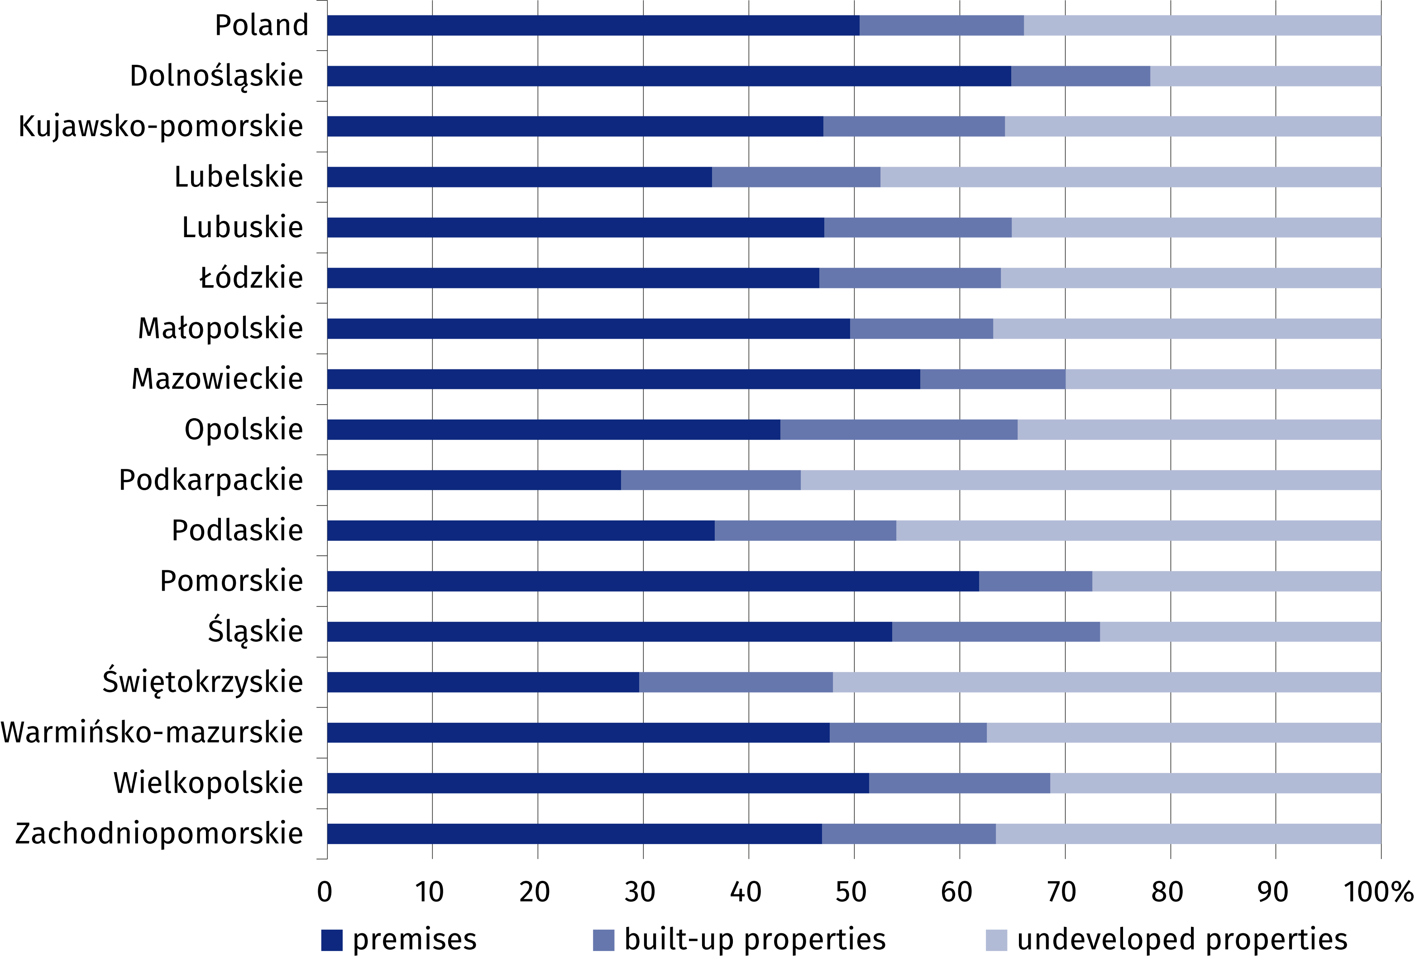

Table 3. Price indices of residential premises in 2023
Specification | 2023
Specification | 2022=100 | 2015=100
Total | 108.8 | 179.8
Primary market | 110.5 | 168.0
Secondary market | 107.3 | 189.6
Chart 2. Changes in prices of residential premises compared to the previous year
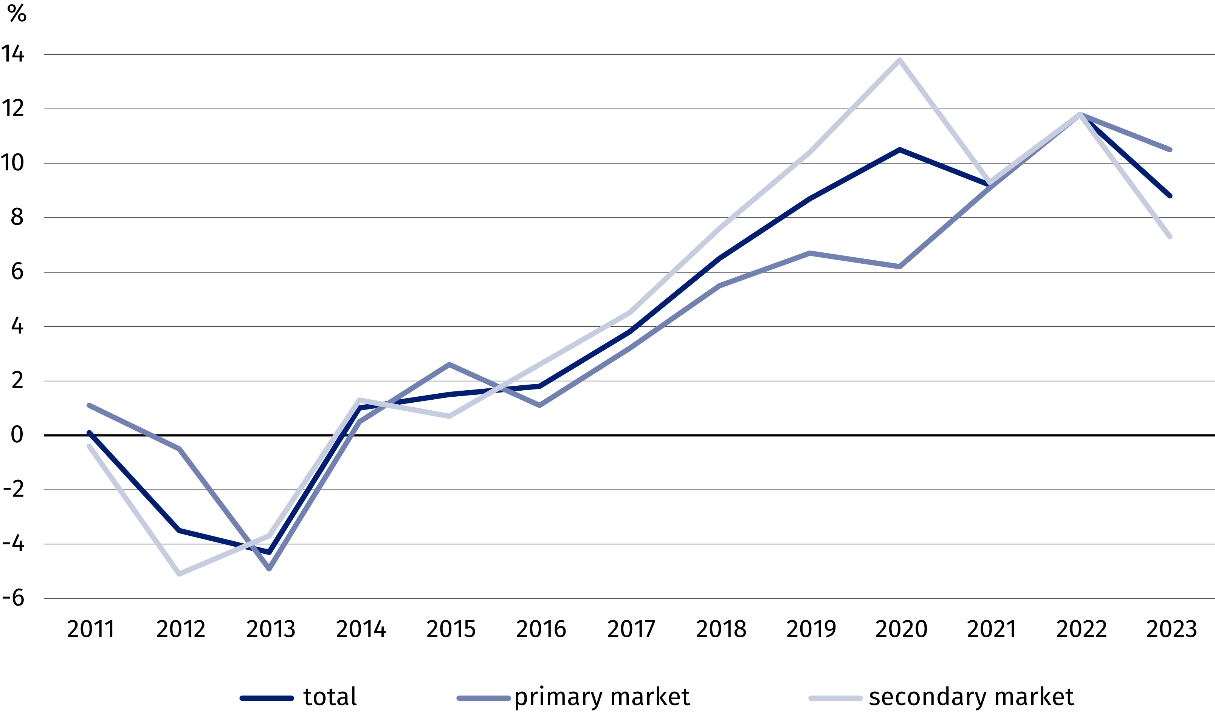
Prices of residential premises
in 2023, compared to 2022,
increased by 8.8% (of which 10.5% on the primary market and 7.3% on the secondary
market)
Chart 3. Changes in prices of residential premises compared to 2015
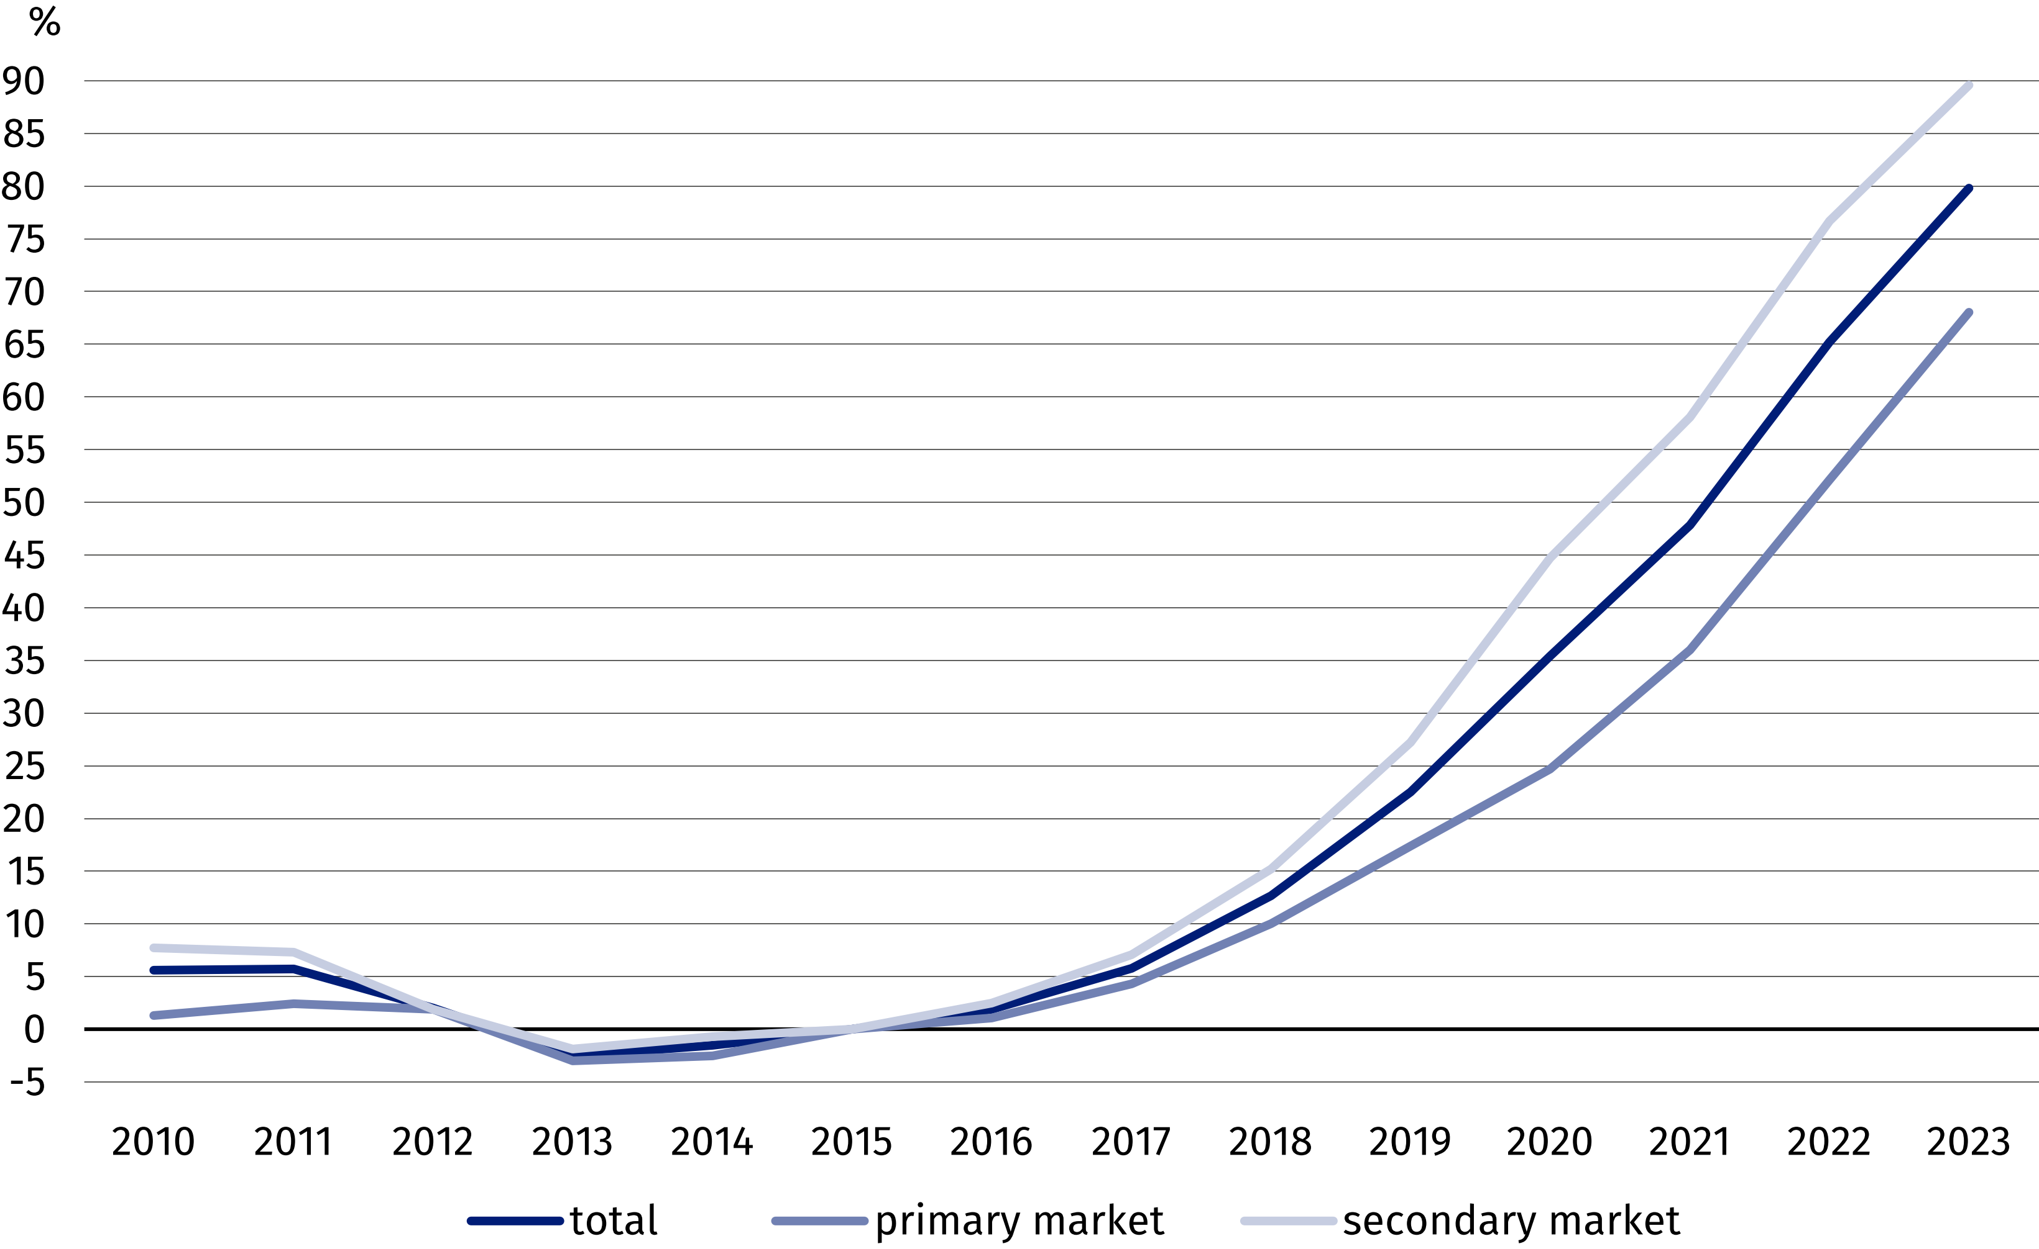

When quoting Statistics Poland data, please provide the information: “Source of data: Statistics Poland”, and when publishing calculations based on Statistics Poland data, please
include the following information: “Own work based on Statistics Poland data”.

Prepared by:  Statistical Office in Szczecin  Deputy Director Katarzyna Dmitrowicz-Życka  Phone: 91 459 77 00 | Issued by:  Press Office  Mobile: (+48) 695 255 032  Phone: (+48 22) 608 38 04, (+48 22) 449 41 45,  (+48 22) 608 30 09  e-mail: obslugaprasowa@stat.gov.pl

stat.gov.pl

@GUS_STAT

@GlownyUrzadStatystyczny

gus_stat

glownyurzadstatystycznygus

glownyurzadstatystyczny
Related information
Price indices of residential premises by voivodships
Price of one square meter of usable floor space of a residential building
Real estate sales in 2022
Data available in databases
Knowledge Databases (DBW) Prices
Local Data Bank – Real Estate Market
Terms used in official statistics
Real estate turnover
Real estate Price Register
Premises
Price indices of residential premises
Real estate transaction

