Price indices of residential premises in the second quarter of 2024

In the second quarter of 2024 prices of residential premises in Poland compared to the corresponding quarter of 2023, increased by 17.7%, whereas on the primary market the increase was higher than on the secondary market (19.2% vs. 16.0%). Compared to the first quarter of 2024, prices of residential premises increased by 2.9%, and the price increases on the primary and secondary markets were
at a similar level.
17.7%
Increase in prices of residential premises compared to the 2nd quarter of 2023

Table 1. Price indices of residential premises in the second quarter of 2024
Specification | Q2 2024
Specification | Q1 2024=100 | Q2 2023=100 | 2015=100
Total | 102.9 | 117.7 | 205.9
Primary market | 103.0 | 119.2 | 194.8
Secondary market | 102.9 | 116.0 | 214.4
Chart 1. Weighting system used in the compilations of price indices of residential premises
in 2024
For compiling price indices
of residential premises
in 2024, the primary market
is assigned a weight of 50.6% and the secondary market
49.4%
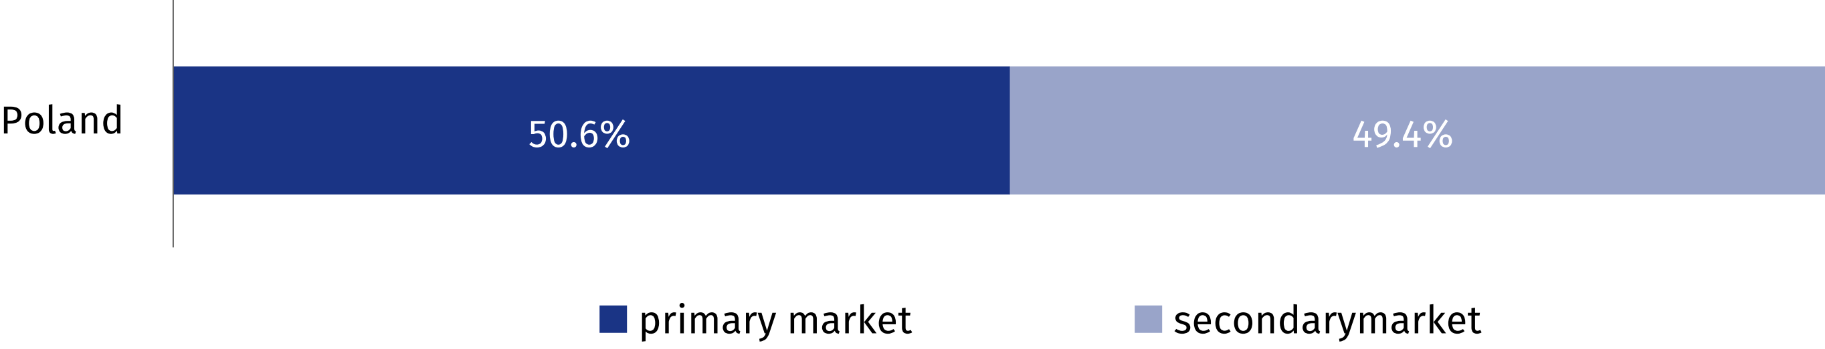
Chart 2. Quarterly changes in prices of residential premises compared to the previous quarter
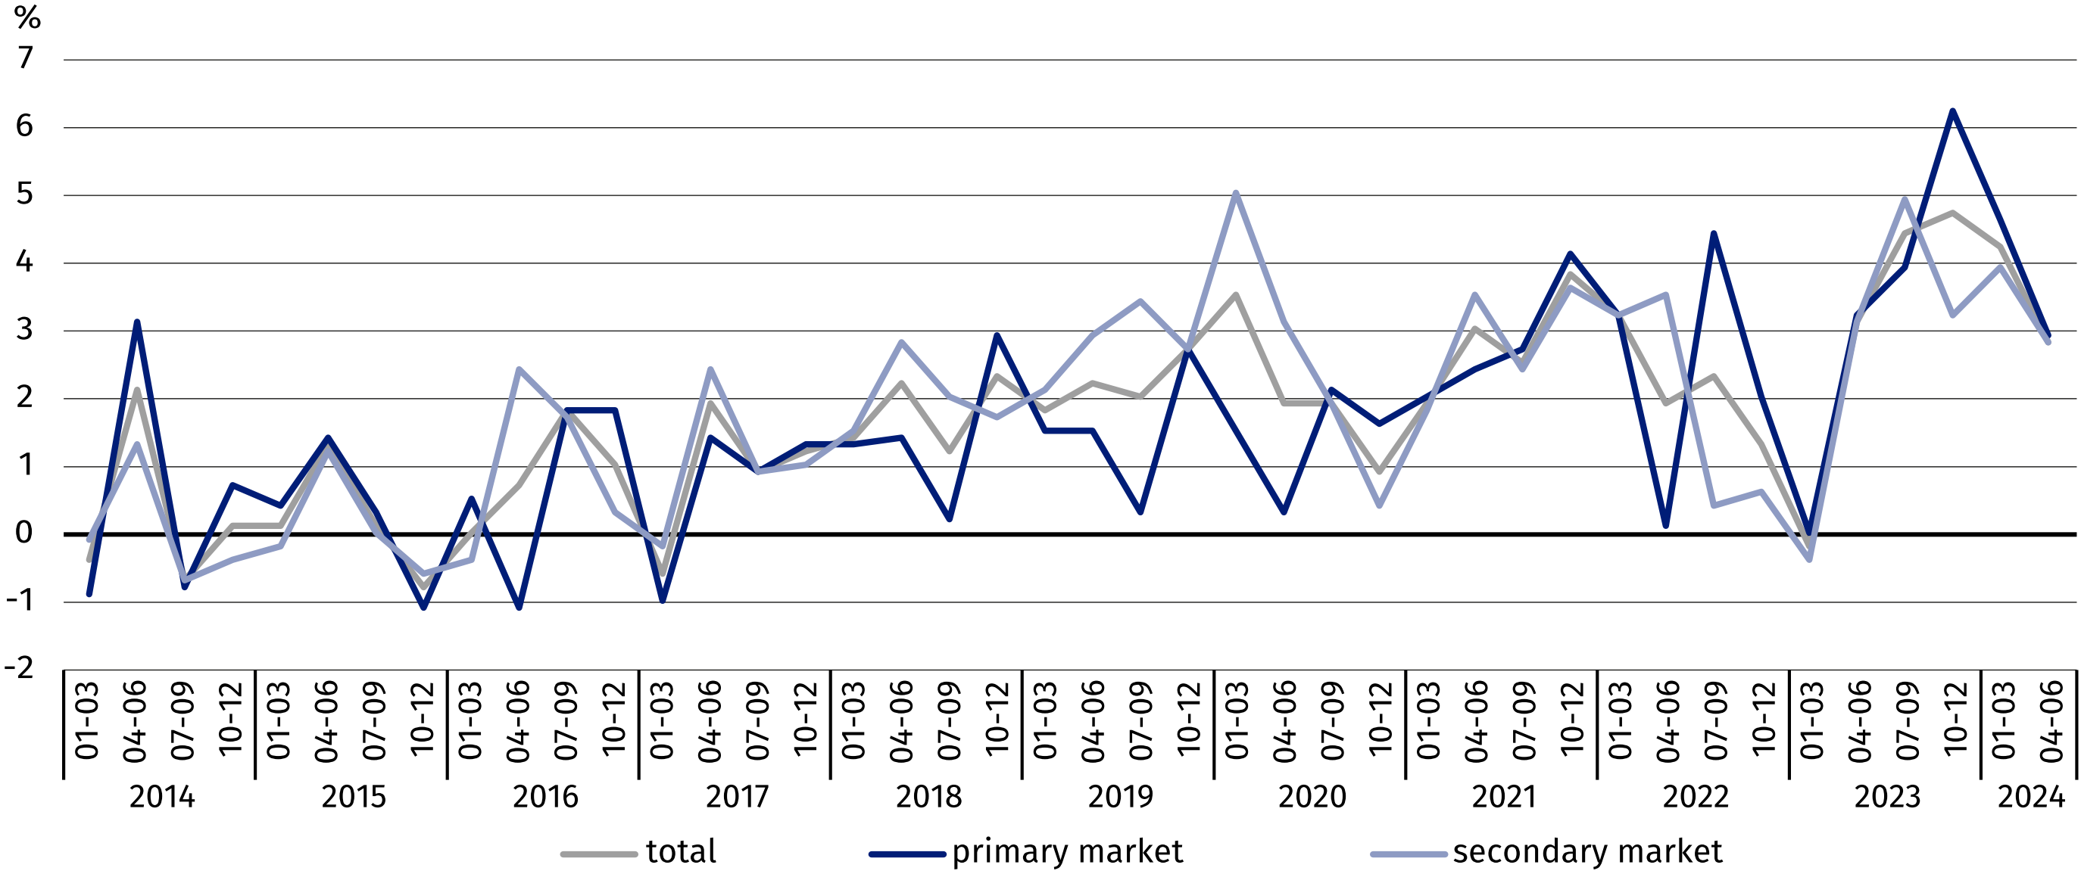
Chart 3. Quarterly changes in prices of residential premises compared to the corresponding
quarter of the previous year
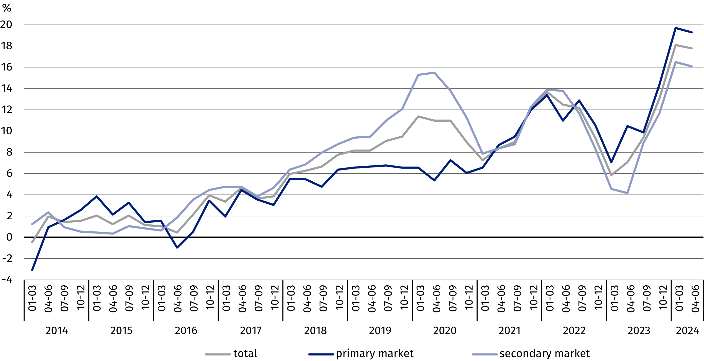
Chart 4. Quarterly changes in prices of residential premises compared to 2015
In the second quarter of 2024 prices of residential premises were by 105.9% higher compared to the average price for 2015
(of which on the primary market – by 94.8% and on the secondary market – by 114.4%)

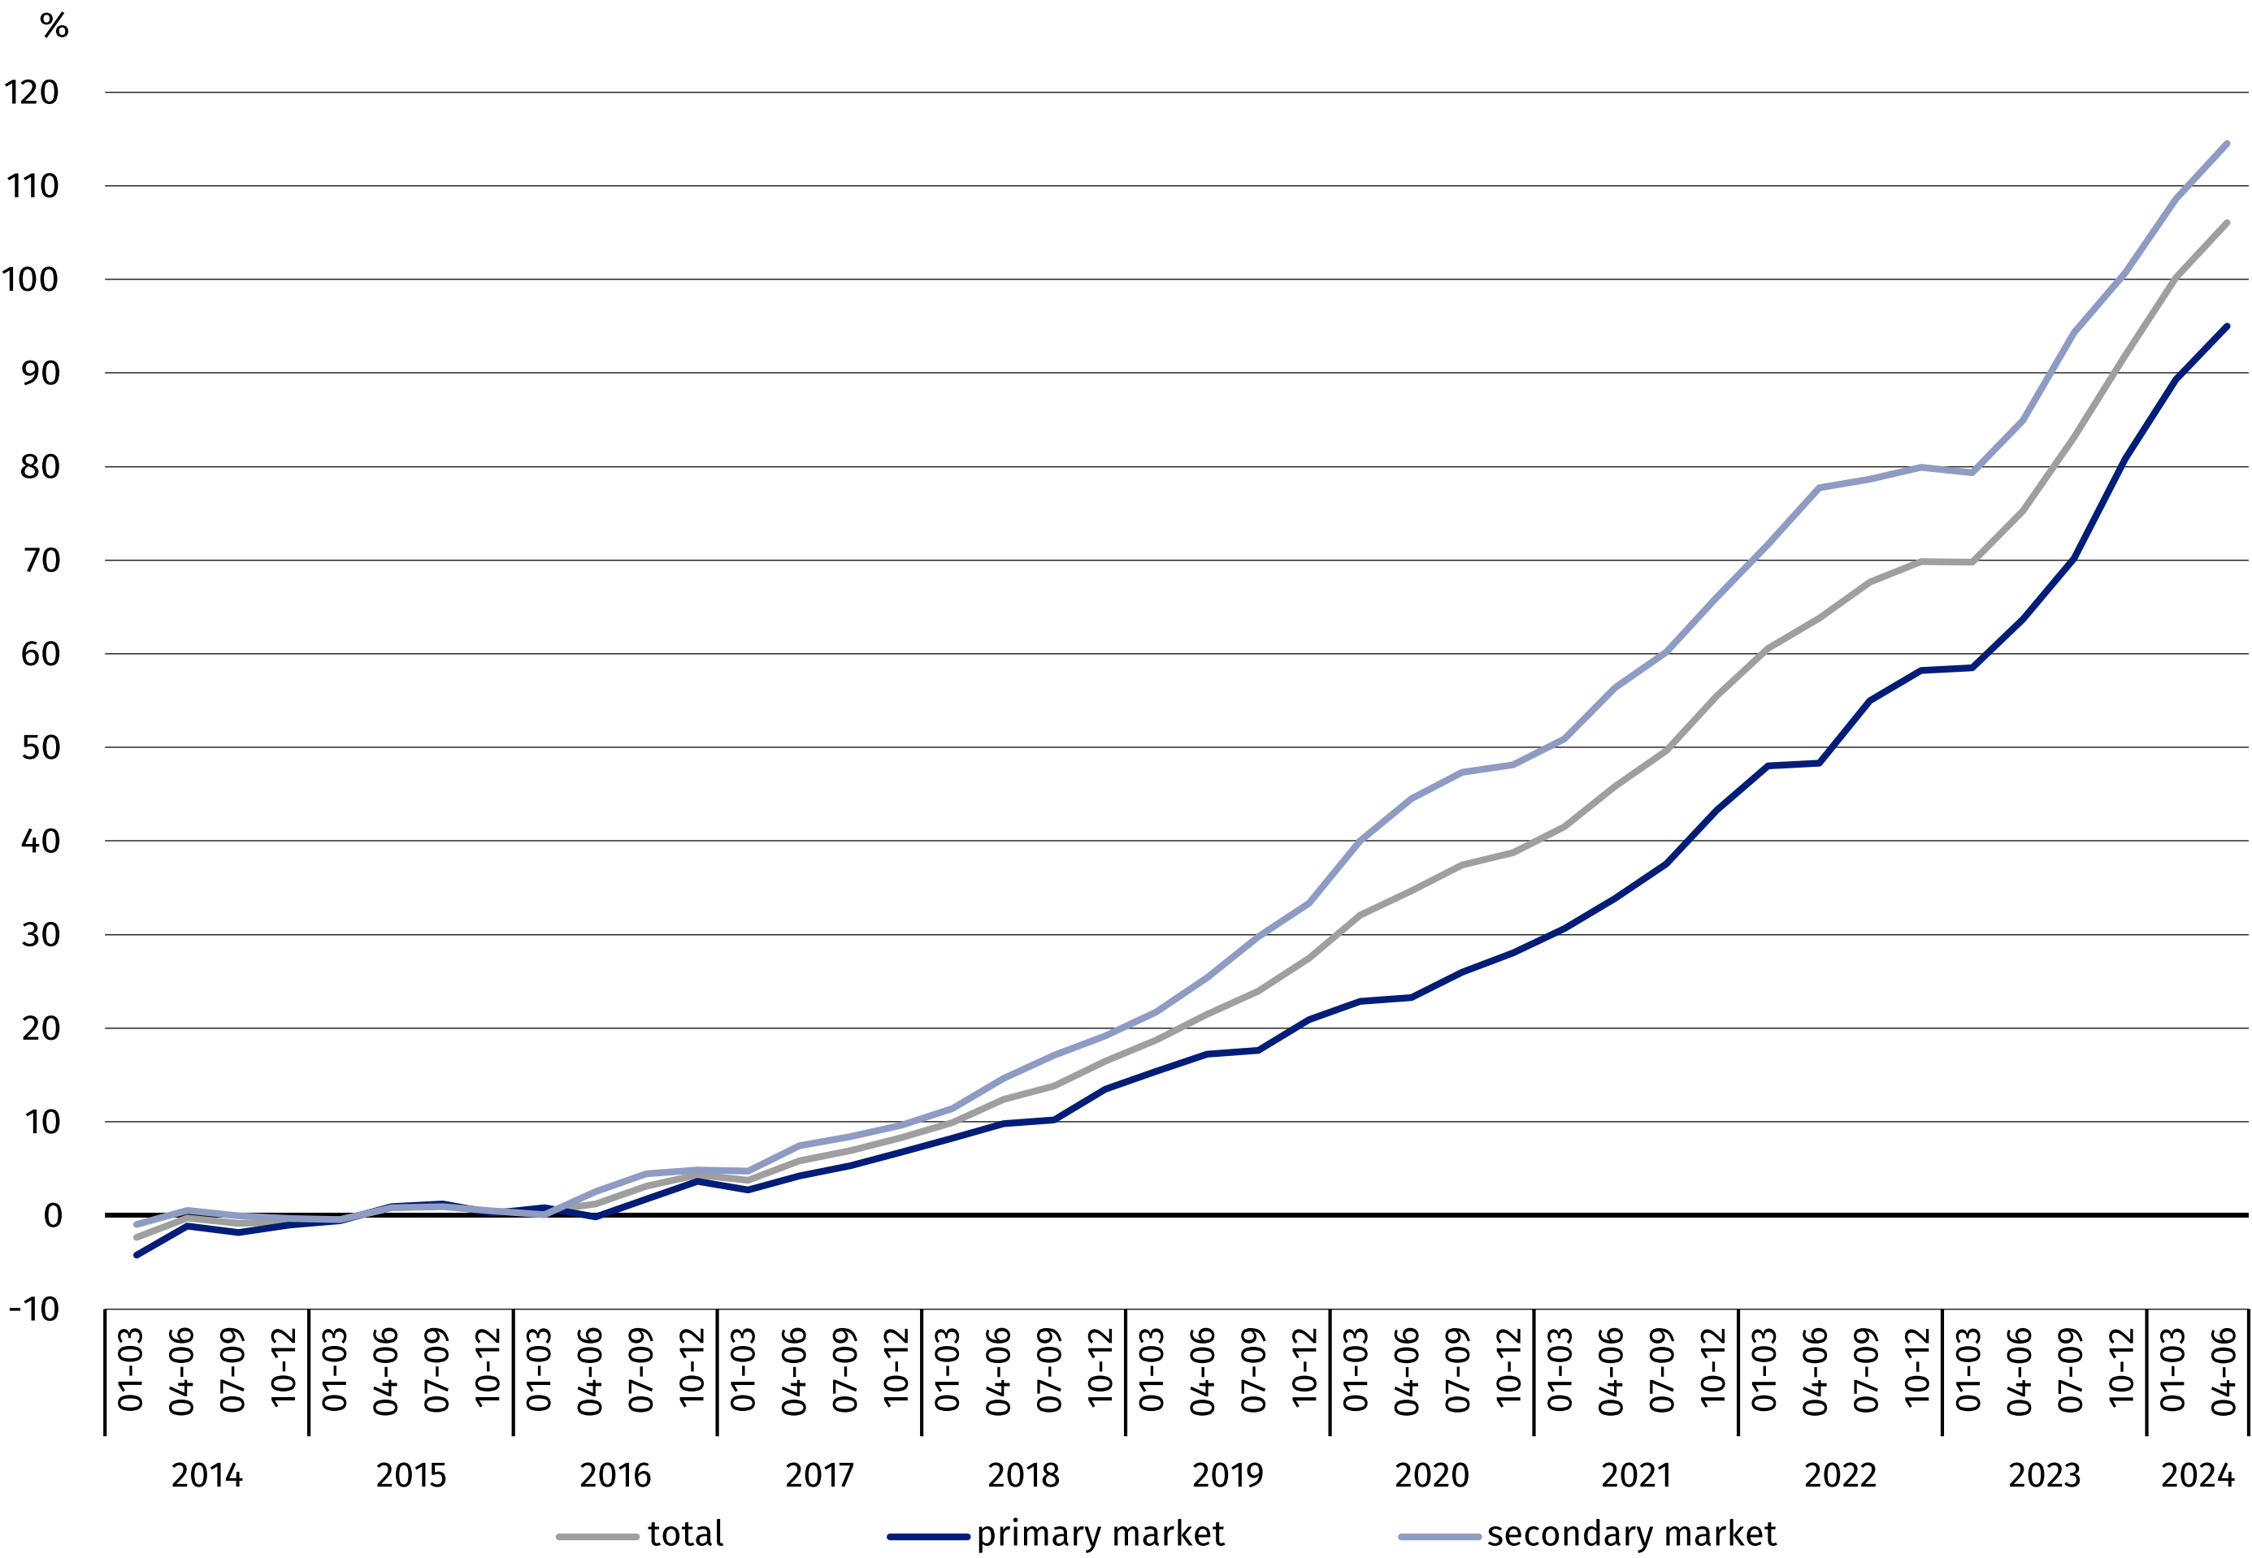

Table 2. Price indices of residential premises by voivodships in the second quarter of 2024
In the second quarter of 2024, the highest increase in prices of residential premises, compared to the previous quarter, was recorded in the Podlaskie Voivodship (by 5.6%), while the smallest price increase was observed in the Warmińsko-Mazurskie Voivodship (by 0.4%)
Specification | Q2 2024
Specification | Q1 2024=100 | Q2 2023=100
Poland | 102.9 | 117.7
Dolnośląskie | 103.4 | 117.4
Kujawsko-Pomorskie | 103.8 | 113.7
Lubelskie | 101.5 | 108.7
Lubuskie | 102.0 | 122.5
Łódzkie | 101.5 | 116.2
Małopolskie | 101.2 | 124.6
Mazowieckie | 102.9 | 118.4
Opolskie | 103.0 | 119.0
Podkarpackie | 102.9 | 119.1
Podlaskie | 105.6 | 119.3
Pomorskie | 103.4 | 112.8
Śląskie | 104.0 | 120.3
Świętokrzyskie | 102.0 | 114.8
Warmińsko-Mazurskie | 100.4 | 116.1
Wielkopolskie | 104.8 | 120.5
Zachodniopomorskie | 103.4 | 110.5

In case of quoting Statistics Poland data, please provide information: “Source of data: Statistics Poland”, and in case of publishing calculations made on data published by Statistics
Poland, please include the following disclaimer: “Own study based on figures from Statistics Poland”.

Prepared by:  Statistical Office in Szczecin  Deputy Director Katarzyna Dmitrowicz-Życka  Phone: 91 459 77 00 | Issued by:  Press Office  Mobile: (+48) 695 255 032  Phone: (+48 22) 608 38 04, (+48 22) 449 41 45,  (+48 22) 608 30 09  e-mail: obslugaprasowa@stat.gov.pl

www.stat.gov.pl/en/

@StatPoland

@GlownyUrzadStatystyczny

gus_stat

glownyurzadstatystycznygus

glownyurzadstatystyczny
Related information
Price indices of residential premises by voivodships
Price of one square meter of usable floor space of a residential building
Real estate sales in 2022
Data available in databases
Knowledge Databases (DBW) Prices
Local Data Bank – Real Estate Market
Terms used in official statistics
Real estate turnover
Real Estate Price Register
Premises
Price indices of residential premises

