Price indices of residential premises in the fourth quarter of 2023

In the fourth quarter of 2023 prices of residential premises in Poland, compared to the third quarter of 2023, increased by 4.8%. On the primary market the increase amounted 6.3% and on the secondary market – 3.3%. Compared to the corresponding quarter of 2022, prices of residential premises increased by 13.0% (of which on the primary market – by 14.3% and on the secondary market – by 11.6%).
13.0%
Increase in prices of residential premises compared to the 4th quarter of 2022

Table 1. Price indices of residential premises in the fourth quarter of 2023
Specification | Q4 2023
Specification | Q3 2023=100 | Q4 2022=100 | 2015=100
Total | 104.8 | 113.0 | 191.7
Primary market | 106.3 | 114.3 | 180.6
Secondary market | 103.3 | 111.6 | 200.5
Chart 1. Weighting system used in the compilations of price indices of residential premises in 2023
For compiling price indices
of residential premises
in 2023, the primary market
is assigned a weight of 51.8% and the secondary market
– 48.2%
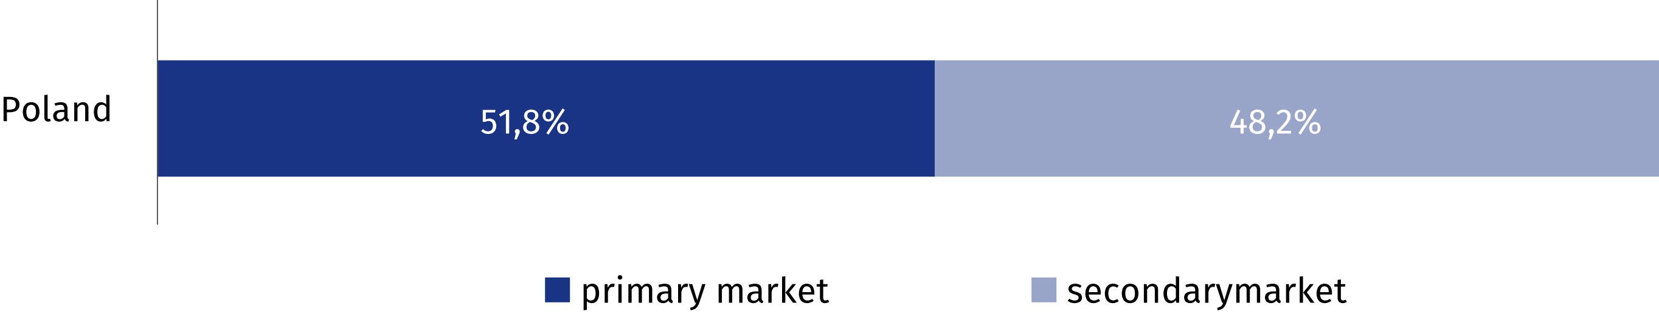
Chart 2. Quarterly changes in prices of residential premises compared to the previous quarter
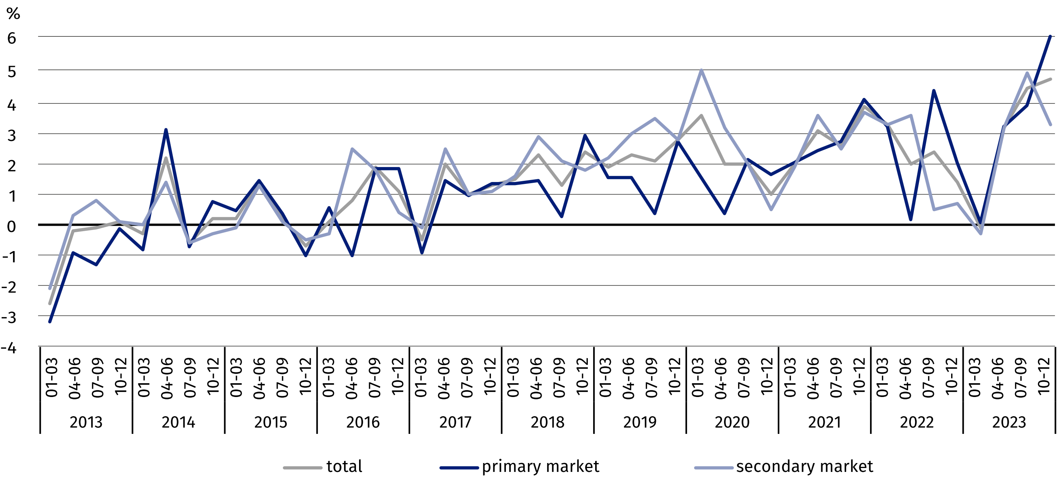
Chart 3. Quarterly changes in prices of residential premises compared to the corresponding
quarter of the previous year
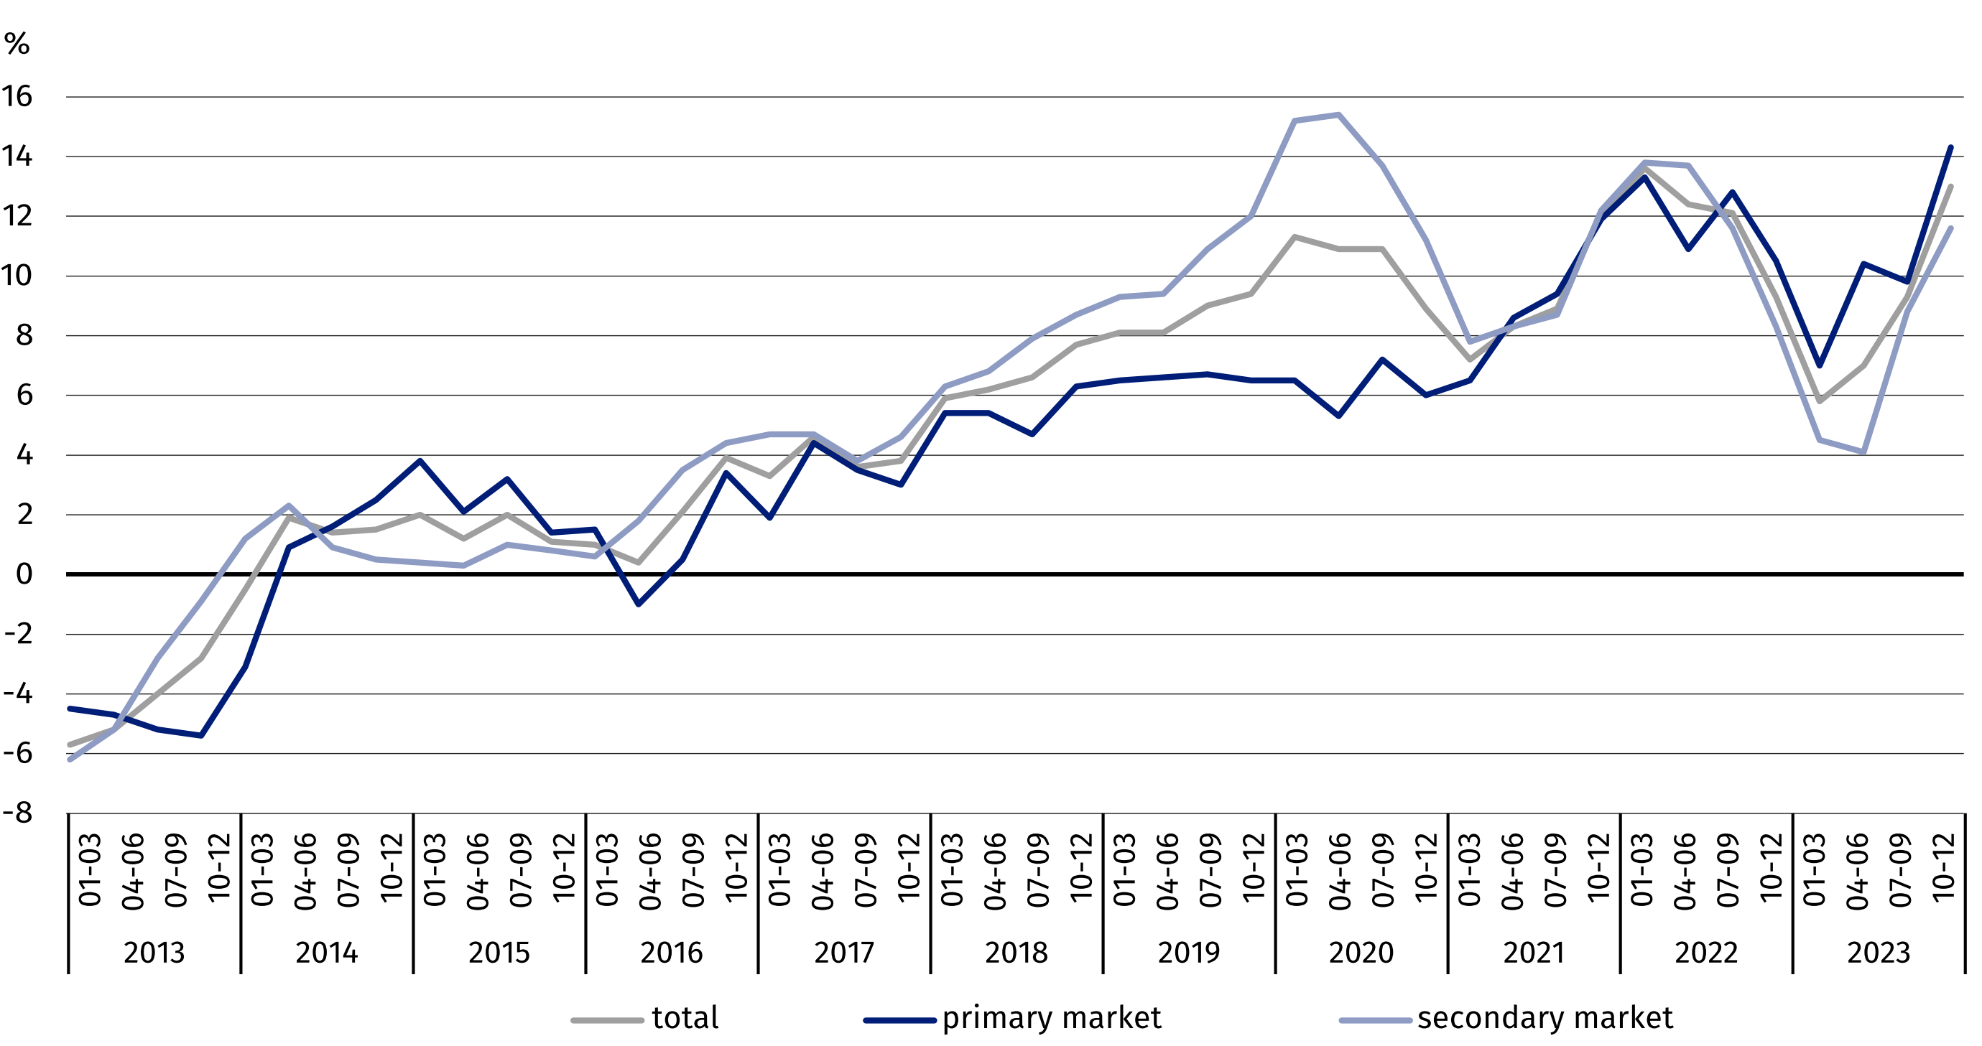

Chart 4. Quarterly changes in prices of residential premises compared to 2015
In the fourth quarter of 2023 prices of residential premises were by 91.7% higher compared to the average price for 2015 (of which on the primary
market – by 80.6% and on the secondary market – by 100.5%)
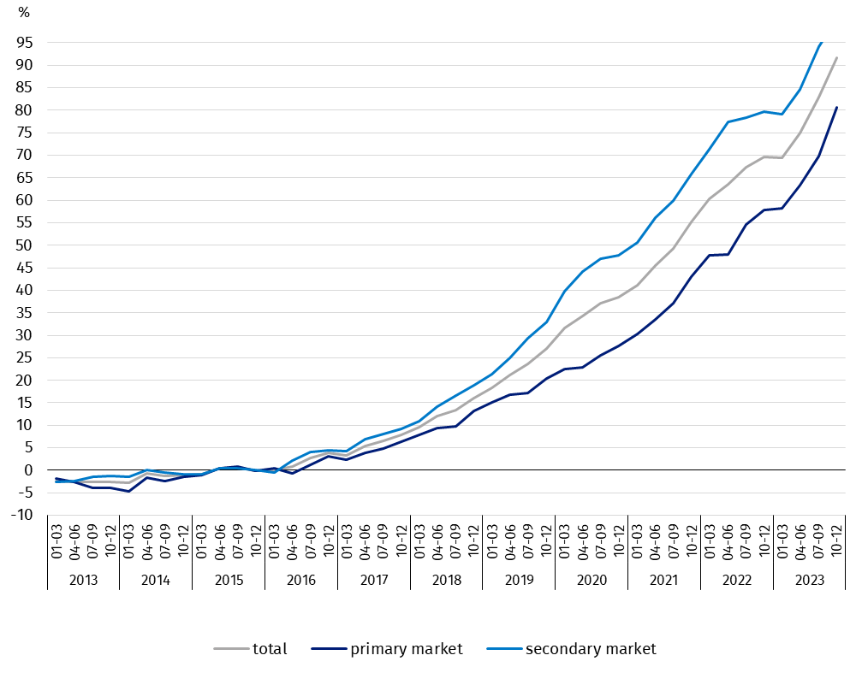

Table 2. Price indices of residential premises by voivodships in the fourth quarter of 2023
In the fourth quarter of 2023, the highest increase in prices of residential premises, compared to the previous quarter, was recorded in the Małopolskie Voivodship (by 7.9%), while a price decrease was observed in the Zachodniopomorskie Voivodship (by 0.4%)
Specification | Q4 2023
Specification | Q3 2023=100 | Q4 2022=100
Poland | 104.8 | 113.0
Dolnośląskie | 105.3 | 118.3
Kujawsko-Pomorskie | 105.9 | 114.7
Lubelskie | 102.3 | 115.0
Lubuskie | 105.3 | 115.0
Łódzkie | 103.9 | 112.3
Małopolskie | 107.9 | 118.6
Mazowieckie | 104.9 | 110.6
Opolskie | 106.1 | 116.7
Podkarpackie | 106.7 | 115.5
Podlaskie | 107.0 | 111.1
Pomorskie | 102.4 | 110.8
Śląskie | 105.4 | 112.7
Świętokrzyskie | 104.5 | 109.4
Warmińsko-Mazurskie | 105.2 | 117.0
Wielkopolskie | 105.3 | 112.1
Zachodniopomorskie | 99.6 | 101.2

In case of quoting Statistics Poland data, please provide information: “Source of data: Statistics Poland”, and in case of publishing calculations made on data published by Statistics
Poland, please include the following disclaimer: “Own study based on figures from Statistics Poland”.

Prepared by:  Statistical Office in Szczecin  Deputy director Katarzyna Dmitrowicz-Życka  Phone: (+48 91) 459 77 00 | Issued by:  The Spokesperson for the President  of Statistics Poland  Karolina Banaszek  Phone: (+48) 695 255 011
Press Office  Phone: (+48 22) 608 38 04  e-mail: obslugaprasowa@stat.gov.pl |   www.stat.gov.pl/en/

@StatPoland

@GlownyUrzadStatystyczny

gus_stat

glownyurzadstatystycznygus

glownyurzadstatystyczny
Related information
Price indices of residential premises by voivodships
Price of one square meter of usable floor space of a residential building
Real estate sales in 2022
Data available in databases
Knowledge Databases (DBW) Prices
Local Data Bank – Real Estate Market
Terms used in official statistics
Real estate turnover
Real Estate Price Register
Premises
Price indices of residential premises

