Price indices of residential premises in the third quarter of 2023

Prices of residential premises in the third quarter of 2023, compared to the second quarter of 2023, increased by 4.5% with the price increase on the primary market (by 4.0%) and secondary market
(by 5.0%). Compared to the corresponding quarter of 2022, prices of residential premises increased by 9.3% (of which on the primary market - by 9.8% and on the secondary market - by 8.8%).
9.3%
Increase in prices of residential premises compared to the 3rd quarter of 2022

Table 1. Price indices of residential premises in the third quarter of 2023
Specification | Q3 2023
Specification | Q2 2023=100 | Q3 2022=100 | 2015=100
Total | 104.5 | 109.3 | 182.9
Primary market | 104.0 | 109.8 | 169.9
Secondary market | 105.0 | 108.8 | 194.1
Chart 1. Weighting system used in the compilations of price indices of residential premises in 2023
For compiling price indices of residential premises in 2023, the primary market is assigned a weight of 51.8% and the secondary market – 48.2%

Chart 2. Quarterly changes in prices of residential premises compared to the previous quarter
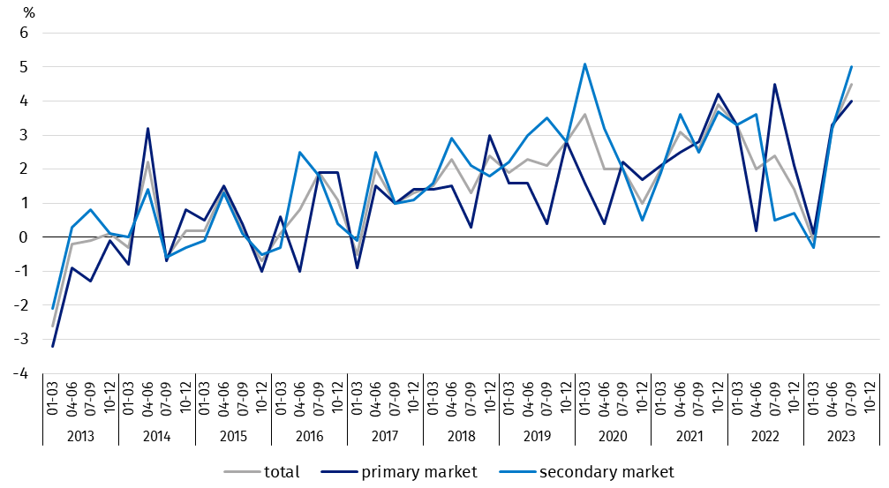
Chart 3. Quarterly changes in prices of residential premises compared to the corresponding
quarter of the previous year
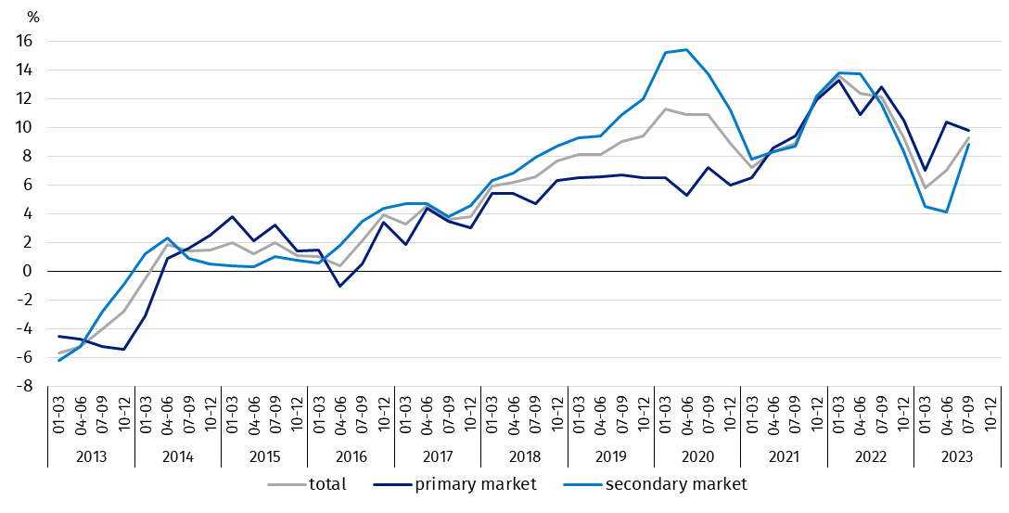

Chart 4. Quarterly changes in prices of residential premises compared to 2015
Prices of residential premises in the third quarter of 2023 were by 82.9% higher compared to the average price for 2015 (of which on the primary
market – by 69.9% and on the secondary market – by 94.1%)
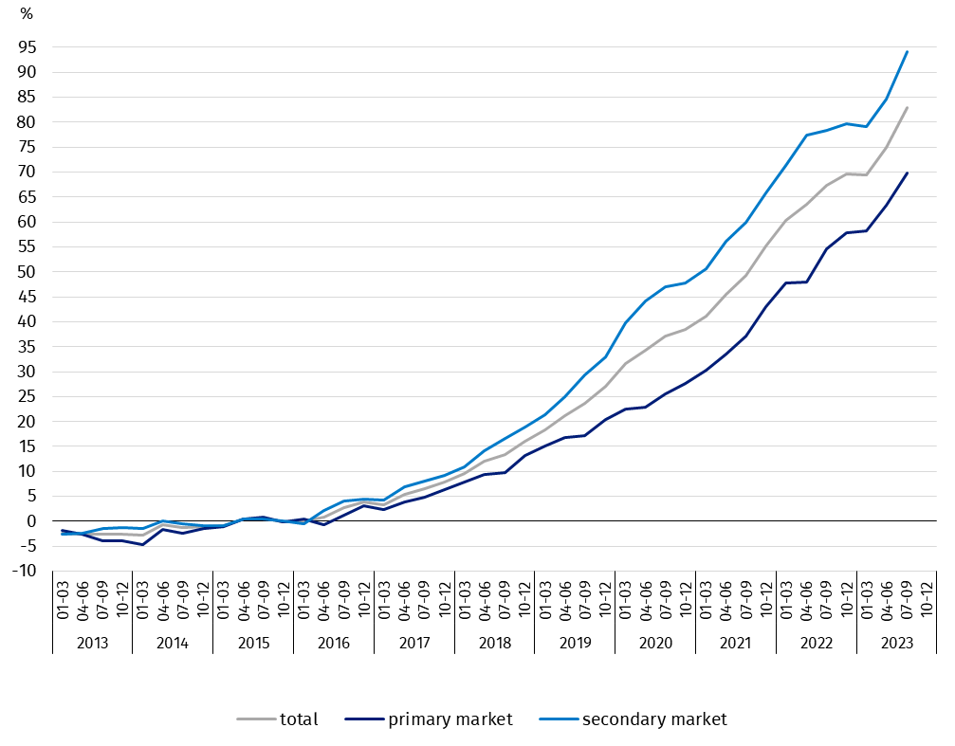

Table 2. Price indices of residential premises by voivodships in the third quarter of 2023
In the 3rd quarter of 2023, compared to the previous quarter, the highest increase in prices of residential premises was recorded in the Lubuskie Voivodship (by 7.2%), but the lowest price increase was observed in the Zachodniopomorskie Voivodship (by 1.6%)
Specification | Q3 2023
Specification | Q2 2023=100 | Q3 2022=100
Poland | 104.5 | 109.3
Dolnośląskie | 104.3 | 115.0
Kujawsko-Pomorskie | 102.3 | 105.1
Lubelskie | 103.9 | 111.8
Lubuskie | 107.2 | 108.2
Łódzkie | 104.4 | 107.5
Małopolskie | 107.0 | 114.2
Mazowieckie | 104.0 | 107.6
Opolskie | 103.7 | 110.7
Podkarpackie | 104.5 | 111.4
Podlaskie | 103.5 | 105.9
Pomorskie | 103.6 | 108.9
Śląskie | 105.5 | 108.5
Świętokrzyskie | 102.1 | 105.8
Warmińsko-Mazurskie | 105.5 | 111.0
Wielkopolskie | 105.8 | 105.1
Zachodniopomorskie | 101.6 | 103.6

In case of quoting Statistics Poland data, please provide information: “Source of data: Statistics Poland”, and in case of publishing calculations made on data published by Statistics Poland, please include the following disclaimer: “Own study based on figures from Statistics Poland”.

Prepared by:  Trade and Services Department  Director Ewa Adach - Stankiewicz  Phone: (+48 22) 608 31 24 | Issued by:  The Spokesperson for the President  of Statistics Poland  Karolina Banaszek  Phone: (+48) 695 255 011
Press Office  Phone: (+48 22) 608 38 04  e-mail: obslugaprasowa@stat.gov.pl |   www.stat.gov.pl/en/

@StatPoland

@GlownyUrzadStatystyczny

gus_stat

glownyurzadstatystycznygus

glownyurzadstatystyczny
Related information
Price indices of residential premises by voivodships
Price of one square meter of usable floor space of a residential building
Real estate sales in 2022

Data available in databases
Knowledge Databases (DBW) Prices
Local Data Bank – Real Estate Market

Terms used in official statistics
Real estate turnover
Real Estate Price Register
Premises
Price indices of residential premises

