Prices of agricultural products in November 2024
Procurement prices of basic agricultural products increased in November 2024 in comparison with the previous month (by 1.7%) as well as while compared to the corresponding period of the last year (by 3.5%).
3.5%
an increase in procurement prices of basic agricultural products in comparison with November 2023

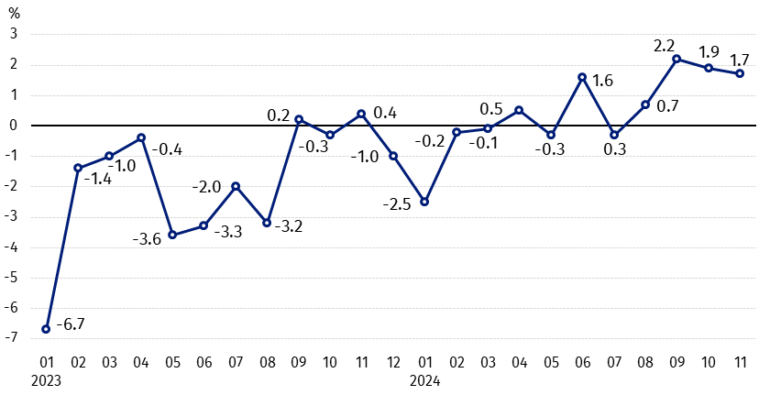
Chart 1. Changes in procurement prices of basic agricultural products in relation to the previous month
In November 2024 compared to October 2024, the procurement prices of wheat, rye, cattle for slaughter and cows’ milk increased

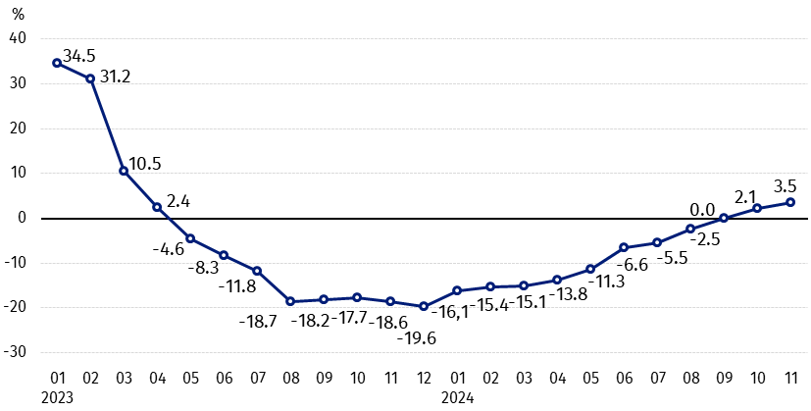
Chart 2. Changes in procurement prices of basic agricultural products in relation to the corresponding month of the previous year
Procurement prices of basic agricultural products, except rye and pigs for slaughter prices, in November 2024 were higher than those recorded in November 2023

Procurement prices and marketplace prices received by farmers

In November 2024 in comparison with the previous month, both in procurement and on marketplaces prices of most agricultural products were higher. On a monthly basis the prices of oats and pigs for slaughter in procurement, rye and triticale on marketplaces, as well as barley on both markets decreased.
Compared to the corresponding month of the previous year, in November 2024 the growth in procurement prices of most agricultural products was noted, while on marketplaces only cattle for slaughter increased. On both markets less was paid for rye, barley, oats and potatoes.

Table 1. Prices of agricultural products (excluding VAT) in November 2024
Specification | Procurement prices |  |  | Marketplaces prices
Specification | 11 2024
Specification | in zloty | 10 2024=100 | 11 2023=100 | in zloty | 10 2024=100 | 11 2023=100
Cereal grain – per 1 dt
Wheat | 90.13 | 102.5 | 102.5 | 108.85 | 100.0 | 94.3
Rye | 63.29 | 100.2 | 99.2 | 84.26 | 98.0 | 93.4
Barley | 76.95 | 96.8 | 92.9 | 101.83 | 99.8 | 94.1
Triticale | 76.86 | 99.3 | 105.0 | 93.71 | 99.4 | 94.4
Oat | 81.74 | 96.0 | 85.4 | 99.05 | 100.6 | 96.6
Maize | 71.84 | 117.3 | 117.7 | 120.39 | 100.4 | 90.9
Potatoes– per 1 dt | 64.86 | 112.2 | 84.1 | 210.75 | 100.8 | 92.8
Animals for slaughter – per kg
Cattle (excl. calves) | 11.54 | 106.9 | 116.8 | 11.96 | 102.0 | 104.4
of which young cattle | 11.95 | 107.7 | 117.2 | . | . | .
Pigs | 6.36 | 92.7 | 81.5 | . | . | .
Poultry | 5.56 | 100.0 | 104.1 | . | . | .
Cows’ milk – per 1 hl | 233.47 | 106.0 | 112.7 | . | . | .

Data on procurement prices were calculated on the basis of information on value and quantity of procurement by legal persons and independent organizational entities without legal personality (without natural persons).
Indices of procurement prices and prices received by farmers on marketplaces were calculated on the basis of absolute data expressed with more precision than In the tables.

Prices of major agricultural products in November 2024
In November 2024 PLN 90.13 was paid per dt of wheat in procurement, i.e. more than in October this year, as well as in the corresponding period of the last year (by 2.5%). On marketplaces, the price of wheat (PLN 108.85 per dt) has not changed in comparison with the previous month, but it was by 5.7% lower than in November 2023.
Rye in procurement (PLN 63.29 per dt) was sold more expensive compared to October this year (by 0.2%), but cheaper than in November 2023 (by 0.8%). The transaction price of rye on marketplace (PLN 84.26 per dt) decreased on a monthly basis (by 2.0%), as well as on an annual basis (by 6.6%).
In November 2024 PLN 64.86 was paid per dt of potatoes in procurement, i.e. by 12.2% more than in the previous month, but by 15.9% less than in the corresponding period of the last year. The price of potatoes on marketplaces (PLN 210.75 per dt) increased by 0.8% in comparison with October this year, but decreased by 7.2% compared to November 2023.
The procurement price of cattle for slaughter (PLN 11.54 per kg) was higher by 6.9% on a monthly basis and by 16.8% – on an annual basis. On marketplaces cattle for slaughter (PLN 11.96 per kg) was sold more expensive compared to October this year (by 2.0%), as well as to the corresponding period of the last year (by 4.4%).
In November 2024 PLN 6.39 was paid per kg of pigs for slaughter in procurement, i.e. by 7.3% less than a month ago and by 18.5% – than a year ago.
The procurement price of poultry for slaughter (PLN 5.56 per kg) has not changed in comparison with October 2024, while compared to November 2023 increased by 4.1%.
PLN 233.47 was paid in procurement per hl of cows’ milk, i.e. by 6.0% more than in the previous month and by 12.7% – than a year ago.

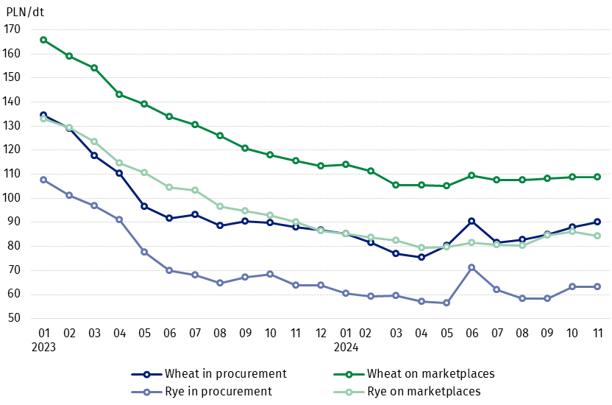
Chart 3. Procurement and marketplaces prices of wheat and rye

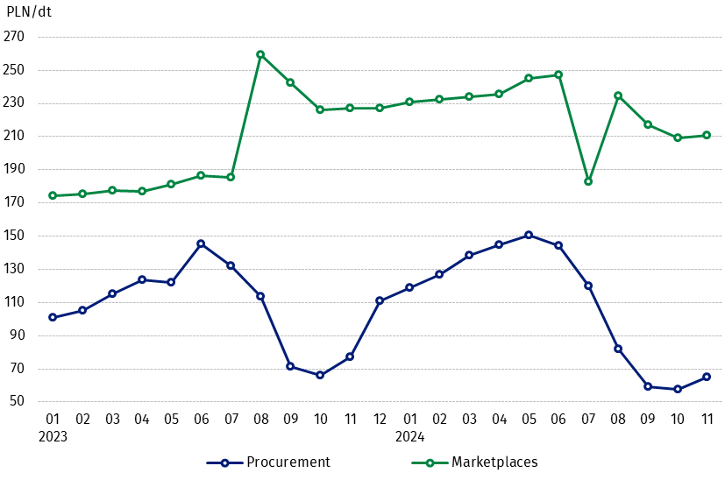
Chart 4. Procurement and marketplaces prices of potatoes

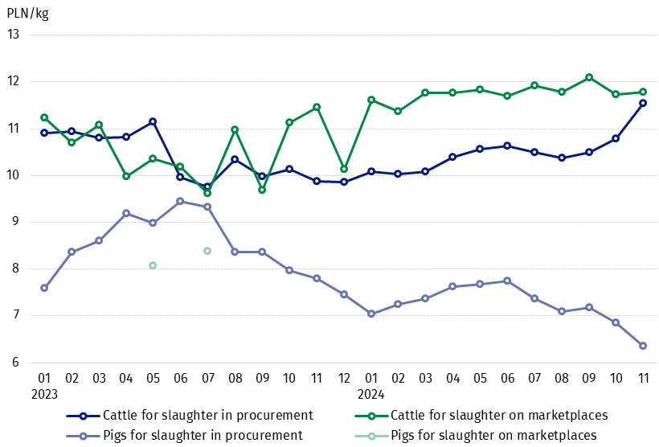
Chart 5. Procurement and marketplaces prices of cattle for slaughter and pigs for slaughter

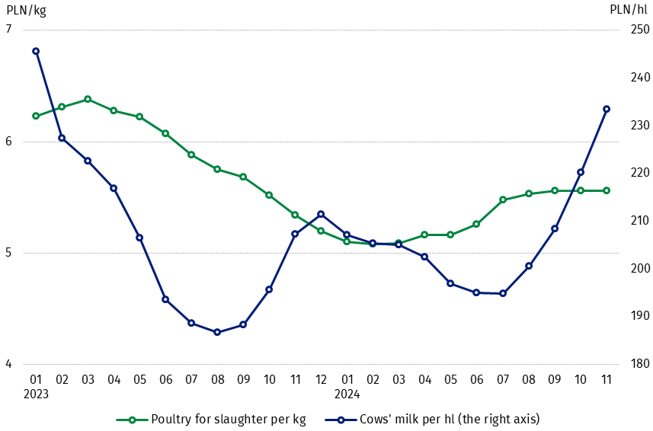
Chart 6. Procurement prices of poultry for slaughter and cows’ milk

The differentiation of the level of prices of basic agricultural products in particular voivodships is presented in Table 2 for procurement prices and in Table 3 for prices obtained by farmers on marketplaces (Excel sheet).
In case of quoting Statistics Poland data, please provide information: “Source of data: Statistics Poland”, and in case of publishing calculations made on data published by Statistics Poland, please include the following disclaimer: “Own study based on figures from Statistics Poland”.

Prepared by:  Trade and Services Departament  Director Ewa Adach-Stankiewicz  Phone: (+48 22) 608 31 24 | Issued by:  Press Office  Mobile: (+48) 695 255 032  Phone: (+48 22) 608 38 04, (+48 22) 449 41 45.  (+48 22) 608 30 09  e-mail: obslugaprasowa@stat.gov.pl

stat.gov.pl/en/

@StatPoland

@GlownyUrzadStatystyczny

gus_stat

glownyurzadstatystycznygus

glownyurzadstatystyczny
Related information
Socio-economic situation of the country in 2024
Procurement and prices of agricultural products in 2023

Data available in databases
BDL - Prices in agriculture (monthly and annual data)
DBW - Prices in agriculture (monthly and annual data)

Terms used in official statistics
Procurement of agricultural products
Procurement prices
Marketplace
Marketplace prices

Wheat, rye, cattle for slaughter, pigs for slaughter, poultry, cows’ milk
Procurement prices – excluding sowing seed.
Procurement prices – total (of which: edible early kinds, seed, edible late, industrial, of which starch). Marketplaces prices – edible excluding early kinds.
Marketplaces prices – average weighted price of cattle for slaughter calculated with the adoption of the structure of procurement quantity of young cattle and cows for slaughter.

