Prices of agricultural products in August 2024
Procurement prices of basic agricultural products increased in August 2024 in comparison with the previous month (by 0.7%), while compared to the corresponding period of the last year decreased (by 2.5%).
2.5%
a decrease in procurement prices of basic agricultural products in comparison with August 2023

Chart 1. Changes in procurement prices of basic agricultural products in relation to the previous month
In August 2024 compared to July 2024, the procurement prices of wheat, rye, poultry and cows’ milk increased

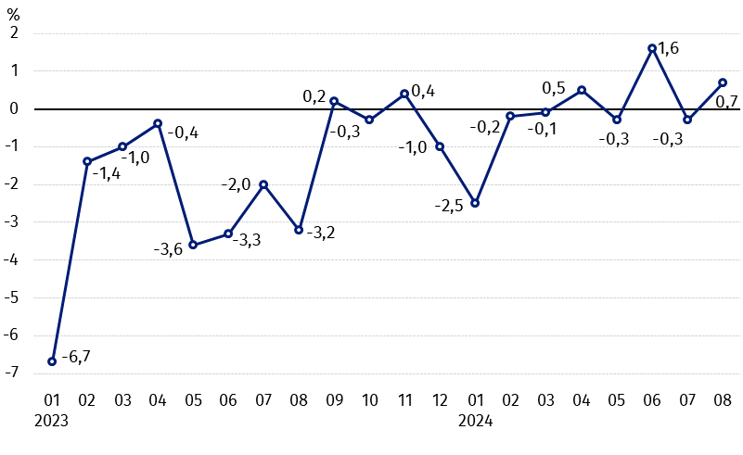Chart 2. Changes in procurement prices of basic agricultural products in relation to the corresponding month of the previous year

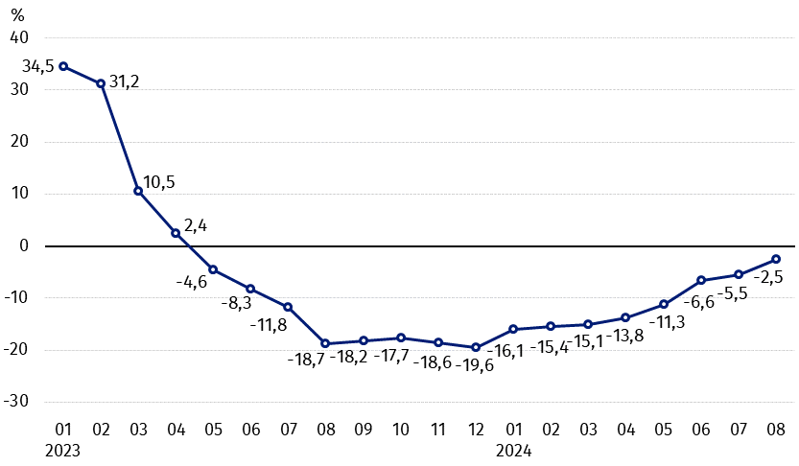
On an annual basis the procurement prices of wheat, rye, pigs for slaughter and poultry decreased

Procurement prices and marketplace prices received by farmers

In August 2024 in comparison with the previous month, both in procurement and on marketplaces prices of most agricultural products were lower. On a monthly basis the prices of wheat, barley, poultry and cows’ milk in procurement, maize and potatoes on marketplaces as well as triticale on both markets increased.
Compared to the corresponding month of the previous year, in August 2024 the fall in procurement prices and marketplaces prices of most agricultural products was noted. The prices cows’ milk in procurement, as well as cattle for slaughter on both markets increased.

Table 1. Prices of agricultural products (excluding VAT) in August 2024
Specification | Procurement prices |  |  | Marketplaces prices
Specification | 08 2024
Specification | in zloty | 07 2024=100 | 08 2023=100 | in zloty | 07 2024=100 | 08 2023=100
Cereal grain – per 1 dt
Wheat | 82.90 | 101.6 | 93.7 | 107.53 | 99.8 | 85.4
Rye | 58.39 | 94.2 | 90.1 | 80.38 | 99.7 | 83.2
Barley | 77.96 | 106.5 | 85.1 | 101.34 | 99.8 | 86.8
Triticale | 72.36 | 110.4 | 91.1 | 92.04 | 101.4 | 84.9
Oat | 73.49 | 99.1 | 96.2 | 99.56 | 100 | 91.4
Maize | 86.76 | 97.7 | 95.2 | 122.06 | 104.3 | 86.3
Potatoes– per 1 dt | 82.14 | 68.5 | 72.2 | 234,40 | 128.1 | 90.3
Animals for slaughter – per kg
Cattle (excl. calves) | 10.38 | 99.0 | 100.4 | 11.91 | 128.1 | 90.3
of which young cattle | 10.61 | 99.3 | 100.2 | . | . | .
Pigs | 7.09 | 96.2 | 84.8 | . | . | .
Poultry | 5.53 | 101.1 | 96.1 | . | . | .
Cows’ milk – per 1 hl | 200.63 | 102.9 | 107.4 | . | . | .
Data on procurement prices were calculated on the basis of information on value and quantity of procurement by legal persons and independent organizational entities without legal personality (without natural persons).
Indices of procurement prices and prices received by farmers on marketplaces were calculated on the basis of absolute data expressed with more precision than In the tables.

Prices of major agricultural products in August 2024
In August 2024 procurement price of wheat (PLN 82.90 per dt) increased by 1.6% in comparison with July this year and decreased by 6.3% compared to the corresponding period of the last year. On marketplaces, PLN 107.53 was paid per dt of wheat, i.e. by 0.2% less than a month ago and by 14.6% – than a year ago.
Rye in procurement (PLN 58.39 per dt) was sold cheaper compared to July this year (by 5.8%), as well as to August 2023 (by 9.9%). The transaction price of rye on marketplace (PLN 80.59 per dt) decrease by 0.3% on a monthly basis and by 16.8% on an annual basis.
In July 2024 PLN 82.14 was paid per dt of potatoes in procurement, i.e. by 31.5% less than in the previous month and by 28.8% – than in the corresponding period of the last year. The price of potatoes on marketplaces (PLN 234.40 per dt) increased by 28.1% in comparison with July this year and decreased by 9.7% compared to August 2023.
The procurement price of cattle for slaughter (PLN 10.38 per kg) was lower by 1.0% on a monthly basis, but it was higher by 0.4% on an annual basis. On marketplaces cattle for slaughter (PLN 11.78 per kg) was sold cheaper compared to July this year (by 1.1%), but more expensive to August 2023 (by 7.4%).
In August 2024 PLN 7.09 was paid per kg of pigs for slaughter in procurement. i.e. by 3.8% less than a month ago and by 15.2% – than a year ago.
The procurement price of poultry for slaughter (PLN 5.53 per kg) was by 1.0% higher in comparison with July 2024, while compared to the same period of the last year decreased by 3.9%.
PLN 200.63 was paid in procurement per hl of cows’ milk. i.e. by 2.9% more than in the previous month and by 7.4% more than a year ago.

Chart 3. Procurement and marketplaces prices of wheat and rye

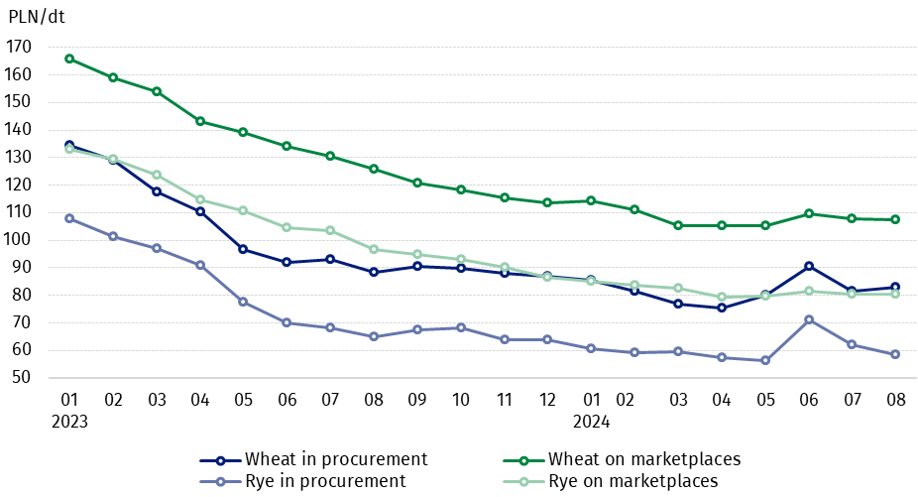

Chart 4. Procurement and marketplaces prices of potatoes

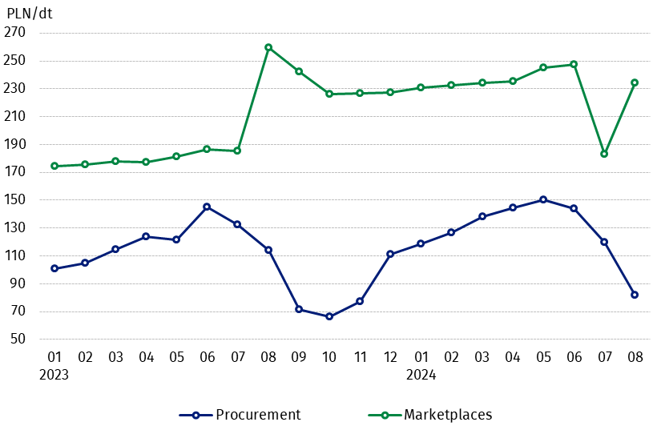

Chart 5. Procurement and marketplaces prices of cattle for slaughter and pigs for slaughter

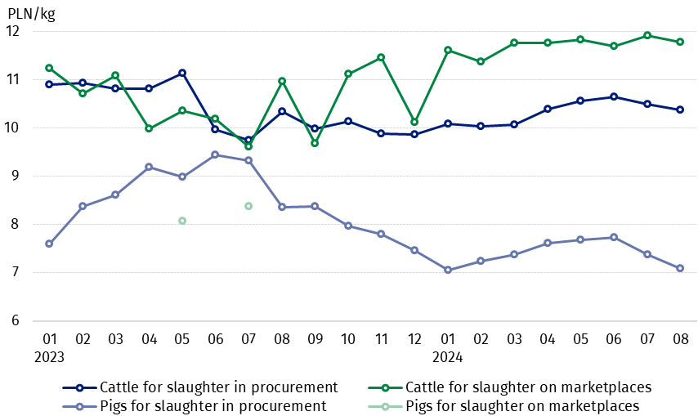

Chart 6. Procurement prices of poultry for slaughter and cows’ milk
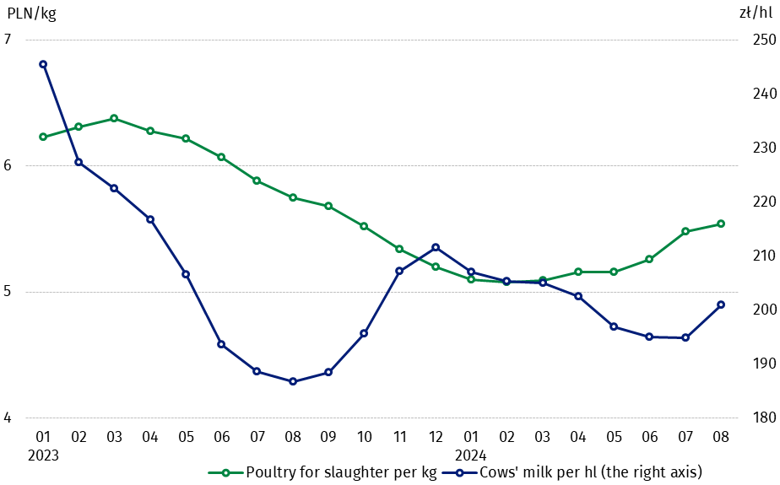

The differentiation of the level of prices of basic agricultural products in particular voivodships is presented in Table 2 for procurement prices and in Table 3 for prices obtained by farmers on marketplaces (Excel sheet).
In case of quoting Statistics Poland data, please provide information: “Source of data: Statistics Poland”, and in case of publishing calculations made on data published by Statistics Poland, please include the following disclaimer: “Own study based on figures from Statistics Poland”.

Prepared by:  Trade and Services Departament  Director Ewa Adach-Stankiewicz  Phone: (+48 22) 608 31 24 | Issued by:  Press Office  Mobile: (+48) 695 255 032  Phone: (+48 22) 608 38 04, (+48 22) 449 41 45.  (+48 22) 608 30 09  e-mail: obslugaprasowa@stat.gov.pl

stat.gov.pl/en/

@StatPoland

@GlownyUrzadStatystyczny

gus_stat

glownyurzadstatystycznygus

glownyurzadstatystyczny
Related information
Socio-economic situation of the country in 2024
Procurement and prices of agricultural products in 2023

Data available in databases
BDL - Prices in agriculture (monthly and annual data)
DBW - Prices in agriculture (monthly and annual data)

Terms used in official statistics
Procurement of agricultural products
Procurement prices
Marketplace
Marketplace prices

Wheat, rye, cattle for slaughter, pigs for slaughter, poultry, cows’ milk
Procurement prices – excluding sowing seed.
Procurement prices – total (of which: edible early kinds, seed, edible late, industrial, of which starch). Marketplaces prices – edible excluding early kinds.
Marketplaces prices – average weighted price of cattle for slaughter calculated with the adoption of the structure of procurement quantity of young cattle and cows for slaughter.

