Prices of agricultural products in June 2024
Procurement prices of basic agricultural products increased in June 2024 in comparison with the previous month (by 1.6%), while compared to the corresponding period of the last year decreased (by 6.6%).
6.6%
a decrease in procurement prices of basic agricultural products in comparison with June 2023

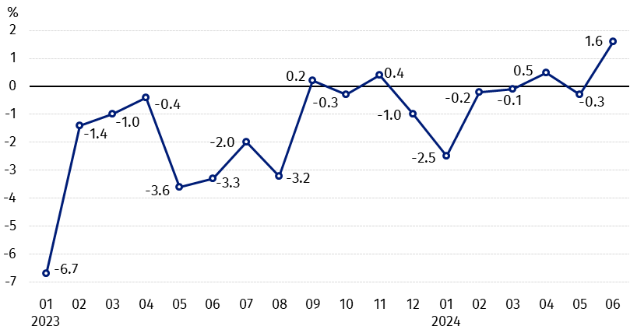
Chart 1. Changes in procurement prices of basic agricultural products in relation to the previous month
In June 2024 compared to May 2024, the procurement prices of wheat, rye and animals for slaughter increased

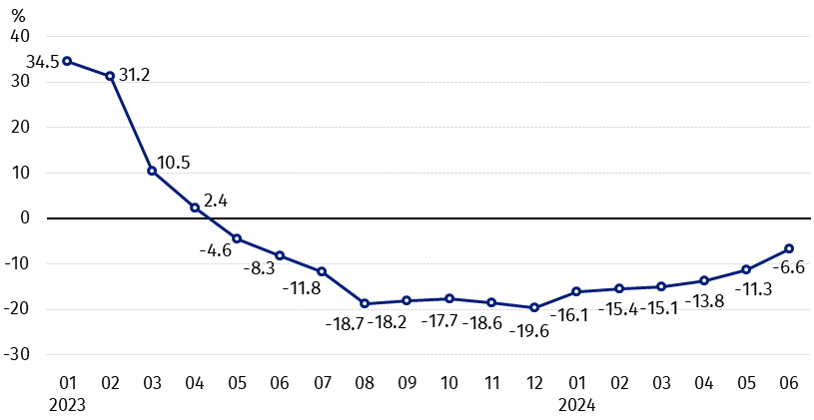
Chart 2. Changes in procurement prices of basic agricultural products in relation to the corresponding month of the previous year
On an annual basis the procurement prices of wheat, pigs for slaughter and poultry decreased

Procurement prices and marketplace prices received by farmers

In June 2024, in comparison with the previous month, both in procurement and on marketplaces, prices of most agricultural products were higher. On a monthly basis the prices of barley, potatoes and cows’ milk in procurement, as well as cattle for slaughter on marketplaces decreased.
Compared to the corresponding month of the previous year, in June 2024 the fall in procurement prices and marketplaces prices of most agricultural products was noted. The prices of rye, oats, maize and cows’ milk in procurement, as well as potatoes on marketplaces and cattle for slaughter on both markets increased.

Table 1. Prices of agricultural products (excluding VAT) in June 2024
Specification | Procurement prices |  |  | Marketplaces prices
Specification | 06 2024
Specification | in zloty | 05 2024=100 | 06 2023=100 | in zloty | 05 2024=100 | 06 2023=100
Cereal grain – per 1 dt
Wheat | 90.32 | 112.6 | 98.4 | 109.49 | 104.1 | 81.7
Rye | 71.12 | 126.1 | 101.5 | 81.45 | 102.3 | 78.0
Barley | 68.05 | 96.4 | 84.7 | 105.15 | 103.4 | 84.0
Triticale | 79.10 | 117.8 | 94.9 | 92.76 | 104.1 | 79.8
Oat | 90.54 | 109.0 | 113.9 | 103.02 | 103.2 | 89.2
Maize | 88.01 | 117.6 | 102.8 | 119.57 | 100.7 | 81.4
Potatoes– per 1 dt | 144.09 | 95.8 | 99.4 | 247.16 | 100.9 | 132.4
Animals for slaughter – per kg
Cattle (excl. calves) | 10.64 | 100.8 | 106.7 | 11.70 | 98.9 | 114.8
of which young cattle | 10.92 | 100.0 | 108.4 | . | . | .
Pigs | 7.74 | 100.7 | 82.0 | . | . | .
Poultry | 5.26 | 102.0 | 86.8 | . | . | .
Cows’ milk – per 1 hl | 195.04 | 99.1 | 100.8 | . | . | .
Data on procurement prices were calculated on the basis of information on value and quantity of procurement by legal persons and independent organizational entities without legal personality (without natural persons).
Indices of procurement prices and prices received by farmers on marketplaces were calculated on the basis of absolute data expressed with more precision than In the tables.

Prices of major agricultural products in June 2024
In June 2024 procurement price of wheat (PLN 90.32 per dt) increased in comparison with May this year (by 12.6%), but decreased compared to the corresponding period of the last year (by 1,6%). On marketplaces, PLN 109.49 was paid per dt of wheat, i.e. by 4.1% more than a month ago, but by 18.3% less than a year ago.
The price of rye in procurement (PLN 71.12 per dt) was by 26.1% higher compared to May this year and by 1.5% in comparison with June 2023. The transaction price of rye on marketplace (PLN 81.45 per dt) increased by 2.3% on a monthly basis, but decreased by 22.0% on an annual basis.
In June 2024 PLN 144.09 was paid per dt of potatoes in procurement, i.e. by 4.2% less than in the previous month and by 0.6% – than in the corresponding period of the last year. The price of potatoes on marketplaces (PLN 247.16 per dt) increased by 0.9% in comparison with May this year and by 32.4% compared to June 2023.
The procurement price of cattle for slaughter (PLN 10.64 per kg) was higher by 0.8% on a monthly basis and by 6.7% on an annual basis. On marketplaces cattle for slaughter (PLN 11.70 per kg) was sold cheaper compared to May this year (by 1.1%), while more expensive than in June 2023 (by 14.8%).
In June 2024 PLN 7.74 was paid per kg of pigs for slaughter in procurement, i.e. by 0.7% more than a month ago, but by 18.0% less than a year ago.
The procurement price of poultry for slaughter (PLN 5.26 per kg) was by 2.0% higher in comparison with May 2024, while compared to the same period of the last year decreased by 13.2%.
PLN 195.04 was paid in procurement per hl of cows’ milk, i.e. by 0.9% less than in the previous month, but by 0.8% more than a year ago.

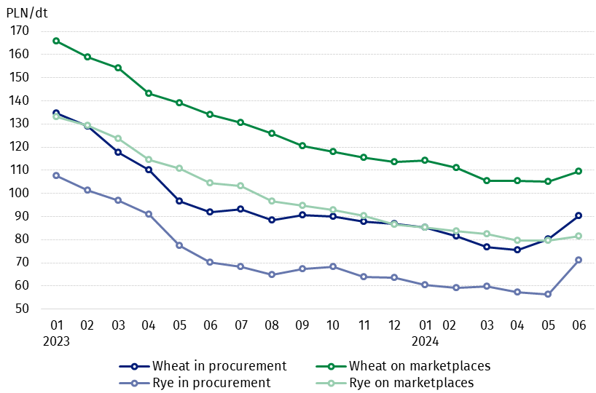
Chart 3. Procurement and marketplaces prices of wheat and rye

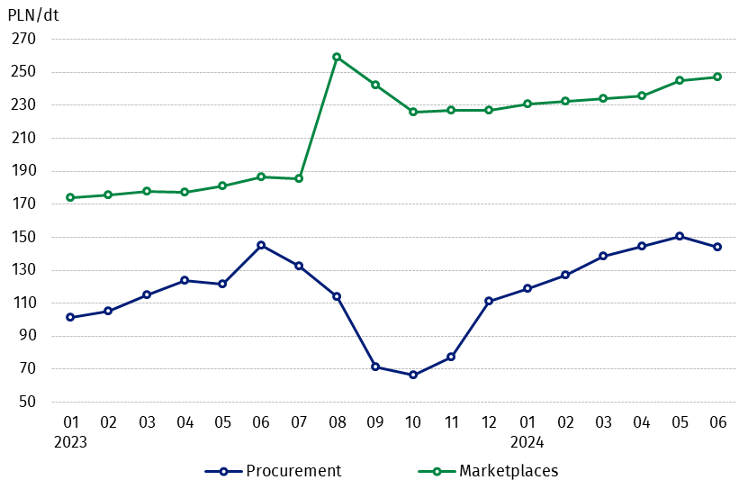
Chart 4. Procurement and marketplaces prices of potatoes

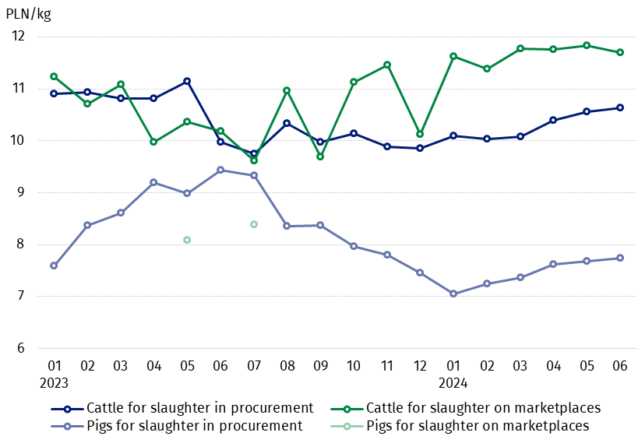
Chart 5. Procurement and marketplaces prices of cattle for slaughter and pigs for slaughter

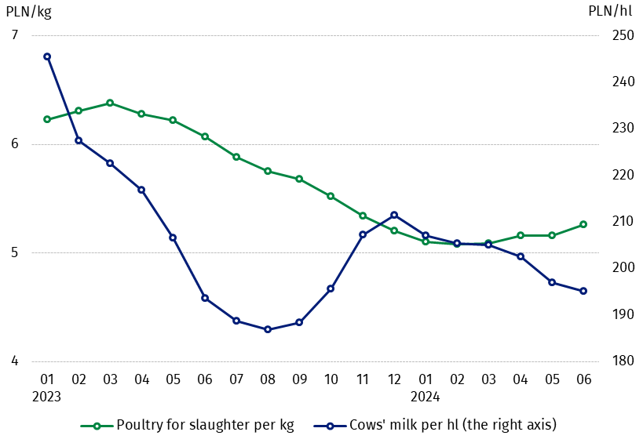
Chart 6. Procurement prices of poultry for slaughter and cows’ milk

The differentiation of the level of prices of basic agricultural products in particular voivodships is presented in Table 2 for procurement prices and in Table 3 for prices obtained by farmers on marketplaces (Excel sheet).
In case of quoting Statistics Poland data, please provide information: “Source of data: Statistics Poland”, and in case of publishing calculations made on data published by Statistics Poland, please include the following disclaimer: “Own study based on figures from Statistics Poland”.

Prepared by:  Trade and Services Departament  Director Ewa Adach-Stankiewicz  Phone: (+48 22) 608 31 24 | Issued by:  Press Office  Mobile: (+48) 695 255 032  Phone: (+48 22) 608 38 04, (+48 22) 449 41 45,  (+48 22) 608 30 09  e-mail: obslugaprasowa@stat.gov.pl

stat.gov.pl/en/

@StatPoland

@GlownyUrzadStatystyczny

gus_stat

glownyurzadstatystycznygus

glownyurzadstatystyczny
Related information
Socio-economic situation of the country in 2024
Procurement and prices of agricultural products in 2023

Data available in databases
BDL - Prices in agriculture (monthly and annual data)
DBW - Prices in agriculture (monthly and annual data)

Terms used in official statistics
Procurement of agricultural products
Procurement prices
Marketplace
Marketplace prices

Wheat, rye, cattle for slaughter, pigs for slaughter, poultry, cows’ milk
Procurement prices – excluding sowing seed.
Procurement prices – total (of which: edible early kinds, seed, edible late, industrial, of which starch). Marketplaces prices – edible excluding early kinds.
Marketplaces prices – average weighted price of cattle for slaughter calculated with the adoption of the structure of procurement quantity of young cattle and cows for slaughter.

