Prices of agricultural products in May 2024
Procurement prices of basic agricultural products decreased in May 2024 in comparison with the previous month (by 0.3%) as well as while compared to the corresponding period of the last year (by 11.3%).
11.3%
a decrease in procurement prices of basic agricultural products in comparison with May 2023

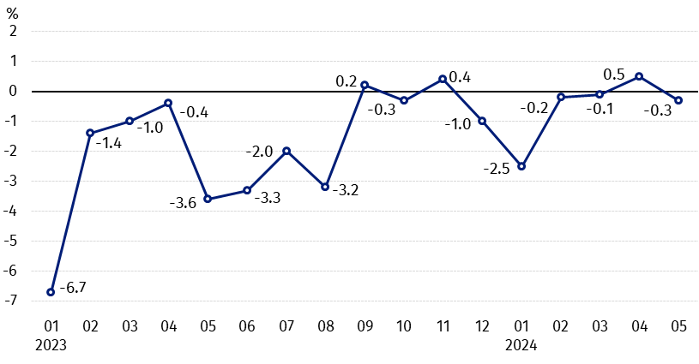
Chart 1. Changes in procurement prices of basic agricultural products in relation to the previous month
In May 2024 compared to April 2024, the procurement prices of rye and cows’ milk decreased

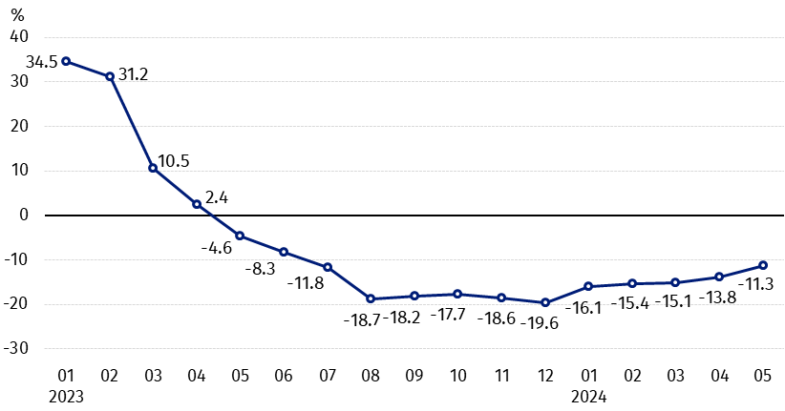
Chart 2. Changes in procurement prices of basic agricultural products in relation to the corresponding month of the previous year
Procurement prices of all basic agricultural products, in May 2024 were lower than those recorded in May 2023

Procurement prices and marketplace prices received by farmers

In May 2024, in comparison with the previous month, both in procurement and on marketplaces, prices of most agricultural products were higher. On a monthly basis the prices of rye, barley and cows’ milk in procurement, as well as oats on both markets decreased.
Compared to the corresponding month of the previous year, in May 2024 the fall in procurement prices and marketplaces prices of all agricultural products was noted, except cattle for slaughter on marketplaces, as well as potatoes (in procurement and on marketplaces).

Table 1. Prices of agricultural products (excluding VAT) in May 2024
Specification | Procurement prices |  |  | Marketplaces prices
Specification | 05 2024
Specification | in zloty | 04 2024=100 | 05 2023=100 | in zloty | 04 2024=100 | 05 2023=100
Cereal grain – per 1 dt
Wheat | 80.20 | 106.4 | 83.0 | 105.19 | 99.9 | 75.6
Rye | 56.40 | 98.6 | 72.7 | 79.64 | 100.2 | 72.0
Barley | 70.60 | 99.1 | 81.4 | 101.73 | 100.4 | 77.0
Triticale | 67.15 | 100.7 | 76.2 | 89.11 | 99.4 | 72.0
Oat | 83.08 | 90.7 | 94.1 | 99.83 | 98.0 | 81.4
Maize | 74.83 | 108.7 | 79.1 | 118.69 | 100.9 | 78.6
Potatoes– per 1 dt | 150.36 | 104.0 | 123.4 | 244.90 | 103.9 | 135.1
Animals for slaughter – per kg
Cattle (excl. calves) | 10.56 | 101.7 | 94.8 | 11.83 | 100.6 | 114.2
of which young cattle | 10.92 | 102.4 | 95.8 | . | . | .
Pigs | 7.68 | 100.8 | 85.5 | . | . | .
Poultry | 5.16 | 100.1 | 82.9 | . | . | .
Cows’ milk – per 1 hl | 196.89 | 97.2 | 95.3 | . | . | .
Data on procurement prices were calculated on the basis of information on value and quantity of procurement by legal persons and independent organizational entities without legal personality (without natural persons).
Indices of procurement prices and prices received by farmers on marketplaces were calculated on the basis of absolute data expressed with more precision than In the tables.

Prices of major agricultural products in May 2024
In May 2024 procurement price of wheat (PLN 80.20 per dt) increased in comparison with April this year (by 6.4%), but decreased with the corresponding period of the last year (by 17.0%). On marketplaces, PLN 105.19 was paid per dt of wheat, i.e. by 0.1% less than a month ago and by 24.4% – than a year ago.
The price of rye in procurement (PLN 56.40 per dt) was by 1.4% lower compared to April this year and by 27.3% in comparison with May 2023. The transaction price of rye on marketplace (PLN 79.64 per dt) increased by 0.2% on a monthly basis, but decreased by 28.0% on an annual basis.
In May 2024 PLN 150.36 was paid per dt of potatoes in procurement, i.e. by 4.0% more than in the previous month and by 23.4% – than in the corresponding period of the last year. The price of potatoes on marketplaces (PLN 244.90 per dt) increased by 3.9% in comparison with April this year and by 35.1% compared to May 2023.
The procurement price of cattle for slaughter (PLN 10.56 per kg) was higher on a monthly basis (by 1.7%), but it was lower on an annual basis (by 5.2%). On marketplaces cattle for slaughter (PLN 11.83 per kg) was sold more expensive compared to April this year (by 0.6%), as well as compared to May 2023 (by 14.2%).
In May 2024 PLN 7.68 was paid per kg of pigs for slaughter in procurement, i.e. by 0.8% more than a month ago, but by 14.5% less than a year ago.
The procurement price of poultry for slaughter (PLN 5.16 per kg) was by 0.1% higher in comparison with April 2024, while compared to the same period of the last year decreased by 17.1%.
PLN 196.89 was paid in procurement per hl of cows’ milk, i.e. by 2.8% less than in the previous month and by 4.7% – than a year ago.

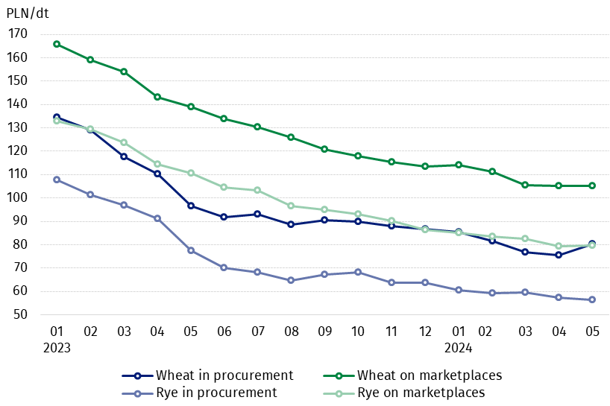
Chart 3. Procurement and marketplaces prices of wheat and rye

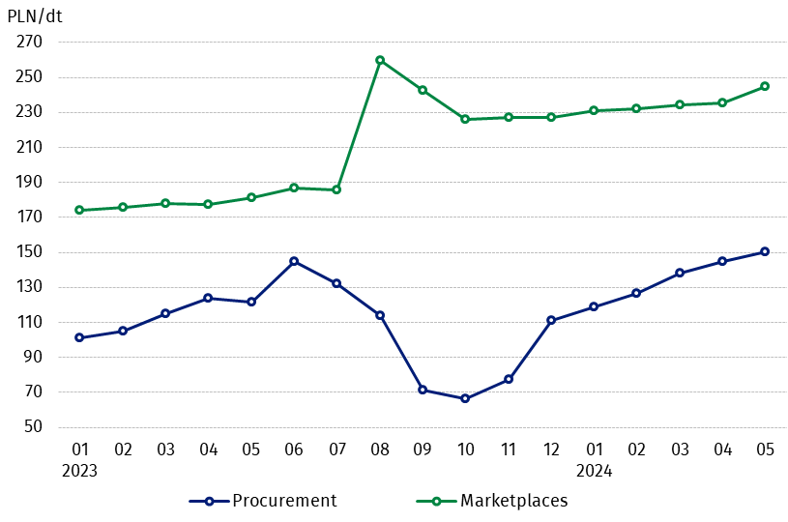
Chart 4. Procurement and marketplaces prices of potatoes

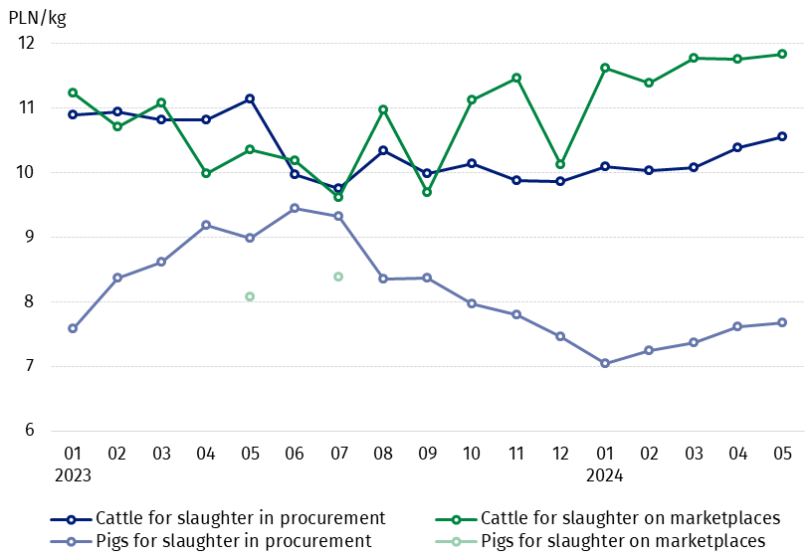
Chart 5. Procurement and marketplaces prices of cattle for slaughter and pigs for slaughter

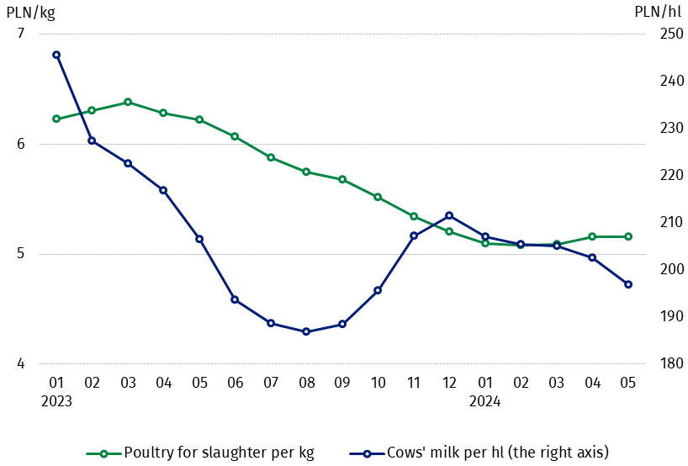
Chart 6. Procurement prices of poultry for slaughter and cows’ milk

The differentiation of the level of prices of basic agricultural products in particular voivodships is presented in Table 2 for procurement prices and in Table 3 for prices obtained by farmers on marketplaces (Excel sheet).
In case of quoting Statistics Poland data, please provide information: “Source of data: Statistics Poland”, and in case of publishing calculations made on data published by Statistics Poland, please include the following disclaimer: “Own study based on figures from Statistics Poland”.

Prepared by:  Trade and Services Departament  Director Ewa Adach-Stankiewicz  Phone: (+48 22) 608 31 24 | Issued by:  Press Office  Mobile: (+48) 695 255 032  Phone: (+48 22) 608 38 04, (+48 22) 449 41 45,  (+48 22) 608 30 09  e-mail: obslugaprasowa@stat.gov.pl

stat.gov.pl/en/

@StatPoland

@GlownyUrzadStatystyczny

gus_stat

glownyurzadstatystycznygus

glownyurzadstatystyczny
Related information
Socio-economic situation of the country in 2024
Procurement and prices of agricultural products in 2023

Data available in databases
BDL - Prices in agriculture (monthly and annual data)
DBW - Prices in agriculture (monthly and annual data)

Terms used in official statistics
Procurement of agricultural products
Procurement prices
Marketplace
Marketplace prices

Wheat, rye, cattle for slaughter, pigs for slaughter, poultry, cows’ milk
Procurement prices – excluding sowing seed.
Procurement prices – total (of which: edible early kinds, seed, edible late, industrial, of which starch). Marketplaces prices – edible excluding early kinds.
Marketplaces prices – average weighted price of cattle for slaughter calculated with the adoption of the structure of procurement quantity of young cattle and cows for slaughter.

