Prices of agricultural products in December 2023
Procurement prices of basic agricultural products decreased in December 2023 in comparison with the previous month (by 1.0%) as well as while compared to the corresponding period of the last year (by 19.6%).
19.6%
a decrease in procurement prices of basic agricultural products in comparison with December 2022

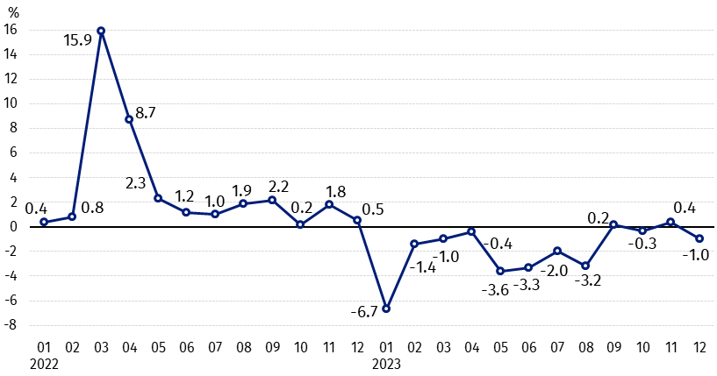
Chart 1. Changes in procurement prices of basic agricultural products in relation to the previous month
In December 2023 compared to November 2023, the procurement prices of all basic agricultural products except cows’ milk decreased

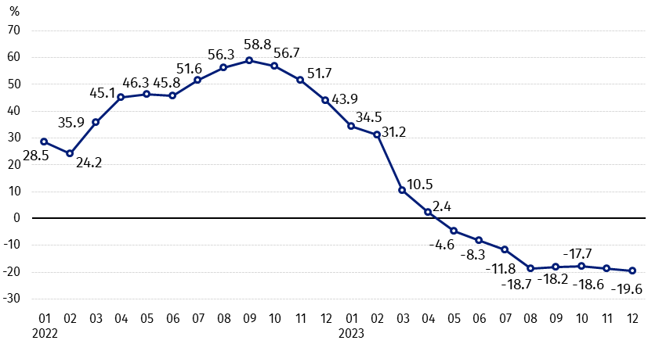
Chart 2. Changes in procurement prices of basic agricultural products in relation to the corresponding month of the previous year
Procurement prices of all basic agricultural products, in December 2023 were lower than those recorded in December 2022

Procurement prices and marketplace prices received by farmers
In December 2023, in comparison with the previous month, as well as compared to the corresponding period of the last year, both in procurement and on marketplaces, prices of most agricultural products were lower. On a monthly basis the prices of triticale, maize, potatoes and cows’ milk in procurement, as well as oats on both markets increased. The prices of triticale and potatoes on marketplaces have not changed. While on an annual basis more was paid only for potatoes (in procurement and on marketplaces).

Table 1. Prices of agricultural products (excluding VAT) in December 2023
Specification | Procurement prices |  |  | Marketplaces prices
Specification | 12 2023
Specification | in zloty | 11 2023=100 | 12 2022=100 | in zloty | 11 2023=100 | 12 2022=100
Cereal grain – per 1 dt
Wheat | 86.79 | 98.7 | 59.2 | 113.53 | 98.4 | 67.0
Rye | 63.70 | 99.9 | 55.2 | 86.48 | 95.9 | 63.8
Barley | 82.70 | 99.8 | 60.9 | 107.19 | 99.0 | 68.4
Triticale | 73.85 | 100.9 | 55.7 | 99.20 | 100.0 | 65.9
Oat | 96.73 | 101.1 | 72.7 | 102.73 | 100.2 | 74.0
Maize | 74.82 | 122.6 | 58.3 | 123.43 | 93.2 | 71.9
Potatoes– per 1 dt | 111.11 | 144.0 | 112.9 | 227.02 | 100.0 | 131.0
Animals for slaughter – per kg
Cattle (excl. calves) | 9.86 | 99.8 | 90.3 | 10.13 | 88.4 | 96.5
of which young cattle | 10.29 | 100.9 | 92.5 | 10.94 | . | 98.5
Pigs ª | 7.46 | 95.7 | 94.8 | . | . | .
Poultry | 5.20 | 97.3 | 81.4 | . | . | .
Cows’ milk – per 1 hl | 211.51 | 102.1 | 76.8 | . | . | .
a – No data.
Data on procurement prices were calculated on the basis of information on value and quantity of procurement by legal persons and independent organizational entities without legal personality (without natural persons).
Indices of procurement prices and prices received by farmers on marketplaces were calculated on the basis of absolute data expressed with more precision than In the tables.

Prices of major agricultural products in December 2023
In December 2023 procurement price of wheat (PLN 86.79 per dt) decreased in comparison with November 2023 (by 1.3%), as well as with the corresponding period 2022 (by 40.8%). On marketplaces, wheat was sold for PLN 113.53 per dt, i.e. by 1.6% cheaper than in the previous month and by 33.0% – than in December 2022.
The price of rye in procurement (PLN 63.70 per dt) was lower by (0.1%) compared to November 2023 and by 44.8% in comparison with December 2022. The transaction price of rye on marketplace (PLN 86.48 per dt) decreased by 4.1% on a monthly basis and by 36.2% on an annual basis.
In December 2023 PLN 111.11 was paid per dt of potatoes in procurement, i.e. by 44.0% more than in November 2023 and by 12.9% – than in the corresponding period 2022. Such a large increase in prices in comparison with the previous month was caused by purchase of late potatoes, whose share in purchase amounted to almost 50%. The price of potatoes on marketplaces (PLN 227.02 per dt) remained at the November 2023 level, but it increased by 31.0% compared to December 2022.
The procurement price of cattle for slaughter (PLN 9.86 per kg) was lower on a monthly basis (by 0.2%), as well as on an annual basis (by 9.7%). On marketplaces cattle for slaughter (PLN 10.13 per kg) was sold by 11.6% cheaper than in November 2023 and by 3.5% – than in the corresponding period 2022.
In December 2023 PLN 7.46 was paid per kg of pigs for slaughter in procurement, i.e. by 4.3% less than a month ago and by 5.2% – than in December 2022.
The procurement price of poultry for slaughter (PLN 5.20 per kg) decreased in comparison with November 2023 (by 2.7%), as well as compared to the same period 2022 (by 18.6%).
PLN 211.51 was paid in procurement per hl of cows’ milk, i.e. by 2.1% more than in the previous month, but by 23.2% less than in December 2022.

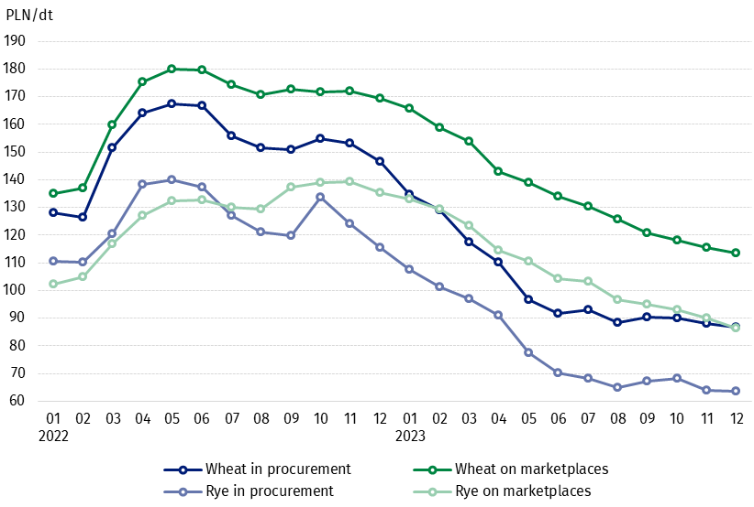
Chart 3. Procurement and marketplaces prices of wheat and rye

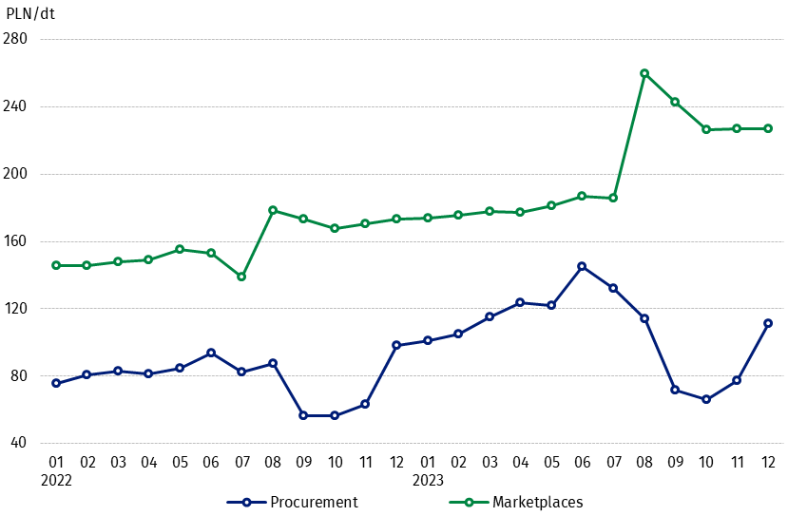
Chart 4. Procurement and marketplaces prices of potatoes

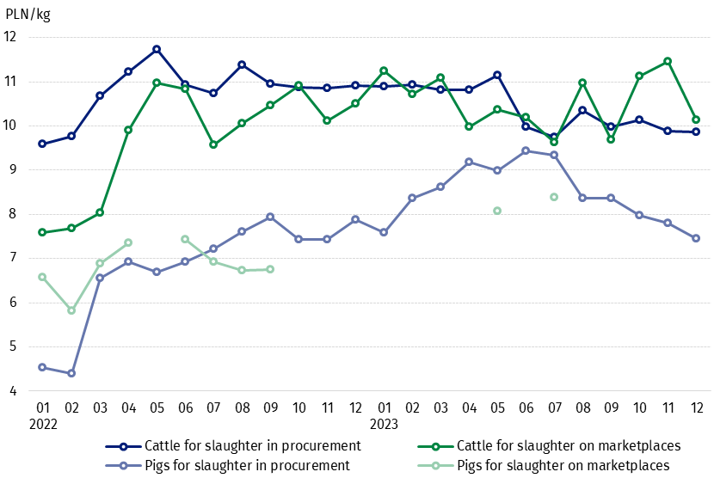
Chart 5. Procurement and marketplaces prices of cattle for slaughter and pigs for slaughter

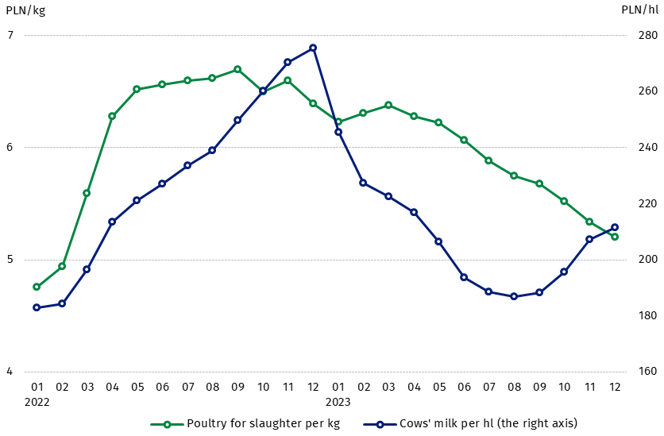
Chart 6. Procurement prices of poultry for slaughter and cows’ milk

The differentiation of the level of prices of basic agricultural products in particular voivodships is presented in Table 2 for procurement prices and in Table 3 for prices obtained by farmers on marketplaces (Excel sheet).
In case of quoting Statistics Poland data, please provide information: “Source of data: Statistics Poland”, and in case of publishing calculations made on data published by Statistics Poland, please include the following disclaimer: “Own study based on figures from Statistics Poland”.

Prepared by:  Trade and Services Departament  Director Ewa Adach-Stankiewicz  Phone: (+48 22) 608 31 24 | Issued by:  The Spokesperson for the President  of Statistics Poland  Karolina Banaszek  Phone: (+48) 695 255 011
Press Office  Phone: (+48 22) 608 38 04  e-mail: obslugaprasowa@stat.gov.pl |   www.stat.gov.pl/en/

@StatPoland

@GlownyUrzadStatystyczny

gus_stat

glownyurzadstatystycznygus

glownyurzadstatystyczny
Related information
Socio-economic situation of the country in 2023
Procurement and prices of agricultural products in 2022

Data available in databases
BDL - Prices in agriculture (monthly and annual data)
DBW - Prices in agriculture (monthly and annual data)

Terms used in official statistics
Procurement of agricultural products
Procurement prices
Marketplace
Marketplace prices

Wheat, rye, cattle for slaughter, pigs for slaughter, poultry, cows’ milk
Procurement prices – excluding sowing seed.
Procurement prices – total (of which: edible early kinds, seed, edible late, industrial, of which starch). Marketplaces prices – edible excluding early kinds.
Marketplaces prices – average weighted price of cattle for slaughter calculated with the adoption of the structure of procurement quantity of young cattle and cows for slaughter.

