Health care in households in 2023 – preliminary
results
30.10.2024
In 2023 every fourth person assessed their own health as very good (24.8%) and about half as good (47.0%). 5.2% of respondents assessed their health state as bad and 0.8% of respondents as very bad. More than one fifth of interviewees stated that their health state is fair (22.2%). Men more often than women assessed their health as good or very good (76.3% and 67.6%, respectively).
71.8%
of respondents assessed their own health as good or very good, i.e. 3.3 percentage points more than in 2020

Background information on survey
The survey was conducted on a sample of households taking part in household budget surveys in the 4th quarter of 2022 and the 4th quarter of 2023. All persons aged 15 or more were interviewed, while information about children up to the age of 14 were given by their parents or other persons best aware in children situation. The collected answers covered a period from 1 January to 31 December 2023, whereas chosen questions (due to surveyed phenomenon) were relevant to 4th quarter of 2023 only.
When comparing with the previous edition of survey from 2021 (covering the state for 2020) it should be noted that the COVID-19 pandemic happened.
Assessment of health
In 2023 71.8% of respondents assessed their own health as good or very good (68.5% in 2020), while every fourth person rated their health as very good (24.8%; 26.4% in 2020) and 47.0% as good (42.1% in 2020). On the other hand 5.2% of persons assessed their health state as bad and 0.8% of persons as very bad (6.0% and 0.7% in 2020, respectively). More than one fifth
of interviewees stated that their health state is fair (22.2%; 24.8% in 2020). Men more often than women assessed their health as good or very good (76.3% and 67.6% respectively).
Men more often than women assessed their health as good or very good (76.3% and 67.6% respectively).
Chronically ill persons appeared in more than half of surveyed households (53.6%;
57.2% in 2020) , while their share was different depending on place of residence. It was 52.1% in urban areas and 56.7% in rural areas.
In 14.2% of households there were persons with relevant certificate of disability issued by the authorized authorities, whereas in 2020 the percentage was 17%. The households with persons with disabilities were more common in rural areas (16.1%) than in urban areas (13.2%).
Serious health problems (including rapid exacerbation of illness) in the last quarter of 2023 occurred in about 12% of households (above 14% in 2020).
In 2023, when all respondents, regardless of age, were asked about occurrence of diseases identified by doctor, similarly to the previous edition of survey most persons identified illnesses such as: hypertension (20.0%; 20.7% in 2020) and joint diseases (12.8%; 14.4%
in 2020). The biggest difference in percentage of diseases declared by respondents has been noted in the case of lung diseases other than asthma. In 2023 4.6% of persons declared
the occurrence of that disease (1.6% in 2020) .
In 2023 every fifth respondent identified hypertension, while joint diseases (12.8%) and thyroid diseases (8.1%) were also common

Chart 1. Percentage of persons suffering from selected illnesses in respondents’
declarations in 2023

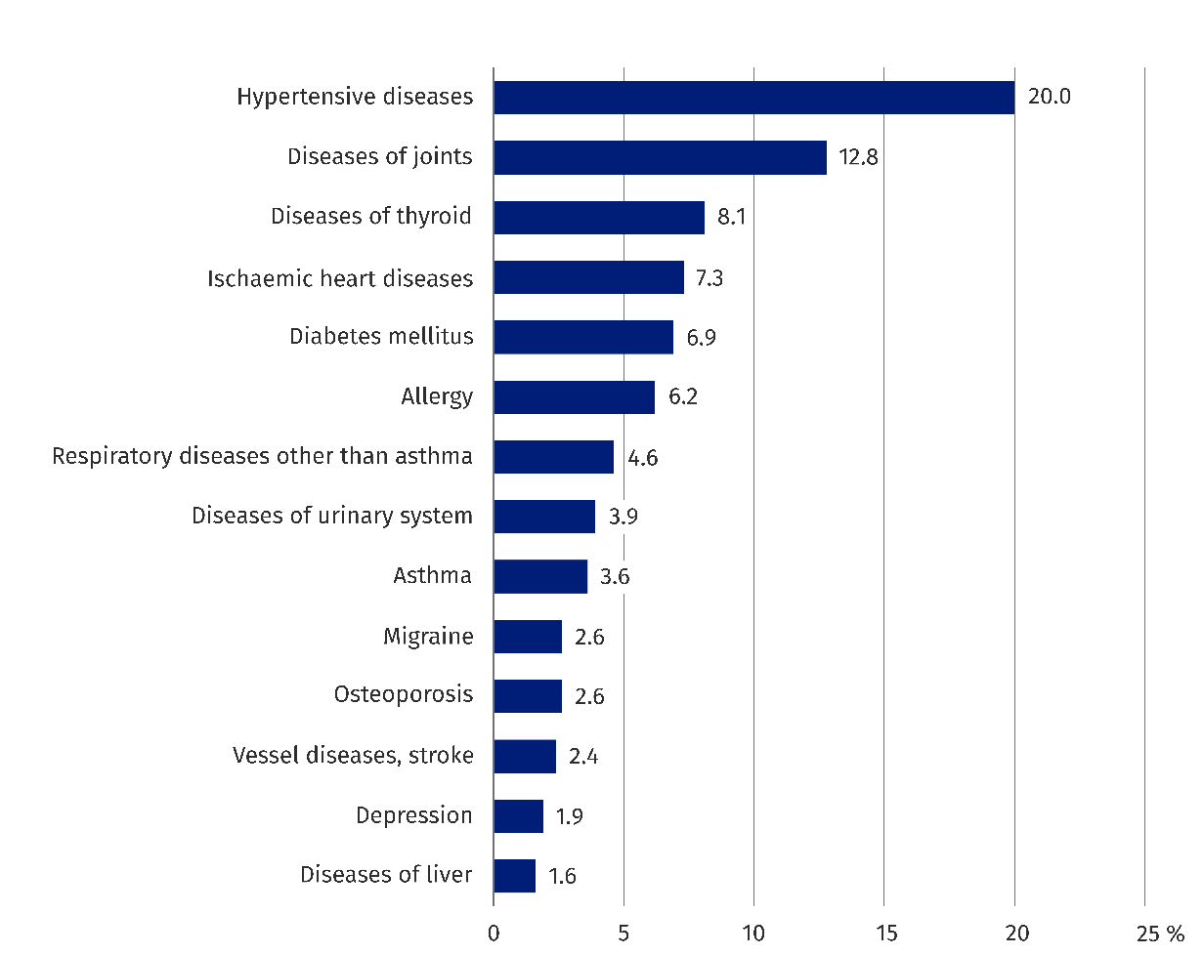

Almost every fifth respondent (19.9%) aged 15 and more had limited ability to perform activities, performed usually by humans, that lasted 6 months or more due to health problems. In 2020 the number was 21.8% of persons. Severely limited abilities to perform activities were reported by 3.8% of respondents (3.9% in 2020), while limited, but not severely by 16.1% of respondents (17.9% in 2020). The percentage of persons with limitations increased accordingly with age. In 80 years and more age group more than half of respondents (53.9%; 63.4% in 2020) had these limitations.
In 2023 when asked about crucial factors of health state over half (51.3%) of respondents aged 15 and more stated their own behavior as the most important factor (54.6% in 2020). The next group was persons that stated quality of health care as the most important crucial factor of their health state – 37.0% (32.2% in 2020). The least amount of persons, 11.7%, said that the factors that decide primarily on their health state were factors beyond their control (13.3% in 2020).

Chart 2. The most important factors that have impact on health state by respondents

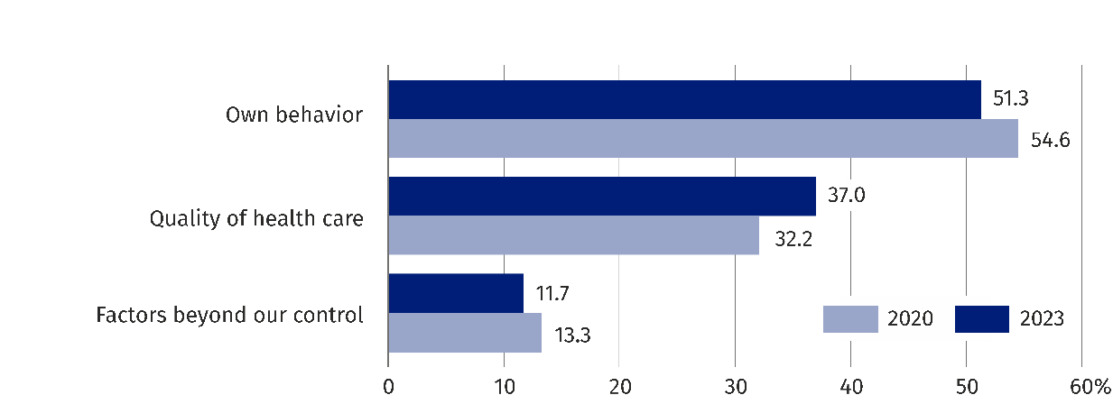

Use of medicines in the 4th quarter of 2023
Women (73.6%) more often than men (64.8%) consumed medicines or dietary supplements.
In the last quarter of 2023 69.4% of persons used at least one medicine or dietary supplement (74.3% in 2020). Women (73.6%) more often than men (64.8%) consumed medicines or dietary supplements. In 2020 it was 80.1% of women and 68.2% of men respectively. Almost three quarters (73.4%) of urban areas population used medicines or dietary supplements, while this percentage among population of rural areas was 63.1% (76.3% and 71.2% in 2020, respectively).
When it comes to consumption of medicines or dietary supplements, the important factors were the self-assessment of health state or age of respondent. In the last quarter of 2023, medicines or dietary supplements were consumed by 61.1% of persons with at least good self-assessment of health state and 94.2% of respondents with bad or very bad self-assessment. Medicines or dietary supplements were consumed most often by older persons – 90.6% by persons aged 70 and more, and 86.4% of persons aged 60-69. On the other hand these medicines were consumed most rarely by persons aged 17-24 (53.3%).
Almost three quarters (73.4%) of urban areas population consumed medicines or dietary supplements, while the percentage among inhabitants of rural areas was 63.1% (76.3% and 71.2% in 2020, respectively).

By analysing types of medicine or dietary supplements we can see that 40.0% of total consumers took headache medicine, in which case women (45.9%) consumed them more often than men (32.9%). The next were cardiovascular disease medicines (24.5%) and joint disease medicines (21.0%). Almost every fourth respondent that took medicines or dietary supplements (23.5%) consumed antibiotics in the 4th quarter of 2023.

Chart 3. Persons using medicines or dietary supplements in the 4th quarter of 2023
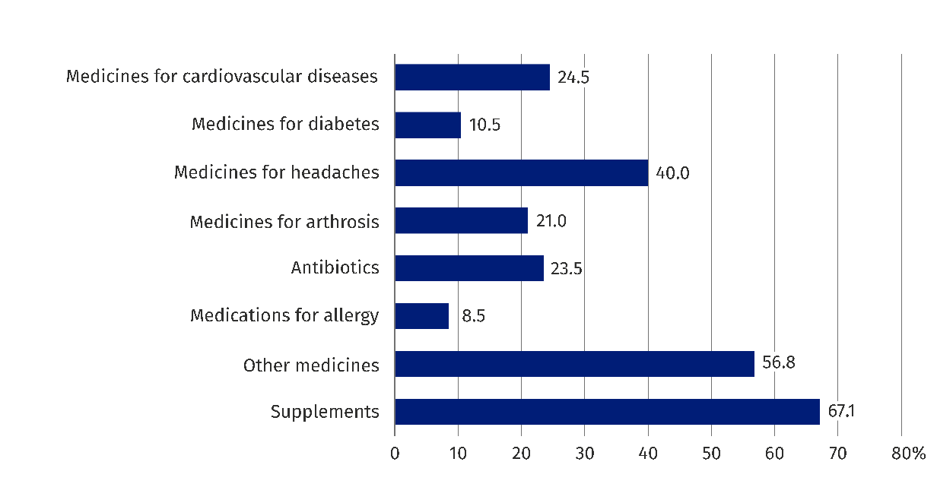

Use of health care services
In 2023, 7.6% of Polish residents were admitted to a hospital or other inpatient health care facility. 6.2% of men and 9.0% of women used health care in such facilities. Compared to previous study, the proportion of people receiving inpatient health care has decreased – in 2020 it amounted to 8.3%³. The frequency of hospitalisation and the use of doctor consultation in primary health care are closely related to the health status of the population and increased with age.

Chart 4. Persons staying in inpatient health care facilities by sex
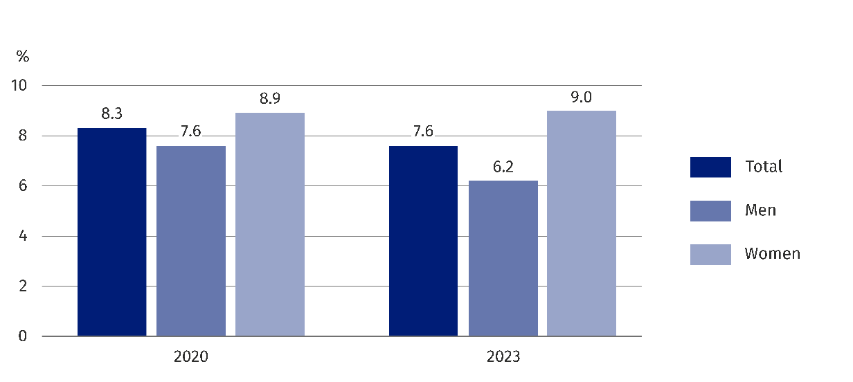

Elderly people were relatively more likely to stay in inpatient health care facilities. Unlike the total population, older men were hospitalised more often than women. The proportion of those aged 70 or more and hospitalised in hospitals or other inpatient health care facilities in 2023 was 18.2% among men and 13.5% among women.
The predominant financing agent of stays in hospitals and other inpatient health care facilities in 2023 remains the National Health Fund – 94.0% of stays (in 2020 it was 97.9% of stays).
In 2023, more than a quarter of stays (26.0%) were due to illness, 24.2% of stays were related to surgery or a post-operative stay, and 22.4% were for observation or diagnosis. (30.7%, 20.3% and 23.4% in 2020, respectively).
The average duration of stay in inpatient health care facilities in 2023 was just over 7 days, which was over one day shorter than in 2020. The length of stay due to illness was over 7 days, while the length of stay related to surgery and post-surgery stays was over 5 days. The average length of stay related to observation and diagnosis lasted less than 5 days.
Compared to the previous survey, there was an increase in the percentage of people using outpatient health care consultations. In the 4th quarter of 2023, the percentage of people using doctor consultations in primary health care was 29.1%, specialist consultations 16.7%, and dental services 8.9% (in the same period of the previous survey the percentages were 24.9%, 14.3% and 8.7%, respectively).
Chart 5. Use of outpatient health care consultations in the 4th quarter
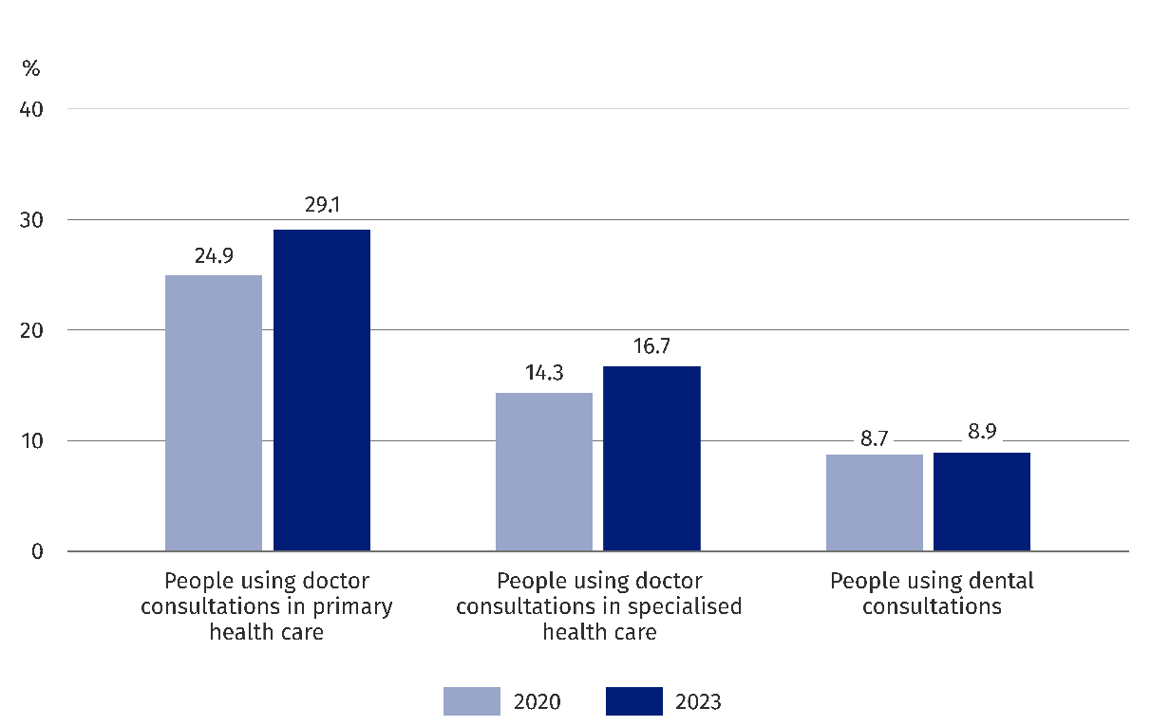

Almost every (97.5%) person using doctor consultations in primary health care in the 4th quarter of 2023 had them provided in the scope of the National Health Fund (96.2% in 2020). In the case of outpatient specialist health care, an increase in the proportion of those using these services in the scope of the National Health Fund was also observed, and amounted to 67.8%, compared to 61.5% in 2020. The largest share of health care services provided outside the insurance was recorded for dental services. In the 4th quarter of 2023, 25.9% of those using dental services had them provided in the scope of the National Health Fund (23.0% in 2020). Outpatient health care services were financed from funds other than the National Health Fund by 5.2% of those using primary health care, 38.6% of those using specialist health care, and 74.7% of those using dental services.
The percentage of diagnostic tests financed by the
National Health Fund has
increased. Among all laboratory tests performed in 2023, 85.9% were financed by health insurance, and in the case of imaging and other tests, this percentage was 80.1% (76.4% and 75.5% in 2020, respectively).
Compared to 2020, the proportion of people who had diagnostic tests increased. In 2023, laboratory tests were performed by 52.5% of the population, while imaging and other tests by 28.9% (42.9% and 25.7% in 2020, respectively). The share of diagnostic tests financed by the National Health Fund also increased.
In 2023, 85.9% of all laboratory tests performed were financed under health insurance, and in the case of imaging services it was 80.1% (76.4% and 75.5% in 2020, respectively).
The share of households declaring the use of medical services (excluding dental services) that were not financed by the National Health Fund has increased – in 2023 it was 40.4% of households (38.1% in 2020). The main reason was long waiting period for medical consultations provided by entities in the scope of the National Health Fund, as indicated
by two thirds of households (70.7%) using this type of service (in 2020 it was more than half
of households – 51.7%).
Use of telecommunication and Internet during the usage of medical services
In 2023, 35.8% of household members used the Internet to get knowledge and information about diseases and treatments, and 31.5% to get information on a healthy lifestyle
(34.2% and 31.0% in 2020, respectively). Quarter of respondents (25.8%) used the Internet to obtain information on doctors’ opinions (22.4% in 2020). In 2023, 9.8% of respondents (9.2% in 2020) used the Internet to purchase a medical product.
The interest for using the Internet for making appointments or medical examinations and for receiving test results electronically has increased. In the 4th quarter of 2023, the proportion of such people was amounted to 5.9% and 10.9% respectively (4.9% and 6.6% in 2020, respectively). When making an appointment or medical examination, the telephone was still a more common method than via the website, although in 2023 it was more rarely used than in 2020 – during the ongoing COVID-19 pandemic. In the 4th quarter of 2023, 23.7% of respondents made an appointment by telephone (36.2% in 2020).
Chart 6. Use of communication and Internet during usage of health care services
by sex in 2023
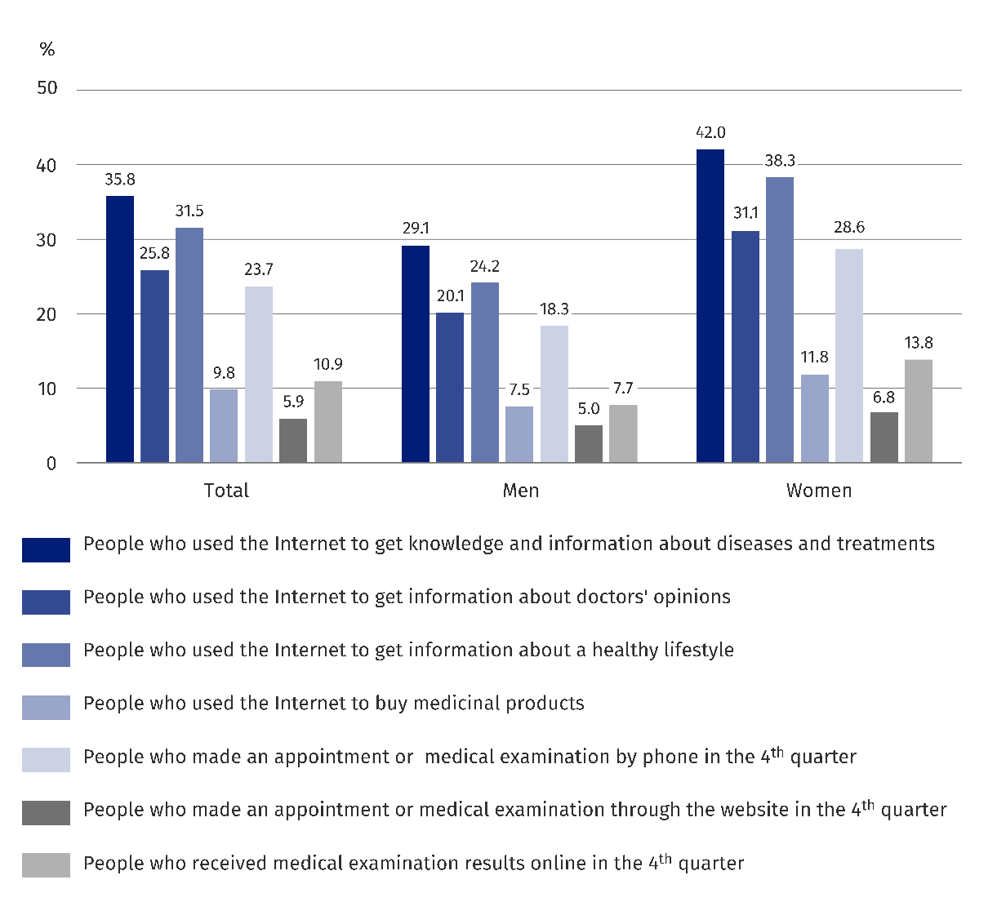

Quality of health care by respondents
The responsiveness of doctors, defined as meeting patients’ expectations, is one of factors of primary health care quality. The right attitude of doctor allows the patient easier understanding of problems associated with illness and engagement in the process of treatment. It allows both the patient and their family behave in a more favourable way from the medical point of view and builds relationship between the doctor and the patient.
86.6% of respondents stated that doctor of primary health care treated them with kindness and respect always or often

In 2023 respondents aged 15 or more most favourably rated the way of referring the doctor of primary health care to the patient. Among all interviewees who answered on question regarding the relationship with the doctor of primary health care, 86.6% stated that the doctor treated them with kindness and respect always or often, whereby 52.5% were always treated that way. Clear explanation (82.7%) and knowledge of medical history (81.1%) were also highly rated – in 2020 the percentages were 81.7% and 75.6% respectively.

Chart 7. Responsiveness of doctors of primary health care in 2023
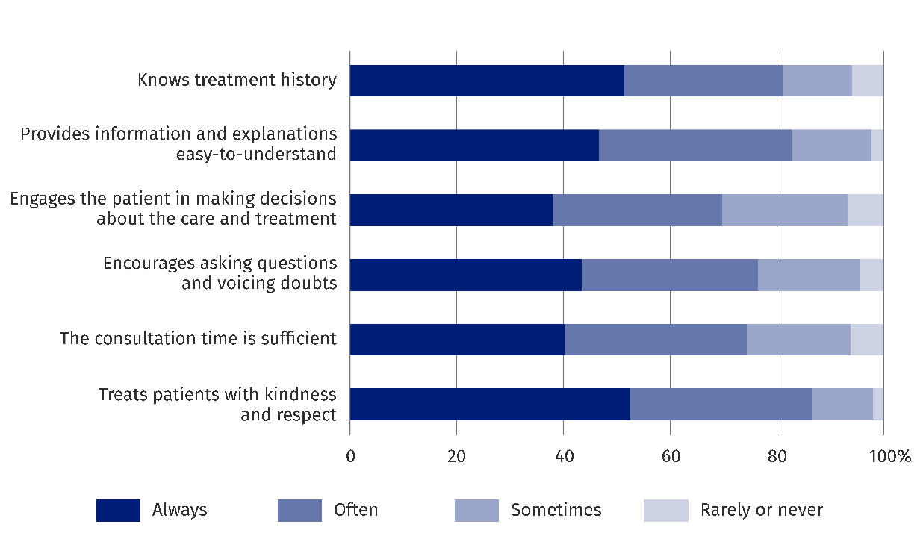

The worst ratings were given to engagement of patients in making decisions regarding care and treatment – answers “always” or “often” were given by 69.6% (64.7% of persons answered gave that answer in the previous edition of survey).
In 2023 2.8% of household members (both among women and among men) did not use the services of doctor of primary health care despite the need. In 2020 there were more persons – 6.1%. It should be noted that the ratings related to the need of use of health care services were all subjective answers of respondents.

Chart 8. Reasons of not using the consultations of doctor of primary health care in 2023
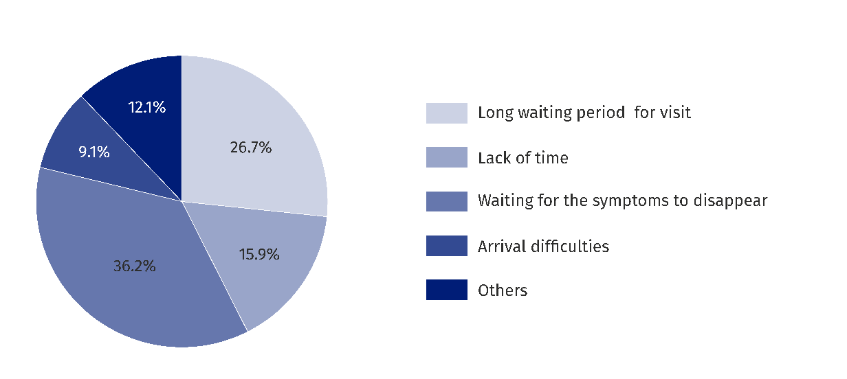
In 2023 the most common reason for resignations (over 36 %) from consultations of doctors of basic health care was waiting for the symptoms to disappear.

In 2023 the most common reason for resignations (over 36%) from consultations of doctors of primary health care was waiting for the symptoms to disappear.
Despite the need, 2.9% of household members in 2023 did not use the consultations
of specialized doctor (without dentists) (in 2020 the percentage was 5.9%).
The main reasons for resignations from consultations of specialized doctor (without dentists) was long waiting period for visit – above 42% of all reasons. The rise of choosing this answer was noted in comparison to 2020, where almost 28% of respondents that resigned from specialized doctors services (without dentists) chose that answer as the main reason of resignation. However the COVID-19 pandemic should be taken into consideration during the previous edition of the survey, which could have an impact on other answer preferences.
The main reason of resignations from consultations of specialized doctors (without dentists) was long waiting period for visit – above 42% of all reasons

Chart 9. Reasons of not using the consultations of specialized doctors (without dentists)
in 2023
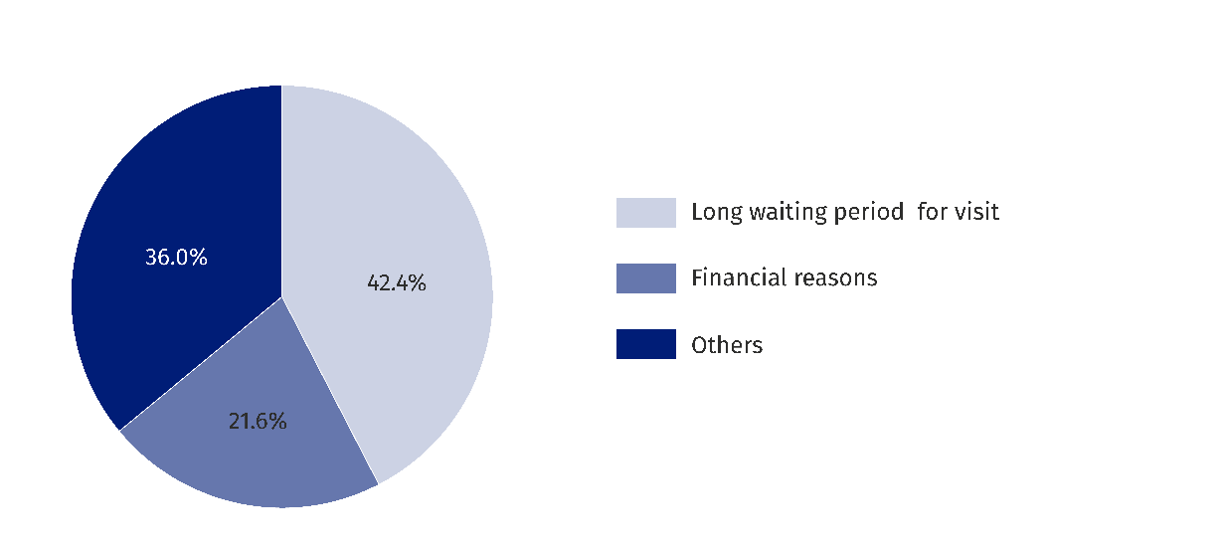

2.4% of household members (2.2% of men and 2.7% of women) did not use the dental services despite the need. The total percentage was 1.4 percentage points lower compared to 2020 (3.8%).
Financial reasons were
chosen as the main reason of not using the dental
services – over 33%
of respondents.
As the reason of not using the dental services, the respondents stated most often the financial reasons – over 33%, and long waiting period for visit – almost 19%.
When asked about not taking diagnostic tests despite the need, 1.1% of respondents answered positively, which is 2 percentage points less than in 2020 (3.1%). Women more often resigned from tests than men (1.4% of women versus 0.8% of men).
In case of chronically ill persons almost 2% resigned from tests, while in 2020 the percentage was over 6% of persons.
The predominant reason of resignations from diagnostic tests despite the need, as in other types of services were long waiting period for visit (24.0%) and no money (21.5%).
0.7% of respondents (1.3% in 2020) have chosen resignation from performed procedures⁷.
The waiting period for service also complements the quality of health care services.
In the 2023 questionnaire respondents were asked about performance of diagnostic tests and waiting period for the last of performed tests. The longest waiting period – 8 weeks
on average – was for colonoscopy. The shortest waiting period was for x-ray tests – 1 week, and ECG – 1.7 weeks on average.
Household expenses on health care in 2023
In the survey the information on part of expenses has been collected on annual basis (expenses related with inpatient health care and purchase of medical equipment),
and on part in the 4th quarter (expenses related to outpatient health care and purchase
of medicine).
In the news release all presented data refer to the level of monthly expenses calculated
on the basis of annual and quarterly data.
The results of survey indicate that 58.0% of households incurred expenses on visits
to doctors, 51.5% – on visits to dentists, 39.3% – on medical tests, 27.6% - on purchase of medical equipment, 12.1% – on rehabilitation procedures, 7.7% – on hospital stays, and 97.2% – on medicines.
In 2023 97.2% of households had expenses on medicines, and 58.0% - on visits to doctors.
By looking from the point of view of structure of expenses incurred by households on health care, just like in previous years, the expenses on medicines, medical articles and medical goods for permanent use are predominant. The combined share of this group of expenditure in the grand total of described expenses of households (per household) has decreased in comparison to 2020 (from 72.6% to 65.9%).
The household expenditure on medicines and medical articles accounted for 65.9% of all expenses on health care.
The share of household expenditure on inpatient health care has also decreased (from 2.1% to 1.6%). On the other hand, the share of expenses on outpatient health care has increased (from 25.3% to 32.4%).

Chart 10. Structure of direct household expenditure on health care
in the 4th quarter of 2023.
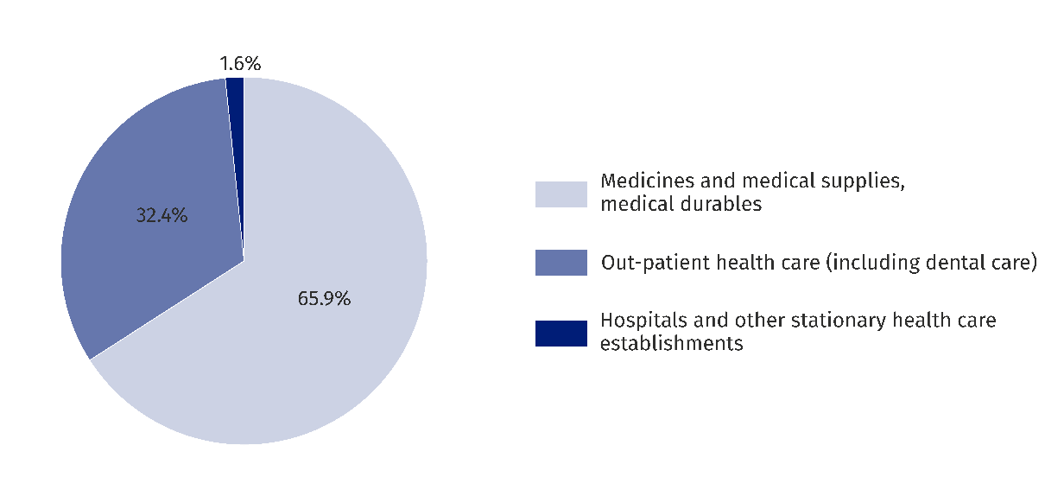

The structure of household expenditure on outpatient health care according to types
of services in the 4th quarter of 2023 has changed compared to the same period in 2020.
The predominant group in terms of share in total household expenses on given type of health care are dental services (covering the following types of treatment: conservative, prosthetic and orthodontic) and its share has increased from 45.8% in 2020 to 47.5% in 2023. The second group in terms of share was specialized outpatient care (without dental care
and rehabilitation), which share in the 4th quarter has decreased from 36.8% in 2020
to 32.3% in 2023.
Among the expenditure on outpatient health care the most has been incurred on dental care (47.5%).

Chart 11. Structure of household expenses on outpatient health care
in the 4th quarter of 2023
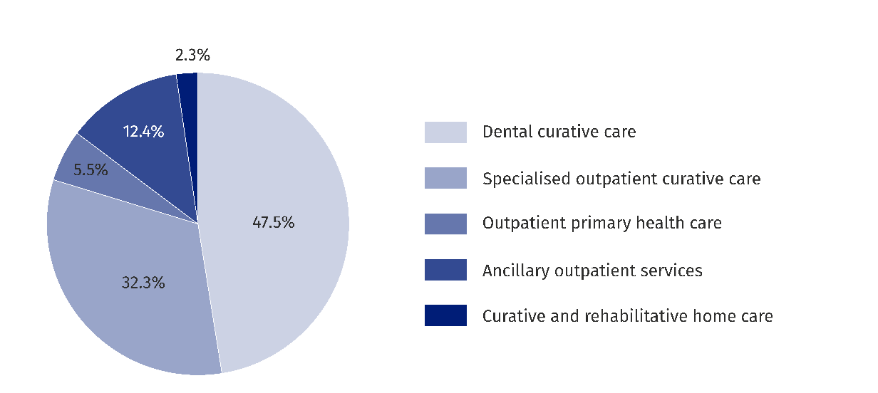
In the structure of direct household expenses in the 4th quarter on dental care in outpatient health care in 2023, similarly to 2020 and previous years, the expenditure on conservative treatment were dominating (71.6% of grand total). These expenses were almost completely (91.9%) realised outside the National Health Fund. Meanwhile the treatment subsidies within
the scope of National Health Fund accounted for 8.1% of grand total of expenses
on conservative treatment.
Chart 12. Structure of household expenditure on dental care in outpatient health care
in the 4th quarter of 2023
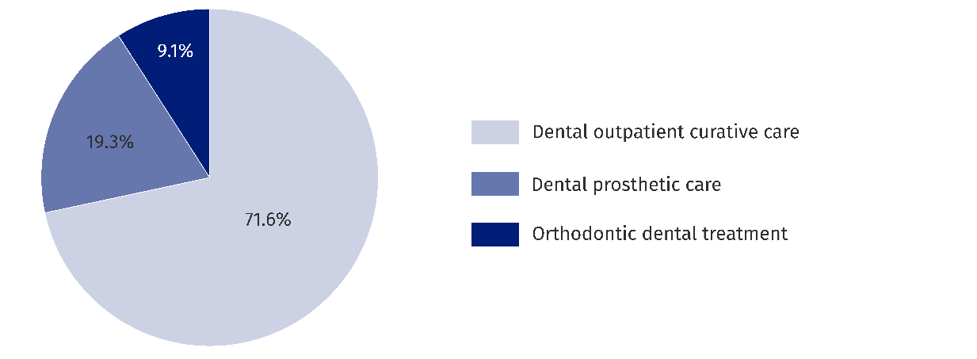

From the grand total of household expenses on laboratory tests in the 4th quarter of 2023 almost 80% were incurred on tests conducted outside insurance, and 20.9% – on co-financing tests financed by National Health Fund. In the case of diagnostic imaging the co-financing
of tests amounted to 5.0%.
Information regarding communicable disease caused by SARS-CoV-2 coronavirus,
called ”COVID-19” in 2023
In 2023 14.6% of tested population aged 15 or more suffered from COVID-19. The inhabitants of urban areas (17.2%) suffered more often from COVID-19 than inhabitants of rural areas (10.0%). 16.3% of persons among the population of women suffered, while 11.8% of persons among the population of men suffered.
In 2023 about 43% of
surveyed were vaccinated. Women, inhabitants of urban areas and persons with tertiary education were more often vaccinated.
42.9% of tested population aged above 14 were vaccinated against COVID-19. Women were vaccinated more often than men. 44.7% of women and 39.8% of men took vaccinations. Inhabitants of urban areas (46.2%) were vaccinated more often than inhabitants of rural areas (36.9%) and persons with tertiary education (45.3%) were vaccinated more often than persons with secondary education (42.1%) and persons with primary or no school education (42.0%).
The analysis of data reveals the complex picture of health complications experienced by persons aged 15 or more infected with COVID-19. The most common complications were: chronic fatigue (52.9%), loss of smell and taste (45.0%) and loss of immunity (42.6%). The higher vulnerability to majority of complications appeared among women than men and inhabitants of urban areas compared to inhabitants of rural areas.

Chart 13. Complications associated with COVID-19 among men and women in 2023
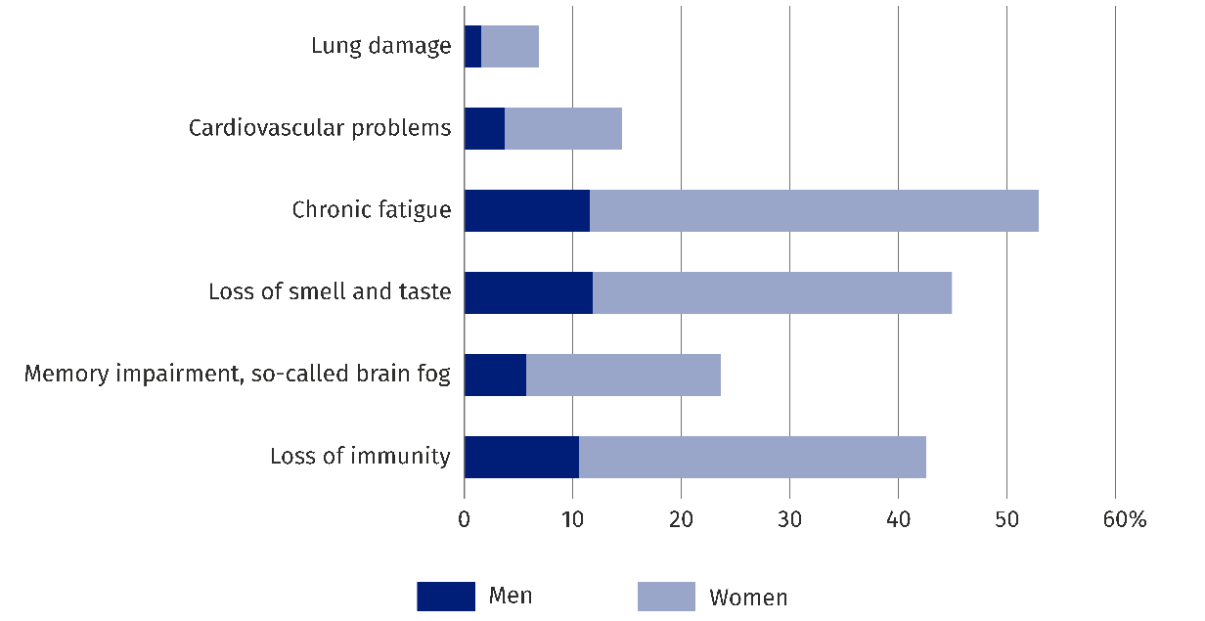

Chart 14. Complications associated with COVID-19 among inhabitants of rural
and urban areas in 2023
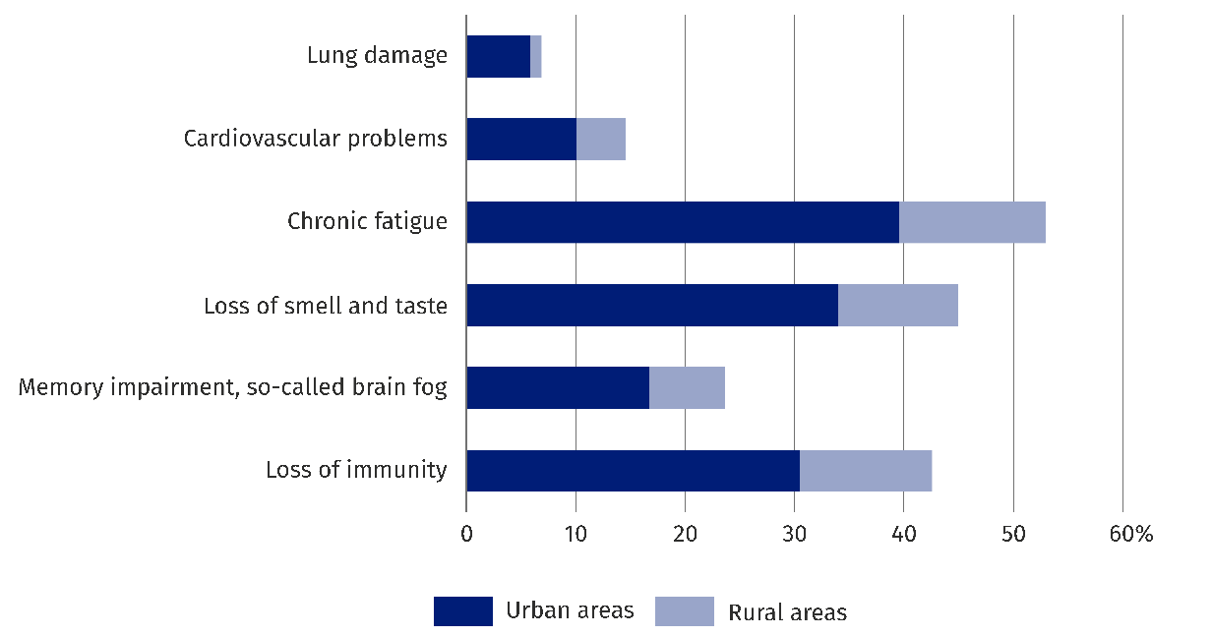

Only the small percentage of respondents aged 15 or more (4.1%) cancelled or limited the treatment or rehabilitation because of COVID-19. The distribution of answers among sexes was similar, although men (3.6%) showed slightly smaller tendency to cancel treatment compared to women (4.4%). The inhabitants of urban areas (5.2%) more often cancelled, limited or stopped treatment or rehabilitation because of COVID-19, compared to inhabitants
of rural areas, where the percentage was only 2.1%.
Consultations concerning COVID-19 in the form of remote medical consultations by phone or video camera were relatively rare. Only 13.0% of all respondents aged 15 or more used that form of contact with doctor. Women used this form of contact more often (14.2%) than men (10.9%). In 2023 the differences are also evident within the scope of using remote consultations between the inhabitants of urban and rural areas: in urban areas 14.8% of respondents used this form of contact with doctor, while in rural areas this percentage was lower and accounted for 9.7%.

When quoting Statistics Poland data, please provide the information: “Source of data: Statistics Poland”, and when publishing calculations made on data published by Statistics Poland, please include the following disclaimer: “Own study based on figures from Statistics Poland”.

Prepared by:  Social Surveys and Labour Market Department  Director Hanna Strzelecka  Phone: (+48 22) 608 32 79 | Issued by:  Press Office  Mobile: (+48) 695 255 032  Phone: (+48 22) 608 38 04, (+48 22) 449 41 45,  (+48 22) 608 30 09  e-mail: obslugaprasowa@stat.gov.pl

stat.gov.pl/en/

@StatPoland

@GlownyUrzadStatystyczny

gus_stat

glownyurzadstatystycznygus

glownyurzadstatystyczny
Related information
Health care in households in 2020
Health and health care in 2022
Household budget survey in 2023
Data available in databases
DBW
Terms used inn official statistics
Health
Primary health care
Inpatient Health Care

Some of the questions regarding the issue of health care have been directed to persons aged 15 or more. In case when a question concerned only persons aged 15 or more, it has been highlighted in the news release.
The percentage of households in which at least one person answered positively on asked question “Have you had long lasting health problems or chronic disease lasting for 6 months or longer?”.
This type of disability is defined as legal disability.
When comparing with the previous survey from 2021 (concerning the situation from 2020) the COVID-19 pandemic should be taken into consideration.
In case when a person does not have certificate issued by authorized authorities, but feels limited ability to perform basic activities for their age, this is a case of biological disability.
⁶ Some respondents used various sources of financing, both from the funds of the National Health Fund and the others, hence the sum is greater than 100%.
⁷ Because of low scale of phenomenon, the more in-depth analysis is impossible due to too great random error of results.

