Sales of prescription medicines in 2023
8.5%
Increase in the number of prescriptions issued in 2023 compared to 2022

In 2023, 495.1 million prescriptions were issued, of which 96.6% were in electronic form, i.e. 0.8 percentage points more than in 2022

In 2023, 495.1 million prescriptions were issued (41.8 million more than in 2022). The largest number of electronic prescriptions per capita in poviat were issued in Zamość (28.5), and the least in przemyski poviat (2.9)
In 2023, 495.1 million prescriptions were issued (41.8 million more than a year ago), of which 96.6% were electronic prescriptions (in 2022, the percentage of electronic prescriptions in the total number of prescriptions was 95.8%).
In 2023, there was no more than a 1.9 percentage point difference in the percentage of electronic prescriptions issued across voivodships. The highest percentage of electronic prescriptions occurred, as in 2022, in the pomorskie voivodship (97.6%) and the lowest in podkarpackie voivodship (95.7%). In the case of poviats, the highest percentage of electronic prescriptions were observed in poviats: siedlecki (99.3%), moniecki (99.2%), grudziądzki (99.1%), while the lowest in poviats: węgrowski (88.0%), sanocki (91.1%), chodzieski (91.2%) and ropczycko-sędziszowski (91.3%).
In 2023, the highest number of electronic prescriptions per inhabitant were issued in cities with the status of poviat: Zamość (28.5), Krosno (26.2), Tarnów (25.8), Chełm (24.1) and Siedlce (22.7) and the lowest in the following poviats: przemyski (2.9), łomżyński (3.0), suwalski (3.5), siedlecki (3.6), skierniewicki (3.7). When interpreting these data, it should be noted that the highest values of this indicator were observed in cities with the status of poviat. These cities play the role of public service centers with a reach extending beyond their administrative borders.

Map 1. Number of electronic prescriptions per capita in poviat in 2023

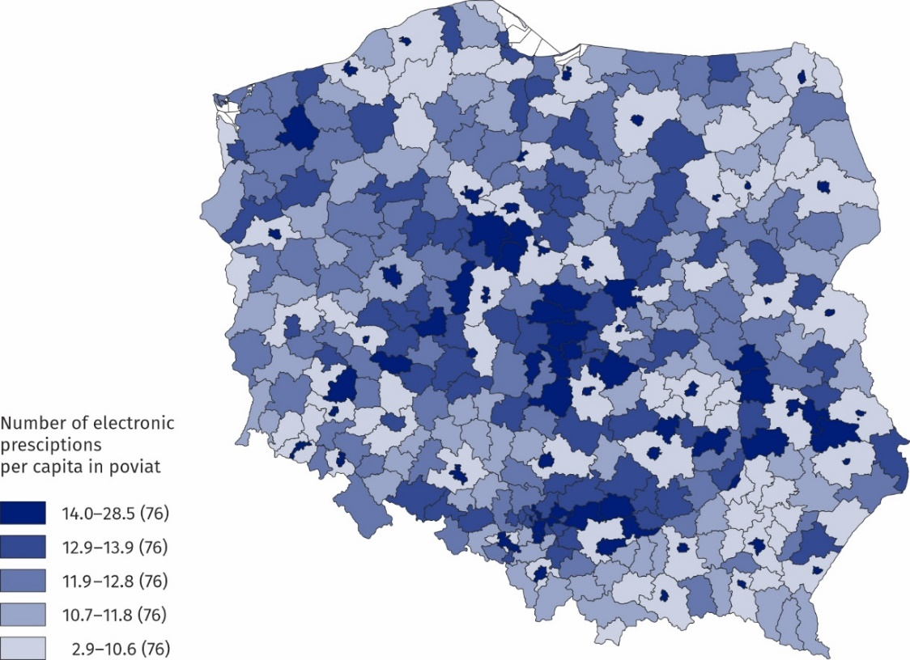
Source: E-Health Centre.

According to data from the Ministry of Health, in 2023 the value of sales of all medicines on prescription amounted to PLN 26.1 billion (by PLN 4.2 billion more than in 2022), while the value of the refund amounted to PLN 10.5 billion (PLN 1.9 billion more than in 2022),
and patients spent PLN 15.6 billion on prescription medicines (PLN 2.3 billion more than
in 2022). In 2023, the refund represented 40.4% of the value of medicines sold on prescription (in 2022 – 39.3%).

Table 1. Sale of prescription medicines in Poland
In 2023, the value of sales of prescription medicines amounted to PLN 26.1 billion, value of the refund – PLN 10.5 billion and patient’s surcharge for prescription medicines amounted to PLN 15.6 billion
Specification | 2022 | 2023
Specification | in billions of PLN
Value of sales | 21.9 | 26.1
Value of refunds | 8.6 | 10.5
Value of patient’s surcharge | 13.3 | 15.6
Source: E-Health Centre.

In 2023, the value of prescription medicines sold per capita in Poland amounted to PLN 693 (by PLN 114 more than in 2022), of which the surcharge by the patient amounted to PLN 413 (by PLN 61 more than in 2022) and refund by the National Health Fund amounted to PLN 280 (by PLN 53 more than in 2022).

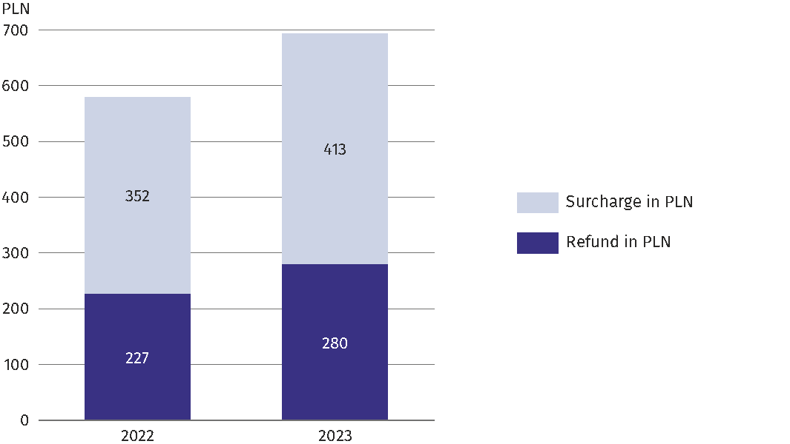
Chart 1. Value of refund and surcharge for prescription medicines
per capita in Poland
In 2023, the value of prescription medicines sold per capita of Poland amounted to PLN 693 the value of the patient’s surcharge – PLN 413, the refund – PLN 280 and amounted to 40.4% of the value of medicines sold on prescription
Source: E-Health Centre.

The highest value of prescription medicines sales, refund by the National Health Fund and patient surcharge for medicines in 2023 per capita is noticed in the łódzkie voivodship and the lowest in the podkarpackie voivodship. In the case of the łódzkie voivodship, these values were: PLN 783, PLN 324 and PLN 459, in the case of podkarpackie voivodship, these values were: PLN 585, PLN 234 and PLN 351.

Chart 2. Prescription medicines sales value per capita in voivodship in 2023

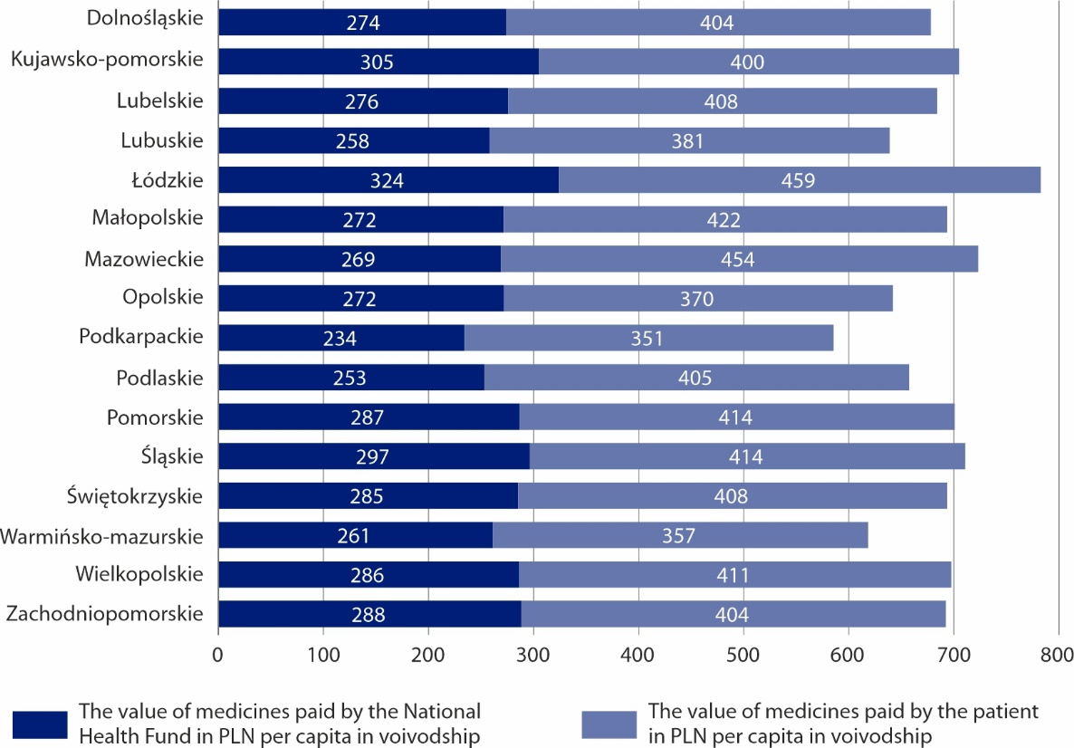
Source: E-Health Centre.

Map 2. Medicine sales value per capita in poviat in 2023
In 2023, the highest value of sales of prescription medicines per capita was noticed in Zamość (PLN 1 439), and the lowest in przemyski poviat (PLN 130)

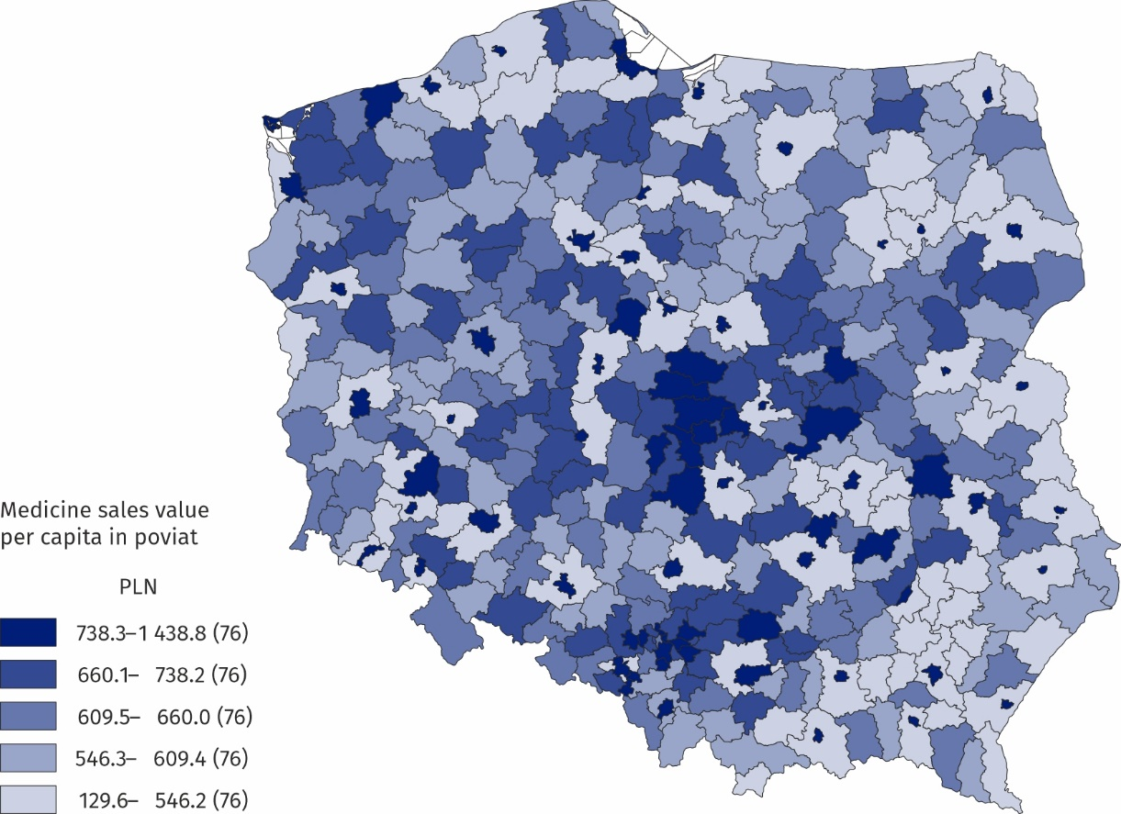
Source: E-Health Centre.
The highest value of sales of prescription medicines per capita in 2023 was observed in cities with the status of poviat: Zamość (PLN 1 439), Krosno (PLN 1 437), Tarnów (PLN 1 382), Chełm (PLN 1 260) and Skierniewice (PLN 1 228) and the smallest in poviats: przemyski (PLN 130), łomżyński (PLN 155), suwalski (PLN 156), siedlecki (PLN 161) and skierniewicki (PLN 175). However, it should be remembered that patients buy medicines not only in their poviat (especially in the case of poviats surrounding the city with poviat status).

Map 3. Percentage of medicines refund in the value of medicines sold in poviats in 2023
In 2023, the highest percentage of refund in the value of prescription medicines sold was noticed in the myślenicki poviat (50.4%), and the lowest in the piaseczyński poviat (34.4%)
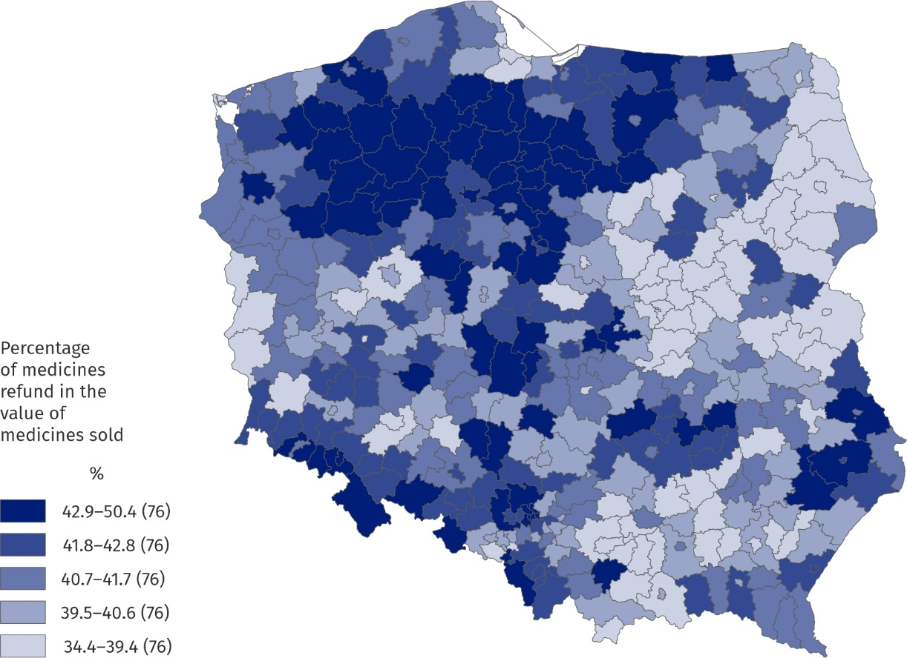
Source: E-Health Centre.

The poviats with the lowest refund reimbursement rate in the value of medicines sold are: piaseczyński (34.4%), warszawski-zachodni (35.1%), grodziski mazowiecki (35.1%), Warszawa (35.4%) and grójecki (35.5%). The poviats with the highest refund rate in the value of medicines sold are: myślenicki (50.4%), sępoleński (47.7%), złotowski (47.3%), grudziądzki (47.0%) and chojnicki (46.7%).
Cardiovascular system medicines (19.2%) and alimentary tract and metabolism medicines (18.9%) accounted for the largest share in the value of medicines sold in 2023.

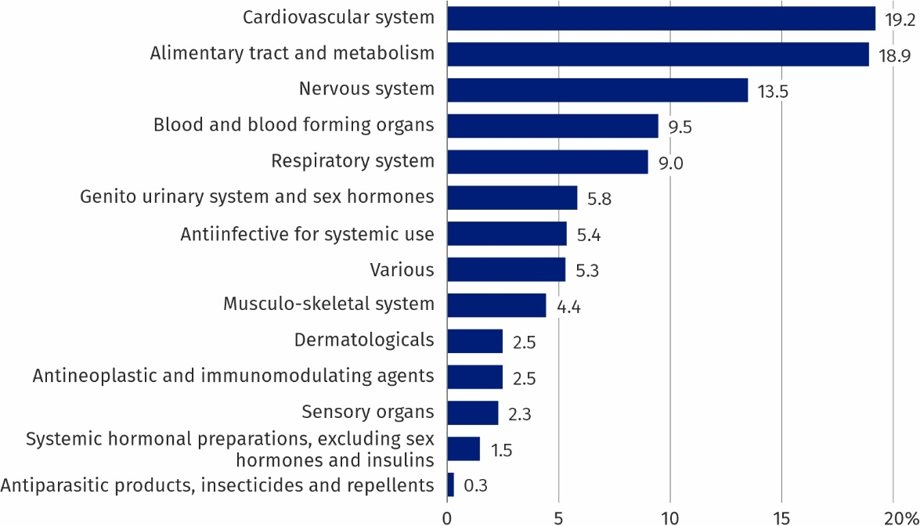
Chart 3. Share of prescription medicines sales by anatomical groups (ATC) in 2023
In 2023 the largest share in value of medicines sold were cardiovascular system medicines (19.2%), alimentary tract and metabolism medicines (18.9%) and nervous system medicines (13.5%)
Source: E-Health Centre.

In 2023, the lowest amount spent per poviat inhabitant on filling prescriptions for cardiovascular system medicines was in the following poviats: przemyski (PLN 32), łomżyński (PLN 40), siedlecki (PLN 40), skierniewicki (PLN 43), suwalski (PLN 45), and the highest amount — in cities with the poviat status: Zamość (PLN 253), Krosno (PLN 249), Tarnów (PLN 247), Chełm (PLN 236) and Siedlce (PLN 231).

Map 4. Sales value of prescription medicines related to the cardiovascular system
per capita in poviat in 2023

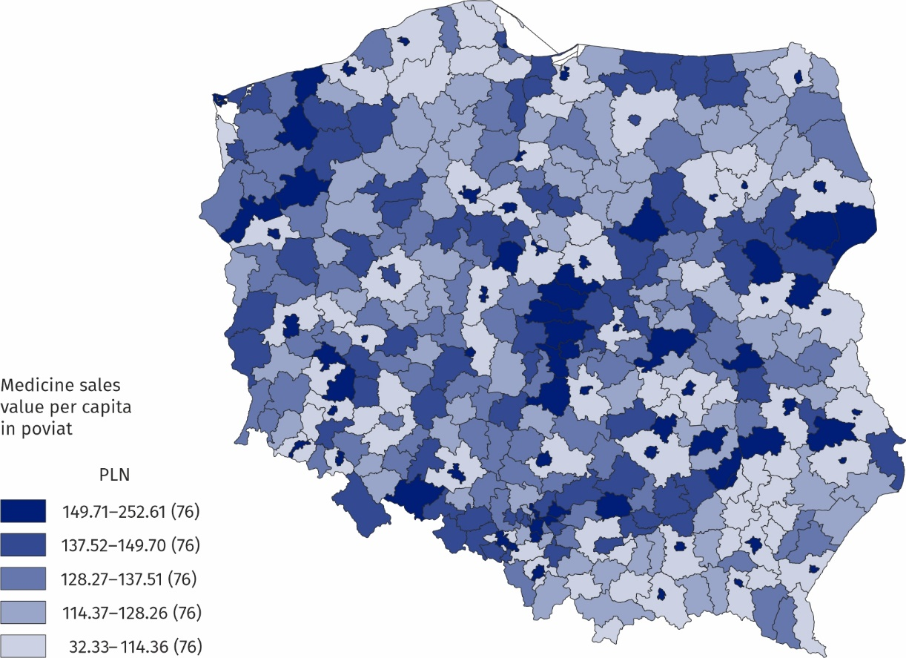
Source: E-Health Centre.
In 2023, the lowest amount spent per poviat inhabitant on filling prescriptions for medicines for the alimentary tract and metabolism was in the following poviats: przemyski (PLN 21), suwalski (PLN 28), siedlecki (PLN 29) and łomżyński (PLN 30) while the highest amount in cities with poviat status: Tarnów (PLN 276), Skierniewice (PLN 271), Nowy Sącz (PLN 260), Zamość (PLN 258) and Kielce (PLN 246).

Map 5. Sales value of prescription medicines related to the alimentary tract and metabolism system per capita in poviat in 2023
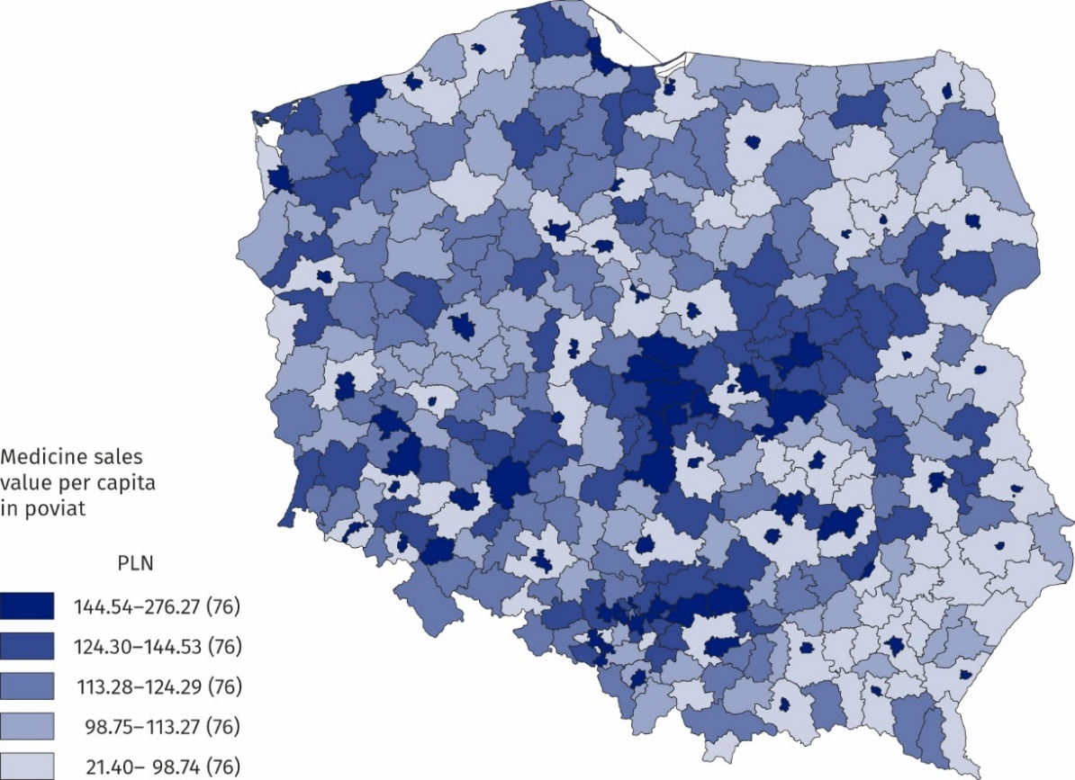
Source: E-Health Centre.
The Statistic in Focus was based on data from the Medical Information System of the Ministry of Health regarding the implementation of prescriptions (including, among others, the number of prescriptions, the number of packages, the value of sales, reimbursement and patient subsidies for medicines according to the ATC classification).

When quoting Statistics Poland data, please provide the information: “Source of data: Statistics Poland”, and when publishing calculations made on data published by Statistics Poland, please include the following disclaimer: “Own study based on figures from Statistics Poland”.
Prepared by:  Social Surveys and Labour Market Department  Director Piotr Łysoń, Ph.D.  Phone: (+48 22) 449 40 27 | Issued by:  Press Office  Mobile: (+48) 695 255 032  Phone: (+48 22) 608 38 04, (+48 22) 449 41 45,  (+48 22) 608 30 09  e-mail: obslugaprasowa@stat.gov.pl

stat.gov.pl/en/

@StatPoland

@GlownyUrzadStatystyczny

gus_stat

glownyurzadstatystycznygus

glownyurzadstatystyczny
Related information
Health and health care in 2022
Methodological report. Health and health care statistics − Statistics Poland’s reports

According to the address of the pharmacy or pharmacy where the prescription was completed.

