Health care expenditure in 2021-2023
This document describes information on health care expenditure coming from two sources: results of the National Health Account (SHA2011), developed by Statistics Poland and public expenditures on health care, developed by the Ministry of Health. Due to methodological differences, these data vary. The main difference between those schemes is coverage of the domain of expenditure. National Health Account covers current expenditure on healthcare, both public and private, while public expenditures on healthcare, in accordance with the provisions of the Act refers only to public funds and is not limited to current expenditure and does not include local government expenditure. The information produced is also used differently: the results of the National Health Account serve mainly international comparisons and create the possibility of describing health care system from the perspective of total current expenditure incurred by various entities, while the information developed by the Ministry of Health serves monitoring and evaluating public funding of health care system.

National Health Account

According to preliminary estimates, current expenditure on health care in 2023 amounted to PLN 241.6 billion (representing 7.1% of GDP) and was higher than in 2022 by about PLN 45.4 billion (in relation to preliminary data for 2022, which amounted to PLN 196.2 billion). An increase in spending was observed in public spending, while a decrease was observed in private spending.
23.1%
Estimated increase in current health expenditure in 2023 compared to 2022

In 2023, preliminary estimates of current expenditure on health care amounted to PLN 241.6 billion to and was higher than in 2022 by PLN 45.4 billion, i.e. by 23.1% compared to the amount of corresponding expenditure from 2022 according to preliminary data. Current expenditure on health care (public and private) according to preliminary NHA estimates, accounted for 7.1% of GDP in 2023.
In 2023, current expenditure on healthcare, according to preliminary estimates, represented 7,1% of GDP

An increase in current expenditure has been observed for public expenditure, which amounted to PLN 197.8 billion in 2023 and was PLN 53.2 billion higher than in 2022, and their share in GDP amounted to 5.8%. Current private expenditure (including households’ direct out-of-pocket payment) decreased by PLN 7.8 billion and amounted to PLN 43.8 billion in 2023, though the increase in households’ direct out-of-pocket payment, which amounted to PLN 38.6 billion, i.e. by 1.6 billion (4.4%) more than in 2022.

Table 1. Current expenditure on health care and its share of GDP
SPECIFICATION |  | 2021 |  | 2022  (preliminary data)^{d} |  | 2023  (preliminary estimate)^{e}
 |  | PLN million | %  GDP | PLN million | %  GDP | PLN million | %  GDP
 | Gross domestic productª | 2 631 302 | 100 | 3 074 798 | 100 | 3 410 137 | 100
Methodology of SHA 2011^{b}
HF.1+HF.2+  HF.3 | Total current expenditure on healthcare^{c} | 169 418.4 | 6.4 | 196 205.1 | 6.4 | 241 617.4 | 7.1
HF.1 | Public expenditure | 122 767.2 | 4.7 | 144 639.4 | 4.7 | 197 818.2 | 5.8
 | of which:
HF.1.1 | Government schemes | 25 639.3 | 1.0 | 20 678.1 | 0.7 | . | .
HF.1.2 | Compulsory contributory health insurance schemes | 97 127.8 | 3.7 | 123 961.3 | 4.0 | . | .
HF.2+HF.3 | Private expenditure | 46 651.3 | 1.8 | 51 56.7 | 1.7 | 43 799.2 | 1.3
HF.3 | of which households’ direct out-of-pocket payment | 33 625.3 | 1.3 | 36 963.4 | 1.2 | 38 578.9 | 1.1
ª Source: GDP data available at: Poland macroeconomic indicators – update as of June 20, 2024.
^{b} SHA 2011 – A System of Health Accounts 2011.
^{c} With private expenditure (HF.2+HF.3).
^{d} Preliminary data term of NHA explained in methodological comment.
^{e} Preliminary estimate term of NHA explained in methodological comment.

According to the preliminary results of the National Health Account for 2022, current expenditure on health care amounted to PLN 196.2 billion, which constituted 6.4% of GDP including current public expenditure amounted to PLN 144.6 billion for 2022, which represented 4.7% of GDP. The percentage share in GDP was similar to 2021.

Structure of expenditure due to financing schemes
Public preliminary expenditure on health in 2022 accounted for 73.7% of current health expenditure
As the elaboration of the results of the NHA for 2023 is at the stage of preliminary estimates, a comparison of the expenditure structure is given for the period 2021-2022. For 2021, final data is provided (announced by the President of the Statistics Poland), and for 2022, preliminary data are provided and used for comparison, which are still being verified.
The structure of expenditure according to health financing schemes (ICHA-HF classification) in the National Health Account for 2022 was as follows:
- public expenditure accounted for 73.7% of current health expenditure (72.5% in 2021)
of which:
  - Government schemes – 10.5% (in 2021 – 15.1%)
  - Compulsory contributory health insurance schemes – 63.2% (in 2021 – 57.3%)
- private expenditure accounted for – 26.3% (2021 – 27.5%)
  - including Household out-of-pocket payment – 18.8% of total current expenditure on health care (in 2021 – 19.8%).

Chart 1. Current expenditure by financing schemes in 2022
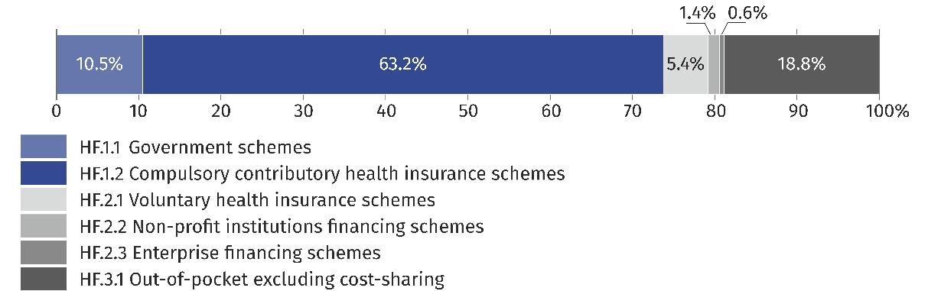

Structure of expenditure by health care functions
Expenditure on medical services accounted for the largest percentage share (60.1%) of current health expenditure in 2022

Within the classification of health care functions (ICHA-HC), the current health expenditure stream in 2022 included, inter alia:
- curative care – 60.1% (in 2021 – 56.1%)
of which:
- inpatient curative care – 32.4% (in 2021 – 30.2%)
- outpatient curative care – 25.0% (in 2021 – 24.2%)
- medical goods (non-specified by function) – 19.0% (in 2021 – 21.0%)
- long-term care (health) – 8.1% (in 2021 – 8.1%)
- rehabilitative care – 4.7% (in 2021 – 4.4%).

Chart 2. Current expenditure on health care by function in 2022
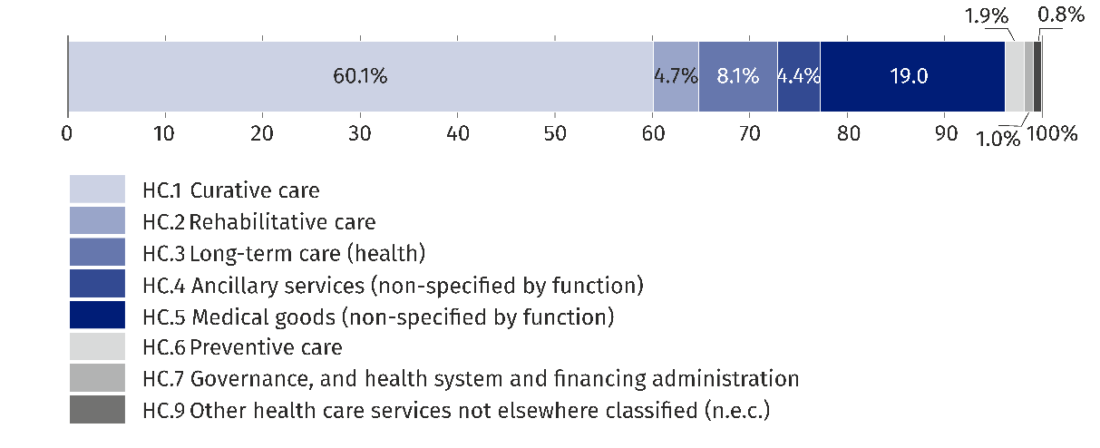

Structure of expenditure for health care providers
The largest stream of funds for health care expenses in 2022 went to hospitals – 42.2%
For health care providers (HP classification), the largest expenditure stream in 2022 went to:
- hospitals – 42.2% of current expenditure on health care (in 2021 – 38.4%)
  - of which to general hospitals – 31.8% (in 2021 – 29.9%)
- providers of ambulatory health care – 26.8% (in 2021 – 25.3%)
- retailers and other providers of medical goods – 18.8% (in 2021 – 20.2%)
- most of them to pharmacies, to which more than 16.8% of the total funds were transferred (in 2021 – 18.0%).

Chart 3. Current expenditure by health care providers in 2022
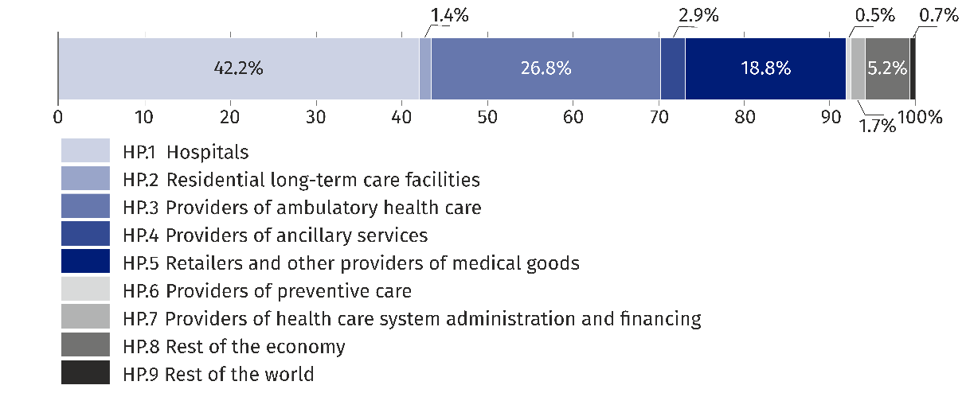

The structure of expenditure by the revenues of financing schemes
In 2022, the largest contribution to health care funding was from compulsory health contributions classified under the ICHA-FS category FS.3: social contributions – 62.1% (in 2021 – 56.1%).
Health care funding was based on health contributions, which accounted for 62.1% of total revenue in 2022

More than one-fifth (21.0%) of health expenditure was transferred to the health care system in the form of voluntary financial transfers by households, national institutional units, businesses units, non-profit institutions and other national revenues n.e.c. (in 2021 – 21.7%).
Whereas 11.2% were funds allocated by central and local government institutions (in 2021 – 16.0%).
Smaller, but also significant share had voluntary prepayments – 5.4% (in 2021 — 5.8%). This item includes contributions to voluntary, private health insurance.

Chart 4. Current expenditure by revenues of financing schemes in 2022
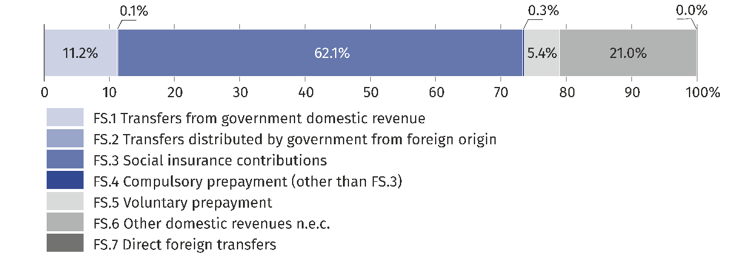

Increase in expenditure in the National Health Account in 2013-2023
Between 2013 and 2023, there is a steady increase in expenditure included in the NHA. For years final results were presented for 2013-2021, preliminary results were presented for 2022 and preliminary estimates for 2023.

Chart 5. Increase of expenditure in National Health Account

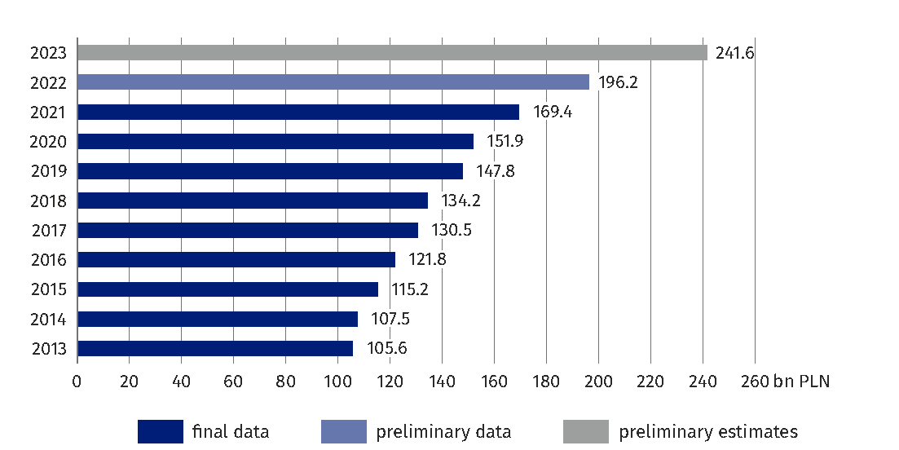

Public expenditure on health in 2023
According to Article 131c of the Act of 27 August 2004 on health care services financed from public funds (Journal of Laws of 2024 item 146), measures of not less than 6.00% of GDP in the notice of the President of the Statistics Poland should be used to finance health care in 2023. Therefore, expenditure on financing health care in 2023 should be planned at a level of at least PLN 157.3 billion, however, it was planned at a higher level, i.e. PLN 165.5 billion, and was ultimately implemented in the amount PLN 184.8 billion.
22.4%
Increase in public expenditure on health care
in 2023 compared to 2022

Pursuant to the provisions of the Budget Act for 2023 and the initial plan of the National Health Fund, funds amounting to PLN 165.5 billion were planned for this year, which in the course of the year were increased, and their final implementation amounted to PLN 184.8 billion (including PLN 0.3 billion from the COVID-19, COVID-19 Counteracting Fund and PLN 0.8 billion from the Aid Fund transferred to the National Health Found), which represents 7.05% of GDP (from year N-2). It should be emphasized that in 2023 these funds were about PLN 33.8 billion higher (22.4%) than the expenditures allocated to health care in 2022.
Compared to 2023, there was an increase in expenditure on health care by PLN 33.8 billion, i.e. by 22.4%

Table 2. Public expenditure on health care and share in GDP of year Nª, i.e. current year and year N-2, i.e. according to the Act
Year | GDP N-2  according to the act^{b} | GDP for  current year (N)^{c} | Plan^{b} |  | Execution
Year | in billion PLN |  |  | % GDP  N-2 | in billion  PLN | % GDP  N-2^{b} | % GDP  N^{c}
2022 | 2 323.9 | 3 074.4 | 133.6 | 5.75 | 151.0 | 6.50 | 4.91
2023 | 2 622.2 | 3 410.1 | 165.5 | 6.31 | 184.8 | 7.05 | 5.42

ª The letter N indicates the year to which the data on health expenditure refer (Plan and Execution).
^{b} In accordance to art. 131c paragraph 2 of the Act on health care services financed from public funds, for 2022 expenditure, the benchmark is 2020 GDP and 2023 for 2021 GDP.
^{c} According GDP data. Source: Statistics Poland GDP data available on the website: Macroeconomic Indicators– update as of April 23, 2024.
Structure of expenditure arising from the Act
A breakdown of expenditure on health protection according to the categories resulting from the Act is presented in Table 3.
Table 3. Structure of expenditure on health care according to the categories resulting from the Act
LP. | Categories by law | 2022 |  |  | 2023
LP. | Categories by law | planª | execution |  | planª | execution
LP. | Categories by law | in million PLN | in million PLN | %^{b} | in million PLN | in million PLN | %^{b}
I | Budgetary expenditure in the part of the state budget managed by the minister responsible for health | 14 917 | 15 522 | 10.3 | 14 186 | 15 236 | 8.2
II | Expenditure of the European funds in the “health care” section | 1 598 | 592 | 0.4 | 1 217 | 2 041 | 1,1
III | Budget expenditures in the "health care" section in other parts of the state budget | 8 433 | 7 256 | 4.8 | 5 951 | 4 744 | 2.6
IV | Costs of the National Health Fund included in the Fund’s financial plan excluding planned transfers of funds received from sources referred to in other categories | 108 335 | 127 317^{c} | 84.3 | 143 654 | 162 286^{d} | 87.8
V | The cost of the Medical Studies Loan Fund included in the Fund’s financial plan excluding planned transfers of funds received from sources referred to other categories | 0 | 0 | 0.0 | 0 | 0 | 0.0
VI | Costs included in the financial plan of the Vaccination Compensation Fund, excluding funds from payments from the state budget transferred in a given financial year | 0 | 4 | 0.0 | 4 | 1 | 0.0
VII | Costs included in the financial plan of the Gambling Fund Resolving Problems | 23 | 18 | 0.0 | 40 | 6 | 0.0
VIII | A Copy for the Agency for Health Technology Assessment and Tarification referred to in art. 31t item 5-9 of the Act included in the Fund's financial plan | 0 | 0 | 0.0 | 81 | 81 | 0.0
IX | A Copy for the Medical Research Agency, referred to in Art. 97 section 3e, included in the Fund's financial plan | 323 | 323 | 0.2 | 404 | 404 | 0.2
X | Costs included in the annual financial plan of the Clinical Research Compensation Fund^{e} | 0 | 0 | 0.0 | 0 | 0.04 | 0.0
XI | A copy to the Medical Event Compensation Fund referred to in Art. 97 section 3i and 3j, included in the Fund's financial plan^{f} | 0 | 0 | 0.0 | 0 | 7 | 0.0
XII | Budget expenditure in the part of the state budget administered by the Patients' Rights Ombudsman (part 66, section 750)^{g} | 0 | 0 | 0.0 | 0 | 18 | 0.0
Total^{h} |  | 133 629 | 151 032 | 100.0 | 165 537 | 184 824 | 100.0
ª According to the budget Act.
^{b} Share in the structure of expenditures.
^{c} Of this, PLN 5 539 million came from the COVID-19 Counteracting Fund, and PLN 604 million from the Aid Fund.
^{d} Of this, PLN 261 million came from the COVID-19 Countermeasure Fund, and PLN 848 million came from the Aid Fund.
^{e} Category added to the catalog by the Act of March 9, 2023 on clinical trials of medicinal products for human use (Journal of Laws of 2023, item 605), which entered into force on April 14, 2023.
^{f, g} Categories added to the catalog by the Act of June 16, 2023 amending the Act on Patient Rights and the Patient Ombudsman and certain other acts (Journal of Laws of 2023, item 1675), which entered into force on September 6, 2023.
^{h} Column totals were calculated on rounded values.

In the structure of these expenditures, the main items relate to the costs included in the financial plan of the National Health Fund (point IV of Table 3) and expenditure of the State budget, included in Part 46 – Health (point I of Table 3) and in the health care section in other budgetary parts (point III of Table 3).

Chart 6. Share of expenses in health care expenditures by categories resulting from the Act in 2023
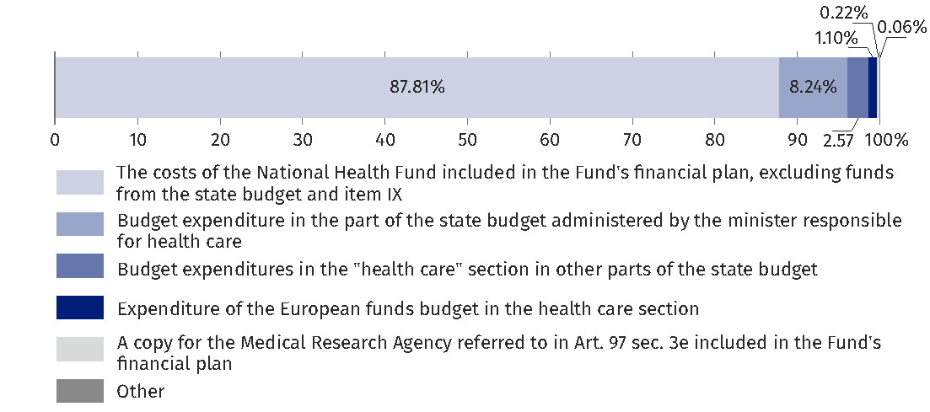

Increase in health care expenditure in 2014-2023
In the years 2014-2023, we can see a steady increase in health care expenditure. This applies to both annual spending plans according to the Act and their implementation, which was almost always larger than the plan, with the exception of 2014. Between 2014 and 2023, expenditure on health care as planned increased by 125.6%, while, according to implementation, it increased by 153.7%. The largest annual increase in health care expenditures in this period was recorded in 2023 – by 22.4%.

Chart 7. Increase of spending on health care
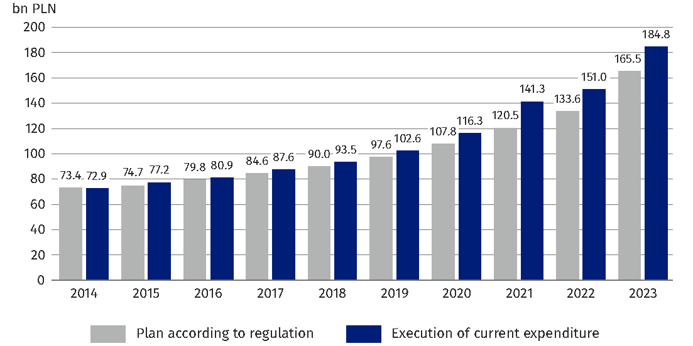
Summary
Regardless of the methodology adopted – according to the National Health Account or in accordance with the provisions of Article 131c of the Act of 27 August 2004 on health care services financed from public funds – in the years 2014-2023 there was a significant increase in the amount of expenditure on health care.
Figures for 2023 indicate that public expenditure has reached 7.05% of GDP and current public and private health expenditure included in the National Health Account is at 7.1% of GDP.
The time series of public expenditure on health care indicates an increase of more than 153.7% between 2014 and 2023. Similarly, between 2014 and 2023, current public and private expenditure on health care, according to the NHA, increased by more than 124.8%.

Methodological commentary
- Method for estimating the National Health Account
The system of health accounts is an international tool for analyzing health expenditure, which captures them in a comprehensive manner, ensuring comparability between countries. National Health Accounts provide systematic description of financial flows related to the consumption of health care goods and services. Their aim is to describe the health care system from a spending perspective. Due to the lengthy, multi-month process of preparation and validation of final data, they are preceded as preliminary data and preliminary estimates between which significant differences may occur.
For several years, these accounts have been drawn up according to the SHA 2011 methodology, according to which information on health care expenditure is transmitted to three international organizations (OECD, WHO, Eurostat) – in 2015 (data for 2013) on the basis of the Gentlemen’s Agreement, and since 2016 in accordance with the Commission Regulation (EU) 2015 and from 2021 on the basis of the new Commission Regulation (EU) 2021/1901.
The National Health Account is drawn up every year for the year T-2. The account is compiled according to the International Classification for Health Accounts (ICHA) and is included in four tables (HCxHF, HPxHF, HCxHP and HFxFS), which are transmitted, in form of Joint Health Accounts Questionnaire (with preliminary estimates and methodological notes) to the OECD, Eurostat and WHO.
Expenditure classifying variables are: HF (financing schemes), HC (health care functions) and HP (health care providers). The additional variable FS contains information on the revenues of financing schemes (HF).
The final results of the National Health Account for the year T-2 are supplemented annually by preliminary data for the year T-2 and preliminary estimates of financing schemes for the year T-1.
The sources of information for the NHA on public expenditure (HF.1), which consist of Government schemes and Compulsory contributory health insurance schemes are so called financing agents (FA), i.e. Ministry of Health, National Health Fund, Social Insurance Institution, Agricultural Social Insurance Fund, Ministry of Interior and Administration, Ministry of National Defense, Ministry of Justice, Ministry of Family and Social Policy and State Fund for the Rehabilitation of the Disabled. Estimates of private expenditure (HF.2 and HF.3) use data from the Polish Financial Supervision Authority, National Health Fund, Social Insurance Institution and Agricultural Social Insurance Fund, as well as the results of other surveys carried out within the framework of the programme of statistical surveys of official statistics such as non-profit institutions, the survey of household budgets and other available sources of information.
It should be borne in mind that health systems around the world are evolving, often subject to complex organizational changes, and financing agents are changing, which requires systematic adaptation to those changes in health accounts, which are supervised internationally by a complex panel of experts. from representatives: Eurostat, OECD and WHO – IHAT (International Health Account Team).
Therefore, every year, the so-called “validation process” is implemented and its aim is to eliminate any inconsistencies that could jeopardize the comparability of data between countries. Countries are making changes to their previously developed accounts to bring the data to the best possible international comparability.
Current expenditure on healthcare, refer to the currently valid GDP on the date of preparation of this note and refer the value of GDP of the same year.

- Method for estimating public spending on healthcare
The methodology for calculating health care expenditures by the Ministry of Health is strictly defined in Article 131c of the Act on health care benefits financed from public funds of 27 August 2004 (Journal of Laws of 2024, item 146) and is not related to the SHA 2011 methodology, according to which the National Health Account is developed.
Pursuant to the provisions of the Act, there shall be appropriated annually for financing of health care an amount not less than 7% of the gross domestic product, provided that the amount of funds appropriated for the financing of health care from 2019 to 2026, shall not be less than:
1) 4.86% of gross domestic product in 2019
2) 5.03% of gross domestic product in 2020
3) 5.30% of gross domestic product in 2021
4) 5.75% of gross domestic product in 2022
5) 6.00% of gross domestic product in 2023
6) 6.20% of gross domestic product in 2024
7) 6.50% of gross domestic product in 2025
8) 6.80% of gross domestic product in 2026.
These limits, in accordance with paragraph 4 of Article 131c of this Act, are taken into account by the Council of Ministers in draft budget laws or draft laws on budget provisions.
The reference point for the value of the gross domestic product is indicated in Article 131c(2) of the Act, according to which the value of gross domestic product is determined on the basis of the value specified in the announcement of the President of Statistics Poland issued pursuant to Article 5 of the Act of 26 October 2000 on the method of calculating the value of annual gross domestic product as at 31 August. This announcement is issued by May 15 of a given year for the previous year. Thus, when planning outlays on health care for the following year, in accordance with the Act, the Council of Ministers, in draft budget laws or draft laws on budget provision, takes into account the value of GDP which is available for year N-2 in relation to years N to which the budget law refers. In addition, the Act on health care services financed from public funds, also defines a strict catalog of expenses or costs that are included in health care outlays.
This catalog includes:
1) budgetary expenditure in the part of the state budget managed by the minister responsible for health;
2) budget expenditure in the “healthcare” in other parts of the state budget;
3) the costs of the National Health Fund included in the Fund’s financial plan excluding funds from the Medical Fund transferred to the Fund;
4) a copy for the Agency for Health Technology Assessment and Tarification, referred to in Article 31t(5-9), included in the financial plan of the Fund;
5) costs of the Medical Studies Loan Fund included in the financial plan of this The Fund;
6) costs included in the financial plan of the Resolving Gambling Problems Fund, referred to in Article 88 of the Gambling Act of 19 November 2009;
7) a copy for the Medical Research Agency referred to in Article 97(3e), included in the Financial Fund plan;
8) costs included in the financial plan of the Immunisation Compensation Fund, referred to in Article 17b(1) of the Act of 5 December 2008 on the prevention and control of infections and infectious diseases in humans;
9) costs included in the annual financial plan of the Clinical Research Compensation Fund referred to in Article 41(5) of the Act of 9 March 2023 on clinical trials of medicinal products for human use (Journal of Laws, item 605);
10) a copy for the Compensation Fund referred to in Art. 97 section 3i and 3j;
11) budget expenditure in the part of the state budget administered by the Patients' Rights Ombudsman
— excluding planned transfers of funds received from sources, referred to in points 1 to 11.

When quoting Statistics Poland data, please provide the information: “Source of data: Statistics Poland”, and when publishing calculations made on data published by Statistics Poland, please include the following disclaimer: “Own study based on figures from Statistics Poland”.
Prepared by:  Social Surveys and Labour Market Department  Director Piotr Łysoń, Ph.D.  Phone: (+48 22) 449 40 27 | Issued by:  Press Office  Mobile: (+48) 695 255 032  Phone: (+48 22) 608 38 04, (+48 22) 449 41 45,  (+48 22) 608 30 09  e-mail: obslugaprasowa@stat.gov.pl

stat.gov.pl/en/

@StatPoland

@GlownyUrzadStatystyczny

gus_stat

glownyurzadstatystycznygus

glownyurzadstatystyczny
Related information
Health and health care in 2022
Announcement of the President of the Statistics Poland on the National Health Account for 2021
Manual of SHA2011
Data available in databases
OECD Data Explorer
Terms used in official statistics
In-patient healthcare
Hospital
Health care facility
Health

For more information on the methodology, please refer to the methodological comments at the end of the note.
Act of 27 August 2004 on health care services financed from public funds Art. 131c (Journal of Laws 2024, item 146).
Preliminary estimates of the National Health Account cover the total current expenditure on health care in the previous year and are presented in three main categories: HF.1: Public expenditure, HF.2: Private expenditure without direct household expenditure and HF.3: Direct household expenditure (out-of pocket payment). Preliminary estimates refer to 2023 data.
The results of the National Health Account for 2022 (until the publication of the official announcement of the President of Statistics Poland are treated as preliminary data) developed in accordance with the so-called The Joint Health Account Questionnaire (JHAQ) which covers health expenditure in four classification: financing schemes (HF), health care functions (HC), health care goods and service providers (HP) and financing schemes revenues (FS). Preliminary data was provided at the end of April this year to international organizations are subject to validation by an international panel of experts on national health accounts (IHAT) and are subject to change. The preliminary data for which the account was developed (not verified by the OECD) refer to the expenditure for 2022.
In Statistics Poland news releases issued on July 27, 2023 called „Health care expenditure in 2020-2022”, showed preliminary current expenditure on health care - PLN 172 884.6 million (for 2021).
Poland macroeconomic Iindicators GDP (current prices): 2021 – PLN 2 631 302 million, 2022 – PLN 3 074 798 million and 3 410 137 million for 2023 (preliminary estimate).
Communications and Announcements.
n.e.c. = Not Elsewhere Classified.
Voluntary contributions are payments made by insured persons or other institutional units to insured persons in order to secure access to voluntary health insurance benefits.
The chapter was developed by the Ministry of Health in cooperation with Statistics Poland on the basis of data from the Ministry of Health.
The catalogue of measures is set out in Article 131c item 3 of the Act on health care services financed from public funds.
The value specified in the notice of the President of Statistics Poland referred to in Article 5 of the Act of 26 October 2000 on the method of calculating the value of the annual gross domestic product, as at 31 August 2021.
The COVID-19 Anti-Action Fund referred to in Article 65(1) of the Act of 31 March 2020 amending the Act on special solutions related to the prevention, prevention and eradication of COVID-19, other infectious diseases and crisis situations caused by them and certain other acts (Journal of Laws item 568, as amended).
The Aid Fund referred to in Article 14(1) Act of 12 March 2022 on assistance to Ukrainian citizens in connection with the armed conflict on the territory of that country (Journal of Laws of 2024, item 167, as amended).
Current year was marked by the letter N, and N-2 means year prior to N by 2 years. In accordance with Article 131c item 2 of the Public-funded health care Services Act, for 2022 expenditure the reference point is GDP from 2020 and for 2023 data reference point GDP is 2021.
According to the statutory methodology of GDP for the year N-2.
According to the NHA, preliminary estimates for 2023 for GDP of the same year.
The methodological justification is included in the annually sent file with the Joint Health Account Questionnaire (JHAQ) called "Explanatory Notes to T-0 JHAQ" entitled: "T-0 JOINT OECD, EUROSTAT AND WHO HEALTH ACCOUNTS (SHA 2011)" in the section "Scope and approach to the T-2 data collections".
Until 2014, the National Health Account was developed on the basis of the SHA 1.0 methodology and sent to the OECD, Eurostat and the WHO based on the Gentlemen’s Agreement. The process of SHA 2011 began in 2007 as part of a collaboration between experts from the OECD, WHO and Eurostat, working under the common name of the International Health Accounts Team (IHAT). The Handbook prepared by the Team was the subject of detailed and extensive consultations aimed at gathering the views of international experts and international organisations from around the world. Statistcs Poland representatives actively participated in the work on the new SHA methodology during the next stages of its development. Since 2015 – data for 2013 according to the Commission Regulation, the National Health Account has been developed according to the methodology of SHA 2011 – A System of Health Accounts 2011. Since the data for 2013 was experimental the comparisons contained in this information concern the years 2014-2023.
Commission Regulation (EU) 2021/1901 of 29 October 2021 implementing Regulation (EC) No 1338/2008 of the European Parliament and of the Council as regards statistics on health care expenditure and its financing.
Data on the value of GDP may change, in accordance with the revision policy applied in the national accounts.
Material developed by the Ministry of Health.

