Economic poverty rates in Poland in 2023

28.06.2024 r.
(based on the results of the Household Budget Survey)
6.6%
Extreme poverty rate in households in 2023 r.
The year 2023 saw a marked increase in the extent of extreme poverty (by 2 p.p. to 6.6% of people in households). The extent of relative poverty remained at a similar level to the previous year (12.2% - a minimal increase of 0.5 p.p.). On the other hand, the extent of legal poverty decreased (by about 2 p.p. to 4.1%) with the same thresholds for this type of poverty as a year earlier. These changes followed a period of high inflation in 2022 and a period of gradual reduction in 2023.

Poverty thresholds and extent of economic poverty
Statistics Poland regularly, every year, calculates and publishes indicators on the extent of economic poverty (poverty rate) in Poland based on the results of the Household Budget Survey. The presented indicators are annual average data. Three different poverty thresholds (lines) are taken into account: extreme poverty line, relative poverty line and the so-called legal poverty line. People living in households in which the level of expenditure was lower than the adopted poverty thresholds were considered to be poor.
In 2023 the extent of extreme poverty has clearly increased, with a similar extent of relative poverty as in 2022. However, the extent of legal poverty decreased.
• The basis for calculating the extreme poverty line is a level of the subsistence minimum estimated by the Institute of Labour and Social Studies (IPiSS). The category of subsistence minimum determines a very low level of satisfaction of needs. Consumption below this level makes it difficult to survive and constitutes a threat to human psychophysical development. In 2023, the extreme poverty rate was 6.6%, 2 p.p. higher than the year before.

• The level of the so-called legal poverty line corresponds to the values of the amounts which, according to the applicable legislation (i.e. the Act of 12 March 2004 on social assistance and the relevant regulations to this Act), entitle one to apply for a cash benefit from social assistance. In 2023, the extent of legal poverty was 4.1%, which is about 2 p.p. less than the year before. However, it is important to note that the thresholds for this poverty were not raised in 2023.
• The application of a relative poverty line at the level of 50% of the amount that households in Poland spend on average in a month makes it possible to distinguish those households and people whose level of consumption differs significantly from the average level. Both in 2023 and 2022, the relative poverty rate was at the level of approximately 12% (12.2% in 2023 and 11.7% in 2022).
As the results of the Household Budget Survey indicate, the observed 2023 the year-on-year increase in the incidence of extreme poverty took place in a situation of improvement in the average income situation of households (in nominal and real terms). However, a decline in the level of spending in real terms was also observed during this period. In addition, it should be mentioned, which may seem surprising, that the percentage of bad or rather bad subjective assessments of the material situation among all households has also decreased (year-on-year) in 2023 (from around 6% to around 5% of households). However, it should be borne in mind that the direction of change in the subjective assessment of material situations does not necessarily go hand in hand with the direction of change in the extent of economic poverty. They are measures of a different nature. The analysis shows that very bad or rather bad household material situation is also declared in the survey by those above the poverty threshold, although slightly less frequently, and good or rather good situation is also declared by those below the poverty threshold. It is worth adding that similar circumstances (with the exception of the high inflation that occurred in 2023 as well as in the preceding period) accompanying the year-on-year increase in extreme poverty coverage also occurred in 2018.
Data for the years 2021-2023 throughout the study have been generalised on the basis of the results of the National Population and Housing Census 2021, taking into account additionally the structure of the population by age and gender (in addition to the urban-rural distinction and household size also used previously), and are therefore not directly comparable with the corresponding data for earlier years. Due to the updated generalisation, the results for 2021-2022 differ from those previously published.

Changes in the incidence of economic poverty between 2010 and 2023
The trajectory of changes in the extent of the different types of economic poverty in Poland between 2010 and 2023 was slightly different (Chart 1).
Only in the case of the extent of legal poverty, there has been a decreasing trend in recent years until 2023.
In the case of extreme poverty, between 2010 and 2015, its extent was around 6-7% of people in households, and from 2016 to 2022 inclusive, around 4-5%. However, it increased markedly to 6.6% in 2023.
The relative poverty rate between 2010 and 2015 stood at 16-17%. Between 2016 and 2019, the value of the relative poverty rate decreased to 13-14%. From 2020 to 2023, around 12% of people in households lived in relative poverty (in 2023 - 12.2%).
In contrast, the extent of so-called 'legal poverty' from 2010 to 2012 was around 7%. In 2013, the rate of legal poverty increased markedly to around 13% and remained at 12-13% between 2013 and 2016. In the following years, the extent of statutory poverty decreased down to 4.1% in 2023.

Chart 1. Poverty rates in the years 2010–2023 according to poverty thresholds adopted in a given year (% of people in households)
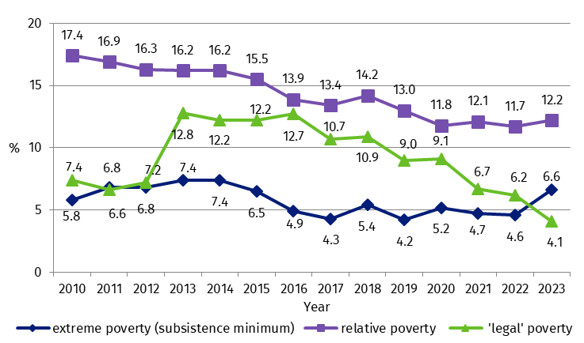
Economic poverty rates depend on the material situation of households and the poverty thresholds adopted. For legal poverty in 2023, its thresholds were the same as the year before, in contrast to the extreme and relative poverty thresholds, which increased.
The changes in the extent of economic poverty depended both on changes in the material situation of households as measured by the level of their expenditure, as well as on the value of the poverty thresholds applied (Charts 2 and 3).
The level of the extreme poverty line depends on the prices of the consumer goods and services included in the basket used to calculate the subsistence minimum by the IPiSS.
The value of relative poverty thresholds depends on the level of average expenditure of all households in the country (it represents 50% of average expenditure).
Chart 2. Poverty thresholdsª for 1-person households in the years 2010–2023

ª On average per month in the 4th quarter.
On the other hand, changes in the value of the so-called legal poverty thresholds result from decisions concerning the level of income thresholds entitling one to apply for a cash benefit. These thresholds change in periods of several years. Until the end of September 2012, thresholds that were set in 2006 were in force. The next three periods in which the same legal poverty thresholds applied were: (1) October 2012 - September 2015; (2) October 2015 - September 2018; (3) October 2018 - December 2021. In 2023, the legal poverty thresholds were in force, which were set on 1 January 2022.
Chart 3. Poverty thresholdsª for 4-person households (2 adults and 2 children up to 14 years) in the years 2010–2023

ª On average per month in the 4th quarter.

Differences in the extent of extreme poverty in 2023
Invariably, those most at risk of extreme poverty were those in households living on social benefits (except retirement and pensions) and from agriculture, as well as households where the reference person had at most a lower secondary school education. Rural residents, especially those living in non-agricultural rural areas, were also clearly more exposed to the risk of extreme poverty.
In 2023, one in fifteen people in households in Poland will be living below the extreme poverty threshold. Analyses of individual population groups show their differentiation in terms of extreme poverty coverage.
For years, we have been able to identify the same groups that most often or least often experience extreme poverty. In 2023, the extreme poverty map was still without significant changes. However, the values for the percentage of extreme poverty among these groups have changed from year to year.
Invariably, the predominant source of livelihood strongly differentiated the extent of poverty in households (Chart 4). Those most at risk of extreme poverty in 2023 were people from households living mainly from non-earning sources other than retirement and pensions (17.9%), as well as farmer households (14.1%). The group least at risk of extreme poverty were people from households whose main source of income was self-employment (3.8%). Lower extreme poverty rates than the national average were also observed among pensioner households (5.9%). The extent of extreme poverty was similar to the national average among people from households living mainly from hired labour (6.4%).
Chart 4. Extreme poverty rate in 2022 r. and 2023 r. by socio-economic groups
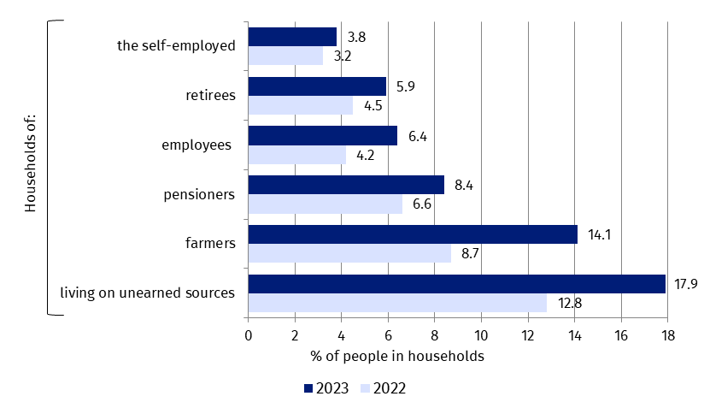
The extent of extreme poverty differed by 14.1 p.p. between people from households where the main source of livelihood was self-employment (3.8%) and people from households living mainly on other sources of unearned income (17.9%).
As the number of dependent children in a household increased, the proportion of people experiencing extreme poverty increased (Chart 5). Among households of married couples with three or more dependent children, the recorded incidence of extreme poverty in 2023 was 6.9%, while in households of married couples without dependent children it was 1.7%, as was the case for one-person households (1.6%).
Chart 5. Extreme poverty rate by households typeª (% of people in households)
Invariably, the higher the number of dependent children in a household, the higher the risk of extreme poverty was.
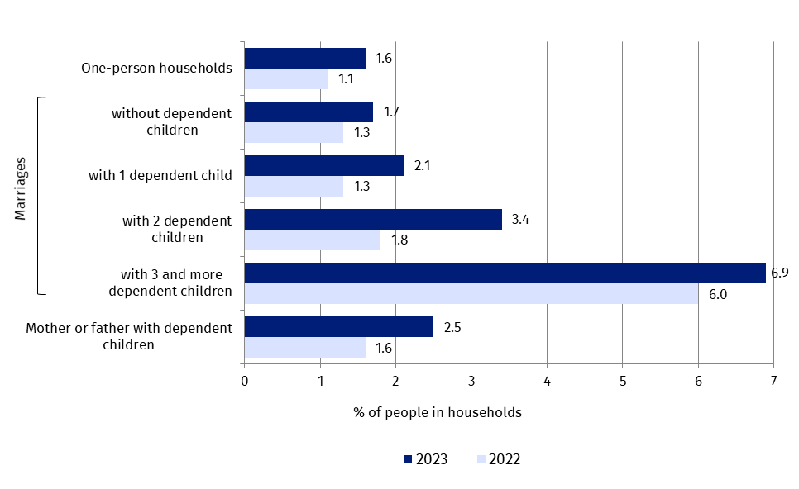
ª A dependent child is a person aged 0-14 or a person aged 15-25 with no own source of income and not married (or not living on cohabiting couple). Cohabiting couple are included in marriages.
Based on a slightly different typology of households by their composition, namely by the presence of persons aged 0-17 in the household, it should be noted that in the extent of extreme poverty, there was a clear difference between households with persons aged 0-17 and households without such persons (Chart 6). In households with at least one person of this age, the extreme poverty incidence was 8.2%. In households without such persons, the corresponding percentage was lower by 3 percentage points (5.2%). Interestingly, unlike in previous years, in 2023, a higher incidence of extreme poverty was recorded among people from households with two persons aged 0-17 (9.4%) than among people from households with at least three persons of this age (8.3%). In earlier years, greater ranges of extreme poverty were recorded among people from the latter type of household than among people from households with two people aged 0-17.
Chart 6. Extreme poverty rate in 2022 and 2023 in households with persons aged 0–17ª
(% of people in households)
In 2023, different from previous years, there was a greater extent of extreme poverty in households with 2 persons aged 0-17 than in households with at least 3 such persons.
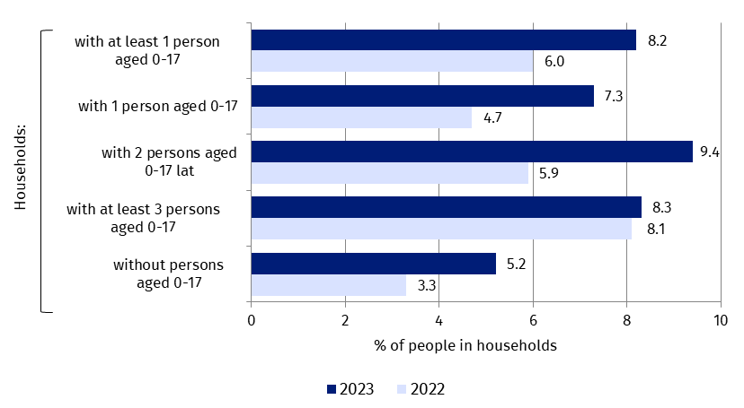
ª The data in Chart 6 refer to households with persons (children) aged 0-17 regardless of whether they are supported by their parents (or other household members) or have their own source of income, such as a survivor pension or maintenance. In addition to parents and children aged 0-17, these households may also include other persons, such as older siblings, grandparents, or brothers or sisters of one of the parents.
Analysing the data by age as a differentiating characteristic (Chart 7), it should be noted, that in 2023 - as in 2022- extreme poverty was most often experienced by the youngest people, aged 0-17 (7.6%). Slightly less often, extreme poverty was experienced by those aged 18-64 (6.6%). In 2023, the lowest extreme poverty rate (5.7%) was recorded among those aged 65 and over.

Chart 7. Extreme poverty rate in 2022 and 2023 by age (% of people in households)
The youngest people (aged 0-17) were still more at risk of extreme poverty in 2023 than those in the other age groups analysed.
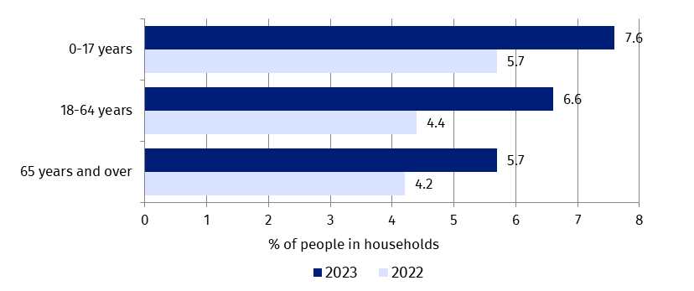
The education level of reference persons in households also strongly differentiated, as in previous years, the extent of extreme poverty (Chart 8). As the level of education increased, the extent of extreme poverty decreased. People from households in which the head of the household had at most a lower secondary school education experienced extreme poverty most frequently (12.8%). The extent of extreme poverty was also markedly higher than average among people from households where the reference person had a basic vocational/basic sectoral vocational education (9.5%). Invariably, the lowest coverage was recorded among households with a reference person with a tertiary education (3.5%).

Chart 8. Extreme poverty rate in 2022 and 2023 by education level of the reference person of the household (% of people in households)
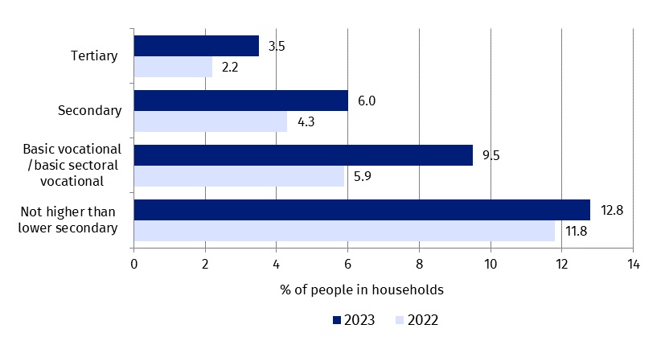
Level of education clearly differentiated the extent of extreme poverty. The higher the education of the reference person in the household, the lower the risk of poverty.
Disability, as in previous years, increased the risk of extreme poverty. In 2023, the extreme poverty rate for households with at least one person with a disability certificate was 9.0%, compared to 6.1% for households without such persons.
In 2023, as in previous years, the class of place of residence also determined the frequency of experiencing extreme poverty (Chart 9). Urban residents were significantly less likely to experience extreme poverty (3.3%) than rural residents (11.5%). The smallest proportions of poor people were found in the largest cities with a population of at least 500 000 (1.6%) and cities with a population between 100 000 and 500 000 (2.0%).
The extent of extreme poverty increased as the population of the localities concerned decreased.
Chart 9. Extreme poverty rate in 2022 and 2023 by place of residence (% of people in households)
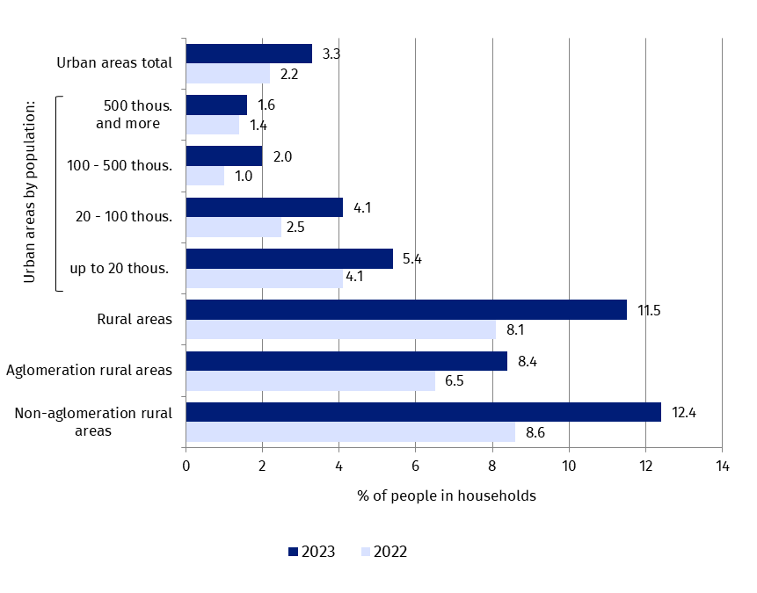
As in previous years, in 2023, a large difference in the extent of extreme poverty was noted between urban residents (3.3 %) and rural residents (11.5 %), who were much more likely to experience extreme poverty.
In smaller cities, the extreme poverty rate was already higher (respectively: 4.1% in cities of 20,000-100,000 inhabitants and 5.4% in the smallest cities of less than 20,000 inhabitants). Among rural residents, poverty was more often experienced in non-agglomeration rural areas (12.4%) than in agglomeration rural areas (8.4%).
The year 2023, although with varying degrees of intensity, saw a year-on-year increase in the extent of extreme poverty in all groups analysed .
The largest increases were recorded among persons from farmer households (by 5.4 p.p.) and among persons living from other unearned sources (by 5.1 p.p.).
Relatively high increases (above average) in the incidence of extreme poverty were also recorded among persons from households in which the reference person had a basic vocational/professional education (by 3.6 p. pp.), from households with two persons aged 0-17 (by 3.5 p.p.) and with one person aged 0-17 in the household (by 2.6 p.p.), as well as among rural residents (by 3.4 p.p.), including non-agricultural rural residents (by 3.8 p.p.).
For the other analysed population groups, an increase in extreme poverty incidence of about 1-2 p.p. was recorded. The exceptions are people from households with at least 500,000 inhabitants and in households with at least 3 persons aged 0-17, for whom a minimal increase in the poverty rate of 0.2 p.p. was recorded.

Sphere of deprivation
The privation rate (also referred to as the rate of low consumption) is also an important measure used by the Statistics Poland to measure the condition of households. The threshold of the privation sphere is based on the social minimum calculated by the Institute of Labour and Social Studies (IPiSS). The basket of the social minimum includes goods and services not only for the satisfaction of existential needs (as in the case of the subsistence minimum), but also goods and services necessary for work, education, maintaining family ties and social contacts as well as modest participation in culture and recreation. Consumption expenditures at a level not less than the social minimum are assumed to allow one to lead a ‘minimally dignified life’ and to fulfil inclusive human needs.
In 2023, the extent of the deprivation sphere was 46%, around 5 p.p. higher than in the previous year. The population groups most at risk of deprivation included the same population groups as for extreme poverty.
In 2023, with the adopted deprivation sphere boundaries, its coverage was 46%, around 5 p.p. higher than in 2022. This was the highest recorded deprivation sphere coverage in the 2010-2023 period, despite an improvement in the average household income situation.
Between 2010 and 2023, deprivation sphere coverage ranged between approximately 39% and 46%. Between 2010 and 2013, there was an increase in the extent of the sphere of deprivation from around 41% to around 45%, with from 2014 to 2017 - decreases (to around 39%). In the following years (2018 to 2022), the rate of the sphere of deprivation fluctuated between about 39% and about 43%, with a rate of about 41% in 2022. In 2023 the extent of the sphere of deprivation reached 46%.
It can be said that the direction of change in deprivation rates between 2010 and 2023, was similar to that of extreme poverty (Chart 10).
In general, the same factors that promote an increased risk of poverty, including extreme poverty, also increase the likelihood of entering the sphere of deprivation.
In 2023, the highest rates of people living in the sphere of deprivation were recorded among farmer households (66.5%), households living on unearned sources other than pensions (65.2%), households in which the reference person had at most lower secondary education (approximately 65.1%) and households with at least 3 persons aged 0-17 (58.6%).
A relatively large extent of the sphere of deprivation was also recorded among people in households with at least 1 person with a disability (53.1%), which is more pronounced when compared with households without such persons (44.5%).
Chart 10. Extreme poverty rate and privation rate in Poland in the years 2010–2023
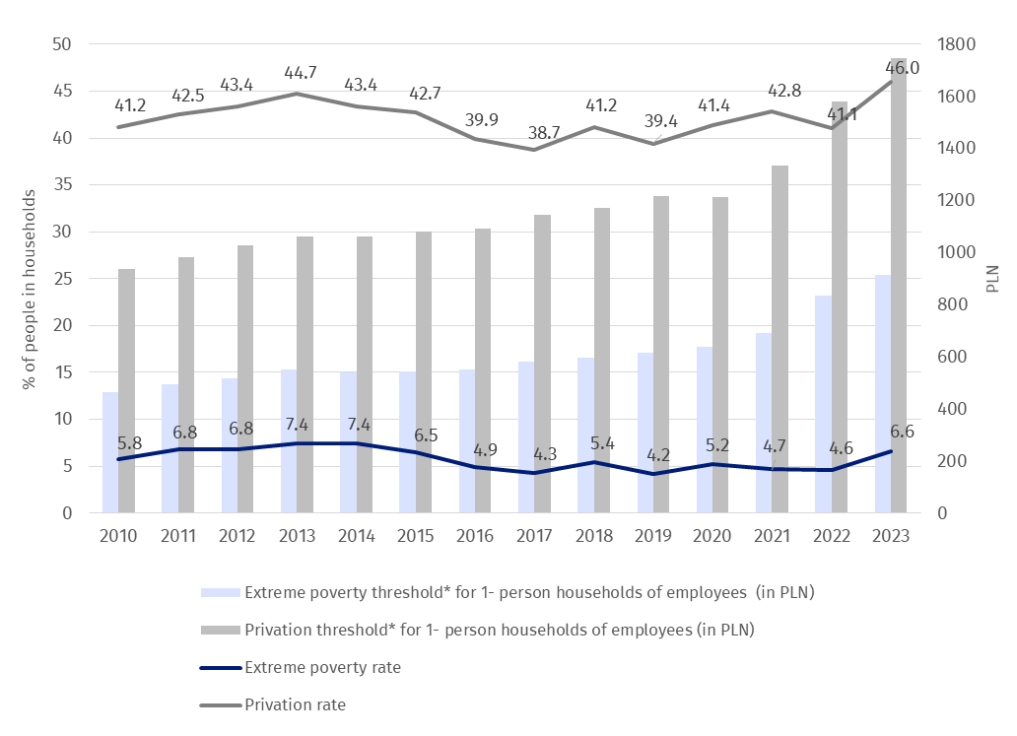
* On average per month in the 4th quarter.
The extent of the deprivation sphere was significantly higher in rural areas (57.2%) than in urban areas (38.3%). Depending on the size of the city, it ranged from 26.8% in the largest cities (with a population of at least 500,000) to 50.1% in the smallest (with a population of less than 20,000). As city size increased, gradual decreases in the extent of the deprivation sphere were recorded. Among rural residents, there was also a relatively large difference in the extent of deprivation. The extent of deprivation among residents of agglomeration rural areas was lower (49.2%) than among residents of non-agglomeration rural areas (59.7%).
In the case of quoting data from the Statistics Poland, please provide information: "Statistics Poland data source", and in the case of publishing calculations made on data published by the Statistics Poland, please provide information: "Own study based on Statistics Poland data".

Prepared by:  Social Surveys and Labour Market Department  Director  Piotr Łysoń, Ph.D.  Office: (+48 22) 449 40 27,  (+48 22) 608 31 22 | Issued by:  Press Office  Mobile +48 695 255 032  Phone +48 22 608 38 04, +48 22 449 41 45,  +48 22 608 30 09  e-mail: obslugaprasowa@stat.gov.pl

stat.gov.pl

@GUS_STAT

@GlownyUrzadStatystyczny

gus_stat

glownyurzadstatystycznygus

glownyurzadstatystyczny
Related information
News release: ‘Economic poverty rates in Poland in 2021 (based on the results of the Household Budget Survey)’
News release: ‘Economic poverty rates in Poland in 2022 (based on the results of the Household Budget Survey)’
News release: ‘Different faces of poverty in Poland in 2015 and 2018 based on the Social Cohesion Survey’
‘Perceptions of poverty and income inequality in Poland. Results of the Social Cohesion Survey 2018’
News release: ‘Household Situation in 2022 in the Light of the Results of the Household Budget Survey’
News release: ‘Household Situation in 2023 r. in the Light of the Results of the Household Budget Survey’
Publication: Incomes and living conditions of the population in Poland – report from EU-SILC of 2021
Publication: Incomes and living conditions of the population in Poland – report from EU-SILC of 2022”
Publication: ‘Poverty in Poland in 2019 and 2020’
Publication: ’Poverty in Poland in 2021 and 2022’
On minimum subsistence and subsistence - Institute of Labour and Social Studies (ipiss.com.pl)
The value of minimum existence
The value of the subsistence minimum
Data available in databases
Local Data Bank
Knowledge Data Base Living Conditions/Poverty by socio-economic groups
Knowledge Data Base Living Conditions/Poverty by urban and rural areas
Terms used in official statistics
Extreme poverty rate
Relative poverty rate
”Legal” poverty rate

The indicators presented on the level (rate) of poverty and deprivation are based on the results of the Household Budget Survey throughout the year and therefore represent an average level of the phenomenon for the whole year.
The value of goods received free of charge, the value of natural consumption and the renovation fund are also included in the expenditure.
Information on the subsistence minimum can be found on the website of the Institute of Labour and Social Studies: O minimum socjalnym i minimum egzystencji - Instytut Pracy i Spraw Socjalnych (ipiss.com.pl) and Wysokość minimum egzystencji - Instytut Pracy i Spraw Socjalnych (ipiss.com.pl)
OJ 2021, points 2268, 2270 and OJ 2022, points 1, 66, 1079.
This refers to so-called equivalent expenditure, taking into account the original OECD equivalence scale, which assigns a weight of 1 to the first person in the household aged 14 and over, a weight of 0.7 to each additional person of that age and a weight of 0.5 to each child under 14.
See: News releases: https://stat.gov.pl/obszary-tematyczne/warunki-zycia/dochody-wydatki-i-warunki-zycia-ludnosci/sytuacja-gospodarstw-domowych-w-2023-r-w-swietle-badania-budzetow-gospodarstw-domowych,3,23.html
See: News releases – as above
See : https://stat.gov.pl/obszary-tematyczne/warunki-zycia/dochody-wydatki-i-warunki-zycia-ludnosci/sytuacja-gospodarstw-domowych-w-2023-r-w-swietle-badania-budzetow-gospodarstw-domowych,3,23.html
Similar phenomena accompanying the increase in the extent of extreme poverty in Poland took place in 2018.
Which is all the more significant because the Household Budget Survey indicates that the poorest households were largely forced to use their savings or loans or credit- see: https://stat.gov.pl/obszary-tematyczne/warunki-zycia/dochody-wydatki-i-warunki-zycia-ludnosci/sytuacja-gospodarstw-domowych-w-2023-r-w-swietle-badania-budzetow-gospodarstw-domowych,3,23.html
The data presented on the extent of poverty are based on the results of the Household Budget Survey, which is a sample survey. As with any sample survey, data from this survey are subject to both non-random and random error. Caution should therefore be exercised when interpreting the data, including when analysing the dynamics of the level of economic poverty, and the values of the standard errors should be taken into account when drawing conclusions. In particular, in the case of small differences in the values of poverty incidence indicators between the years analysed, it cannot be clearly established whether they are due to a real change or to measurement error. The values of the standard errors are given in the annex to this news release.
Rounded to the nearest PLN, the extreme poverty line for a one-person household (on average per month) was PLN 888 in the first quarter 2023, PLN 918 in the second quarter 2023, PLN 909 in the third quarter 2023 , PLN 913 – in the fourth quarter 2023.
Rounded to the nearest PLN, the relative poverty line for a one-person household (on average per month) was PLN 990 in the first quarter 2023, PLN 1041 in the second quarter 2023, PLN 1068 in the third quarter 2023 and PLN 1092 in the fourth quarter 2023.
In all quarters of 2023, the values of the so-called legal poverty thresholds were the same and amounted (on average per month) to PLN 776 per person for single-person households and PLN 600 per person for people in multi-person households.
Conclusions should be drawn cautiously when analysing the dynamics of poverty and deprivation coverage due to measurement standard errors - see Table Annex to this study.
Detailed data and methodological explanations on privation can be found in the annex to this news release. When analysing the level and dynamics of privation rates, standard errors should be taken into account, as in the case of poverty data. The standard errors are presented in the annex to this release.
As in the case of the extreme poverty thresholds, the values of the privation thresholds varied considerably from quarter to quarter in 2023 due to inflation. For 1-person employee and self-employed households they were (average per month) in each quarter: PLN 1682 in Q1, PLN 1741 in Q2, PLN 1728 in Q3, PLN 1745 in Q4. For 1-person households of farmers, pensioners and persons living from other unearned sources, the average (per month) in certain quarters was PLN 1650 in Q1, PLN 1707 in Q2, PLN 1696 in Q3, PLN 1711 in Q4. Threshold values are rounded to full zlotys.
Information on the social minimum is available on the Institute of Labour and Social Studies website: O minimum socjalnym i minimum egzystencji - Instytut Pracy i Spraw Socjalnych (ipiss.com.pl) oraz Wysokość minimum socjalnego - Instytut Pracy i Spraw Socjalnych (ipiss.com.pl)

