Employed, unemployed and economically inactive persons (preliminary results of the Polish Labour Force Survey)
According to the preliminary results of the Polish Labour Force Survey, an increase in the activity rate of the population was observed in the third quarter of this year. The number of employed persons and the employment rate were higher than in the second quarter of this year, the number of unemployed persons and the unemployment rate also increased. On the other hand, the number of economically inactive persons decreased.
In the third quarter of 2024, economically active persons accounted for 58.6% of the population aged 15-89. This indicator was higher compared to both the second quarter of 2024 (by 0.3 pp.) and the third quarter of 2023 (although to a lesser extent - an increase of 0.1 pp.). The activity rate was 65.7% among men and 52.1% among women.
58.6%
Activity rate of persons
aged 15-89

Economic activity of the population aged 15-89 by the LFS
The activity rate for persons aged 15-89 has increased compared to the previous quarter for both men and women. Compared to the same period last year, there was an increase in the rate among women and a decrease among men
In the third quarter of 2024, the number of economically active persons aged 15-89 amounted to 17 798 thousand, of which: 17 277 thousand constituted employed persons, while 521 thousand – the unemployed. The population of economically inactive persons in this age group comprised 12 552 thousand persons.
Population of economically active persons increased compared to the second quarter of 2024 (by 120 thousand persons, i.e. by 0.7%) and to a lesser extent compared to the third quarter of 2023 (by 31 thousand, i.e. by 0.2%).
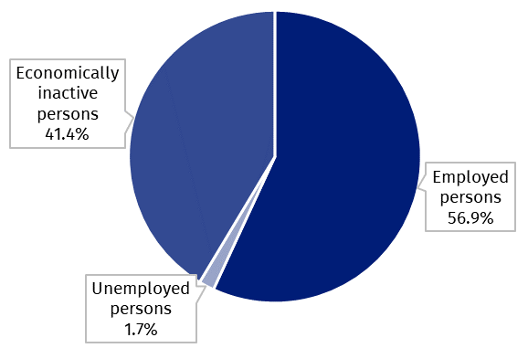
Chart 1. Structure of the population aged 15-89 by status on the labour market in the third quarter of 2024

The activity rate of persons aged 15-89 in the third quarter of 2024 was higher among men and accounted for 65.7%, in the population of women it was 52.1% (respective values for persons at the working age were 84.3% and 78.8%). Corresponding indicators for urban and rural residents accounted respectively for: 59.1% and 58.0% (at the working age: 83.6% and 79.0%).
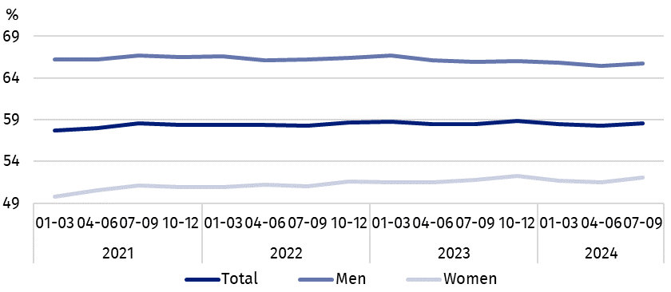
Chart 2. Activity rate of persons aged 15-89
The indicator describing the relation of jobless persons to the number of employed persons decreased compared to the second quarter of 2024, but was the same as in the third quarter of 2023
Within the scope of population aged 15-89, the ratio of the number of not working persons (the unemployed or the economically inactive) to the employed persons decreased compared to the previous quarter and was the same as in the third quarter of 2023. In the third quarter of 2024, there were 757 unemployed or economically inactive persons aged
15-89 per 1 000 working people (in the second quarter of 2024 – 764 persons and in the third quarter of 2023 – 757 persons).
In the third quarter of 2024, employed persons accounted for 56.9% of the population aged
15-89. The employment rate was higher than noted in the second quarter of 2024 (by 0.2 pp.), but it did not change in relation to this observed in the third quarter of 2023. The rate was higher among men (63.9%) than among women (50.5%).
56.9%
Employment rate
of persons aged 15-89

Employed persons aged 15-89 by the LFS
The number of employed persons was higher than in the previous quarter, and remained at the same level compared to the same period of the previous year
In the third quarter of 2024, population of employed persons aged 15-89 amounted to 17 277 thousand persons and increased compared to the second quarter of 2024 (by 72 thousand persons, i.e. by 0.4%), while compared to the third quarter of 2023 it remained at the same level.
Chart 3. Employed persons and employment rate of persons aged 15-89 and at the
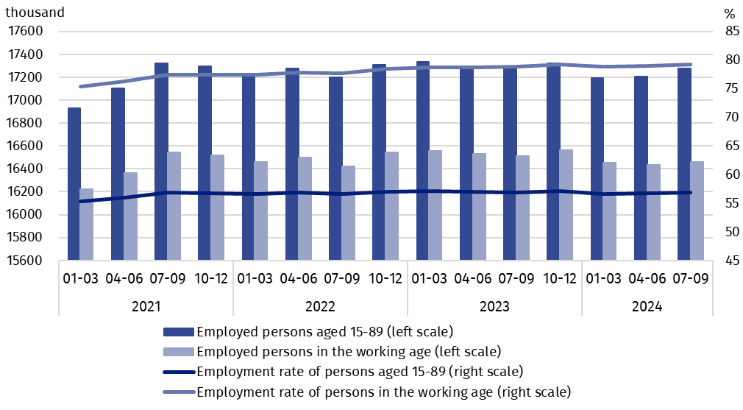
working age
Compared to the second quarter of 2024, the number of employed persons increased both among women (by 48 thousand people, i.e. by 0.6%) and among men (by 24 thousand, i.e. by 0.3%). Taking into account the place of residence, an increase in the number of employed persons occurred only among rural residents (by 98 thousand, i.e. by 1.5%), while among the urban residents there was a decrease in the number of this group (by 27 thousand, i.e. by 0.3%).
Compared to the third quarter of 2023, a decrease in the number of employed persons was noted among men (by 18 thousand persons, i.e. by 0.2%) and an increase among women (by 16 thousand, i.e. by 0.2%), while taking into account the place of residence, the number of employed rural residents decreased (by 50 thousand, i.e. by 0.7%), and the number of employed urban residents increased (by 47 thousand, i.e. by 0.4%).
In the population of employed persons, taking into account division by sex, men still predominated, who constituted 53.9% (i.e. 9 308 thousand persons) of this group, while regarding the place of residence, there were more employed persons living in urban areas (60.8%, i.e. 10 505 thousand), which is a direct consequence of the higher population in urban than rural areas (respectively 3/5 and 2/5 of the total population in Poland).
In the third quarter of 2024, total employment rate amounted to 56.9%, i.e. 0.2 pp. more than in the previous quarter and the same as a year ago.
In line with the observed trend, it was higher among men (63.9%) than among women (50.5%) and regarding the place of residence, a slightly higher level of the indicator was noted in urban areas (57.4%) than in rural areas (56.2%).
Over the quarter, similarly to the total employed population, the employment rate increased among women – by 0.3 pp., as well as among men, although to a lesser extent by 0.1 pp. Taking into account the place of residence, the increase in this indicator was noted only among rural residents - by 0.7 pp., while among urban residents there was a slight decrease (by 0.1 pp.).
Compared to the third quarter of 2023, the increase in the employment rate among women by 0.2 pp. was accompanied by the same decrease among men (by 0.2 pp.). In the case of persons living in rural areas, this indicator decreased by 0.6 pp., and in urban areas it increased by 0.4 pp.
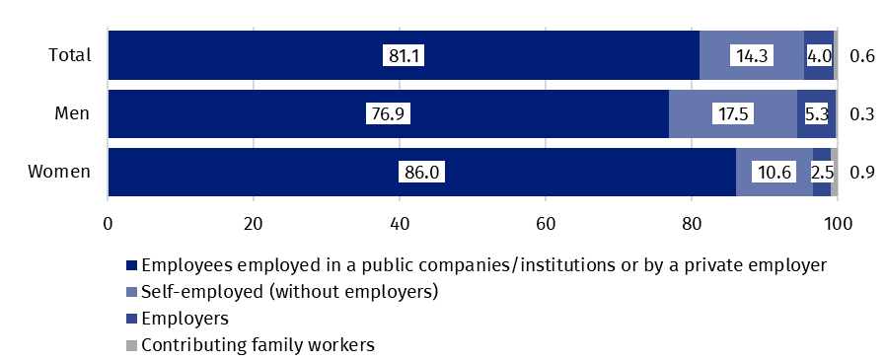
Chart 4. Structure of employed persons aged 15-89 by employment status in the main job in the third quarter of 2024 (in %)
The LFS results indicate that in the third quarter of 2024:
The number of persons employed full-time increased compared to the previous quarter, but decreased compared to the same period last year
- 16 095 thousand persons (i.e. 93.2%) persons performed full-time work, while 1 181 thousand (i.e. 6.8%) were employed part-time,
- the average number of hours worked in the reference week in the main job amounted to 39.6 hours,
- in the total number of employees, the share of employees employed in public companies/institutions or by a private employer was 81.1% (14 013 thousand persons), self-employed – 18.3%, and contributing family members – 0.6%, but a significantly higher share of self-employed was noted among men (22.8%) than women (13.1%), while the share of employees employed by a public or private employer was higher among women (86.0%) than men (76.9%),
- a vast majority of employees employed in public companies/institutions or by a private employer performed their work on the basis of the contract for unlimited duration (84.8%, i.e. 11 878 thousand persons),
- the sections where the most people worked were: manufacturing – 19.2% of all employed persons (3 312 thousand persons); wholesale and retail trade; repair of motor vehicles and motorcycles – 13.0% (2 241 thousand), education – 8.2% (1 424 thousand) and construction – 7.7% (1 332 thousand).
In the third quarter of 2024, the highest increases in the number of employed persons compared to the previous quarter were noted in the public administration and defence; compulsory social security section (by 92 thousand persons) and in education (by 64 thousand). Whereas, the highest declines concerned the number of employed persons in the wholesale and retail trade; repair of motor vehicles and motorcycles section (by 50 thousand) and in the human health and social work activities (by 47 thousand).
Compared to the third quarter of 2023, the highest increases in the number of employed persons occurred in manufacturing (by 169 thousand persons) and in transportation and storage (by 75 thousand), while the highest declines – among the employed persons in the agriculture, forestry and fishing section (by 255 thousand) and in the wholesale and retail trade; repair of motor vehicles and motorcycles section (by 85 thousand).
In the third quarter of 2024, 1605 thousand persons had a job, but were not performing the work in the reference week, which accounted for 9.3% of the total number of the employed (the corresponding population in the previous quarter comprised 839 thousand, i.e. 4.9%, while a year ago it was 1496 thousand, i.e. 8.7%). The most common reasons for not performing work were own illness and paid, unpaid or occasional leave – they accounted jointly 81.4% of all causes of absence.
10.5% of the total number of employed persons worked in a form of remote work

The number of persons performing their work usually or sometimes at home amounted to 2 711 thousand persons, which accounted for 15.7% of the total number of the employed. In a form of remote work (the place of performing work is not considered here), their work related responsibilities were performed usually or sometimes by 1 812 thousand persons, i.e. 10.5% of the total number of the employed.
In the third quarter of 2024, unemployed persons accounted for 2.9% of the economically active population aged 15-89. Unemployment intensity (measured by the unemployment rate) increased compared to the second quarter of 2024 and the third quarter of 2023 (by 0.2 pp. each). The unemployment rate was lower among men than among women (2.7% versus 3.2%).
2.9%
Unemployment rate of persons aged 15-89

Unemployed persons aged 15-74 by the LFS
The number of unemployed persons was higher compared to the previous quarter and the same period of the previous year
In the third quarter of 2024, the population of unemployed persons aged 15-74 was 521 thousand and was higher compared to both the second quarter of 2024 – by 49 thousand persons, i.e. by 10.4%, and the third quarter of 2023 – by 33 thousand, i.e. by 6.8%.
In the third quarter of 2024, more than half of unemployed population were women – 50.9%, i.e. 265 thousand persons. Unemployed urban residents constituted 58.9% of the total number of the unemployed, i.e. 307 thousand which is a lower percentage than the share of the urban population in the population of Poland (60.3%).
It is also worth noting that the percentage of unemployed in the total population aged 15-89 in subpopulations separated by sex and place of residence reaches similar values ranging from 1.7% to 1.8%.
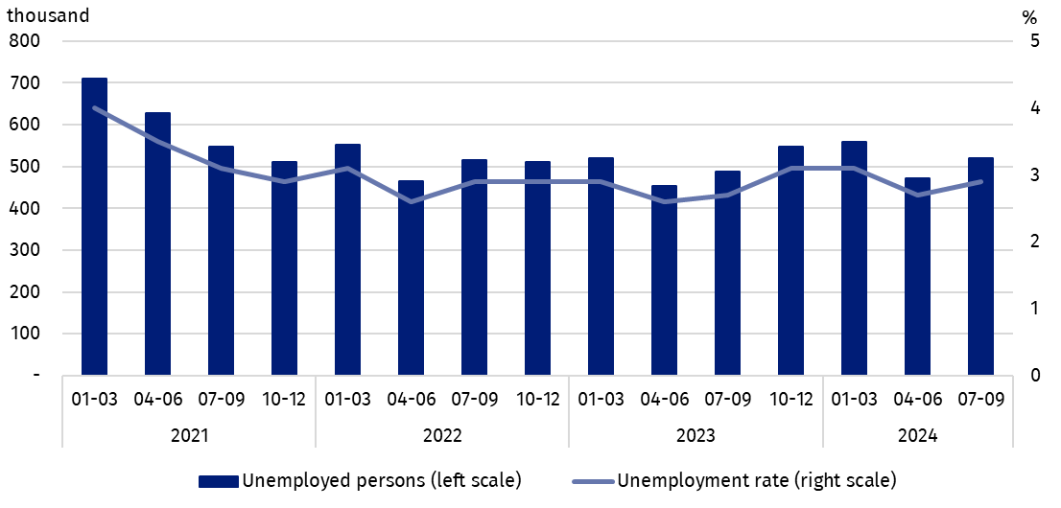
Chart 5. Unemployed persons aged 15-74 and unemployment rate of persons aged 15-89
The increase in the number of unemployed persons compared to the second quarter of 2024 was mainly due to the increase in the number of this population among women (by 47 thousand persons, i.e. by 21.6%), while among men it remained at the similar level. Taking into account the place of residence, the increase was observed among both rural and urban residents, but in the rural areas it was much higher (by 35 thousand, i.e. by 19.6% and by 14 thousand, i.e. by 4.8%, respectively).
Compared to the third quarter of 2023, there was an increase in the number of unemployed among women (by 41 thousand persons, i.e. by 18.3%), while there was a decrease among men (by 7 thousand, i.e. by 2.7%). Among the unemployed specified by place of residence, the increase in the analysed period occurred among rural residents (by 44 thousand, i.e. by 25.9%) and among urban residents a decrease (by 11 thousand, i.e. by 3.5%).
In the third quarter of 2024, the unemployment rate amounted to 2.9% and was higher than in the second quarter of 2024 and the third quarter of 2023 (an equally increase of 0.2 pp. each). A lower unemployment rate was observed among men than among women (2.7% versus 3.2%).
Compared to the previous quarter the unemployment rate among women increased by 0.5 pp. and among men it remained at the same level. Taking into account the place of residence, the increase in the unemployment rate occurred primarily among rural residents – by 0.5 pp., while among urban residents an increase of 0.1 pp. was noted.
Compared to the third quarter of 2023, the same trend was observed among men and women as over the quarter – an increase in unemployment intensity occurred among women – by 0.5 pp., while there was no change among men. Taking into account the place of residence, the increase was noted among rural residents – by 0.7 pp. and a decrease among urban residents – by 0.2 pp.
Changes in the level of unemployment rate are also noticeable when taking into account the division of population by age groups.
As in previous periods, the highest unemployment rate concerned the youngest persons i.e. aged 15-24, with its value increasing compared to the previous quarter, but decreasing slightly compared to the same quarter of 2023
The highest unemployment rate was recorded among the youngest, i.e. in the age group
15-24 years – 10.9%. Significantly lower unemployment rates occurred in other older age groups. The unemployment rate was 3.5% for persons aged 25-34, 2.2% for persons aged
35-44 and 1.9% for persons aged 45-89.
Compared to the second quarter of 2024, the unemployment rate increased in the two youngest age groups: among 15-24 year olds – by 1.6 pp. and among 25-34 year olds – by 0.5 pp. For the other age groups, the unemployment rate did not change and remained at the level observed in the second quarter of 2024.
In relation to the same quarter of the previous year, a slight decrease in the intensity of unemployment occurred among persons aged 15-24 and 45-89 (by 0.1 pp. each). In the other two analysed groups, there were increases in the indicator (by 0.2 pp. among persons aged
35-44 and by 0.7 pp. among persons aged 25-34).
When analysing the unemployment rate according to the level of education of the unemployed, it should be noted that persons with tertiary education still remain in the best situation – the unemployment rate in this group is the lowest – in the third quarter of 2024 amounted to 1.5%. For persons with post-secondary and technical secondary or secondary sectoral vocational education, unemployment rate in the third quarter of 2024 was at the level 3.2% and for those with basic vocational or basic sectoral vocational education - at the level 3.4%. A slightly higher unemployment rate than for vocational school graduates is noted among persons with general secondary education, reaching 4.7% in the third quarter of 2024. However, the highest unemployment rate is observed among persons with the lowest level of education, i.e. with lower secondary education or less, in the third quarter of 2024 it was 9.7%.
To the greatest extent, unemployment affected persons with the lowest level of education

Compared to the second quarter of 2024, the unemployment rate increased in the most groups separated by education level (from 0.3 pp. among persons with tertiary education to 0.7 pp. among persons with lower secondary education or less). Only among persons with basic vocational or basic sectoral vocational education the unemployment rate decrease, but the decrease was small – by 0.1 pp.
Similar trends were observed compared to the third quarter of 2023. The unemployment rate decreased only among persons with basic vocational or basic sectoral vocational education (by 1.0 pp.), in other groups of unemployed persons separated by educational level, the unemployment rate increased (from 0.2 pp. among persons with tertiary education to 3.7 pp. among persons with lower secondary education or less).
Each unemployed person was classified into one of four categories separated due to the reason of inflow to unemployment. The largest population of unemployed were those who lost their job, i.e. persons who left their last job in the last 3 months not on their own initiative (37.8%, i.e. 197 thousand persons). The share of unemployed intending to return to work after a break (lasting longer than 3 months) was 28.0% (i.e. 146 thousand), but among women this share was much higher than among men and amounted to 33.5% and 22.3%, respectively. The unemployed who were looking for their first job constituted 20.0% (i.e. 104 thousand) and the unemployed who resigned from work on their own initiative – 14.2% (i.e. 74 thousand).
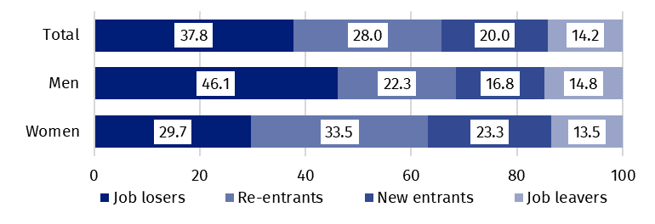
Chart 6. Structure of unemployed persons by the source of unemployment in the third quarter of 2024 (in %)
The average duration of job search by unemployed persons in the third quarter of 2024 was 7.6 months
In the third quarter of 2024, unemployed persons had been looking for a job 7.6 months on average (in the previous quarter and in the third quarter of 2023 it was 7.5 months). On average, persons who were seeking a job for the longest duration were the ones aged
55-74 (9.7 months), aged 45-54 (9.1 months) and aged 35-44 (9.0 months), while the shortest job search duration was observed for the youngest persons i.e. aged 15-19 (3.2 months) and aged 25-29 (5.6 months).
41.4%
The share of economically
inactive persons in the total number of the population aged 15–89

In the third quarter of 2024, economically inactive persons accounted for 41.4% of the total number of population aged 15-89. The percentage was lower compared to the previous quarter (a decrease by 0.3 pp.) and in relation to the third quarter of 2023 (a slight decrease by 0.1 pp.).

Economically inactive persons aged 15-89 by the LFS
In the third quarter of 2024, population of economically inactive persons aged 15-89 amounted to 12 552 thousand and was lower in relation to the second quarter of 2024 (by 115 thousand persons, i.e. 0.9%) and compared to the third quarter of 2023 (by 36 thousand, i.e. 0.3%).
Over half of the population of economically inactive persons constituted women – in the analysed age group their share was 60.2% (7 558 thousand). Economically inactive women accounted for 47.9% of all women aged 15-89, while analogous indicator for men was 34.3%. Taking into account division into urban and rural areas, a majority of economically inactive persons constituted urban residents (59.7%; i.e. 7 491 thousand), which is connected with a higher population in urban than in rural areas (respectively 3/5 and 2/5 of the total population in Poland). The share of economically inactive among all urban residents in the analysed age group was at the level of 40.9% and among rural residents amounted to 42.0%.
Women still constitute a majority of economically inactive population
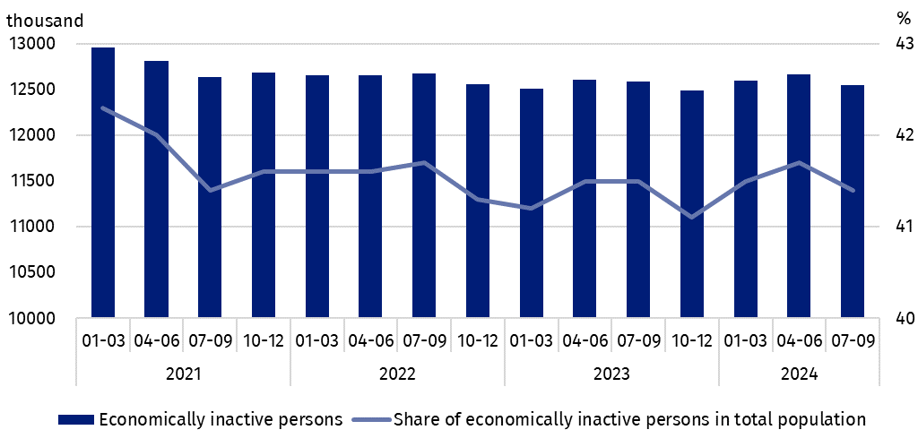
Chart 7. Economically inactive persons and the share of economically inactive persons in population aged 15-89
Compared to the second quarter of 2024, both the number of economically inactive women and men decreased (by 93 thousand persons, i.e. 1.2% and by 22 thousand, i.e. 0.4% respectively). The decrease in the number of economically inactive persons was noted among the all rural population (by 117 thousand, i.e. by 2.3%), while among urban residents their number remained at a similar level.
Compared to the same quarter of 2023, the number of economically inactive women decreased (by 61 thousand persons, i.e. by 0.8%), while among men there was an increase (by 25 thousand, i.e. by 0.5%). The decrease in the number of economically inactive was noted among urban residents – by 71 thousand, i.e. by 0.9%, and an increase among rural residents – by 35 thousand, i.e. by 0.7%.
The economically inactive population is a specific one in respect to the labour market resources. Its scope includes persons who have not entered the labour market yet (including the majority of the youth still participating in education) and persons who have definitely left the labour market or will never enter the labour market (some retirees, pensioners, persons maintaining themselves from other sources than work), but also persons who entered the labour market, then partially deactivated and who will want to re-enter the labour market after a break.
In the third quarter of 2024, over half of the economically inactive persons aged
15-74 comprising 9 951 thousand (the reason for inactivity was determined for this age group) constituted retirees (51.4%), while the second largest group were students (22.1%). It is worth noting that education and training as well as illness and disability were more often the reasons for inactivity among men (respectively 26.7% and 16.2%) than among women (respectively 19.0% and 6.8%). On the other hand, family responsibilities were much more often the reason for inactivity among women (12.2%) than men (1.3%).
Education and training were the most often reason for economic inactivity of persons at the working age, and family and households responsibilities were much more often the reason for women's economic inactivity
In the case of 3 801 thousand economically inactive persons at the working age (women aged 18-59 and men aged 18-64), the most often reasons for inactivity were: education and training – 28.3%, illness and disability – 24.8% and family responsibilities – 19.6%. Retirement as the reason for inactivity on the labour market indicated 8.8% persons at the working age, while persons discouraged with unsuccessful job search constituted 1.2% of this group.
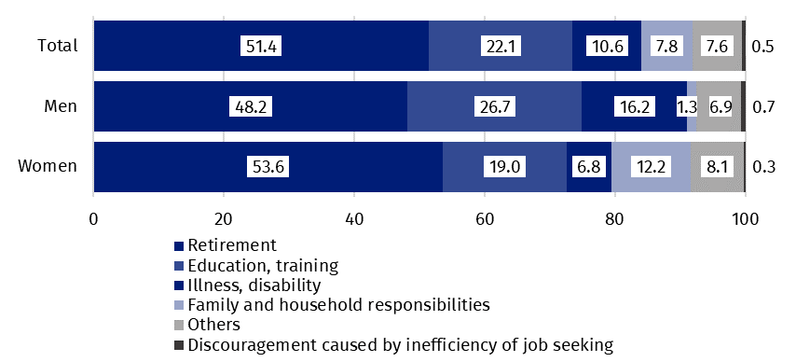
Chart 8. Structure of economically inactive persons aged 15-74 by sex and reasons for inactivity in the third quarter of 2024 (in %)

Methodological notes

The presented news release was prepared on the basis of the generalised results of the sample survey Badanie Aktywności Ekonomicznej Ludności/BAEL.
Since the fourth quarter of 2023, generalization of the survey results over the general population has been carried out with the use of the data on resident population of Poland coming from the balances compiled on the basis of the Population and Housing Census 2021 (by the third quarter of 2023, the results were generalized over the general population using population data from the balances compiled on the basis of the Population and Housing Census 2011). The data published in this news release and in the attached tables for the period from the first quarter of 2021 to the third quarter of 2023 have been recalculated in accordance with the new basis for generalizing results and are therefore comparable.
Badanie Aktywności Ekonomicznej Ludności (Eng. Labour Force Survey) has been carried out in Poland quarterly since May 1992 and it has been improved in accordance with the International Labour Organization and Eurostat recommendations.
From the first quarter of 2021 onwards, the base of the EU-LFS methodology are definitions of the employed, the unemployed and economically inactive persons in accordance with the Resolution concerning statistics of work, employment and labour underutilization adopted in 2013 on the 19th International Conference of Labour Statisticians in Geneva (ICLS) and re-commended by the International Labour Organization (ILO) for the use in all countries. The survey object is the situation within the scope of economic activity of the population, i.e. the fact of performing work, being unemployed or economically inactive persons in the reference week. In the European Union, the implementation of the provisions of the above mentioned Resolution was carried out through introduction of new legal acts. From 2021 onwards, EU-LFS has been one of the key surveys embraced by the framework regulation for social statistics (the so-called IESS FR). Accompanying IESS FR implementing regulations in the domain of the labour force specify the range of the core survey and module surveys, determine survey organisation and define in detail particular populations specified according to the status of persons in the labour market.
Detailed results of the survey as well as the up-dated methodology – obligatory from the first quarter of 2021, are included in the quarterly publication “Labour Force Survey in Poland” and in the Methodological report available on the Statistics Poland website:
https://stat.gov.pl/en/topics/labour-market/working-unemployed-economically-inactive-by-lfs/labour-force-survey-in-poland-quarter-22024,2,54.html
https://stat.gov.pl/en/topics/labour-market/yearbook-of-labour/methodological-report-labour-force-survey,8,2.html

Prepared by:  Social Surveys and Labour Market Department  Director Hanna Strzelecka  Phone: (+48 22) 608 32 79 | Issued by:  Press Office  Mobile +48 695 255 032  Phone +48 22 608 38 04, +48 22 449 41 45,  +48 22 608 30 09  e-mail: obslugaprasowa@stat.gov.pl

www.stat.gov.pl/en/

@StatPoland

@GlownyUrzadStatystyczny

gus_stat

glownyurzadstatystycznygus

glownyurzadstatystyczny
Related information
Methodological report. Labour Force Survey
Labour Force Survey in Poland
Other publications containing the results of LFS and its module surveys
stat.gov.pl → Topics → Labour Market
Data available in databases
Strateg → Topics → Labour Market
Local Data Bank → labour Market
Terms used in official statistics
Economic activity by LFS
Economically active population by LFS
Employed persons by LFS
Unemployed persons by LFS
Economically inactive population according to the LFS

Activity rate by LFS
Employment rate by LFS
Unemployment rate by LFS

Generalisation of the survey results over the general population has been carried out with the use of the data on resident population of Poland coming from the balances compiled on the basis of the Population and Housing Census 2021. Data for the period from the first quarter of 2021 to the third quarter of 2023 was recalculated in line with the new generalisation basis. See methodological notes on page 8.
The LFS results refer to the resident population i.e. staying or intending to stay in the country’s territory for at least 12 months, living in private households.
Men aged 18-64 and women aged 18-59.
Work at home is performed by, for example, persons who conducted own economic activity and their home is their workplace, as well as employees who work at home in the form of remote work.
Remote work is performed outside the establishment with the use of electronic communication means.
The average job search time is the period from which unemployed persons look for a job, because in most cases they have not found a job yet.
Regulation (EU) 2019/1700 of the European Parliament and of the Council of 10 October 2019 establishing a common framework for European statistics relating to persons and households, based on data at individual level collected from samples.

