Employed, unemployed and economically inactive persons (preliminary results of the Polish Labour Force Survey)
In the second quarter of 2024, economically active persons accounted for 58.3% of the population aged 15-89. This indicator was lower both compared to the first quarter of 2024 and the second quarter of 2023 (a decrease of 0.2 pp. each). The activity rate among men amounted to 65.5% and among women 51.5%.
58.3%
Activity rate of persons
aged 15-89

Economic activity of the population aged 15-89 by the LFS
Activity rate for the population aged 15-89 compared to the previous quarter decreased both among men and women. Compared to the same period of the last year, a decrease was noted among men, while the rate remained at the same level among women
In the second quarter of 2024, the number of economically active persons aged 15-89 amounted to 17 678 thousand, of which: 17 205 thousand constituted employed persons, while 472 thousand – the unemployed. The population of economically inactive persons in this age group comprised 12 667 thousand persons.
Population of economically active persons decreased both compared to the first quarter of 2024 (by 76 thousand persons, i.e. by 0.4%) and the second quarter of 2023 (by 68 thousand, i.e. by 0.4%).
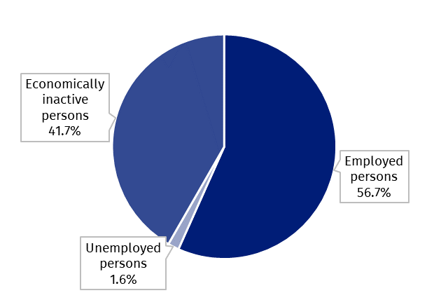
Chart 1. Structure of the population aged 15-89 by status on the labour market in the second quarter of 2024

The activity rate of persons aged 15-89 in the second quarter of 2024 was higher among men and accounted for 65.5%, in the women population it was 51.5% (respective values for persons at the working age were 84.0% and 78.1%). Corresponding indicators for urban and rural residents accounted respectively for: 59.1% and 57.0% (at the working age: 83.7% and 77.6%).
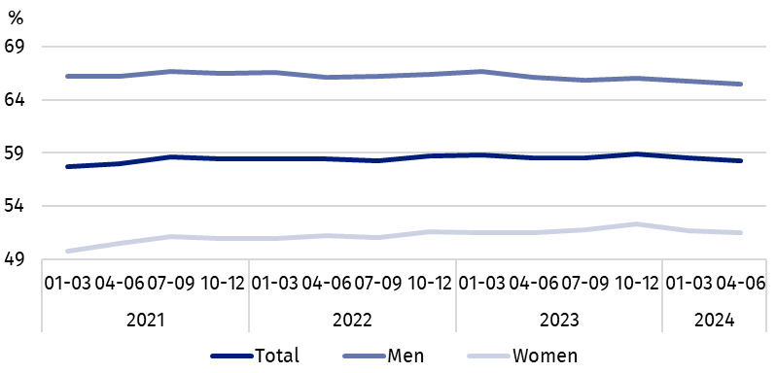
Chart 2. Activity rate of persons aged 15-89
The indicator describing the relation of jobless persons to the number of employed persons remained at a similar level compared to the first quarter of 2024, but increased compared to the second quarter of 2023
Within the scope of population aged 15-89, the ratio of the number of not working persons (the unemployed or the economically inactive) to the employed persons remained at a similar level compared to the previous quarter, but increased compared to the second quarter of 2023. In the second quarter of 2024, per 1 000 working people, there were 764 unemployed or economically inactive persons aged 15-89 (in the first quarter of 2024 there were 765 persons and in the second quarter of 2023 – 755 persons).
In the second quarter of 2024, employed persons accounted for 56.7% of the population aged
15-89. The employment rate was slightly higher than noded in the first quarter of 2024 (by 0.1 pp), but lower than in the second quarter of 2023 (by 0.3 pp.). The higher rate was observed in the male population (63.8%) than among women (50.2%).
56.7%
Employment rate
of persons aged 15-89

Employed persons aged 15-89 by the LFS
The number of employed persons increased compared to the first quarter of 2024, but decreased compared to the second quarter of 2023
In the second quarter of 2024, population of employed persons aged 15-89 amounted to 17 205 thousand persons and was at the similar level as in the previous quarter (an increase by 11 thousand persons, i.e. by 0.1%), but smaller than noted a year ago (a decrease by 87 thousand, i.e. by 0.5%).
Chart 3. Employed persons and employment rate of persons aged 15-89 and at the
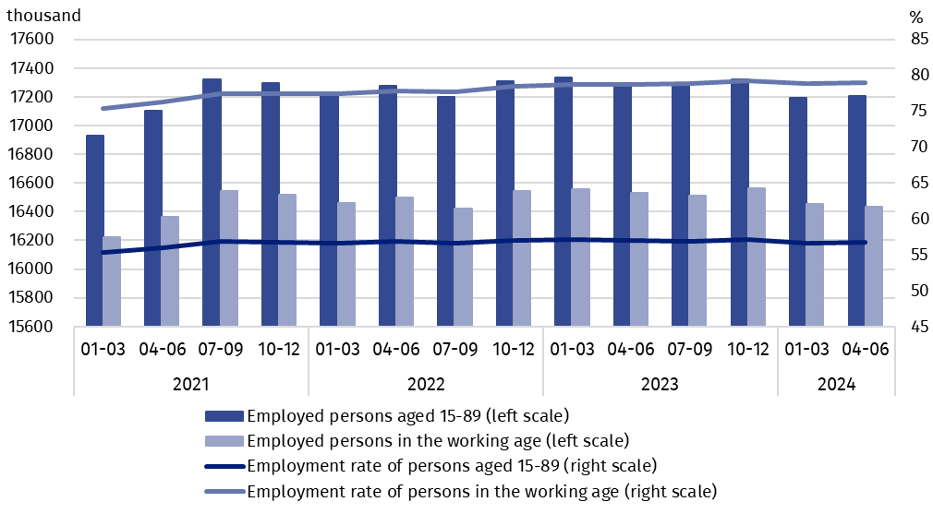
working age
Compared to the first quarter of 2024, the number of employed persons increased only among women (by 29 thousand persons, i.e. by 0.4%), while a decrease was noted among men (by 18 thousand, i.e. by 0.2%). Taking into account the place of residence, an increase in the number of employed persons occurred only among urban residents (by 74 thousand, i.e. by 0.7%), while among the rural residents there was a decrease in the number of this group (by 64 thousand, i.e. by 0.9%).
Compared to the second quarter of 2023, a decrease in the number of employed persons was noted among men (by 95 thousand persons, i.e. by 1.0%) and a slight increase among women (by 9 thousand, i.e. by 0.1%), while taking into account the place of residence, the number of employed rural residents decreased to a greater extent (by 63 thousand, i.e. by 0.9%) than urban residents (by 24 thousand, i.e. by 0.2%).
In the population of employed persons, taking into account division by sex, men still predominated, who constituted 54.0% (i.e. 9 284 thousand persons) of this group, while regarding the place of residence, there were more employed persons living in urban areas (61.2%, i.e. 10 532 thousand), which is a direct consequence of the higher population in urban than rural areas (respectively 3/5 and 2/5 of the total population in Poland).
In the second quarter of 2024, total employment rate amounted to 56.7%, i.e. 0.1 pp. more than in the previous quarter and 0.3 pp. less than a year ago.
In line with the observed trend, it was higher among men (63.8%) than among women (50.2%) and regarding the place of residence, a slightly higher level of the indicator was noted in urban areas (57.5%) than in rural areas (55.5%).
Over the quarter, similarly to the employed population, the employment rate increased among women – by 0.2 pp., and among men it decreased, although slightly – by 0.1 pp. Taking into account the place of residence, the increase in this rate among urban residents by 0.4 pp. was accompanied by the same decrease among rural residents (by 0.4 pp.).
Compared to the second quarter of 2023, the employment rate decreased among men (by 0.6 pp.) and increased slightly among women (by 0.1 pp.). In the case of persons living in rural areas, this rate decreased by 0.6 pp., and in urban areas it remained at the level observed in the second quarter of 2023.
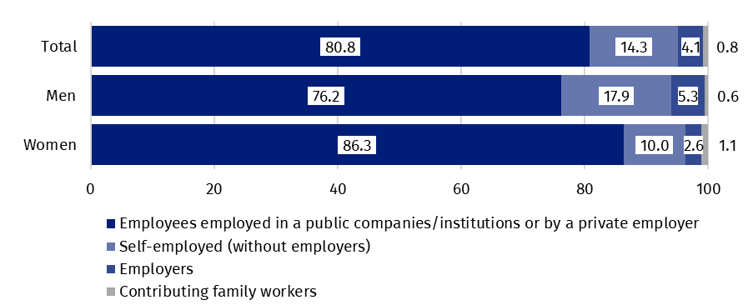
Chart 4. Structure of employed persons aged 15-89 by employment status in the main job in the second quarter of 2024 (in %)
The LFS results indicate that in the second quarter of 2024:
The number of persons employed full-time decreased compared to the previous quarter and the same period last year
- 16 030 thousand persons (i.e. 93.2%) persons performed full-time work, while 1 176 thousand (i.e. 6.8%) were employed part-time,
- the average number of hours worked in the reference week in the main job amounted to 38.2 hours,
- in the total number of employees, the share of employees employed in public companies/institutions or by a private employer was 80.8% (13 907 thousand persons), self-employed – 18.4%, and contributing family members – 0.8%, but a significantly higher share of self-employed is noted among men (23.2%) than women (12.6%), while the share of employees employed by a public or private employer was higher among women (86.3%) than men (76.2%),
- a vast majority of employees employed in public companies/institutions or by a private employer performed their work on the basis of the contract for unlimited duration (85.0%, i.e. 11 815 thousand persons),
- the sections where the most people worked were: manufacturing – 19.2% of all employed persons (3 295 thousand persons); wholesale and retail trade; repair of motor vehicles and motorcycles – 13.3% (2 291 thousand), education – 7.9% (1 360 thousand) and construction – 7.6% (1 315 thousand).
In the second quarter of 2024, the highest increases in the number of employed persons compared to the previous quarter were noted in education (by 50 thousand persons) and in electricity, gas, steam and air conditioning supply section (by 43 thousand). The highest declines concerned the number of employed persons in agriculture, forestry and fishing section (by 56 thousand) and administrative and support service activities (by 34 thousand).
Compared to the second quarter of 2023, the highest increases in the number of employed persons occurred in manufacturing (by 122 thousand persons) and in professional, scientific and technical activities (by 83 thousand), while the highest declines – among the employed persons in agriculture, forestry and fishing (by 247 thousand) and in wholesale and retail trade; repair of motor vehicles and motorcycles section (by 42 thousand).
In the second quarter of 2024, 839 thousand persons had a job, but were not performing the work in the reference week, which accounted for 4.9% of the total number of the employed (the corresponding population in the previous quarter comprised 804 thousand, i.e. 4.7%, while a year ago it was 861 thousand, i.e. 5.0%). The most common reasons for not performing work were own illness and paid, unpaid or occasional leave – they accounted jointly 65,9% of all causes of absence.
10.2% of the total number of employed persons worked in a form of remote work

The number of persons performing their work usually or sometimes at home amounted to 2 707 thousand persons, which accounted for 15.7% of the total number of the employed. In a form of remote work (the place of performing work is not considered here), their work related responsibilities were performed usually or sometimes by 1 756 thousand persons, i.e. 10.2% of the total number of the employed.
In the second quarter of 2024, unemployed persons accounted for 2.7% of the economically active population aged 15-89. Unemployment intensity (measured by the unemployment rate) decreased compared to the first quarter of 2024 (by 0.4 pp.), but increased slightly compared to the second quarter of 2023 (by 0.1 pp.). The unemployment rate among men and women was at the same level and amounted to 2.7%.
2.7%
Unemployment rate of persons aged 15-89

Unemployed persons aged 15-74 by the LFS
The number of unemployed persons was lower compared to the previous quarter, but higher compared to the same period of the previous year
In the second quarter of 2024, the population of unemployed persons aged 15-74 was 472 thousand and was lower than in the first quarter of 2024 – by 87 thousand persons, i.e. by 15.6%, but higher than in the second quarter of 2023 – by 18 thousand, i.e. by 4.0%.
In the second quarter of 2024, more than half of unemployed population were men – 54.0%, i.e. 255 thousand persons. Unemployed urban residents constituted 62.1% of the total number of the unemployed, i.e. 293 thousand which is a higher percentage than the share of the urban population in the population of Poland (60%).
It is also worth noting that the percentage of unemployed in the total population aged 15-89 in subpopulation by sex and place of residence reaches similar values ranging from 1.4% to 1.8%.
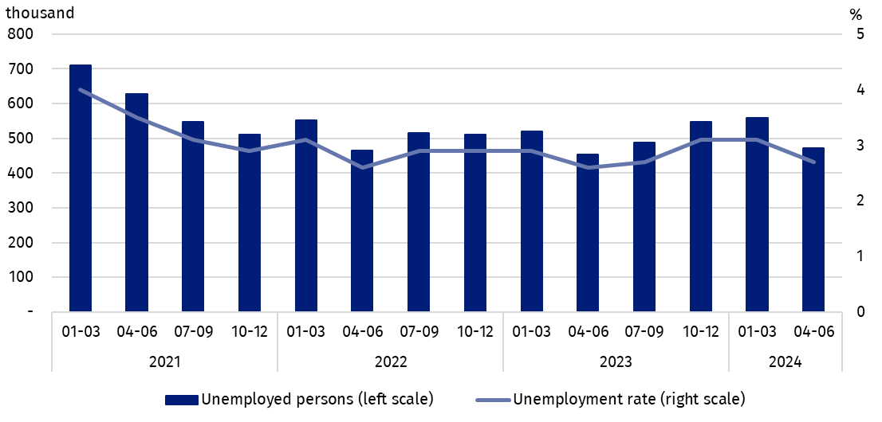
Chart 5. Unemployed persons aged 15-74 and unemployment rate of persons aged 15-89
Compared to the previous quarter, the number of unemployed persons decreased in both groups classified by sex, but it was much higher among women (by 57 thousand persons, i.e. by 20.7%) than among men (by 29 thousand, i.e. by 10.2%). Taking into account the place of residence, the decrease was observed among both rural and urban residents, with the decrease was much greater in rural areas (by 58 thousand, i.e. by 24.5% and by 29 thousand, i.e. by 9.0%, respectively).
The increase in the number of unemployed persons compared to the second quarter of 2023 was mainly due to the increase in this population among men (by 19 thousand persons, i.e. by 8.1%), while among women there was no change. Among the unemployed classified according to the place of residence, an increase in the analysed period was observed among urban residents (by 22 thousand, i.e. by 8.1%), while a slight decrease was noted among rural residents (by 4 thousand, i.e. by 2.2%).
In the second quarter of 2024, the unemployment rate amounted to 2.7%, and was lower than in the first quarter of 2024 – by 0.4 pp., but slightly higher than in the second quarter of 2023 – by 0.1 pp. It reached the same value among men and women, i.e. 2.7%.
Compared to the previous quarter the decrease in unemployment intensity was greater among women (by 0.7 pp.) than among men (by 0.3 pp.). Taking into account the place of residence, the decrease in the unemployment rate occurred among both rural residents – by 0.8 pp. and urban residents – by 0.3 pp.
Compared to the second quarter of 2023, the unemployment rate among men increased by 0.2 pp. and remained at the same level among women. Taking into account the place of residence, its increase was noted among urban residents – by 0.2 pp., and among rural residents it remained at the level observed in the second quarter of 2023.
Changes in the level of unemployment rate are also noticeable when taking into account the division of population by age groups.
As in previous periods, the highest unemployment rate concerned the youngest persons i.e. aged 15-24, while its value decreased compared to the previous quarter and compared to the same quarter of 2023
The highest unemployment rate was recorded among the youngest, i.e. in the age group
15-24 years – 9.3%. In this age group was noted the highest decrease in the unemployment rate compared to the first quarter of 2024 – by 2.5 pp. Declines were also noted in the other age groups – from 0.7 pp. for persons aged 25-34 to 0.1 pp. for persons aged 45-89. Compared to the same quarter of the previous year, the unemployment rate decreased only among persons aged 15-24 – by 1.6 pp. In the other analysed groups, there were increases in the indicator (the highest by 0.5 pp. in the 25-34 age group).
When analysing the unemployment rate according to the level of education of the unemployed, it should be noted that persons with tertiary education still remain in the best situation – the unemployment rate in this group is the lowest – in the second quarter of 2024 amounted to 1.2%. For persons with post-secondary and technical secondary or secondary sectoral vocational education, unemployment rate in the second quarter of 2024 was at the level 2.8% and for those with basic vocational or basic sectoral vocational education at the level 3.5%. A slightly higher unemployment rate than for vocational school graduates is noted among persons with general secondary education, reaching 4.2% in the second quarter of 2024. However, the highest unemployment rate is observed among persons with the lowest level of education, i.e. with lower secondary education or less, in the second quarter of 2024 it was 9.0%.
To the greatest extent, unemployment affected persons with the lowest level of education

Compared to the first quarter of 2024, the unemployment rate increased only among persons with the lowest level of education, i.e. with lower secondary education or less – an increase of 1.8 pp. Among the remaining persons separated on the basis of their level of education, the unemployment rate decreased from 1.2 pp. among persons with post-secondary and technical secondary or secondary sectoral vocational education, to 0.1 pp. among persons with tertiary education.
Compared to the second quarter of 2023, the unemployment rate decreased only among persons with basic vocational or basic sectoral vocational education (by 0.2 pp.), while in the remaining groups of unemployed persons by education level, the unemployment rate increased (from 0.1 pp. among persons with tertiary and general secondary education to 2.0 pp. among persons with lower secondary education or less).
Each unemployed person was classified into one of four categories separated due to the reason of inflow to unemployment. The largest population of unemployed were those who lost their job, i.e. persons who left their last job in the last 3 months not on their own initiative (41.9%, i.e. 198 thousand persons). The share of unemployed intending to return to work after a break (lasting longer than 3 months) was 28.1% (i.e. 133 thousand), but among women this share was much higher than among men and amounted to 33.8% and 23.2%, respectively. Unemployed who resigned from work on their own initiative constituted 16.3% (i.e. 77 thousand) and unemployed who were looking for their first job – 13.7% (i.e. 665 thousand).
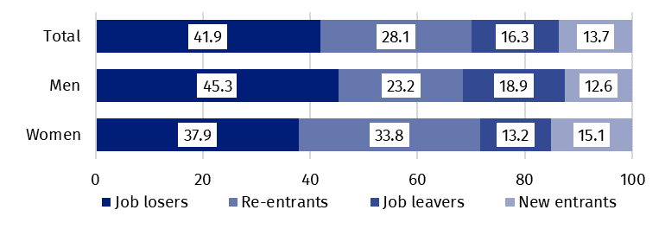
Chart 6. Structure of unemployed persons by the source of unemployment in the second quarter of 2024 (in %)
The average duration of job search by unemployed persons in the second quarter of 2024 was 7.5 months
In the second quarter of 2024, unemployed persons had been looking for a job 7.5 months on average (in the previous quarter 7.8 months, in the second quarter of 2023 – 7.6 months). On average, persons who were seeking a job for the longest duration were the ones aged
55-74 (11.1 months) and aged 35-44 (7.8 months), while the shortest job search duration was observed for the youngest persons aged 15-19 (4.3 months) and aged 20-24 (5.6 months).
41.7%
The share of economically
inactive persons in the total number of the population aged 15–89

In the second quarter of 2024, economically inactive persons accounted for 41.7% of the total number of population aged 15-89. The percentage was higher compared to the previous quarter and compared to second quarter of 2023 (an increase of 0.2 pp. each).

Economically inactive persons aged 15-89 by the LFS
In the second quarter of 2024, population of economically inactive persons aged 15-89 amounted to 12 667 thousand and was higher in relation to the first quarter of 2024 (by 67 thousand persons, i.e. 0.5%) and compared to the second quarter of 2023 (by 59 thousand, i.e. 0.5%).
Over half of the population of economically inactive persons constituted women – in the analysed age group their share was 60.4% (7 651 thousand). Economically inactive women accounted for 48.5% of all women aged 15-89, while analogous indicator for men was 34.5%. Taking into account division into urban and rural areas, a majority of economically inactive persons constituted urban residents (59.1%; i.e. 7 489 thousand), which is connected with a higher population in urban than in rural areas (respectively 3/5 and 2/5 of the total population in Poland). The share of economically inactive among all urban residents in the analysed age group was at the level 40.9% and among rural residents amounted to 43.0%.
Women still constitute a majority of economically inactive population
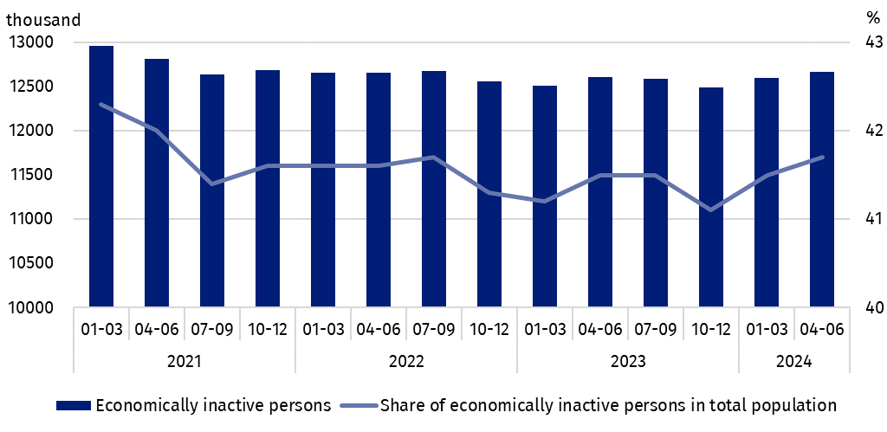
Chart 7. Economically inactive persons and the share of economically inactive persons in population aged 15-89
Compared to the first quarter of 2024, both the number of economically inactive men (by 44 thousand persons, i.e. 0.9%) and women (by 23 thousand, i.e. 0.3%) increased. An increase in the number of economically inactive persons was noted among all rural residents (by 102 thousand, i.e. by 2.0%), while a decrease was observed among urban residents (by 35 thousand, i.e. by 0.5%).
Compared to the same quarter of 2023, the number of economically inactive men increased (by 74 thousand persons, i.e. by 1.5%), while among women there was a decrease (by 15 thousand, i.e. by 0.2%). An increase in the number of economically inactive was noted among rural residents – by 94 thousand, i.e. by 1.8%, and a decrease among urban residents – by 35 thousand, i.e. by 0.5%.
The economically inactive population is a specific one in respect to the labour market resources. Its scope includes persons who have not entered the labour market yet (including the majority of the youth still participating in education) and persons who have definitely left the labour market or will never enter the labour market (some retirees, pensioners, persons maintaining themselves from other sources than work), but also persons who entered the labour market, then partially deactivated and who will want to re-enter the labour market after a break.
In the second quarter of 2024, over half of the economically inactive persons aged
15-74 comprising 10 107 thousand (the reason for inactivity was determined for this age group) constituted retirees (50.8%), while the second largest group were students (23.0%). It is worth noting that education and training as well as illness and disability were more often the reasons for inactivity among men (respectively 28.4% and 15.9%) than among women (respectively 19.4% and 6.7%). On the other hand, family responsibilities were much more often the reason for inactivity among women (12.5%) than men (2.0%).
Participating in education and improving qualification were the most often reason for economic inactivity of persons at the working age, and family and households responsibilities were much more often the reason for women's economic inactivity
In the case of 3 911 thousand economically inactive persons at the working age (women aged 18-59 and men aged 18-64), the most often reasons for inactivity were: education and training – 30.8%, illness and disability – 23.8% and family responsibilities – 20.4%. Retirement as the reason for inactivity on the labour market indicated 8.1% persons at the working age, while persons discouraged with unsuccessful job search constituted 1.3% of this group.
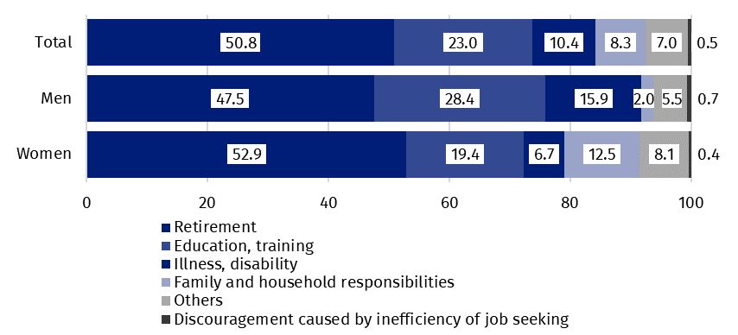
Chart 8. Structure of economically inactive persons aged 15-74 by sex and reasons for inactivity in the second quarter of 2024 (in %)

Transition from work to retirement of persons aged 50-74 according to the LFS
The module survey "Transition from work to retirement" was carried out as part of the Labour Force Survey in 2023. It covered persons aged 50-74. Its main objective was to obtain information on the process of withdrawal from the labour market of older persons, i.e. to learn the reasons why the employed persons retire or decide to continue working while receiving retirement benefit. The situation of persons before and after retirement (in the period immediately after retirement and later) was examined. An important research question was the age of retirement. The scale of using withdrawals within the framework of employees’ pension programs (PPE) or employees’ capital plans (PPK), or withdrawals within the framework of individual pension plans (IKE or IKZE accounts, life insurance with capital fund) was also recognized. The fact of receiving a disability pension or other social benefits due to incapacity for work was examined too.
Linking the answers to the module questions with the information from the basic LFS survey made it also to determine the current situation on the labour market of retirees and pensioners.
It should be noted that the aim of the survey was not to estimate the population of retirees and pensioners but, as mentioned above, to obtain characteristics of the retirement process.
The survey was carried out on part of the sample of the LFS throughout all quarters of 2023. Presented below data are the average results for the whole 2023 year. The basis for all data obtained were the respondents' declarations.
Receiving an old age pension
51.6%
Share of persons receiving a statutory pension in the total number of persons aged 50-74
In 2023, 51.6% of persons aged 50-74 received a statutory pension (exclusively or in combination with withdrawals within the framework of employees’ pension programs or employees’ capital plans, or individual pension plans).

Among all pensioners aged 50-74, the vast majority (89.1%) received only a statutory pension in 2023, and only 10.9% received a statutory pension together with the withdrawals within the framework of employees’ pension programmes or employees’ capital plans, or individual pension plans
In 2023, just over half of persons aged 50-74 (51.6% i.e. 5 864 thousand out of 11 372 thousand persons), received a statutory pension. The vast majority of them, i.e. 89.1% (5 226 thousand persons), only received a statutory pension, the rest (638 thousand, i.e. 10.9%) – statutory pension with withdrawals within the framework of employees’ pension programs (PPE) or employees’ capital plans (PPK), or individual pension plans (IKE or IKZE accounts).
The statutory pension together with the withdrawals from PPE/PPK received 7.6% retirees (447 thousand persons), and together with the withdrawals from IKE or IKZE only 1.1% (63 thousand), while all three forms, i.e. statutory pension and withdrawals within the framework of PPE/PPK and withdrawals from IKE/IKZE received 2.2% (128 thousand persons). There were also cases of receiving a "pension" from employees’ pension programs or employees’ capital plans without receiving a statutory pension, but the scale of the phenomenon was so small that the data were excluded from further analysis due to a high random sampling error.
In the entire group of persons aged 50-74 covered by the module survey, women predominated (they constituted 54.1% of all persons), which results from the demographic structure of this population. However, the predominance of women among all persons receiving a statutory pension (exclusively or together with other payments) was much greater than that resulting from the population structure in this age group. Women constituted 62.6% of the entire group of retirees, which is related to the earlier statutory retirement age for women.
Taking into account the place of residence, 63.8% of retirees lived in urban areas, which is also a higher percentage than for the entire population of persons aged 50-74 living in urban areas (60.8%).
Slightly less than half – 48.4% (5 504 thousand) of all persons aged 50–74 were still at the working age. Due to different upper working age thresholds for men and women, the percentage of men at the working age in the total number of surveyed persons was 59.2% and was significantly higher than the corresponding percentage for women (40.8%). Out of the total number of persons at the working age there was 6.8% (375 thousand) who received a statutory pension. The percentage of men at the working age receiving this benefit was 9.9% (323 thousand), and women – 2.3% (51 thousand). The remaining retirees (5 489 thousand persons) were at the post-working age, men in this group constituted 34.1% (1 870 thousand) and women 65.9% (3 619 thousand).
The percentage of retirees among persons aged 65-69 was 93.8%

The percentage of persons receiving a pension among all surveyed persons aged 50-74 increased with age. After dividing this population into 5-year age groups, it can be seen that in the first two groups, i.e. 50-54 years and 55-59 years, the percentage of retirees was relatively small (3.5% and 6.1%, respectively) but it increased significantly with exceeding the statutory retirement age – among persons aged 60-64 it was 53.0% and in the group of
65-69 years it reached 93.8%. For the oldest surveyed persons, i.e. aged 70-74, the percentage was 97.3% but the increase in the percentage did not have so high dynamics.
This pattern is even more visible when the sex division is taken into account in the analysis, which results from the different age at which women (60 years old) and men (65 years old) can retire to a statutory pension. Among women aged 60-64, the percentage of retired women was 86.4%, while among men in the same age group the percentage of retired men was 15.2%. The share of retirees among men increased significantly in the 65-69 age group (to 92.9%), while among women this increase was not as large (to 94.6%). Among persons aged 70-74, the percentage of persons receiving a pension increased further for both sexes (for men by almost 6 percentage points – to 98.7%, for women by less than 2 percentage points – to 96.4%).
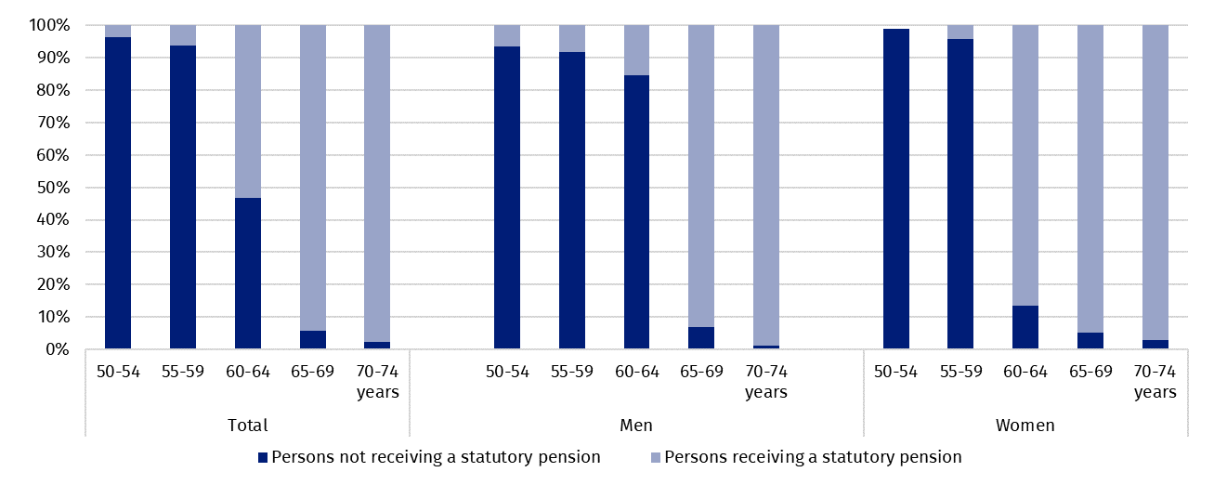
Chart 9. Percentages of persons receiving and not receiving a statutory pension by sex and age in 2023
N o t e. For women aged 50-54 receiving a statutory pension, a specific value cannot be shown due to a high sampling error. Moreover, the chart does not include persons for whom the fact of receiving a statutory pension has not been established.

The age at which persons retired
Persons receiving a pension retired at a different age. As mentioned earlier, a total of 51.6% of persons in the 50‐74 age group received a statutory pension. Among them were persons who retired before reaching the currently binding general retirement age (60 years for women and 65 years for men), while some of those who had already reached that age were still working without receiving a pension. Different retirement age results from, among other things, the rights of certain professional groups working in special conditions or in a special capacity to retire earlier. Some persons took advantage of the opportunity to take early retirement under the provisions from before the pension reform, which were still in force during the transitional period (until 2008). According to these regulations, persons born before 1969 could take early retirement (women after reaching the age of 55, men – 60), if they reached that age by 31 December 2008 and met additional conditions, including having a sufficiently long period of employment.
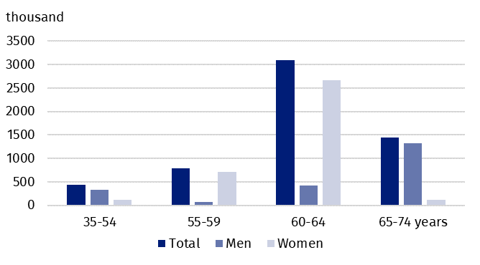
Chart 10. Persons aged 50-74 by sex and age at which they retired

Taking into account the entire surveyed population, the most of persons retired at the age of 60-64, which is related to the fact that women constitute the majority of this group, as well as to their earlier statutory retirement age (after reaching the age of 60). The second largest group consisted of persons retiring at the age of 65-69, which in turn is related to the statutory retirement age for men (after the age of 65). The percentage of persons who retired before reaching the current retirement age, i.e. started receiving a pension when they were at the working age, was 28.1% of all retirees. There were also persons who retired at the age of 70-74, but their percentage in the total number of retirees was only 0.4%.
Considering sex, women made up the majority of those retiring at the age of 55-64. In turn, men retired more often than women at the age of 35-54 and 65-74. In the first case, this is related to the fact that in the groups entitled to early retirement due to their profession or the nature of their work, there are more men, and in the second one – to the higher statutory retirement age compared to women.
The situation on the labour market after retirement
In the module survey, questions were asked about the person’s situation on the labour market in the first six months after retirement and in the later period, i.e. from the seventh month after retirement to the time of the survey.
In the first six months after retirement, only 13.0% of retirees aged 50-74 continued to work
At the time they started receiving their pension, 22.7% of retirees were no longer working (21.5% of men and 23.4% of women), while 63.5% of retirees stopped working within the first six months of retirement (a similar percentage for men and women), and only 13.0% continued working. Half of the latter group continued working without changes, i.e. in their previous workplace and under the same conditions as before. While the other half continued working under changed principles, i.e. they started working in a new place or continued working in their previous workplace but under changed conditions (e.g. on a reduced working time, based on a different type of contract, etc.). Among all persons who continued to work in the first six months after retirement (762 thousand) women predominated (58.9%).
Retirees who stopped working (3 722 thousand persons) within the first six months after retirement most often indicated that the reason for stopping work was simply obtaining the right to a pension – this answer was given by 85.3% of retirees (86.7% of men and 84.5% of women). An additional 3.7% of retirees stopped working because they reached the maximum retirement age set by law. Work-related reasons such as favorable financial conditions to terminate employment or other work-related reasons were indicated by 4.5% of retirees (4.4% of men and 4.6% of women), while 2.9% (3.1% of men and 2.8% of women) indicated health reasons – their own illness or disability. Caring responsibilities or other family reasons were the reason for leaving work for 1.5% of retirees, with the percentage being higher for women (2.1%) than for men (0.5%).
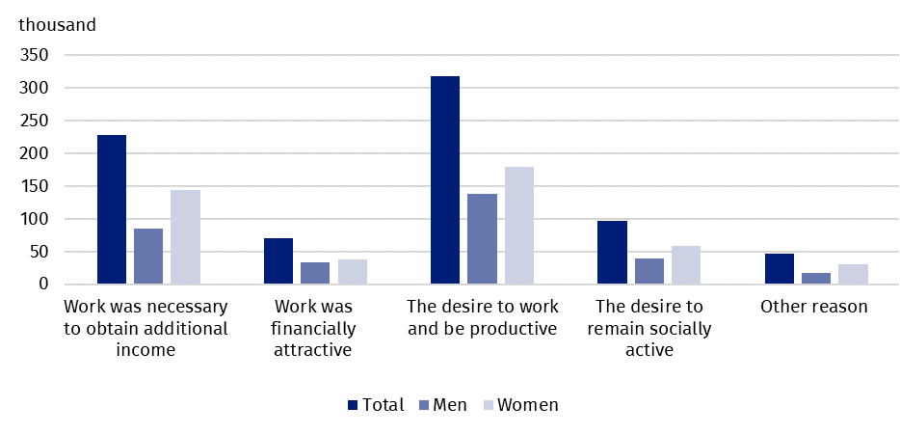
Chart 11. Retirees aged 50–74 who continued working in the first six months of retirement by sex and reason for continuing work
The survey showed that financial reasons, while important, were not the most common motivation for continuing work. Most often, retirees continued working because they wanted to work and be productive. This reason was indicated by 41.6% of retirees who continued working (for men, the percentage was higher at 44.1%, while for women it was 39.9%). A significant proportion of respondents (29.9%) stated that they continued working because the income she earned was necessary for living (which meant that the amount of the pension was not enough to meet their basic needs and maintain a basic standard of living). For men, the percentage was 27.2%, for women – 31.8%. Choosing the answer "the work was financially attractive" assumed that the purpose of continuing work was to earn additional money, which was not necessary for living (it did not determine the satisfaction of basic needs and maintaining a basic standard of living). This answer was given by 9.2% of retirees (10.9% of men and 8.2% of women) who continued to work. It follows from the above that even summing both answers related to financial reasons did not place them in the first place. The most important reason was still the desire to work and be productive.
The most common reason for continuing work after retirement was the desire to work and be productive
Some respondents worked after retirement because they wanted to remain socially active. This reason was indicated by 12.7% of retirees (12.5% of men and 12.9% of women) and was ranked third in terms of frequency of responses.
Persons who stopped working after retirement or were not working at the time of retirement (this group comprised 5 053 thousand persons) were asked whether they had ever taken up any paid employment later (from the seventh month after retirement to the time of the survey). Only 4.2% of this group (212 thousand persons) had at least one paid job lasting at least 3 months, and 0.9% had casual work lasting less than 3 months. The vast majority – 94.7% had no job at all.
The most common reason for re-enter labour market after retirement (after the first six months of retirement) was the need to obtain additional income
Persons who had at least one paid job lasting at least 3 months took it up mainly because the income earned from it was necessary for them to meet their basic needs – this reason was indicated by 39.2% of this group (32.7% of men and 44.1% of women). The desire to work and be productive placed the second position (30.7%). Interestingly, this reason was more often indicated as the most important by men (35.6%, while among women it was 27.0%). However, taking into account the place of residence, it was more often an argument for taking up work for rural residents (42.1%) than for urban residents (27.1%).
The desire to be socially active motivated 11.8% of this population (15.8% of men and 8.1% of women) to take up work, while 10.8% took up work because it was financially attractive. The latter reason was indicated by 6.9% of men and 14.4% of women.
Current economic activity of persons aged 50-74
The current economic activity of persons aged 50-74 varied significantly depending on whether they received or did not receive a statutory pension. The results of the basic and module LFS scope carried out in 2023 showed that:
- in the entire age group of 50-74 years, 43.8% of persons were economically active, while among retirees of this age, the figure was only 9.8%. A significantly higher percentage of economically active population was found in the group of persons not receiving a pension and amounted to 80.2%,
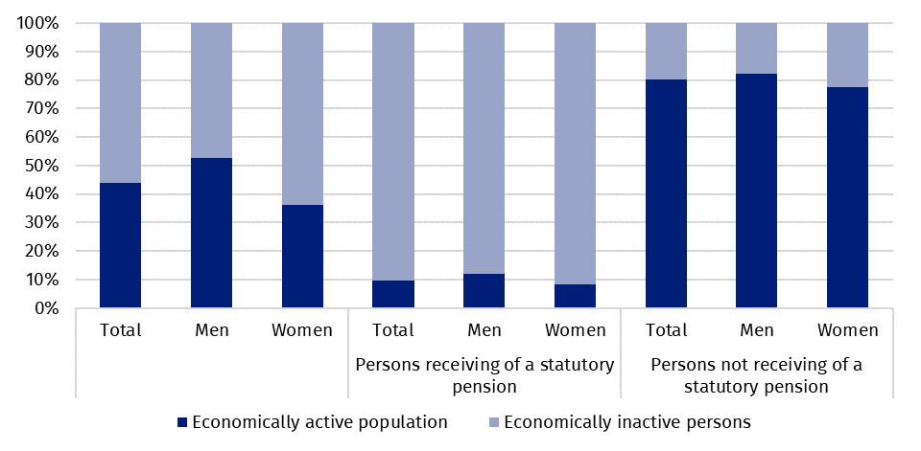
Chart 12. Economic activity of the persons aged 50-74 depending on whether they receive or do not receive a statutory pension in 2023
N o t e. The chart does not include persons for whom it has not been established that they are receiving a statutory pension.
The employment rate among persons aged 50-74 receiving a pension was 9.7%, and among those not receiving this benefit – 78.6%
- the employment rate among all persons aged 50-74 was 42.9%, among those not receiving a pension it was much higher – 78.6%, while among those receiving a pension it was only 9.7%,
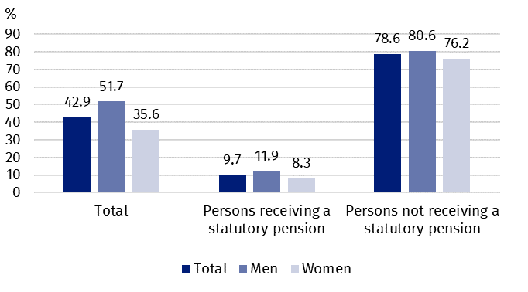
Chart 13. Employment rate for persons aged 50-74 by sex and the fact of receiving or not receiving a statutory pension in 2023

- the employment rate depended on the age of persons. For persons at the working age it amounted to 76.3% (whereas for persons receiving a pension it accounted for 20.5%, and for those not receiving it – 80.4%). For persons at the post-working age this rate was much lower and amounted to 11.7% (for persons receiving a pension it accounted for 8.9%, for those not receiving it – 53.3%),
- 9.7% (568 thousand) of retirees aged 50-74 worked, with more than half of them (54.8%) working full-time (60.7% of working men and 49.7% of working women), the rest working part-time,
- women predominated among all working retirees – they constituted 53.9%, while – as mentioned earlier – the percentage of women among all retirees was 62.6%,
- the majority of working retirees lived in cities (73.2%, which is over 9 percentage points more than it would result from the general structure of retirees by place of residence),
- the largest number of retirees worked in the "human health and social work activities" section (13.9%), followed by education (12.3%), wholesale and retail trade, vehicle repair (11.6%) and manufacturing (10.7). In each of the remaining sections less than 10% worked,
- the most common occupations performed by retirees were specialists – 28.7% of working retirees performed them. Considerably fewer worked as technicians and other middle-level personnel (14.8%) and service and sales workers (13.4%). The percentage of retirees working in other large groups of professions and specialties was lower than 10%.
Receiving a disability pension or other social benefits due to incapacity for work
The module survey also examined the fact of receiving a disability pension or other social benefits due to incapacity for work and the age at which the pension was received.
Disability pension or other benefits due to incapacity for work were received by 4.4% of persons aged 50-74, while among women of this age the percentage was 2.4% and among men 6.9%
Of the 11 372 thousand persons aged 50-74, 503 thousand persons received a disability pension (of which 145 thousand women and 358 thousand men), i.e. 4.4% of persons of that age (2.4% and 6.9% for women and men, respectively).
As can be seen from the data cited above, men predominated among pensioners (71.2%). Slightly more pensioners lived in rural areas (50.5%). Over 86.9% of pensioners were at the working age.
Persons of different age started receiving disability pension. Most often, they started receiving it at the age of 45-54. At this age, 36.0% of pensioners started receive disability pension (31.6% of men and 46.9% of women), but 6.4% started receiving such pension at a much younger age – at the age of 20-24 (5.6% of men and 8.3% of women). A significant proportion of men started receiving disability pension at the age of 35-44 (18.2%) and at the age of 55-59 (18.7%). To sum up, it can be stated that 75.1% of men and 78.6% of women receiving this pension started receiving it at the age of 30-59.
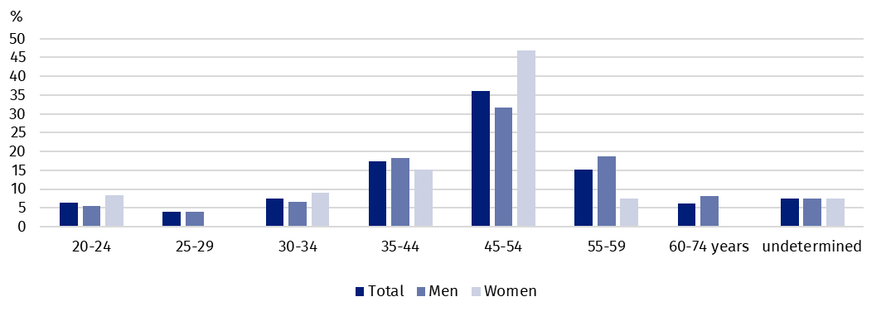
Chart 14. Persons aged 50-74 by sex and age of starting to receive a disability pension
N o t e. For women who started receiving a disability pension at ages 25–29 and 60–74, the specific value cannot be shown due to a high sampling error.
Taking into account economic activity, 89.5% of pensioners were economically inactive, and only 9.9% worked. The economic activity rate of pensioners was 10.5% and was higher in urban areas (14.9%) than in rural areas (6.3%).
Analysing the above data by the sex of pensioners, it should be noted that men worked more often than women. Their employment rate was 11.2%, while for women it was 6.9%. There were 88.3% of men and 91.7% of women economically inactive.

Methodological notes

The presented news release was prepared on the basis of the generalised results of the sample survey Badanie Aktywności Ekonomicznej Ludności/BAEL.
Since the fourth quarter of 2023, generalization of the survey results over the general population has been carried out with the use of the data on resident population of Poland coming from the balances compiled on the basis of the Population and Housing Census 2021 (by the third quarter of 2023, the results were generalized over the general population using population data from the balances compiled on the basis of the Population and Housing Census 2011). The data published in this news release and in the attached tables for the period from the first quarter of 2021 to the third quarter of 2023 have been recalculated in accordance with the new basis for generalizing results and are therefore comparable.
Part of the news release regarding the transition from work to retirement was developed based on the results of the module survey conducted in 2023. The data presented are average results for the whole of 2023. The questions of the module survey were part of the individual ZD questionnaire.
Badanie Aktywności Ekonomicznej Ludności (Eng. Labour Force Survey) has been carried out in Poland quarterly since May 1992 and it has been improved in accordance with the International Labour Organization and Eurostat recommendations.
From the first quarter of 2021 onwards, the base of the EU-LFS methodology are definitions of the employed, the unemployed and economically inactive persons in accordance with the Resolution concerning statistics of work, employment and labour underutilization adopted in 2013 on the 19th International Conference of Labour Statisticians in Geneva (ICLS) and re-commended by the International Labour Organization (ILO) for the use in all countries. The survey object is the situation within the scope of economic activity of the population, i.e. the fact of performing work, being unemployed or economically inactive persons in the reference week. In the European Union, the implementation of the provisions of the above mentioned Resolution was carried out through introduction of new legal acts. From 2021 onwards, EU-LFS has been one of the key surveys embraced by the framework regulation for social statistics (the so-called IESS FR). Accompanying IESS FR implementing regulations in the domain of the labour force specify the range of the core survey and module surveys, determine survey organisation and define in detail particular populations specified according to the status of persons in the labour market.
Detailed results of the survey as well as the up-dated methodology – obligatory from the first quarter of 2021, are included in the quarterly publication “Labour Force Survey in Poland” and in the Methodological report available on the Statistics Poland website:
https://stat.gov.pl/en/topics/labour-market/working-unemployed-economically-inactive-by-lfs/labour-force-survey-in-poland-quarter-12024,2,53.html
https://stat.gov.pl/en/topics/labour-market/yearbook-of-labour/methodological-report-labour-force-survey,8,2.html
The module survey "Transition from work to retirement" is one of six regular European LFS module surveys, which, starting from 2021, are realised out exactly every 8 years. It was carried out on part of the LFS sample in all quarters of 2023 and it concerned persons aged 50-74. The survey covered the following issues:
- receiving a statutory pension in connection with the economic activity of persons after they start receiving the pension and in the period preceding it,
- the main reasons for ceasing or continuing to work at the beginning of receiving a pension and a possible return to the labour market at a later date and the main reasons for such return,
- the scale of using withdrawals within the framework of employees’ pension programs (PPE) or employees’ capital plans (PPK), or withdrawals within the framework of individual pension plans, e.g. from an Individual Retirement Account (IKE) or an Individual Retirement Security Account (IKZE),
- receiving a disability pension or other social benefits due to incapacity for work.
An old-age pension within the framework of statutory pension system may be paid by various institutions:
- Social Insurance Institution (ZUS)
- Agricultural Social Insurance Funds (KRUS)
- Pension Office of the Ministry of Internal Affairs and Administration
- Military Pension Offices
- courts, prosecutor's offices, Ministry of Justice
- Pension Office of Prison Service
Employee pension programs (PPE) are a form of organized, group and systematic saving of funds for the retirement period. In Poland, these programs have been functioning since 1999 and they are one of the elements of third pillar of the pension system. They are pension programs created by employers for their employees. The participants of the program may become persons employed full-time or part-time on the basis of employment contract, call, election, appointment or cooperative employment contract. Two kinds of contributions are paid within the framework of PPE: the base one and additional. The first one is financed by the employer. The employer who joined PPE is obliged to pay this contribution. However, such obligation does not encumber an employee who, if he/she wants, may pay additional contribution from his/her remuneration. The payment can be made on request of a participant after reaching 60 years of age or after reaching 55 years if he/she has been already granted old-age pension.
Employee Capital Plans (PPK) is a private, long-term savings program in which savings are built jointly by employees, employers and the state.
Individual Retirement Account (IKE) has been operating since 20 April 2004. It is an element of third pillar of the pension system. It is a special account maintained for a saver by an authorized institution. Natural persons who are aged 16 years or more can make payments to the account, subject to the rules specified in the regulation.
Individual Retirement Security Account (IKZE) is an optional pension product. IKZE account, similarly to IKE account may be opened by a natural person who reached 16 years of age. A withdrawal of funds gathered by IKZE is made only on request of the saver after reaching 65 years of age and providing that payments to the IKZE account were made for a minimum period of 5 calendar years. The funds gathered by a saver on IKZE account, can be paid in a lump sum or in instalments, depending on saver’s request.
Employee pensions (from PPE and PPK) and pensions within an individual pension plan (IKE, IKZE, life insurance with a capital fund) are not considered old-age benefit (pension) from the formal point of view, they are only a withdrawal of funds accumulated in a given person's account. Withdrawals of such funds were treated in the survey as "pension" if they were made with regular frequency (e.g. monthly). In reference to such payments, the word pension was placed in quotation marks on the questionnaire and in this news release.
Survivor pension (received after the death of a spouse) is not a statutory pension. However, in the case when instead of his/her own old-age pension, a respondent received survivor pension because of its higher amount, then this pension was treated as old-age pension in the survey. If a person received a survivor's pension but was not entitled to their own retirement pension, e.g. he/she never worked or received a survivor's pension but continued to work (did not retire), such a survivor's pension was not treated as a retirement pension and should not have been taken into account.
Disability pensions or other periodic cash benefits for incapacity for work may be paid by ZUS, KRUS or other institutions. If the pensioner reaches the general retirement age, then they receive a retirement benefit ex officio.
It is not possible to combine a typical disability pension and a retirement benefit. Only a disability pension due to an accident at work or occupational disease may be combined with a retirement benefit.
All data obtained in the survey were based on respondents' declarations. If the person concerned by the survey was absent during the interview, substitute answers were allowed for the entire study (basic and module) by another person from the household who knew the situation of the person being surveyed. Additionally, in the module questions, positional missing answers were allowed (only in the case of substitute answers), hence there was a small percentage of undetermined answers to individual questions.
In some tables, the sums of components may be different from the values given in the "Total" items, this is due to rounding made when generalizing the survey results.

Prepared by:  Social Surveys and Labour Market Department  Director Piotr Łysoń, Ph.D.  Phone: (+48 22) 449 40 27 | Issued by:  Press Office  Mobile +48 695 255 032  Phone +48 22 608 38 04, +48 22 449 41 45,  +48 22 608 30 09  e-mail: obslugaprasowa@stat.gov.pl

www.stat.gov.pl/en/

@StatPoland

@GlownyUrzadStatystyczny

gus_stat

glownyurzadstatystycznygus

glownyurzadstatystyczny
Related information
Methodological report. Labour Force Survey
Labour Force Survey in Poland
Other publications containing the results of LFS and its module surveys
stat.gov.pl → Topics → Labour Market
Data available in databases
Strateg → Topics → Labour Market
Local Data Bank → labour Market
Terms used in official statistics
Economic activity by LFS
Economically active population by LFS
Employed persons by LFS
Unemployed persons by LFS
Economically inactive population according to the LFS

Activity rate by LFS
Employment rate by LFS
Unemployment rate by LFS

EUROPEAN UNION
News release contains the results of the survey on „Pension and labour market participation”
co-financed by the European Union

Generalisation of the survey results over the general population has been carried out with the use of the data on resident population of Poland coming from the balances compiled on the basis of the Population and Housing Census 2021. Data for the period from the first quarter of 2021 to the third quarter of 2023 was recalculated in line with the new generalisation basis. See methodological notes on page 15.
The LFS results refer to the population staying or intending to stay in the country’s territory for at least 12 months, living in private households.
Men aged 18-64 and women aged 18-59.
Work at home is performed by, for example, persons who conducted own economic activity and their home is their workplace, as well as employees who work at home in the form of remote work.
Remote work is performed outside the establishment with the use of electronic communication means.
The average job search time is the period from which unemployed persons look for a job, because in most cases they have not found a job yet.
The results of the module survey of LFS, see Methodological notes on page 15.
The upper working age limit for women is 59 years, for men – 64 years.
For 0.8% of persons, no answer was obtained regarding the situation on the labour market in the first six months after retirement.
The maximum statutory retirement age is the age at which an employee is required by law to leave their current job – this may apply to jobs in selected professions – for example, a judge is retired at the age of 65.
Regulation (EU) 2019/1700 of the European Parliament and of the Council of 10 October 2019 establishing a common framework for European statistics relating to persons and households, based on data at individual level collected from samples.
In line with the timetable set out in Delegated Regulation (EU) 2020/256 on multiannual rolling planning.

