Employed, unemployed and economically inactive persons (preliminary results of the Polish Labour Force Survey)
In the first quarter of 2024, economically active persons accounted for 58.5% of the population aged 15-89. This indicator was lower both compared to the fourth quarter of 2023 (by 0.4 pp.) and the first quarter of 2023 (by 0.3 pp.). The activity rate among men amounted to 65.8% and among women 51.7%.
58.5%
Activity rate of persons
aged 15-89

Economic activity of the population aged 15-89 by the LFS
Activity rate for the population aged 15-89 compared to the previous quarter decreased among men and women. Over the year, a decrease was noted among men and an increase among women
In the first quarter of 2024, the number of economically active persons aged 15-89 amounted to 17 754 thousand, of which: 17 194 thousand constituted employed persons, while 559 thousand – the unemployed. The population of economically inactive persons in this age group comprised 12 600 thousand persons.
Population of economically active persons decreased both compared to the fourth quarter of 2023 (by 116 thousand, i.e. by 0.6%) and the first quarter of 2023 (by 98 thousand, i.e. by 0.5%).
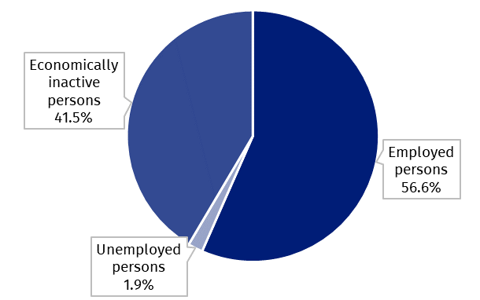
Chart 1. Structure of the population aged 15-89 by status on the labour market in the first quarter of 2024

The activity rate of persons aged 15-89 in the first quarter of 2024 was higher among men and accounted for 65.8%, in the women population it was 51.7% (respective values for persons at the working age were 84.3% and 78.5%). Corresponding indicators for urban and rural residents accounted respectively for: 58.9% and 57.9% (at the working age: 83.5% and 78.8%).
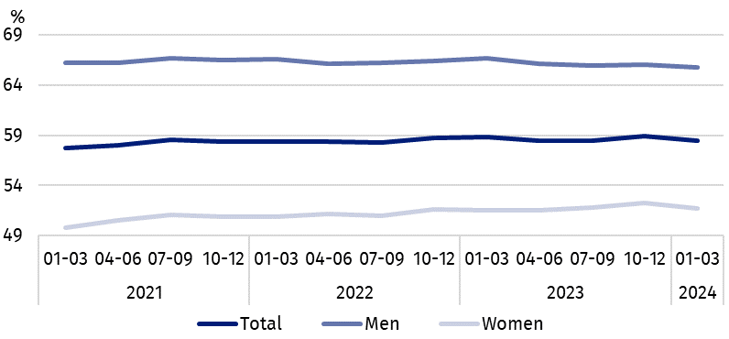
Chart 2. Activity rate of persons aged 15-89
The indicator describing the relation of jobless persons to the number of employed persons increased both over the quarter and over the year
Within the scope of population aged 15-89, the ratio of the number of not working persons (the unemployed or the economically inactive) to the employed persons increased compared to the previous quarter and compared to the first quarter of 2023. In the first quarter of 2024, per 1 000 working people, there were 765 unemployed or economically inactive persons aged 15-89 (in the fourth quarter of 2023 there were 753 persons and in the first quarter of 2023 – 752 persons).
In the first quarter of 2024, employed persons accounted for 56.6% of the population aged
15-89. The employment rate was lower than noted both in the fourth quarter of 2023 and in the first quarter of 2023 (decrease by 0.5 pp. in each). The rate was higher in the male population (63.9%) than among women (50.0%).
56.6%
Employment rate
of persons aged 15-89

Employed persons aged 15-89 by the LFS
The number of employed persons decreased over the quarter and over the year
In the first quarter of 2024, population of employed persons aged 15-89 amounted to 17 194 thousand persons and was lower than in the previous quarter (by 129 thousand, i.e. by 0.7%), as well as in the same period of 2023 (by 138 thousand, i.e. 0.8%).
Chart 3. Employed persons and employment rate of persons aged 15-89 and in the
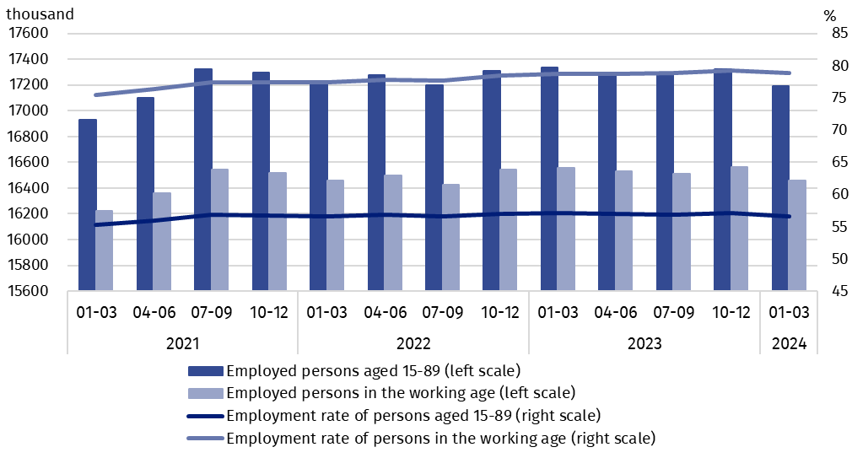
working age
Compared to the fourth quarter of 2023, the number of employed persons decreased among women (by 105 thousand, i.e. 1.3%), and among men, although to a smaller extent (by 24 thousand, i.e. 0.3%). Taking into account the place of residence, the number of employed persons decreased more among rural residents (by 100 thousand, i.e. 1.5%) than urban areas (by 28 thousand, i.e. 0.3%).
Over the year (compared to the first quarter of 2023) a greater decrease in employed persons was noted among men (by 113 thousand, i.e. 1.2%) than among women (by 25 thousand, i.e. 0.3%) and taking into account the place of residence, the number of employed urban residents decreased to a greater extent (by 122 thousand, i.e. by 1.2%) than of rural residents (by 15 thousand, i.e. by 0.2%).
In the population of employed persons, taking into account division by sex, men still predominated, who constituted 54.1% (i.e. 9 302 thousand persons) of this group, while regarding the place of residence, there were more employed persons living in urban areas (60.8%, i.e. 10 458 thousand persons), which is a direct consequence of the higher population in urban than rural areas (respectively 3/5 and 2/5 of the total population in Poland).
In the first quarter of 2024, total employment rate amounted to 56.6% and in line with the observed trend was higher among men (63.9%) than among women (50.0%) and regarding the place of residence, a slightly higher level of the indicator was noted in urban areas (57.1%) than in rural areas (55.9%).
Over the quarter, the employment rate decreased among women (by 0.6 pp.) and among men, although to a slight extent (by 0.1 pp.). Taking into account the place of residence, the decrease in the indicator occurred both among rural and urban residents, but for the second group it was insignificant (by 0.9 pp. and by 0.1 pp., respectively).
Over the year, the employment rate decreased among men (by 0.8 pp.) and slightly among women (by 0.1 pp.). In the case of persons living in urban areas this indicator decreased by 0.5 pp., and in rural areas by 0.3 pp.
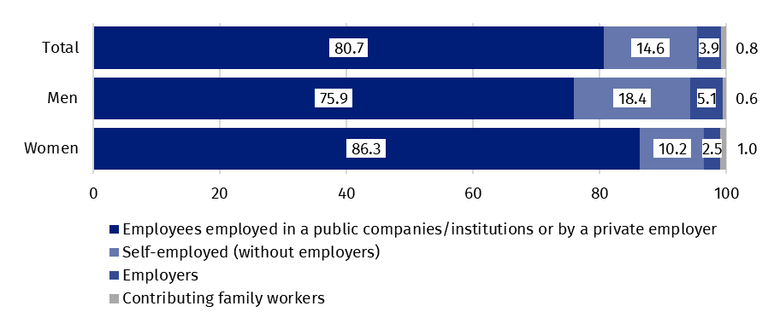
Chart 4. Structure of employed persons aged 15-89 by employment status in the main job in the first quarter of 2024 (in %)
The LFS results indicate that in the first quarter of 2024:
The number of persons employed full-time decreased over the quarter as well as over the year
- 16 053 thousand (i.e. 93.4%) persons performed full-time work, while 1 141 thousand (i.e. 6.6%) were employed part-time,
- the average number of hours worked in the reference week in the main job amounted to 39.0 hours,
- in the total number of employees, the share of employees employed in public companies/institutions or by a private employer was 80.7% (13 872 thousand persons), self-employed – 18.5%, and contributing family members – 0.8%, but a significantly higher share of self-employed is noted among men (18.4%) than women (10.2%), while the share of employees employed by a public or private employer was higher among women (86.3%) than men (75.9%),
- a vast majority of employees employed in public companies/institutions or by a private employer performed their work on the basis of the contract for unlimited duration (84.8%, i.e. 11 758 thousand),
- the sections where the most people worked were: manufacturing – 19.1% of all employed persons (3 290 thousand); wholesale and retail trade; repair of motor vehicles and motorcycles – 13.5% (2 313 thousand), education – 7.6% (1 310 thousand) and construction – 7.4% (1 280 thousand).
In the first quarter of 2024, the highest decline in the number of employed persons compared to the previous quarter was noted in agriculture, forestry and fishing section (by 55 thousand) and in education (by 35 thousand). The highest growth concerned the number of employed persons in transportation and storage (by 29 thousand) and administrative and support service activities (by 24 thousand).
Compared to the first quarter of 2023, the highest decline in the number of employed persons occurred in agriculture, forestry and fishing section (by 113 thousand) and in education (by 64 thousand), while the highest growth – among the employed persons in human health and social work activities (by 64 thousand) and in professional, scientific and technical activities section (by 46 thousand).
In the first quarter of 2024, 804 thousand persons had a job, but were not performing the work in the reference week, which accounted for 4.7% of the total number of the employed (the corresponding population in the previous quarter comprised 936 thousand, i.e. 5.4%, while a year ago it was 804 thousand, i.e. 4.6%). The most common reasons for not performing work were own illness and paid, unpaid or occasional leave – they accounted jointly 58.6% of all causes of absence.
The number of persons performing their work usually or sometimes at home amounted to 2 602 thousand, which accounted for 15.1% of the total number of the employed. In a form of remote work (the place of performing work is not considered here), their work related responsibilities were performed usually or sometimes by 1 614 thousand persons, i.e. 9.4% of the total number of the employed.
9.4% of the total number of employed persons worked in a form of remote work

In the first quarter of 2024, unemployed persons accounted for 3.1% of the economically active population aged 15-89. Unemployment intensity (measured by the unemployment rate) remained at the level observed in the previous quarter, but increased compared to the first quarter of 2023 - by 0.2 pp. The unemployment rate was lower among men than among women (3.0% vs. 3.4%, respectively).
3.1%
Unemployment rate of persons aged 15-89

Unemployed persons aged 15-74 by the LFS
The number of unemployed persons was higher both compared to the previous quarter and the same period of the previous year
In the first quarter of 2024, the population of unemployed persons aged 15-74 was 559 thousand and was slightly higher than in the fourth quarter of 2023 – by 12 thousand, i.e. by 2.2%, as well as in the first quarter of 2023 – by 39 thousand, i.e. by 7.5%.
In the first quarter of 2024, more than half of unemployed population were men – 50.8%, i.e. 284 thousand. Unemployed urban residents constituted 57.6% of the total number of the unemployed, i.e. 322 thousand which is a significantly lower percentage than the share of the urban population in the population of Poland (60%).
It is also worth noting that the percentage of unemployed in the total population aged 15-89 in subpopulation by sex and place of residence reaches similar values ranging from 1.7% to 2.0%.
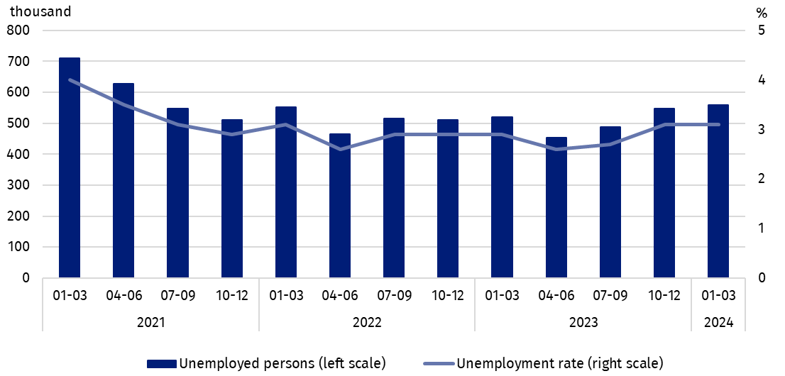
Chart 5. Unemployed persons aged 15-74 and unemployment rate of persons aged 15-89
Compared to the previous quarter, the number of unemployed persons increased among women (by 10 thousand, i.e. 3.8%), and among men it remained at a similar level. The number of unemployed among urban residents increased (by 30 thousand, i.e. 10.3%), while among rural residents there was a decrease (by 18 thousand, i.e. 7.1%).
The increase in the number of unemployed persons over the year (compared to the first quarter of 2023) was mainly due to the increase in this population among women (by 48 thousand, i.e. 21.1%), while among men it decreased (by 9 thousand, i.e. 3.1%). Among the unemployed classified according to the place of residence, a greater increase in the analysed period occurred among rural residents (by 24 thousand, i.e. 11.3%) than among urban residents (by 16 thousand, i.e. 5.2%).
Compared to the previous quarter the unemployment rate remained at the same level 3.1%. Slightly greater changes in the intensity of unemployment occurred only depending on the place of residence, among urban residents there was an increase in the indicator by 0.3 pp. to 3.0%, and in rural areas there was a decrease – by 0.2 pp. to 3.4%.
Over the year (compared to the first quarter of 2023) the unemployment rate increased among women (by 0.6 pp.) and among men it remained at the same level. Taking into account the place of residence, its increase was noted among both rural residents – by 0.3 pp., and urban residents – by 0.2 pp.
Changes in the level of unemployment rate are also noticeable when taking into account the division of population by age groups.
As in previous periods, the highest unemployment rate concerned the youngest persons i.e. aged 15-24, but its value decreased compared to the previous quarter, but increased compared to the same quarter of 2023
The highest unemployment rate was recorded among the youngest, i.e. in the age group
15-24 years – 11.8%. Simultaneously, it was the only group covered by the analyses, for which compared to the previous quarter, there was a decrease in the value of this indicator (by 1.0 pp.), among persons in the other analysed age groups, the indicator increased – from 0.1 pp. (for persons aged 45-89) up to 0.5 pp. (for persons aged 35-44 years). Compared to the same quarter of the previous year, an increase in unemployment occurred in most of the analysed age groups (from 0.3 pp. for persons aged 35-44 to 1.1 pp. for persons aged 15-24), only in the oldest age group (45-89 years) the level of unemployment did not change.
When analysing the unemployment rate according to the level of education of the unemployed, it should be noted that persons with tertiary education still remain in the best situation – the unemployment rate in this group is the lowest – in the first quarter of 2024 amounted to 1.3%. For persons with post-secondary and technical secondary or secondary sectoral vocational education, unemployment rate in the first quarter of 2024 was at the level 4.0% and for those with basic vocational or basic sectoral vocational education at the level 4.3%. A slightly higher unemployment rate than for vocational school graduates is noted among persons with general secondary education, reaching 4.6% in the first quarter of 2024. However, the highest unemployment rate is observed among persons with the lowest level of education, i.e. with lower secondary education or less, in the first quarter of 2024 it was 7.2%.
To the greatest extent, unemployment affected persons with the lowest level of education

Compared to the fourth quarter of 2023, the unemployment rate decreased among persons with the two lowest levels of education: lower secondary education or less and basic vocational or basic sectoral vocational education (by 0.5 pp. and 0.2 pp., respectively). In the case of persons with general secondary education, post-secondary and technical secondary or secondary sectoral vocational education, the unemployment rate increased (by 0.7 pp. and 0.2 pp., respectively). No change in the value of the indicator was recorded among persons with tertiary education.
Compared to the first quarter of 2023, the intensity of unemployment decreased only among persons with tertiary education (by 0.2 pp.), in other groups of unemployed persons separated on the basis of their level of education, the unemployment rate increased (from 0.1 pp. among persons with basic vocational or basic sectoral vocational education to 1.2 pp. among persons with post-secondary and technical secondary or secondary sectoral vocational education).
Each unemployed person was classified into one of four categories separated due to the reason of inflow to unemployment. The largest population of unemployed were those who lost their job, i.e. people who left their last job not on their own initiative in the last 3 months (40.9%, i.e. 228 thousand). The share of unemployed intending to return to work after a break (lasting longer than 3 months) was 24.7% (i.e. 138 thousand), but among women this share was much higher than among men and amounted to 31.3% and 18.6%, respectively. Unemployed who resigned from work on their own initiative constituted 18.3% (i.e. 102 thousand) and unemployed who were looking for their first job – 16.1% (i.e. 90 thousand).
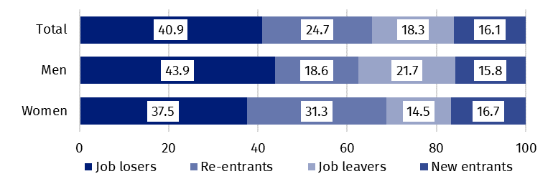
Chart 6. Structure of unemployed persons by the source of unemployment in the first quarter of 2024 (in %)

In the first quarter of 2024, unemployed persons had been looking for a job 7.8 months on average (in the previous quarter 8.5 months, in the first quarter of 2023 – 8.1 months). On average, persons who were seeking a job for the longest duration were the ones aged 55-74 (10.7 months) and aged 45-54 (9.2 months), while the shortest job search duration was observed for the youngest persons aged 20-24 (5.6 months) and aged 15-19 (5.7 months).
The average duration of job search by unemployed persons in the first quarter of 2024 was 7.8 months
41.5%
The share of economically
inactive persons in the total number of the population aged 15–89

In the first quarter of 2024, economically inactive persons accounted for 41.5% of the total number of population aged 15-89. The percentage was higher compared to the previous quarter (an increase by 0.4 pp.) and in relation to the first quarter of 2023 (an increase by 0.3 pp.).

Economically inactive persons aged 15-89 by the LFS
In the first quarter of 2024, population of economically inactive persons aged 15-89 amounted to 12 600 thousand and was higher in relation to the fourth quarter of 2023 (by 108 thousand, i.e. 0.9%) and compared to the first quarter of 2023 (by 87 thousand, i.e. 0.7%).
Over half of the population of economically inactive persons constituted women – in the analysed age group their share was 60.5% (7 628 thousand). Taking into account division into urban and rural areas, a majority of economically inactive persons constituted urban residents (59.7%; i.e. 7 524 thousand), which is connected with a higher population in urban than in rural areas (3/5 and 2/5 respectively). Economically inactive women accounted for 48.3% of all women aged 15-89, while analogous indicator for men was 34.2%. The share of economically inactive among all urban residents in the analysed age group was at the level 41.1% and among rural residents amounted to 42.1%.
Women still constitute a majority of economically inactive population
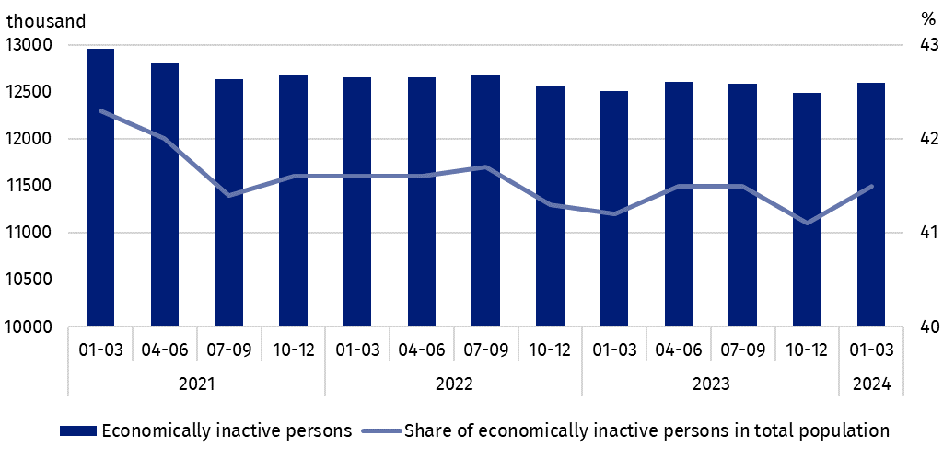
Chart 7. Economically inactive persons and the share of economically inactive persons in population aged 15-89
Compared to the fourth quarter of 2023, both the number of economically inactive women (by 91 thousand, i.e. 1.2%) and men (by 18 thousand, i.e. 0.4%) increased. An increase in the number of economically inactive persons was noted among all rural residents (by 131 thousand, i.e. 2.6%), and among the urban residents there was a decrease in this population (by 22 thousand, i.e. by 0.3%).
Compared to the same quarter of 2023, the number of economically inactive men increased (by 118 thousand, i.e. 2.4%), while among women there was a decrease (by 31 thousand, i.e. 0.4%). An increase in the number of economically inactive persons was noted both among urban residents – by 58 thousand, i.e. 0.8% and among rural residents – by 30 thousand, i.e. 0.6%.
The economically inactive population is a specific one in respect to the labour market resources. Its scope includes persons who have not entered the labour market yet (including the majority of the youth still participating in education) and persons who have definitely left the labour market or will never enter the labour market (some retirees, pensioners, persons maintaining themselves from other sources than work), but also persons who entered the labour market, then partially deactivated and who will want to re-enter the labour market after a break.
In the first quarter of 2024, over half of the economically inactive persons aged
15-74 comprising 10 074 thousand (the reason for inactivity was determined for this age group) constituted retirees (51.4%), while the second largest group were students (22.7%). It is worth noting that education and training as well as illness and disability were more often the reasons for inactivity among men (respectively 28.2% and 16.0%) than among women (respectively 19.1% and 6.7%). On the other hand, family responsibilities were much more often the reason for inactivity among women (11.9%) than men (1.6%).
Participating in education and improving qualification were the most often reason for economic inactivity of persons at the working age, and family and households responsibilities were much more often the reason for women's economic inactivity
In the case of 3 847 thousand economically inactive persons at the working age (women aged
18-59 and men aged 18-64), the most often reasons for inactivity were: education and training – 30.9%, illness and disability – 24.0% and family responsibilities – 19.5%. Retirement as the reason for inactivity on the labour market indicated 8.1% persons at the working age, while persons discouraged with unsuccessful job search constituted 1.4% of this group.
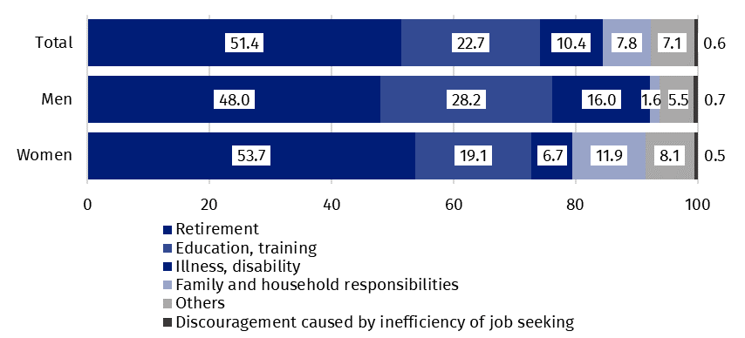
Chart 8. Structure of economically inactive persons aged 15-74 by sex and reasons for inactivity in the first quarter of 2024 (in %)

Methodological notes

The presented news release was prepared on the basis of the generalised results of the sample survey Badanie Aktywności Ekonomicznej Ludności/BAEL.
Since the fourth quarter of 2023, generalization of the survey results over the general population has been carried out with the use of the data on resident population of Poland coming from the balances compiled on the basis of the Population and Housing Census 2021 (by the third quarter of 2023, the results were generalized over the general population using population data from the balances compiled on the basis of the Population and Housing Census 2011). The data published in this news release and in the attached tables for the period from the first quarter of 2021 to the third quarter of 2023 have been recalculated in accordance with the new basis for generalizing results and are therefore comparable.
Badanie Aktywności Ekonomicznej Ludności (Eng. Labour Force Survey) has been carried out in Poland quarterly since May 1992 and it has been improved in accordance with the International Labour Organization and Eurostat recommendations.
From the first quarter of 2021 onwards, the base of the EU-LFS methodology are definitions of the employed, the unemployed and economically inactive persons in accordance with the Resolution concerning statistics of work, employment and labour underutilization adopted in 2013 on the 19th International Conference of Labour Statisticians in Geneva (ICLS) and re-commended by the International Labour Organization (ILO) for the use in all countries. The survey object is the situation within the scope of economic activity of the population, i.e. the fact of performing work, being unemployed or economically inactive persons in the reference week. In the European Union, the implementation of the provisions of the above mentioned Resolution was carried out through introduction of new legal acts. From 2021 onwards, EU-LFS has been one of the key surveys embraced by the framework regulation for social statistics (the so-called IESS FR). Accompanying IESS FR implementing regulations in the domain of the labour force specify the range of the core survey and module surveys, determine survey organisation and define in detail particular populations specified according to the status of persons in the labour market.
Detailed results of the survey as well as the up-dated methodology – obligatory from the first quarter of 2021, are included in the quarterly publication “Labour Force Survey in Poland” and in the Methodological report available on the Statistics Poland website:
https://stat.gov.pl/en/topics/labour-market/working-unemployed-economically-inactive-by-lfs/labour-force-survey-in-poland-quarter-42023,2,52.html
https://stat.gov.pl/en/topics/labour-market/yearbook-of-labour/methodological-report-labour-force-survey,8,2.html

Prepared by:  Social Surveys and Labour Market Department  Director Piotr Łysoń, Ph.D.  Phone: (+48 22) 449 40 27 | Issued by:  Press Office  Mobile +48 695 255 032  Phone +48 22 608 38 04, +48 22 449 41 45,  +48 22 608 30 09  e-mail: obslugaprasowa@stat.gov.pl

www.stat.gov.pl/en/

@StatPoland

@GlownyUrzadStatystyczny

gus_stat

glownyurzadstatystycznygus

glownyurzadstatystyczny
Related information
Methodological report. Labour Force Survey
Labour Force Survey in Poland
Other publications containing the results of LFS and its module surveys
stat.gov.pl → Topics → Labour Market
Data available in databases
Strateg → Topics → Labour Market
Local Data Bank → labour Market
Terms used in official statistics
Economic activity by LFS
Economically active population by LFS
Employed persons by LFS
Unemployed persons by LFS
Economically inactive population according to the LFS

Activity rate by LFS
Employment rate by LFS
Unemployment rate by LFS

Generalisation of the survey results over the general population has been carried out with the use of the data on resident population of Poland coming from the balances compiled on the basis of the Population and Housing Census 2021. Data for the period from the first quarter of 2021 to the third quarter of 2023 was recalculated in line with the new generalisation basis. See methodological notes on page 8.
The LFS results refer to the population staying or intending to stay in the country’s territory for at least 12 months, living in private households.
Men aged 18-64 and women aged 18-59.
Work at home is performed by, for example, persons who conducted own economic activity and their home is their workplace, as well as employees who work at home in the form of remote work.
Remote work is performed outside the establishment with the use of electronic communication means.
The average job search time is the period from which unemployed persons look for a job, because in most cases they have not found a job yet.
Regulation (EU) 2019/1700 of the European Parliament and of the Council of 10 October 2019 establishing a common framework for European statistics relating to persons and households, based on data at individual level collected from samples.

