Employed, unemployed and economically inactive persons (preliminary results of the Polish Labour Force Survey)
In the fourth quarter of 2023, economically active persons accounted for 58.9% of the population aged 15-89. This indicator was higher than in the third quarter of 2023 (by 0.4 pp.) as well as in the fourth quarter of 2022 (by 0.2 pp.). The activity rate among men amounted to 66.0% and among women 52.3%.
58.9%
Activity rate of persons
aged 15-89

Economic activity of the population aged 15-89 by the LFS
Activity rate for the population aged 15-89 compared to the previous quarter increased among men and women. Over the year, an increase was noted among women and a decrease among men
In the fourth quarter of 2023, the number of economically active persons aged 15-89 amounted to 17 870 thousand, of which: 17 323 thousand constituted employed persons, while 547 thousand – the unemployed. The population of economically inactive persons in this age group comprised 12 492 thousand persons.
Population of economically active persons increased both compared to the third quarter of 2023 by 103 thousand, i.e. by 0.6%, and the fourth quarter of 2022, by 51 thousand, i.e. by 0.3%.
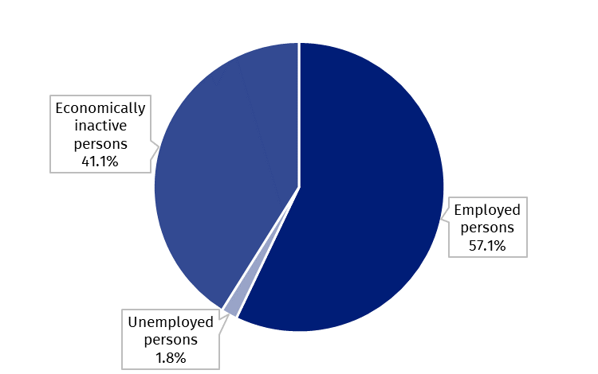
Chart 1. Structure of the population aged 15-89 by status on the labour market in the fourth quarter of 2023

The activity rate of persons aged 15-89 in the fourth quarter of 2023 was higher among men and accounted for 66.0%, in the women population it was 52.3% (respective values for persons at working age were 84.3% and 79.0%). This indicator for persons aged 15-89 living in rural and urban areas was similar – 58.9% and 58.8% respectively (for persons of working age, the indicator was higher among urban residents than among rural residents and amounted to 83.1% and 80.0% respectively).
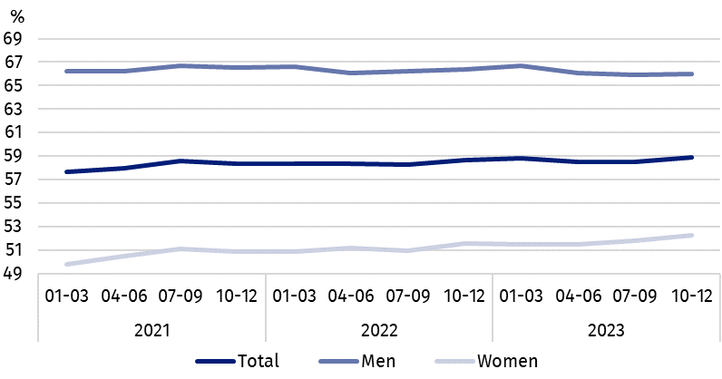
Chart 2. Activity rate of persons aged 15-89
The indicator describing the relation of jobless persons to the number of employed persons decreased slightly compared to the previous quarter and over the year
Within the scope of population aged 15-89, the ratio of the number of not working persons (the unemployed or the economically inactive) to the employed persons decreased compared to the previous quarter and compared to the fourth quarter of 2022. In the fourth quarter of 2023, per 1 000 working people, there were 753 unemployed or economically inactive persons aged 15-89 (in the third quarter of 2023 there were 757 persons and in the fourth quarter of the last year – 755 persons).
In the fourth quarter of 2023, employed persons accounted for 57.1% of the population aged
15-89. The employment rate increased slightly both compared to the third quarter of 2023 (by 0.2 pp.) and compared to the fourth quarter of 2022 (by 0.1 pp.). The rate was higher in the male population (64.0%) than among women (50.6%).
57.1%
Employment rate
of persons aged 15-89

Employed persons aged 15-89 by the LFS
The number of employed persons increased slightly over the quarter and over the year
In the fourth quarter of 2023, population of employed persons aged 15-89 amounted to 17 323 thousand persons and increased slightly both compared to the third quarter of 2023 (by 44 thousand, i.e. by 0.3%), and the fourth quarter of 2022 (by 15 thousand, i.e. by 0.1%).
Compared to the third quarter of 2023, the number of employed increased among women (by 44 thousand, i.e. 0.6%), while among men it remained at the same level. Taking into account the place of residence, the number of employed persons increased both among urban residents (by 28 thousand, i.e. 0.3%) and rural residents (by 16 thousand, i.e. 0.2%).
Over the year, there was an increase in the number of employed women - by 72 thousand, i.e. by 0.9%, with a simultaneous decrease in the number of employed men - by 57 thousand, i.e. by 0.6%. Taking into account the place of residence, the number of employed rural residents increased - by 90 thousand, i.e. by 1.3%, and the population of employed urban residents decreased - by 75 thousand, i.e. by 0.7%.
In the population of employed persons, taking into account sex, men still predominated, who constituted 53.8% (i.e. 9 326 thousand) of this group, while regarding the place of residence, there were more employed persons living in urban areas (60.5%, i.e. 10 486 thousand persons), which is a direct consequence of the higher population in urban than rural areas (respectively 3/5 and 2/5 of the total population in Poland).

Chart 3. Employed persons and employment rate of persons aged 15-89 and in the
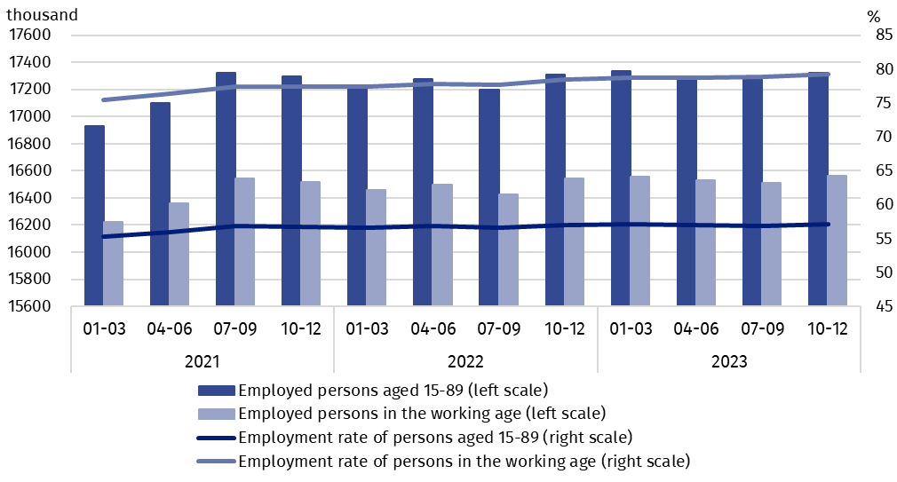
working age
In the fourth quarter of 2023, total employment rate amounted to 57.1% and in line with the observed trend was higher among men (64.0%) than among women (50.6%) and regarding the place of residence, a slightly higher level of the indicator was recorded in urban areas – 57.2% than in rural areas – 56.8%.
Over the quarter, the employment rate increased among women and decreased slightly among men (an increase by 0.3 pp. and a decrease by 0.1 pp., respectively). Taking into account place of residence, an increase of 0.2 pp. occurred among urban residents, while in rural areas the employment rate did not change.
Over the year, the employment rate increased in the female population (by 0.5 pp.), but decreased in the male population (by 0.4 pp.). In the case of persons living in urban areas, this indicator decreased (by 0.3 pp.), but increased among persons living in rural areas (by 0.6 pp.).
The LFS results indicate that in the fourth quarter of 2023:
The number of persons employed full-time remained at a similar level compared to the third quarter of 2023, but decreased compared to the fourth quarter of 2022
- 16 191 thousand (i.e. 93.5%) persons performed full-time work, while 1 133 thousand (i.e. 6.5%) were employed part-time,
- the average number of hours worked in the reference week in the main job amounted to 38.5 hours,
- the share of employees employed in public companies/institutions or by a private employer in the total number of employed persons accounted for 80.4%, (13 928 thousand persons), self-employed persons constituted 18.9%, while the share of contributing family workers accounted for 0.7%,
- a decided majority of employees employed in public companies/institutions or by a private employer performed their work on the basis of the contract for unlimited duration (84.5%, i.e. 11 765 thousand),
- the sections where the most people worked were: manufacturing – 19.2% of all employed persons (3 322 thousand); wholesale and retail trade; repair of motor vehicles and motorcycles – 13.5% (2 337 thousand), education – 7.8% (1 345 thousand) and construction – 7.4% (1 279 thousand).

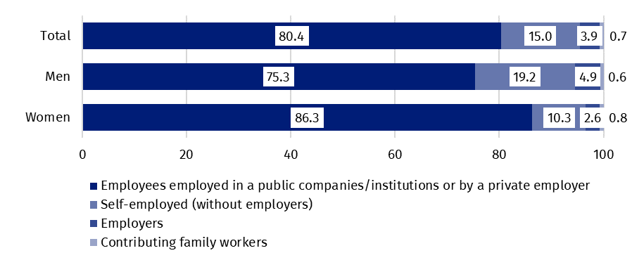
Chart 4. Structure of employed persons aged 15-89 by employment status in the main job in the fourth quarter of 2023 (in %)
In the fourth quarter of 2023, the highest growth in the number of employed persons compared to the previous quarter was recorded in manufacturing (by 179 thousand) and human health and social work activities section (by 56 thousand). The highest decline concerned the number of employed persons in agriculture, forestry and fishing section (by 144 thousand) and in education (by 80 thousand).
Compared to the fourth quarter of 2022, the highest growth in the number of employed persons occurred in information and communication section (by 86 thousand) and in human health and social work activities (by 69 thousand), while the highest decline – in agriculture, forestry and fishing (by 85 thousand) and in manufacturing (by 64 thousand).
In the fourth quarter of 2023, 936 thousand persons had a job, but were not performing the work in the reference week, which accounted for 5.4% of the total number of the employed (the corresponding population in the previous quarter comprised 1 496 thousand, i.e. 8.7%, while a year ago it was 856 thousand, i.e. 4.9%). The most common reasons for not performing work were own illness and paid, unpaid or occasional leave – they accounted for 64.2% of all causes of absence.
The number of persons performing their work usually or sometimes at home amounted to 2 583 thousand, which accounted for 14.9% of the total number of the employed. In a form of remote work (the place of performing work is not considered here), their work related responsibilities were performed usually or sometimes by 1 508 thousand persons, i.e. 8.7% of the total number of the employed.
8.7% of the total number of employed persons worked in a form of remote work

In the fourth quarter of 2023, unemployed persons accounted for 3.1% of the economically active population aged 15-89. Unemployment intensity (measured by the unemployment rate) increased compared to the previous quarter by 0.4 pp. and also compared to the fourth quarter of 2022 – by 0.2 pp. Unemployment rate was lower among men than among women (2.9% vs. 3.2%, respectively).
3.1%
Unemployment rate of persons aged 15-89

Unemployed persons aged 15-74 by the LFS
The number of unemployed persons was higher both compared to the third quarter of 2023 and the fourth quarter of 2022
In the fourth quarter of 2023, the population of unemployed persons aged 15-74 was 547 thousand and was higher than in the third quarter of 2023 – by 59 thousand, i.e. by 12.1%, as well as in the fourth quarter of 2022 – by 36 thousand, i.e. by 7.0%.
In the fourth quarter of 2023, more than half of unemployed population are men – 51.4%, i.e. 281 thousand. Taking into account the place of residence – unemployed urban residents constituted 53.4% of the total number of the unemployed, i.e. 292 thousand which is a significantly lower percentage than the share of the urban population in the population of Poland (60%).
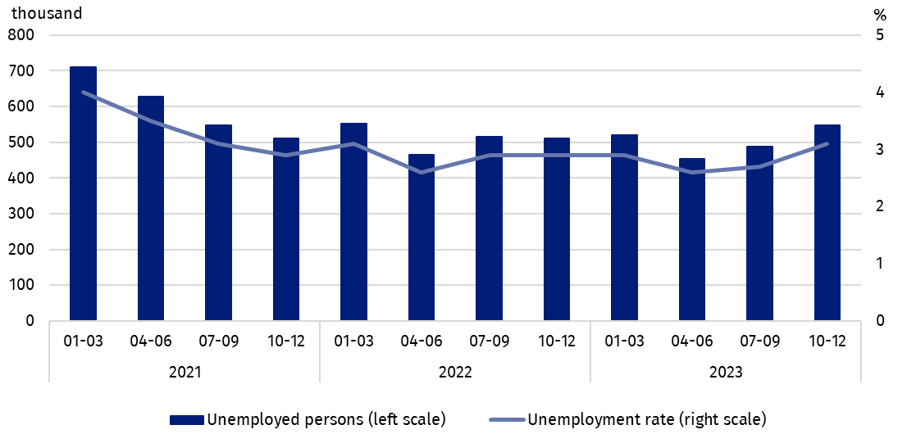
Chart 5. Unemployed persons aged 15-74 and unemployment rate of persons aged 15-89
It is also worth noting that the percentage of unemployed in the total population aged 15-89 both by sex and place of residence reaches similar values ranging from 1.6% to 2.1%.
Compared to the previous quarter, a greater increase in the number of unemployed persons was recorded among women (by 41 thousand, i.e. 18.3%) than among men (by 18 thousand, i.e. 6.8%). The number of unemployed persons increased among rural residents (by 85 thousand, i.e. 50.0%), while among urban residents there was a decrease (by 26 thousand, i.e. 8.2%).
The increase in the number of unemployed persons over the year was mainly due to the increase in this population among women (by 40 thousand, i.e. 17.8%), while among men it decreased (by 5 thousand, i.e. 1.7%). Among the unemployed classified according to the place of residence, a greater increase in the analysed period occurred among rural residents (by 29 thousand, i.e. 12.8%), among urban residents it was not significant considering the representative character of the survey.
Compared to the previous quarter, the unemployment rate increased (by 0.4 pp.), and an increase was recorded both in the women (by 0.5 pp.) and men population (by 0.2 pp.). For all rural residents, the increase in this indicator amounted to 1.2 pp., while in urban areas there was a decrease - by 0.3 pp.
Over the year, the unemployment rate increased among women (by 0.4 pp.) and decreased slightly among men (by 0.1 pp.). Taking into account the place of residence, an increase was recorded among rural residents - by 0.4 pp., and among urban residents - by 0.1 pp.
Changes in the level of unemployment rate are also noticeable when taking into account the division of population by analysed age groups.
As in previous periods, the highest unemployment rate concerned the youngest persons i.e. aged 15-24, and still increased compared to the previous quarter and over the year
The highest unemployment rate was recorded among the youngest persons, i.e. in the age group 15-24 years. In the fourth quarter of 2023, it amounted to 12.8% and increased the most both over the quarter - by 1.8 pp. and over the year - by 0.8 pp.
Among persons aged 25-34, the unemployment rate was 3.5% and increased over the quarter and year by 0.7 pp. and 0.4 pp. respectively. In the remaining analysed age groups, i.e. 35-44 years and 45-89 years, the unemployment rate in the fourth quarter of 2023 amounted to 2.1% and 1.9%, respectively, and remained at a level similar to the previous quarter (changes within 0.1 pp.) and did not change over the year.
When analysing the intensity of unemployment by level of education of the unemployed, it should be noted that its value decreases with the increase in education attained. The highest unemployment rate is observed among people with the lowest level of education, i.e. with lower secondary education or less. In the fourth quarter of 2023, for this group of persons, its value reached 7.7% and it was also the largest increase in the quarter (by 1.7 pp.). Among persons with basic vocational or basic sectoral vocational education, the unemployment rate in the analysed period was 4.5%, and the quarterly change was small (an increase of 0.1 pp.). In the group with general secondary education and post-secondary and technical secondary or secondary sectoral vocational education, the unemployment rate was similar and amounted to 3.9% and 3.8%, respectively, but during the quarter a greater change (increase by 1.1 pp.) was recorded among persons with post-secondary and technical secondary or secondary sectoral vocational education (in the group of persons with general education, the rate decreased by 0.2 pp.).
To the greatest extent, unemployment affected persons with the lowest level of education

Among persons with tertiary education, the unemployment rate in the fourth quarter of 2023 was the lowest and amounted to 1.3%, and remained unchanged in relation to both the third quarter of 2023 and the fourth quarter of 2022. In other groups regarding to the level of education, the unemployment rate increased during the year (from 0.1 pp. for persons with general secondary education to 0.7 pp. for persons with basic vocational or basic sectoral vocational education), the exception was the group of unemployed persons with lower secondary education or less, for which the unemployment rate decreased during the year (by 0.3 pp.).
Each unemployed person was classified into one of four categories. The largest population of the unemployed were those who lost their job, i.e. people who left their last job not on their own initiative in the last 3 months (41.1%, i.e. 225 thousand). The share of the unemployed intending to return to work after a break (lasting longer than 3 months) was 27.3%, i.e. 149 thousand, the share of the unemployed who were looking for their first job – 17.9%, i.e. 98 thousand and the share of the unemployed who resigned from work on their own initiative – 13.7%, i.e. 75 thousand.
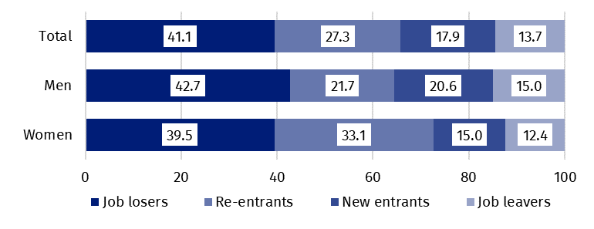
Chart 6. Structure of unemployed persons by the source of unemployment in the fourth quarter of 2023 (in %)
The average duration of job search by unemployed persons was 8.5 months
In the fourth quarter of 2023, unemployed persons had been looking for a job 8.5 months on average (in the previous quarter 7.5 months, in the fourth quarter of 2022 – 8.2 months). Persons who were seeking a job for the longest duration were the ones aged 45-54 (11.9 months) and aged 35-44 (9.1 months), while the shortest job search duration was observed for the youngest persons, in the age group 15-19 (3.6 months).
41.1%
The share of economically
inactive persons in the total number of the population aged 15–89

In the fourth quarter of 2023, economically inactive persons accounted for 41.1% of the total number of population aged 15-89. The percentage was lower compared to the previous quarter (a decrease by 0.4 pp.) and in relation to the fourth quarter of 2022 (a decrease by 0.2 pp.).

Economically inactive persons aged 15-89 by the LFS
In the fourth quarter of 2023, population of economically inactive persons aged 15-89 amounted to 12 492 thousand and decreased in relation to the third quarter of 2023 (a decrease by 96 thousand, i.e. 0.8%) and compared to the fourth quarter of 2022 (a decrease by 65 thousand, i.e. by 0.5%).
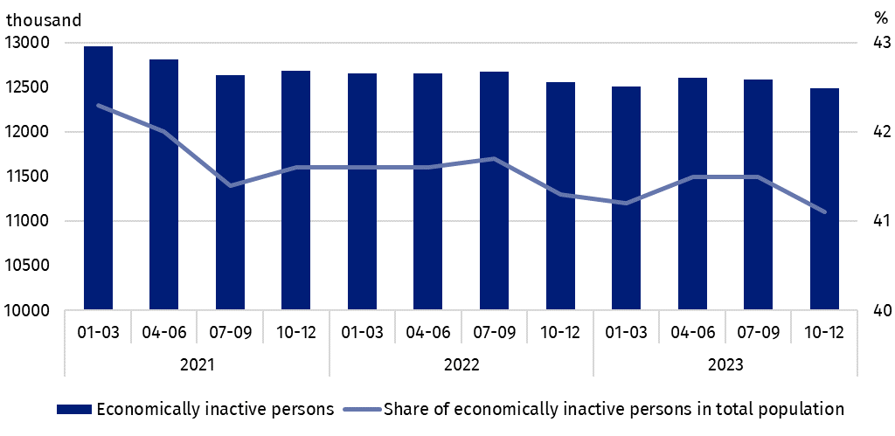
Chart 7. Economically inactive persons and the share of economically inactive persons in population aged 15-89
Women still constitute a majority of economically inactive population
Over half of the population of economically inactive persons constituted women – in the analysed age group their share was 60.3% (7 537 thousand). Taking into account division into urban and rural areas, a majority of economically inactive persons constituted urban residents (60.4%; 7 546 thousand), which is connected with a higher population in urban than in rural areas (3/5 and 2/5 respectively). Economically inactive women accounted for 47.7% of all women aged 15-89, while analogous indicator for men was 34.0%. The share of economically inactive among all urban residents in the analysed age group was at the level 41.2% and among rural residents amounted to 41.1%.
Compared to the third quarter of 2023, the number of economically inactive persons decreased taking into account both sex and the place of residence (among women by 82 thousand, i.e. by 1.1%, among men by 15 thousand, i.e. 0.3%, in urban areas by 16 thousand, i.e. 0.2%, in rural areas by 81 thousand, i.e. 1.6%).
Over the year the number of economically inactive women decreased (by 119 thousand, i.e. 1.6%), while an increase was observed among men (by 53 thousand, i.e. 1.1%). A decrease in the number of economically inactive persons was recorded among all rural residents (by 80 thousand, i.e. 1.6%), and among urban residents there was a slight increase (by 13 thousand, i.e. 0.2%).
The economically inactive population is a specific one in respect to the labour market resources. Its scope includes persons who have not entered the labour market yet (including the majority of the youth still participating in education) and persons who have definitely left the labour market or will never enter the labour market (some retirees, pensioners, persons maintaining themselves from other sources than work), but also persons who entered the labour market, then partially deactivated and who will want to re-enter the labour market after a break.
In the fourth quarter of 2023, over half of the economically inactive persons aged
15-74 comprising 10 036 thousand (the reason for inactivity was determined for this age group) constituted retirees (51.7%), while the second largest group were students (22.3%). It is worth noting that education and training as well as illness and disability were more often the reasons for inactivity among men (respectively 27.0% and 17.0%) than among women (respectively 19.1% and 6.5%). On the other hand, family responsibilities were much more often the reason for inactivity among women (11.7%) than men (1.5%).
Participating in education and improving qualification were the most often reason for economic inactivity of persons at working age
In the case of 3 798 thousand economically inactive persons at working age (women aged
18-59 and men aged 18-64), the most often reasons for inactivity were: education and training – 30.2%, illness and disability – 24.6% and family responsibilities – 19.1%. Retirement as the reason for inactivity on the labour market indicated 8.1% persons at working age, while persons discouraged with unsuccessful job search constituted 1.3% of this group.
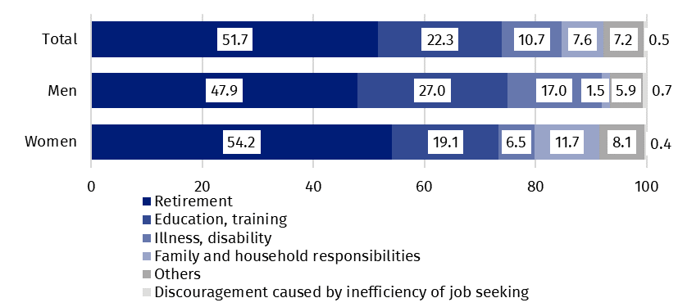
Chart 8. Structure of economically inactive persons aged 15-74 by sex and reasons for inactivity in the fourth quarter of 2023 (in %)

Methodological notes

The presented news release was prepared on the basis of the generalised results of the sample survey Badanie Aktywności Ekonomicznej Ludności/BAEL.
Since the fourth quarter of 2023, generalization of the survey results over the general population has been carried out with the use of the data on resident population of Poland coming from the balances compiled on the basis of the Population and Housing Census 2021 (by the third quarter of 2023, the results were generalized over the general population using population data from the balances compiled on the basis of the Population and Housing Census 2011). The data published in this news release and in the attached tables for the period from the first quarter of 2021 to the third quarter of 2023 have been recalculated in accordance with the new basis for generalizing results and are therefore comparable to the results for the fourth quarter of 2023.
Badanie Aktywności Ekonomicznej Ludności (Eng. Labour Force Survey) has been carried out in Poland quarterly since May 1992 and it has been improved in accordance with the International Labour Organization and Eurostat recommendations.
From the first quarter of 2021 onwards, the base of the EU-LFS methodology are definitions of the employed, the unemployed and economically inactive persons in accordance with the Resolution concerning statistics of work, employment and labour underutilization adopted in 2013 on the 19th International Conference of Labour Statisticians in Geneva (ICLS) and re-commended by the International Labour Organization (ILO) for the use in all countries. The survey object is the situation within the scope of economic activity of the population, i.e. the fact of performing work, being unemployed or economically inactive persons in the reference week. In the European Union, the implementation of the provisions of the above mentioned Resolution was carried out through introduction of new legal acts. From 2021 onwards, EU-LFS has been one of the key surveys embraced by the framework regulation for social statistics (the so-called IESS FR). Accompanying IESS FR implementing regulations in the domain of the labour force specify the range of the core survey and module surveys, determine survey organisation and define in detail particular populations specified according to the status of persons in the labour market.
Detailed results of the survey as well as the up-dated methodology – obligatory from the first quarter of 2021, are included in the quarterly publication “Labour Force Survey in Poland” and in the Methodological report available on the Statistics Poland website:
https://stat.gov.pl/en/topics/labour-market/working-unemployed-economically-inactive-by-lfs/labour-force-survey-in-poland-quarter-32023,2,51.html
https://stat.gov.pl/en/topics/labour-market/yearbook-of-labour/methodological-report-labour-force-survey,8,2.html
Prepared by:  Social Surveys and Labour Market Department  Director Piotr Łysoń, Ph.D.  Phone: (+48 22) 449 40 27 | Issued by:  The Spokesperson for the President  of Statistics Poland  Karolina Banaszek  Phone: (+48) 695 255 011
Press Office  Phone: (+48 22) 608 38 04  e-mail: obslugaprasowa@stat.gov.pl |   www.stat.gov.pl/en/

@StatPoland

@GlownyUrzadStatystyczny

gus_stat

glownyurzadstatystycznygus

glownyurzadstatystyczny
Related information
Methodological report. Labour Force Survey
Labour Force Survey in Poland
Other publications containing the results of LFS and its module surveys
stat.gov.pl → Topics → Labour Market
Data available in databases
Strateg → Topics → Labour Market
Local Data Bank → labour Market
Terms used in official statistics
Economic activity by LFS
Economically active population by LFS
Employed persons by LFS
Unemployed persons by LFS
Economically inactive population according to the LFS

Activity rate by LFS
Employment rate by LFS
Unemployment rate by LFS

Generalization of the survey results over the overall population has been carried out with the use of the data on resident population of Poland coming from the balances compiled on the basis of the Population and Housing Census 2021. Data for the period from the first quarter of 2021 to the third quarter of 2023 was recalculated in line with the new generalisation basis, therefore they differ from those presented in previous editions of the news release. See methodological notes on page 9.
The LFS results refer to the population staying or intending to stay in the country’s territory for at least 12 months, living in private households.
Men aged 18-64 and women aged 18-59.
Work at home is performed by, for example, persons who conducted own economic activity and their home is their workplace, as well as employees who work at home in the form of telework or remote work.
Remote work or telework is performed outside the establishment with the use of electronic communication means.
When analysing this change, it is necessary to take into account the decline in the number of economically inactive persons in rural areas in the same period.
The average job search time is the period from which unemployed persons look for a job, because in most cases they have not found a job yet.

