Foreigners performing work in Poland in 2022
At the end of December 2022, the share of foreigners in the total number of people performing work in Poland was 6.5%. The number of foreigners in this group increased by 27.3% between January and December 2022.
1 004.4 thousand
number of foreigners performing work in Poland as at 31 December 2022

Introduction
The study analyses the population of foreigners employed in the national economy and working under civil law contracts in Poland in 2022 by sex and age, PKD/NACE section, citizenship and in territorial breakdowns. The studied population as at the end of December 2022 numbered over 1 million people.
At the end of December 2022 more than 1 million foreigners were performing work in Poland

The complexity and changeability of the situation on the Polish labour market entails the need to provide new and more detailed data on labour resources, including foreigners performing work in Poland. The demand for information on foreigners on the labour market increased, inter alia, after the Russian invasion of Ukraine, when the inflow of foreigners to Poland increased. In order to satisfy new information needs, an attempt was made – as part of experimental statistics – to estimate the number of foreigners on the labour market on the basis of administrative sources. The developed methodology for identifying foreigners performing work allows to present data on a monthly basis, taking into account the division into women and men, as well as at a low level of territorial aggregation, i.e. in powiats and cities with powiat status.

Access to the Polish labour market for foreigners
Access of foreigners to the Polish market is regulated by both national and international laws

A very wide group of foreigners have the right to take up employment in Poland. Citizens of the European Union, Iceland, Norway, Liechtenstein (within the European Economic Area) and Switzerland have free access to the Polish labour market – they are entitled to work under the same conditions as apply to Polish citizens. Citizens of other countries may work in Poland if the entrepreneur who wants to employ them obtains an appropriate work permit for them or the foreigner holds a uniform permit for temporary residence and work. An exception to this rule applies to citizens of five countries: Armenia, Belarus, Georgia, Moldova and Ukraine. Citizens of these countries can legally work on the basis of an employer's declaration on entrusting work to a foreigner without the need to obtain a work permit. Moreover, additional facilitation of legalisation of employment has been introduced for citizens of Ukraine and their spouses, provided that they have arrived in Poland from the territory of Ukraine since 24 February 2022 and declare their intention to stay in Poland.

Foreigners performing work
At the end of December 2022, there were 27.3% more foreigners performing work than at the end of January 2022
In 2022, the number of foreigners performing work, who were subject to social insurance under this title, was increasing month by month. At the end of December 2022, there were 1 004.4 thousand of them – i.e. 27.3% more than at the end of January 2022. Of this number, 432.6 thousand were foreigners working under civil law contracts.
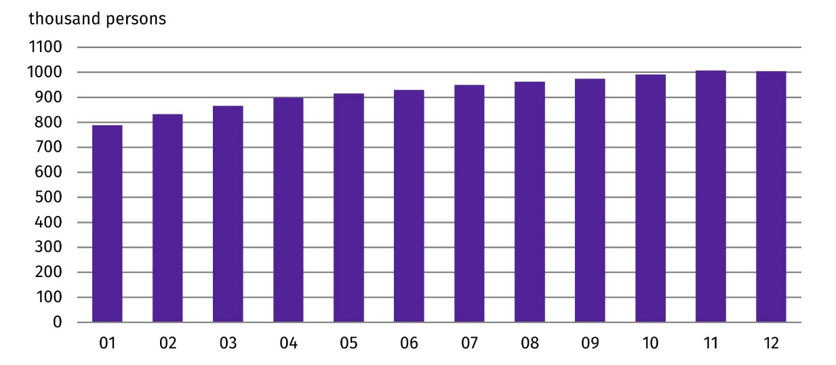
Chart 1. Foreigners performing work in 2022
As at the end of the month

As the size of the population of foreigners performing work increased, so did their share in the total number of people performing work in Poland – from 5.2% in January 2022 to 6.5% at the end of 2022.
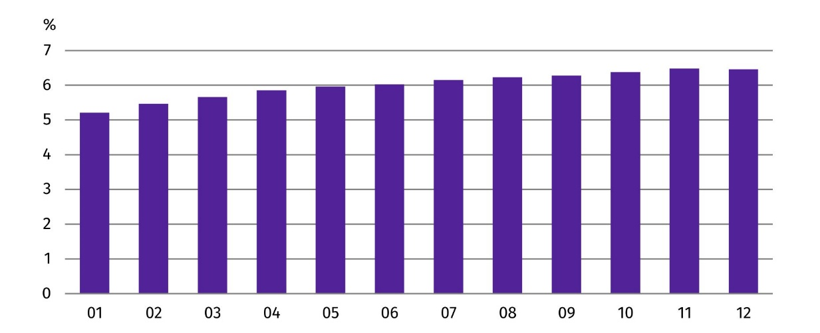
Chart 2. Share of foreigners in the total number of persons performing work in 2022
As at the end of the month

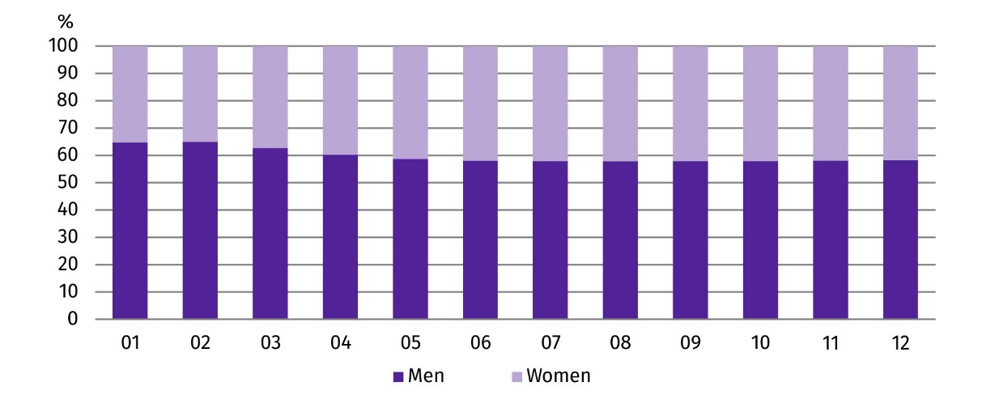
Chart 3. Structure of foreigners performing work by sex in 2022
As at the end of the month
In the analysed population of foreigners, the majority were men, but over the course of 2022 their share decreased from 64.7% at the end of January to 58.2% at the end of December.
In 2022, Ukrainian citizens were the most numerous group of foreigners performing work in Poland
Foreigners performing work in 2022 came from more than 150 countries. The most numerous group were Ukrainian citizens. Both in January and in the following months, i.e. after the Russian invasion of Ukraine, their share in the total number of foreigners performing work oscillated around 73%.
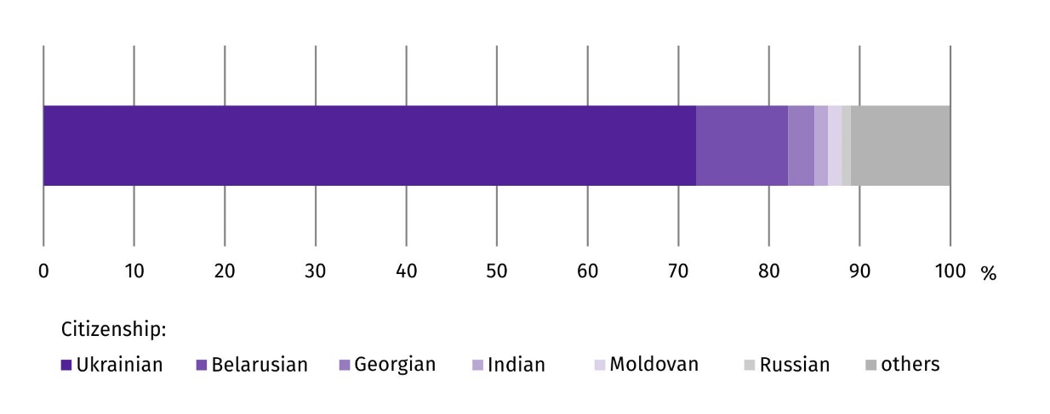
Chart 4. Structure of foreigners performing work by citizenship in 2022
As at 31 December
As in the case of all foreigners performing work, men also dominated the sex structure among Ukrainian citizens, although their share was lower. At the end of January 2022, men accounted for 61.0% of Ukrainian citizens performing work, while among other foreigners, men accounted for 74.6%. In the following months, in the group of foreigners who are not Ukrainian citizens, the sex structure did not change significantly, while in the case of Ukrainian citizens, starting from the end of March 2022, the share of men was lower and lower. At the end of December 2022, it stood at 51.4%, and was 9.7 percentage points lower than at the end of January 2022.
At the end of December 2022, men accounted for 51.4% of Ukrainian citizens performing work in Poland
The second largest group of foreigners performing work in Poland were Belarusian citizens. At the end of December 2022, they accounted for 10.1% of the analysed population. Citizens of each of the other countries accounted for less than 3% of the total described group of foreigners.
Foreigners performing work in 2022 were younger than the corresponding population of Polish citizens. This is indicated by both the mean and median age. At the end of December 2022, the mean age in the described group of foreigners in Poland was lower compared with Polish citizens (37.4 years against 42.6 years). Among foreigners performing work, Ukrainian citizens were, in turn, older than foreigners from other countries. The mean age of Ukrainian citizens of the analysed population was 37.6 years compared with 36.7 years for other foreigners. Relationships expressed by the median age were similar. At the end of December 2022, the median age of Polish citizens performing work was 42.0 years and was higher than the median age of foreigners, which was 36.0 years. In the described group of foreigners, the median age of Ukrainian citizens was 37.0 years and was 2 years higher than the median age of foreigners from other countries.
At the end of December 2022, the median age of foreigners performing work was 36.0 years
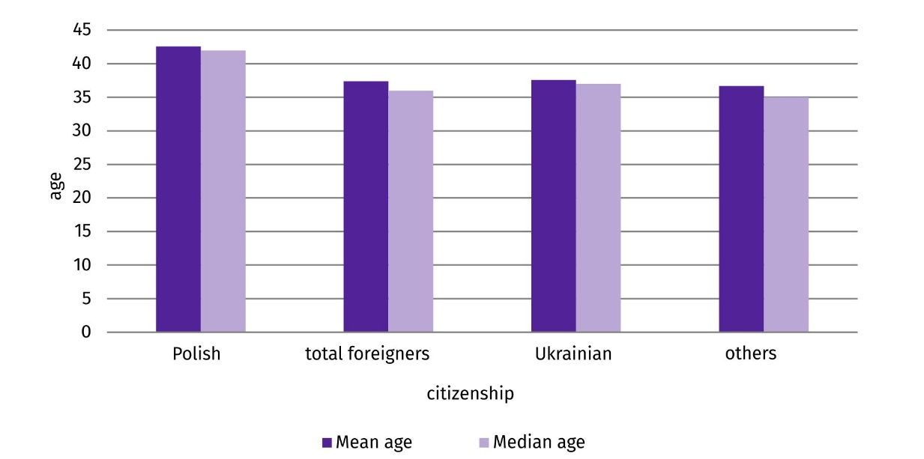
Chart 5. Mean age and median age of people performing work by citizenship in 2022
As at 31 December
As at the end of December 2022, all powiats and cities with powiat status were inhabited by foreigners performing work

As at the end of December 2022, all powiats and cities with powiat status were inhabited by foreigners performing work. A relatively high share of foreigners in the total number of people performing work characterised the powiats and cities with powiat status of the Lubuskie Voivodship. However, the highest share of foreigners performing work was recorded in the Sejneński Powiat in the Podlaskie Voivodship (25.6%).
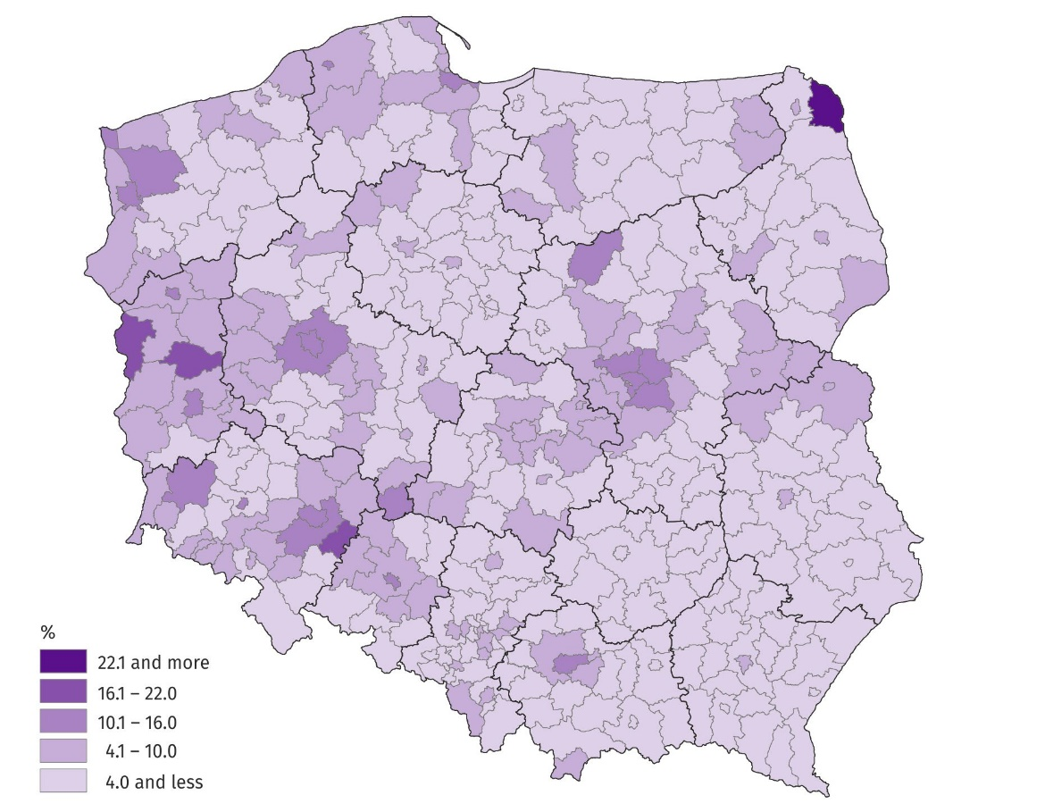
Map 1. Share of foreigners in the total number of people performing work in the powiats and cities with powiat status of residence in 2022
As at 31 December
In the majority of powiats and cities with powiat status, Ukrainian citizens predominated among foreigners. Their share ranged from 93.8% in the Oławski Powiat in the Dolnośląskie Voivodship to 19.9% in the city of Biała Podlaska – a city with powiat status, in the Lubelskie Voivodship.
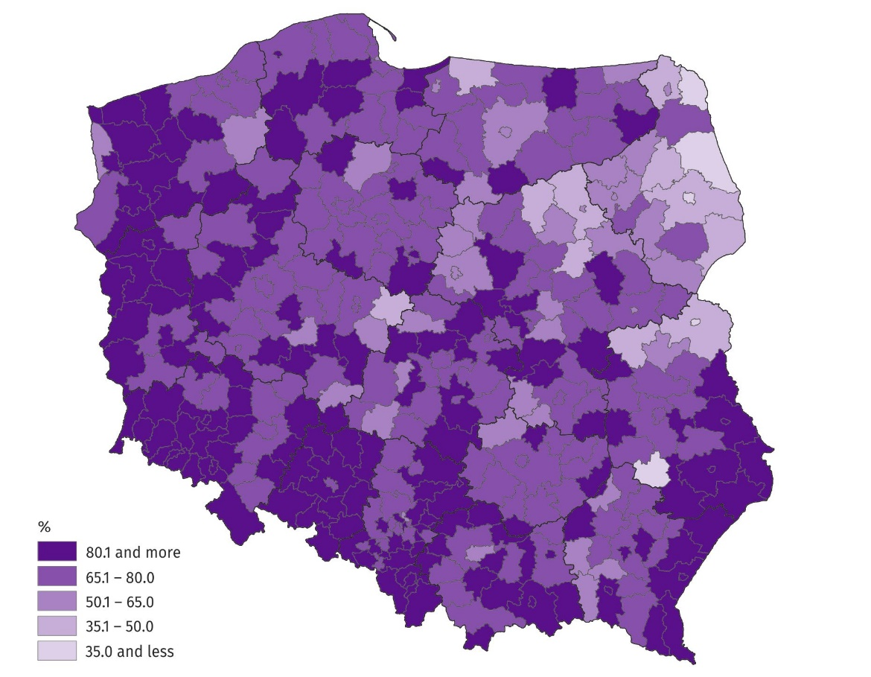
Map 2. Share of Ukrainian citizens performing work in the total number of foreigners performing work in the powiats and cities with powiat status of residence in 2022
As at 31 December
At the end of December 2022, in 13 powiats and cities with powiat status, Ukrainian citizens accounted for more than 90% of the foreigners living there and performing work
As at the end of December 2022, the relatively largest number of foreigners performing work was recorded in national economy entities operating in the scope of PKD/NACE section Administrative and support service activities – every fourth person had non-Polish citizenship. In both the Accommodation and food service activities section and the Transportation and storage section the share of foreigners in the total number of people performing work was around 14%. In the remaining sections, their share did not exceed 10%, and in three sections it was less than 1%.
At the end of December 2022, more than a quarter of people performing work in the Administrative and support services activities section were foreigners
In terms of the number of foreigners performing work, their largest number was concentrated in the Administrative and support service activities section – around 244 thousand foreigners. There were around 71 thousand fewer foreigners in the Manufacturing section and around 101 thousand fewer in the Transportation and storage section.
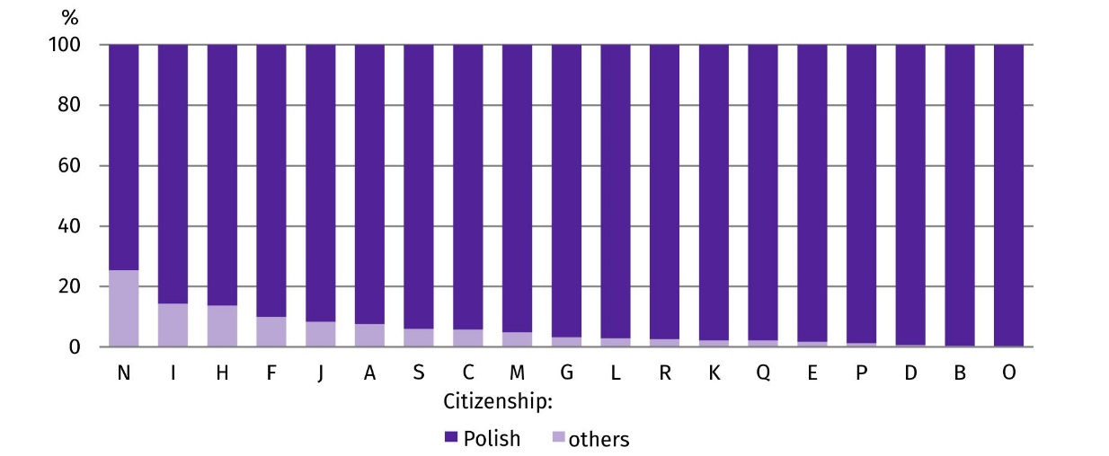
Chart 6. Structure of persons performing work by citizenship and PKD/NACE section in 2022
As at 31 December

In almost all PKD/NACE sections, Ukrainian citizens were the most numerous group among all foreigners performing work. The exception was the Information and communication section, where Belarusian citizens prevailed.
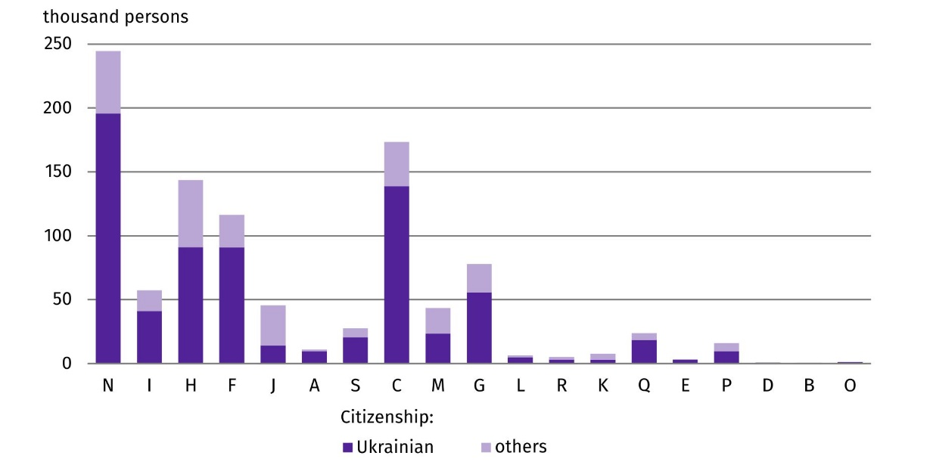
Chart 7. Foreigners performing work by PKD/NACE section in 2022
As at 31 December

PKD/NACE sections:
A – Agriculture, forestry and fishing
B – Mining and quarrying;
C – Manufacturing;
D – Electricity, gas, steam and air conditioning supply;
E – Water supply; sewerage, waste management and remediation activities;
F – Construction;
G – Wholesale and retail trade; repair of motor vehicles and motorcycles;
H – Transportation and storage;
I – Accommodation and food service activities;
J – Information and communication;
K – Financial and insurance activities;
L – Real estate activities;
M – Professional, scientific and technical activities;
N – Administrative and support service activities;
O – Public administration and defence; compulsory social security;
P – Education;
Q – Human health and social work activities;
R – Arts, entertainment and recreation;
S – Other service activities;
In the case of quoting Statistics Poland data, please provide information: ‘Source of data: Statistics Poland’, and in the case of publishing calculations made on data published by Statistics Poland, please provide information: ‘Own elaboration based on Statistics Poland data.’

Prepared by:  Statistical Office in Bydgoszcz  Director Wiesława Gierańczyk, Ph.D.  Phone: (+48 52) 366 93 90 | Issued by:  The Spokesperson for the President  of Statistics Poland  Karolina Banaszek  Phone: (+48) 695 255 011
Press Office  Phone: (+48 22) 608 38 04  e-mail: obslugaprasowa@stat.gov.pl |   stat.gov.pl/en/

@GUS_STAT

@GlownyUrzadStatystyczny

gus_stat

glownyurzadstatystycznygus

glownyurzadstatystyczny
Related information
Methodological report Employment in the national economy
Methodological report Employment in the national economy according to administrative data sources
Terms used in official statistics
Median age
Employment in national economy

According to the definition in force in official statistics, persons working under civil law contracts are not included in the population of employed persons in the national economy. However, the data presented in the experimental study concern employed persons in the national economy and persons working under civil law contracts identifiable in administrative records. Persons classified as employed who at the same time work under civil law contracts are counted only once and included in the group of employed persons. The analysed population does not include owners, co-owners and leaseholders of individual agricultural holdings (including contributing family workers), as well as persons working under contracts to perform a specified task and farmer's helpers. For simplicity, this population is referred to in the study as those performing work.
The median value determines the age limit relative to which half of the people in a given population are no younger and the other half no older than the median value.

