Education in the 2022/2023 school year
(preliminary data)

In the 2022/23 school year, there were
22.5 thousand pre-primary establishments
(0.3% more than in the 2021/22 school year)
with a total of 1534.2 thousand children enrolled (respectively 4.2% more).
4.2%
An increase in the number of children participating in
pre-primary education in comparison with the 2021/22 school year

Pre-primary education
Pre-primary education is the first stage of education in the Polish education system.
It usually covers children aged 3-6 years. Education is implemented in nursery schools,
pre-primary sections in primary schools, pre-primary education units and pre-primary centres. In the 2022/23 school year, there were 22.5 thousand pre-primary establishments in Poland (0.1 thousand more than in the 2021/22 school year) with a total of 1534.2 thousand children (61.6 thousand more).
949 per 1,000 children aged 3-6 years participated in various forms of pre-primary education in the surveyed period (904 a year earlier). The net enrollment rate for pre-primary education stood at 114.1% in cities and 71.2% in rural areas.

Table 1. Pre-primary education
As of 30 September
81.4% of children covered by pre-primary education attended nursery schools, while 17.0% - pre-primary sections in primary schools
SPECIFICATION  a – 2021/22  b – 2022/23 |  | Establishments | Sections | Children
TOTAL | a | 22 430 | 75 020 | 1 472 572
TOTAL | b | 22 505 | 76 002 | 1 534 212
Nursery schools | a | 13 483 | 58 996 | 1 196 841
Nursery schools | b | 13 756 | 60 538 | 1 249 173
Pre-primary sections in primary schools | a | 7 463 | 13 854 | 247 511
Pre-primary sections in primary schools | b | 7 305 | 14 020 | 260 235
Pre-primary education units | a | 59 | 74 | 1 044
Pre-primary education units | b | 45 | 45 | 664
Pre-primary centres | a | 1 425 | 2 096 | 27 176
Pre-primary centres | b | 1 399 | 1 399 | 24 140

Chart 1. Pre-primary education in urban and rural areas
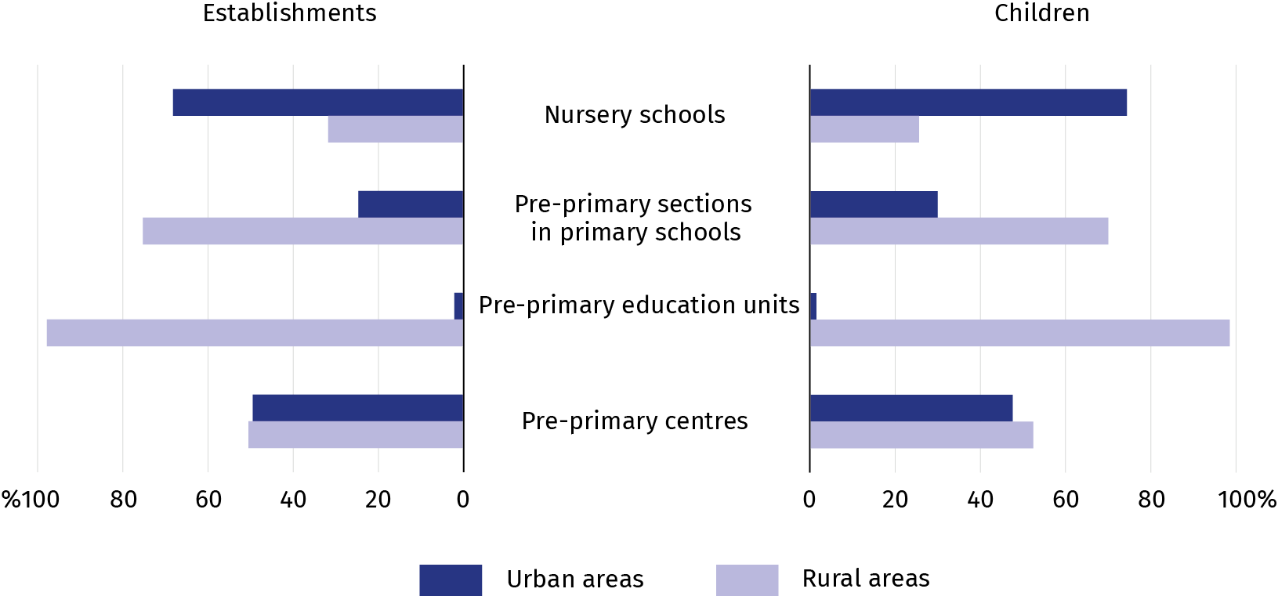
As of 30 September
In the 2022/23 school year, 66.4% of the total number of children covered by
pre-primary education attended establishments in urban areas

Primary schools for children and youth
In the 2022/23 school year, 3.1 million pupils attended 14.1 thousand primary schools for children and youth in Poland (like a year earlier).
0.5%
A decrease in the number of primary schools in comparison with the 2021/22 school year
In the 2022/23 school year, there were 1.1 thousand primary schools for children and youth in Poland, 5.9 thousand in urban and 8.2 thousand in rural areas. 2.0 million pupils were enrolled in schools located in cities, while 1.1 million pupils attended schools in rural areas.

Table 2. Primary schools for children and youth
As of 30 September
SPECIFICATION  a – 2021/22  b – 2022/23 |  | Schools | Sections | Pupils |  | Graduates
 |  | Schools | Sections | total | of which girls | total | of which girls
TOTAL | a | 14 144 | 187 329 | 3 121 648 | 1 512 698 | 502 922 | 249 154
TOTAL | b | 14 073 | 184 105 | 3 122 826 | 1 510 787 | • | •
of which:
Branch schools | a | 204 | 802 | 7 683 | 3 702 | 318 | 146
Branch schools | b | 186 | 742 | 7 523 | 3 617 | • | •
General art schools ª | a | 53 | 562 | 9 508 | 5 830 | 512 | 323
General art schools ª | b | 55 | 612 | 10 210 | 6 252 | • | •
Special schools | a | 953 | 14 159 | 48 349 | 16 473 | 6 484 | 2 202
Special schools | b | 951 | 15 005 | 51 830 | 17 568 | • | •
a Not leading to professional certification.

Chart 2. Pupils in primary schools in urban and rural areas
As of 30 September
In the 2022/23 school year, 35.6% pupils were enrolled in primary schools for children and youth in urban areas, 64.4% in rural areas
do szkół podstawowych dla dzieci i młodzieży na wsi
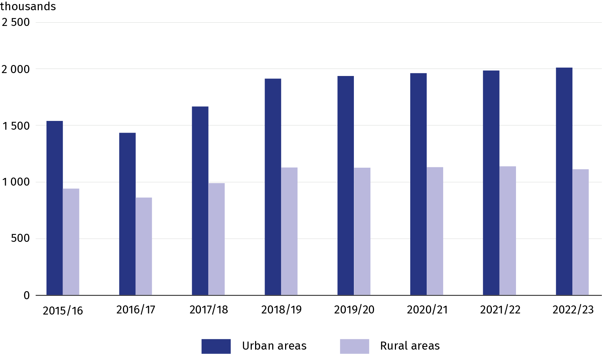
Primary schools for children and youth run by public sector units represented 88.8% of all establishments (in urban areas – 81.3%, in rural areas – 94.2%). Non-public sector entities,
on the other hand, ran 11.2% of schools (including special schools) which concentrated 94.5% and 5.5% of pupils respectively. Schools governed by local government units were the prevalent group (84.1%), accounting for 78.2% in urban and 88.3% in rural areas.
In the 2022/23 school year, an average section in a mainstream primary school comprised
18 pupils. Sections in primary schools for children and youth (excluding special schools) were smaller in rural areas. They averaged 15 pupils, whereas an average primary school section in urban areas concentrated 21 pupils.
There were 502.9 thousand graduates of primary schools in June 2022.

Post-primary schools for youth
In the 2022/23 school year, there were
1671,2 thousand students of post-primary
schools for youth in Poland (8.0% more than
in 2021/22).
8.0%
An increase in the number of students in post-primary schools for youth in comparison with the 2021/22 school year
In the 2022/23 school year, there were 6819
post-primary schools
which concentrated by 8.0% more students than
a year earlier. The general secondary school students (43.5%) and technical school students (42.6%) prevailed among the students of this type of schools

In the 2022/23 school year, there were 6.8 thousand post-primary schools for youth (including special schools) in Poland with a total of 1671.2 thousand students enrolled
(1547.6 thousand in the previous school year). 2398 general secondary schools for youth were educating 726.4 thousand students, most of whom were women (62.7%). However, 1861 technical secondary schools with 711.1 thousand students concentrated mostly men (61.0%). 195.1 thousand students, 67.2% of whom were men, attended 1672 stage I sectoral vocational schools. 11.4 thousand pursued their education in 226 stage II sectoral vocational schools, including 10.8 thousand students in urban and 0.5 thousand in rural areas. For the first time, these schools released 0.9 thousand graduates who accounted for 0.3% of the post-primary school graduates.
Special job-training schools are three-year schools exclusively for students with moderate and severe intellectual disability, as well as for students with multiple disabilities.
The graduates of these schools obtain a special job-training certificate. In the
2022/23 school year, 12.7 thousand students were enrolled in 560 schools of this type.

General art schools leading to professional certification represent a separate group of
post-primary schools. In the 2022/23 school year in Poland, 102 schools of this type were educating 14.5 thousand students (1.7 % fewer than in the 2021/22 school year).
Most post-primary schools were governed by local government units – 74.5%.
In the 2021/22 school year, 362.0 thousand students graduated from post-primary schools for children and youth, including 173.8 thousand women.

Table 3. Post-primary schools for youth
51.1% of post-primary school students were men
As of 30 September
SPECIFICATION  a – 2021/22  b – 2022/23 |  | Schools | Sections | Students |  | Graduates
 |  | Schools | Sections | total | of which females | total | of which females
TOTAL | a | 6 678 | 67 424 | 1 547 581 | 748 241 | 361 958 | 173 806
TOTAL | b | 6 819 | 70 693 | 1 671 187 | 816 920 | • | •
Special job-training schools | a | 557 | 3 726 | 12 832 | 5 029 | 2 497 | 987
Special job-training schools | b | 560 | 3 813 | 12 713 | 4 924 | • | •
Stage I sectoral vocational schools | a | 1 674 | 10 503 | 207 097 | 65 680 | 82 968 | 26 309
Stage I sectoral vocational schools | b | 1 672 | 9 257 | 195 097 | 63 930 | • | •
Stage II sectoral vocational schools | a | 136 | 247 | 3 729 | 1 033 | 907 | 280
Stage II sectoral vocational schools | b | 226 | 585 | 11 375 | 3 167 | • | •
General secondary schools | a | 2 331 | 25 347 | 652 690 | 409 471 | 156 375 | 98 531
General secondary schools | b | 2 398 | 27 646 | 726 386 | 455 213 | • | •
Technical secondary schools | a | 1 854 | 26 793 | 656 513 | 255 095 | 116 694 | 45 690
Technical secondary schools | b | 1 861 | 28 603 | 711 140 | 277 608 | • | •
General art schools ª | a | 126 | 808 | 14 720 | 11 933 | 2 517 | 2 009
General art schools ª | b | 102 | 789 | 14 476 | 12 078 | • | •
a Leading to professional certification.

Post-secondary schools
In the 2022/23 school year, there were 1287
post-secondary schools in Poland, educating 234.8 thousand students (0.9% more than in the 2021/22 school year).
5.2%
A decrease in the number of post-secondary schools in comparison with the 2021/22 school year
In the 2022/23 school year, there were 1287 post-secondary schools (70 schools fewer than in the previous school year) with a total of 234.8 thousand students enrolled (respectively
2.1 thousand more), 71.7% of whom were women. These schools were mostly governed by private sector units (79.9%). Public schools accounted for 20.1%.

Table 4. Post-secondary schools
SPECIFICATION | 2021/22 | 2022/23
Schools | 1 357 | 1 287
Sections | 9 813 | 9 932
Students | 232 696 | 234 817
of which females | 163 900 | 168 275
Graduates | 58 191 | •
of which females | 44 645 | •
As of 30 September

Schools for adults
In the 2022/23 school year, 816 schools for adults operated in Poland. They concentrated
88.6 thousand students (a 0.7% decline on the previous school year).
8.9%
A decrease in the number of schools for adults in comparison with the 2021/22 school year

88.6 thousand students attended 816 schools for adults in the 2022/23 school year. General secondary schools with 87.4 thousand students prevailed among the schools for adults (98.6% of the total number of students in schools for adults). Women represented 46.5%
of students in general secondary schools and 33.0% in primary schools.

Table 5. Schools for adults
As of 30 September
SPECIFICATION  a – 2021/22  b – 2022/23 |  | Schools | Sections | Students |  | Graduates
 |  | Schools | Sections | total | of which females | total | of which females
TOTAL | a | 896 | 3 365 | 89 249 | 40 586 | 27 665 | 13 514
TOTAL | b | 816 | 3 160 | 88 640 | 41 043 | • | •
Primary schools | a | 61 | 136 | 1 761 | 615 | 447 | 159
Primary schools | b | 47 | 96 | 1 206 | 398 | • | •
General secondary schools | a | 835 | 3 229 | 87 488 | 39 971 | 27 218 | 13 355
General secondary schools | b | 769 | 3 064 | 87 434 | 40 645 | • | •

Enrollment rates
In the 2022/23 school year, 6.7 million children, youth and adults were enrolled in
pre-primary establishments, primary schools, post-primary and post-secondary schools, which accounted for 17.6% of the population of Poland.

Table 6. Enrollment rates
SPECIFICATION | Age groups | Total | Males | Females
SPECIFICATION | Age groups | in %
Gross enrollment rates
Pre-primary education | 3-6 | 97,3 | 97,1 | 97,5
Primary schools | 7-14 | 96,0 | 96,5 | 95,4
Stage I sectoral vocational schools ª | 15-17 | 18,3 | 23,9 | 12,4
General secondary schools | 15-18 | 54,8 | 41,8 | 68,5
Technical secondary schools ^{b} | 15-19 | 39,7 | 46,6 | 32,5
Post-secondary schools ^{c} | 19-21 | 23,5 | 14,0 | 33,5
Net enrollment rates
Pre-primary education | 3-6 | 94,9 | 94,5 | 95,3
Primary schools | 7-14 | 94,7 | 95,0 | 94,4
Stage I sectoral vocational schools ª | 15-17 | 13,6 | 17,9 | 9,1
General secondary schools | 15-18 | 44,4 | 33,0 | 56,3
Technical secondary schools ^{b} | 15-19 | 35,2 | 41,7 | 28,5
Post-secondary schools ^{c} | 19-21 | 5,6 | 3,8 | 7,5
As of 30 September
abc Including: a – special job-trainig schools, b – general art schools leading to professional certification,
c – stage II sectoral vocational schools.
Gross enrollment rate is the ratio of the number of pupils and students at a given level of education regardless of age to the population in the age group defined as corresponding to this level of education.
Net enrollment rate is the ratio of the number of pupils and students in a given age group at a given level of education to the population in the age group defined as corresponding to this level of education.

Teachers
In the 2022/23 school year, there were
512.1 thousand teachers employed in Poland
(in full-time equivalents).
0.7%
A decrease in the number of teachers in comparison with the 2021/22 school year

In the 2022/23 school year, the educational establishments employed a total of
512.1 thousand teachers (in full-time equivalents). Primary school teachers were the prevalent group – 51.7%. The most women were employed in pre-primary establishments (99.1%) and in primary schools (83.2%). Men prevailed among teachers in art schools (42.4%) and in stage I sectoral secondary schools (41.1%). The majority of teachers were employed as chartered teachers (56.8%).

Women accounted for 82.3% of all teachers

Table 7. Teachers ª (in full-time equivalents) by type of school
As of 30 September
SPECIFICATION | 2021/22 | 2022/23
TOTAL | 515 701 | 512 102
Pre-primary establishments | 109 051 | 108 844
Primary schools | 271 257 | 264 780
Stage I sectoral vocational schools | 13 830 | 12 995
Stage II sectoral vocational schools | 136 | 349
General secondary schools | 50 174 | 51 790
Technical secondary schools | 51 971 | 54 603
Post-secondary schools ^{b} | 3 102 | 2 756
Art schools | 11 151 | 11 006
Special job training schools | 5 030 | 4 981
a Data may not sum up due to rounding. b Including colleges of social work.
Chart 3. Full-time and part-time teachers ª (full-time equivalents) in urban and rural areas by career advancement degree
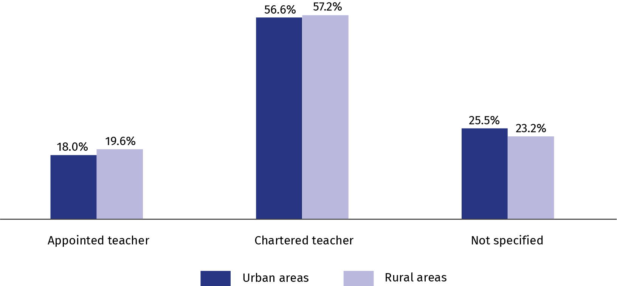
As of 30 September
In the 2022/23 school year, 71.2% of teachers worked in urban areas

a Data may not sum up due to rounding.
When citing data from the Statistics Poland please provide the following information: "Statistics Poland's data". When publishing calculations made on data published by the Statistics Poland, provide the following information: "Own study based on the Statistics Poland's data".
Prepared by:  Statistical Office in Gdańsk  Director Jerzy Auksztol  Phone (+48 58) 76 83 130 | Issued by:  The Spokesperson for the President  of Statistics Poland  Karolina Banaszek  Phone: (+48) 695 255 011
Press Office  Phone: (+48 22) 608 38 04  e-mail: obslugaprasowa@stat.gov.pl |   www.stat.gov.pl/en/

@GUS_STAT

@GlownyUrzadStatystyczny

gus_stat

glownyurzadstatystycznygus

glownyurzadstatystyczny
Related information
Education in the 2021/2022 school year
Data available in databases
Local Data Bank – Pre-primary education
Local Data Bank – Education
Knowledge Databases – Education
STRATEG system – Education
Public Services Monitoring System – Education
OECD Database – Education
Eurostat Database – Education and training
Terms used in official statistics
Pre-primary education
Primary school
Post-primary school
Post-secondary school
School for adults
Gross enrollment rate
Net enrollment rate
Student
Graduate
Teacher

