Municipal infrastructure - energy and gas in 2022
In Poland in 2022 household consumption of electricity decreased by 5.0%, and the number of consumers increased by 1.8%.
5.0%
Decrease in the household consumption of electricity in 2022 in comparison to 2021
Electricity
In 2022, household consumption of electricity amounted to 30,062.0 GWh
In 2022, household consumption of electricity in Poland decreased by 5.0% compared to 2021 and amounted to 30,062.0 GWh, with an increase in the number of consumers (households) of 1.8%.
In 2022, compared to the previous year, consumption of electricity per consumer (household) in Poland decreased by 6.7% and amounted to 1,847.7 kWh, whereas in urban areas amounted to 1,649.1 kWh (decrease of 2.4%), and in rural areas - 2,242.8 kWh (decrease by 8.6%).
Table 1. Consumers and household consumption of electricity
Specification | 2021 | 2020 = 100 | 2022 | 2021 = 100
Consumption of electricity in GWh (during the year)  urban areas  rural areas | 31,647.1  18,516.4  13,130.7 | 100.4  100.1  100.7 | 30,062.0  17,855.9  12,206.1 | 95.0  96.4  93.0
Consumers of electricity in thousands (as of 31 December)  urban areas  rural areas | 15,984  10,961  5,353 | 101.2  103.8  102.1 | 16,270  10,823  5,442 | 101.8  98.7  101.7
Consumption of electricity per consumer in kWh (during the year)  urban areas  rural areas | 1,979.9  1,689.3  2,453.0 | 99.2  96.4  98.7 | 1,847.7  1,649.1  2,242.8 | 93.3  97.6  91.4
Consumption of electricity per capita in kWh (during the year)  urban areas  rural areas | 829.3  810.9  856.6 | 100.9  100.8  100.9 | 794.7  791.3  799.7 | 95.8  97.6  93.4

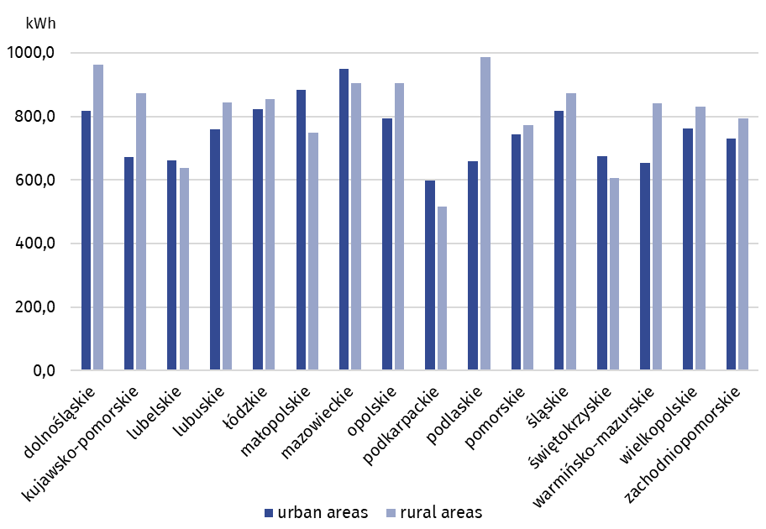
Chart 1. Household consumption of electricity per capita in 2022

Heat energy
96% of the length of the heating network located in urban areas at the end of 2022
At the end of 2022, the length of the heat supply network in Poland amounted to 25,469.9 km, of which 96.0% was located in urban areas.
The highest density of heat supply network was observed in the following voivodships: Śląskie (19.9 km per 100 km²), followed by Małopolskie (8.9 km per 100 km²), Pomorskie (7.2 km per 100 km²), Łódzkie (6.9 km per 100 km²) and Mazowieckie (6.5 km per 100 km²), while the lowest denisty - in the following voivodships: Podlaskie, Lubuskie and Warmińsko-Mazurskie (2.7 km per 100 km²) and Zachodniopomorskie (3.2 km per 100 km²).
Table 2. Heat supply system infrastructure and sale of heat energy

Specification | 2021 | 2020 = 100 | 2022 | 2021 = 100
Heat supply network (total) in km (as of 31 December)  urban areas  rural areas | 25,238.7  24,167.7  1,071.0 | 99.7  99.8  97.3 | 25,469.9  24,441.5  1,028.4 | 100.9  101.1  96.0
Heat supply network (transmission and distribution) in km (as of 31 December) | 16,524.8 | 99.7 | 16,679.3 | 100.9
urban areas  rural areas | 15,839.7  685.1 | 99.9  96.3 | 16,017.3  662.0 | 101.1  96.6
Connections to buildings in km (as of 31 December)  urban areas  rural areas | 8,713.9  8,328.0  385.9 | 99.6  99.6  99.1 | 8,790.6  8,424.2  366.4 | 100.9  101.2  94.9
Sale of heat energy in thousand TJ (during the year)  urban areas  rural areas | 211.7  208.7  3.0 | 115.2  115.3  110.1 | 194.0  191.3  2.7 | 91.6  91.7  90.0
Sale of heat energy for residential buildings in thousand TJ (during the year)  urban areas  rural areas | 166.5  164.6  1.9 | 114.6  114.6  109.0 | 151.7  150.1  1.6 | 91.1  91.2  85.0

Chart 2. The length of heat supply network – as of 31.12.2022
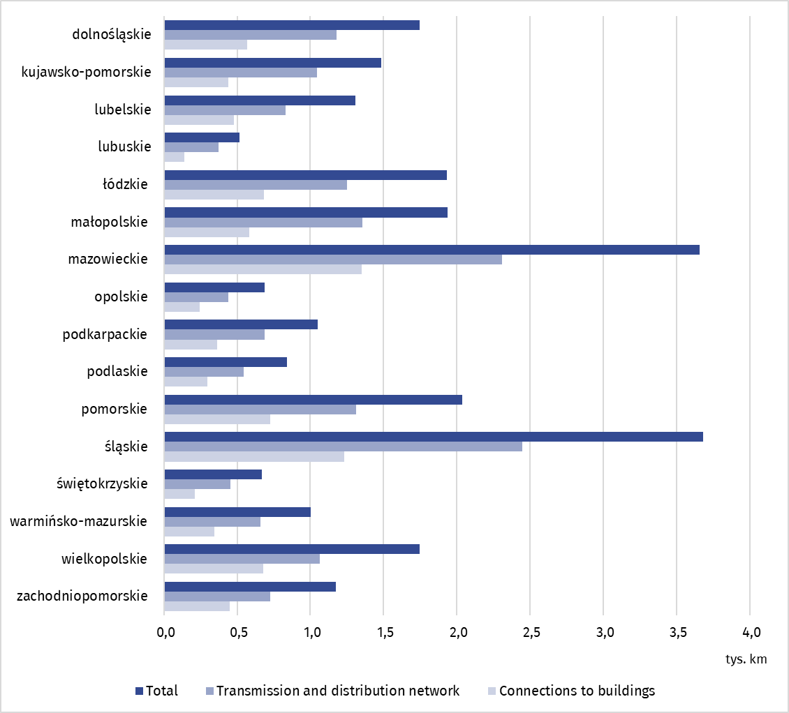

In 2022, about 151.7 thousand TJ of heat energy was sold for heating purposes in residential buildings , of which almost 99% to inhabitants of urban areas
In 2022, 194.0 thousand TJ of heat energy was sold, of which 151.7 thousand TJ (i.e. 72.2%) for heating purposes in residential buildings. About 191.3 thousand. TJ (98.6%) of heat energy was sold to inhabitants of urban areas, of which approximately 150.1 thousand. TJ for heating purposes in residential buildings.
In 2022, in the structure of fuels used for production of heat energy for heating purposes, the largest share constituted solid fuels (i.e. 60.0%), followed by gaseous fuels (i.e. 37.0%), whereas the least heat energy for heating purposes was produced using oil fuels (i.e. 3.0%).
Gas supply system
As of the end of 2022, gas supply network in Poland reached the length of about 171.2 thousand km, by 3.3% more than a year before
As of the end of 2022, gas supply network in Poland reached the length of 171.2 thousand km, the number of connections to buildings amounted to 3,398.8 thousand pcs. Compared to the previous year, the length of gas supply network increased by. 5.4 thous. km (3.3%), whereas the number of connections to buildings - by 113.5 thous. pcs. (3.5%).
The household consumption of gas from gas supply system in Poland in 2022 compared to 2021 decreased by 5.1%, while the number of customers increased by 2.2%. In urban areas, gas consumption decreased by 4.6%, while the number of customers increased by 1.6%. In rural areas, gas consumption decreased by 6.2%, while the number of recipients increased by 4.9%.
In relation to 2021, households consumption of gas from gas supply system in decreased by 3,017.1 GWh and amounted to 6,458.4 kWh per customer, with 5,488.4 kWh per customer in urban areas and in rural areas 11,326 kWh per consumer.
Table 3. Gas supply network, consumers, and consumption of gas from gas supply system in households
Specification | 2021 | 2020 = 100 | 2022 | 2021 = 100
Gas supply network in km (as of 31 December)  urban areas  rural areas | 165,733  68,749  96,983 | 102.2  102.2  102.3 | 171,179  70,909  100,270 | 103.3  103.1  103.4
Connections leading to residential and non-residential buildings in thousand pcs (as of 31 December)  urban areas  rural areas | 3,285.3  1,909.3  1,376.0 | 104.0  103.2  105.1 | 3,398.8  1,966.1  1,432.6 | 103.5  103.0  104.1
Consumers of gas from gas supply system in thousands (as of 31 December)  urban areas  rural areas | 8,549  7,166  1,383 | 102.5  101.7  107.1 | 8,735.1  7,283.8  1,451.2 | 102.2  101.6  104.9
Consumption of gas from gas supply system in GWh (during the year)  urban areas  rural areas | 59,431.5  41903.8  17,527.7 | 118.2  113.0  132.5 | 56,414.4  39976.9  16,437.5 | 94.9  95.4  93.8
Consumption of gas from gas supply system per capita in kWh (during the year)  urban areas  rural areas | 1,564.4  1,845.5  1,146.8 | 118.8  113.9  132.7 | 1,491.4  1,771.7  1,077.0 | 95.3  96.0  93.9
Consumption of gas from gas supply system per consumer in kWh (during the year)  urban areas  rural areas | 6,951.7  5,847.6  12,672.0 | 115.3  111.2  123.8 | 6,458.4  5,488.4  11,326.7 | 92.9  93.9  89.4
Chart 3. Household consumption of gas from gas supply system per capita in 2022
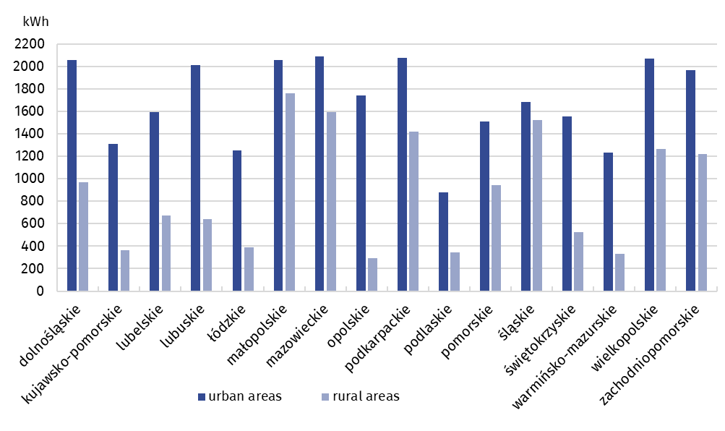

In case of quoting Statistics Poland data, please provide information: “Source of data:
Statistics Poland”, and in case of publishing calculations made on data published by
Statistics Poland, please include the following disclaimer: “Own study based on figures from
Statistics Poland”.

Prepared by:  Statistical Office in Rzeszów  Director Marek Cierpiał-Wolan  Phone: (+48) 17 853 52 10 | Issued by:  The Spokesperson for the President  of Statistics Poland  Karolina Banaszek  Phone: (+48) 695 255 011
Press Office  Phone: (+48 22) 608 38 04  e-mail: obslugaprasowa@stat.gov.pl |   stat.gov.pl/en/

@StatPoland

@GlownyUrzadStatystyczny

gus_stat

glownyurzadstatystycznygus

glownyurzadstatystyczny
Related information
Energy management and gas supply system in Poland in 2021
Housing Economy and Municipal Infrastructure in 2021
Data available in databases
Local Data Base
Knowledge Databases Municipal and Dwelling Infrastructure
Terms used in official statistics
Energy consumption
Consumers of electric energy in households
Distribution heat network
Transmission heat network
Gas supply network
Gas supply connection
Consumer of gas from gas supply system
Consumption of gas in households

