Sales of prescription medicines in 2022
In 2022, 453 million prescriptions were issued, of which 95.8% were in electronic form, i.e. 1.4% more than in 2021
6.6%
Increase in the number of prescriptions issued in 2022 compared to 2021

In 2022, the number of pharmacies and pharmaceutical outlets amounted to 12 776, i.e. 1.8% fewer than a year ago, with an average of 2 956 per pharmacy

As of 31 December 2022, there were 11 657 pharmacies in Poland (209 fewer than in 2021) and 1 119 pharmaceutical outlets (28 fewer than in 2021), which gave an average of 2 956 people per pharmacy or pharmaceutical outlets (30 more than in 2021). 453.3 million prescriptions were issued (27.9 million more than a year ago), of which 95.8% were electronic (in 2021, the percentage of electronic prescriptions in the total number of prescriptions was 94.4%).
In 2022, the highest number of people per pharmacy or pharmaceutical outlet occurred in voivodships: Pomorskie (3 369), Warmińsko-Mazurskie (3 261) and Mazowieckie (3 213).
The smallest occurred in the following voivodships: Lubelskie (2 606), Wielkopolskie (2 669) and Łódzkie (2 709). Poviats with the least number of people per pharmacy or pharmaceutical outlet are poviats or cities with the poviat status: Krosno (1 528), Konin (1 746), kłobucki (1 874), Ostrołęka (1 948) and janowski (1 963). The poviats with the highest number of people per pharmacy or pharmaceutical outlet are poviats: przemyski (5 949), elbląski (5 462), siedlecki (5 366), radomski (5 214) and łomżyński (4 971).

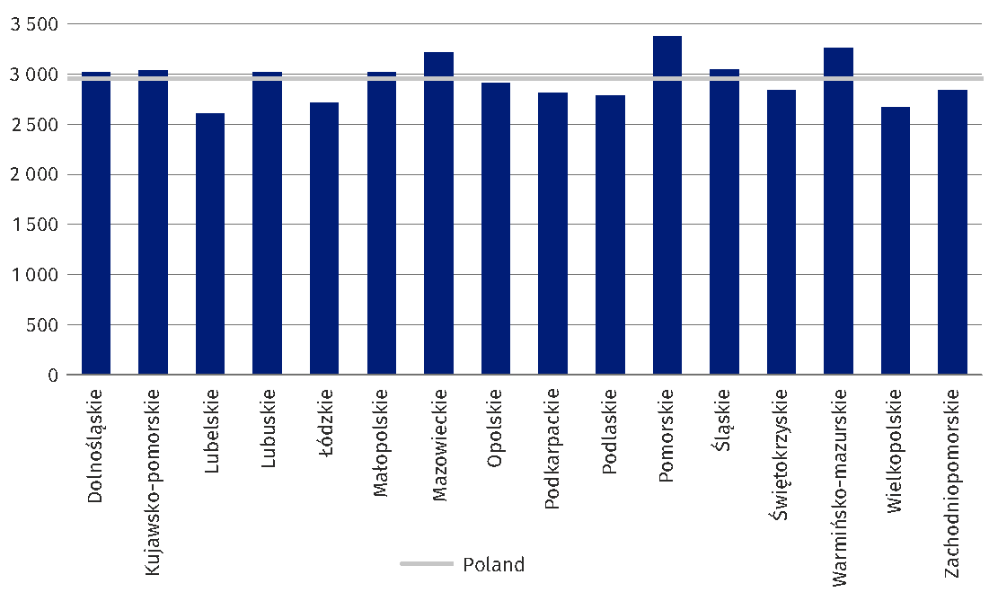
Chart1. Population per pharmacy or pharmaceutical outlet in 2022

In 2022, the percentage of e-prescriptions issued in individual voivodships varied by no more than 2.3 percentage points. The highest percentage of electronic prescriptions occurred, as in 2021, in the Pomorskie Voivodship (99.0%) and the lowest in Świętokrzyskie Voivodship (94.7%). In the case of poviats, the highest percentage of electronic prescriptions were observed in poviats: siedlecki (99.1%), moniecki (98.9%), człuchowski (98.9%), nowomiejski (98.7%) and nidzicki (98.6%), while the lowest in poviats: węgrowski (85.7%), chodzieski (87.1%), sanocki (88.8%), złotoryjski (89.4%) and sulęciński (89.7%).
In 2022, the least electronic prescriptions per inhabitant of the poviat were issued in poviats: łomżyński (2.4), przemyski (2.6), skierniewicki (3.2), siedlecki (3.2) and suwalski (3.2) and most in cities with the status of poviat: Zamość (25.3), Tarnów (23.4), Krosno (22.6), Chełm (22.2) and Siedlce (20.7). However, when interpreting these resultant data, it should be noted that the highest values of this indicator were observed in cities with the status of poviat, surrounded by the so-called land poviats so-called “bagels”, and the lowest in the poviats surrounding cities with the poviatstatus of a poviat, the so-called ”bagels”.

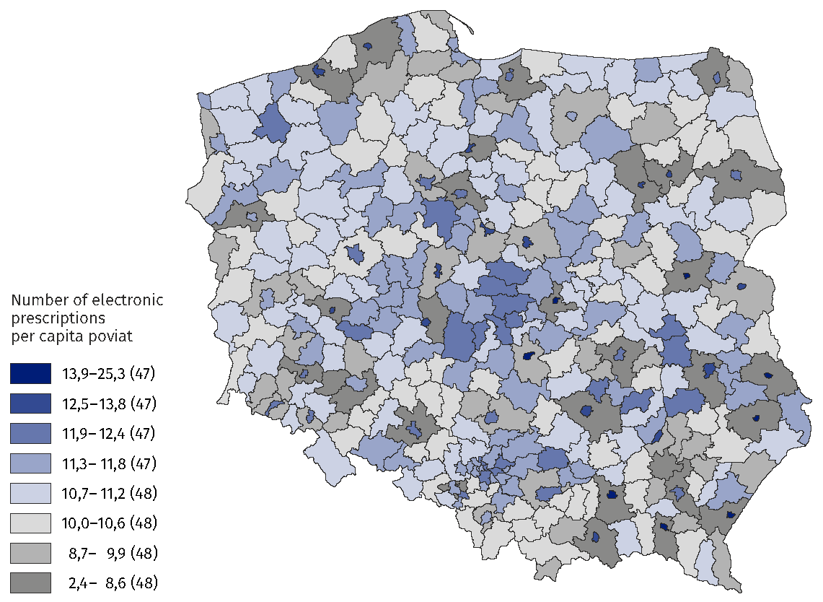
Map 1. Number of electronic prescriptions per capita poviat in 2022

According to data from the Ministry of Health, in 2022 the value of sales of all prescription medicines amounted to 21.9 billion PLN (by PLN 2.2 billion more than in 2021). On the other hand, the value of the refund is PLN 8.6 billion (PLN 0.5 billion more than in 2021), and patients spent PLN 13.3 billion on prescription medicines (PLN 1.7 billion more than in 2021). In 2022, the refund represented 39.3% of the value of medicines sold on prescription
(2021 – 41.2%).

Table 1. Sale of prescription medicines in Poland
Specification | 2021 | 2022
Specification | in billions of PLN
Value of sales | 19.7 | 21.9
Value of refunds | 8.1 | 8.6
Value of patients’ fees for medicines | 11.6 | 13.3
Source: E-Health Centre.
In 2022, the value of prescription medicines sold per capita of Poland amounted to PLN 579 the value of the patient’s surcharge – PLN 352 and the refund amounted to 39.3% of the value of medicines sold
on prescription
In 2022, the value of prescription medicines sold per capita in Poland amounted to PLN 579 (by PLN 61 more than in 2021), of which the surcharge by the patient amounted to PLN 352 (by PLN 48 more than in 2021) and refund by the National Health Fund amounted to PLN 227 (by PLN 13 more than in 2021).

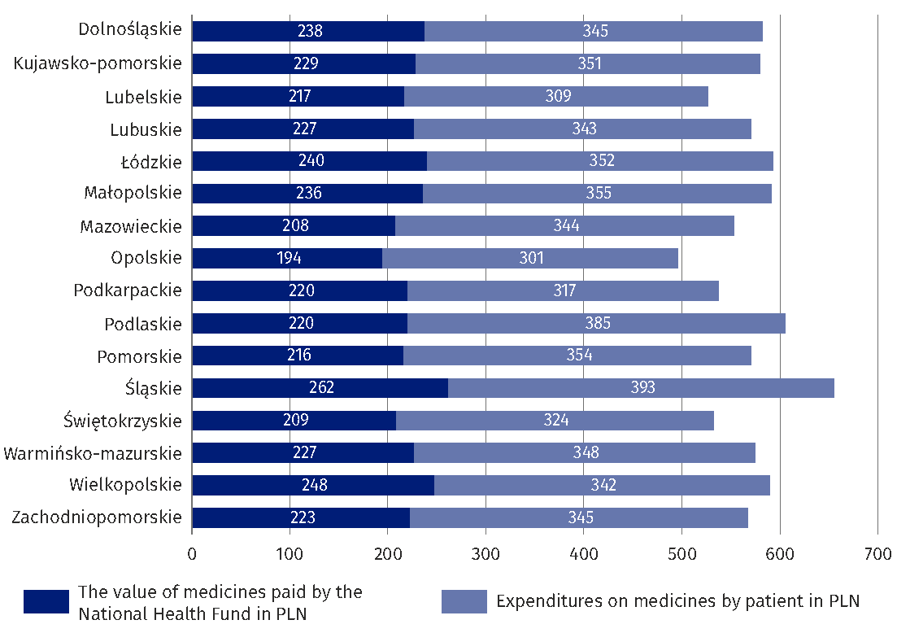
Chart 2. Prescription medicines sales value per capita voivodship in 2022
Source: E-Health Centre.

The highest value of medicines sold per capita is characterised by the Łódzkie Voivodship (PLN 655) and the smallest one – Podkarpackie Voivodship (PLN 495). On average, a resident of the Łódzkie Voivodship paid the most to prescription medicines (PLN 393) and the least — resident of Podkarpackie Voivodship (PLN 301). The highest value of refunds per capita
is characterised by the Łódzkie Voivodship (PLN 262) and the smallest Podkarpackie Voivodship (PLN 194).

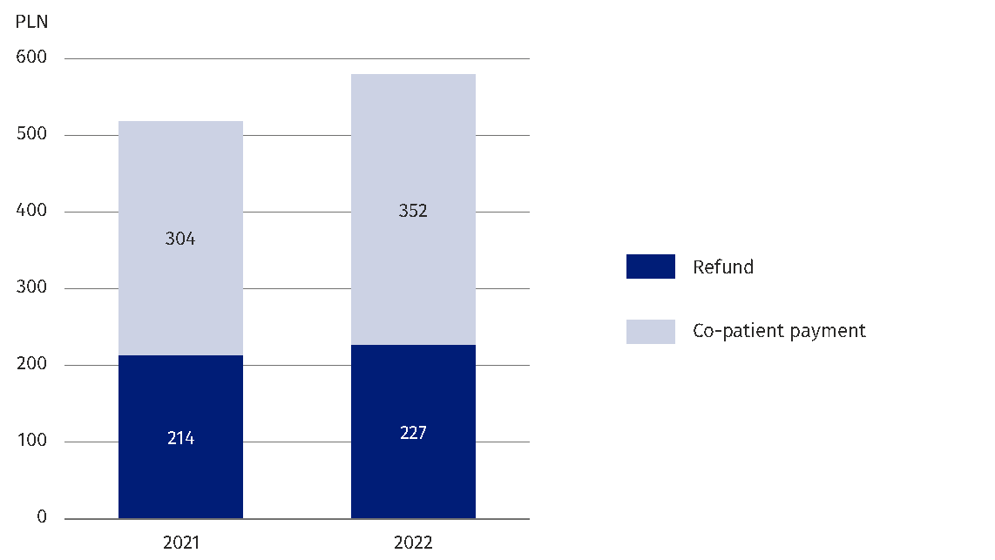
Chart 3. Value of reimbursement and co-payments for prescription medicines per capita
Poland

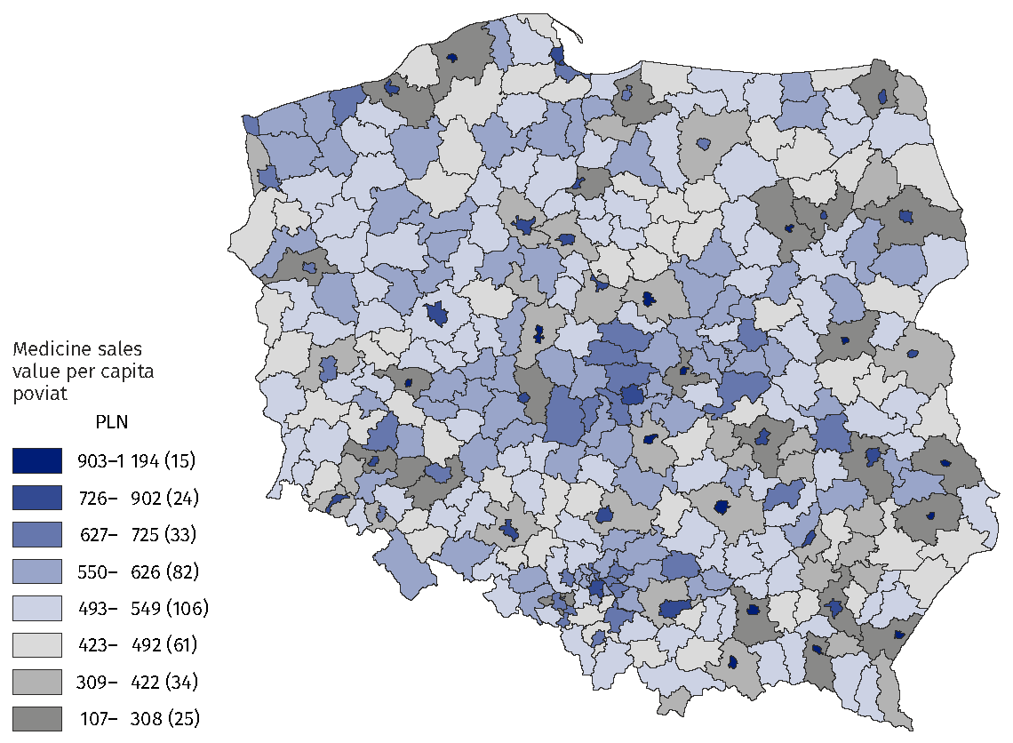
Map 2. Medicine sales value per capita poviat in 2022

The highest value of sales of prescription medicines per capita was observed in cities
with the status of poviat: Zamość (PLN 1 194), Tarnów (PLN 1 163), Krosno (PLN 1 145), Chełm
(PLN 1 074) and Skierniewice (PLN 1 010), and the smallest in poviats: przemyski (PLN 107), łomżyński (PLN 115), siedlecki (PLN 125), suwalski (PLN 132) and skierniewicki (PLN 137). However, it should be remembered that patients buy medicines not only in their poviats (especially in the case of poviats surrounding the city with the status of poviat).
Poviats with the lowest rate of reimbursement in the value of medicines sold are poviats: piaseczyński (33.4%), grójecki (33.4%), wielicki (34.2%), wysokomazowiecki (34.6%) and grodziski mazowiecki (34.6%). The poviats with the highest rate of reimbursement in the value of medicines sold are poviats: sępoleński (47.3%), złotowski (46.7%), chojnicki (45.4%), wałecki (45.3%) and wąbrzeski (45.1%).
The largest share in 2022 cardiovascular-related medicines (20.9%), gastrointestinal tract and metabolism (17.5%) and central nervous system (14.9%) were sold in 2022
Cardiovascular-related medicines (20.9%), gastrointestinal tract and metabolism (17.5%) and central nervous system (14.9%) accounted for the largest share in the value of medicines sold in 2022.

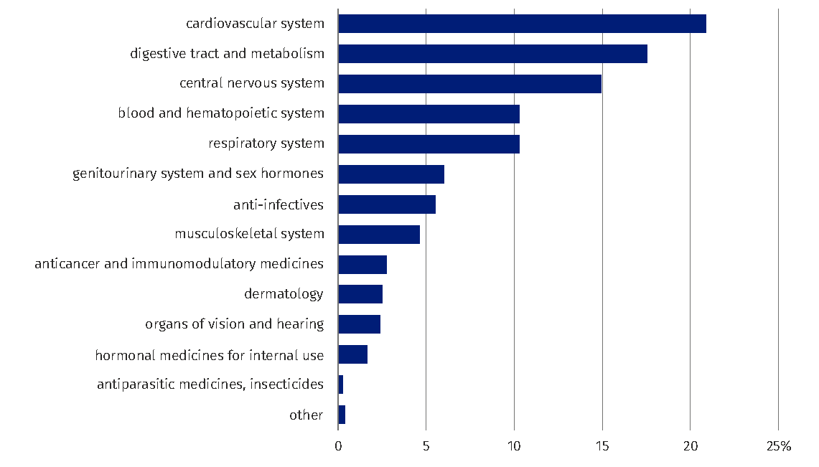
Chart 4. Share of prescription medicines sales by anatomical groups (ATC)

For the implementation of prescriptions for cardiovascular-related medicines, the least, per capita of the poviat, in 2022 was issued in the following poviats: przemyski (PLN 29), łomżyński (PLN 31), siedlecki (PLN 35), skierniewicki (PLN 36) and suwalski (PLN 39) and most — in cities with the status of poviat: Tarnów (PLN 223), Zamość (PLN 222), Chełm (PLN 218), Krosno (PLN 211) and Przemyśl (PLN 210).

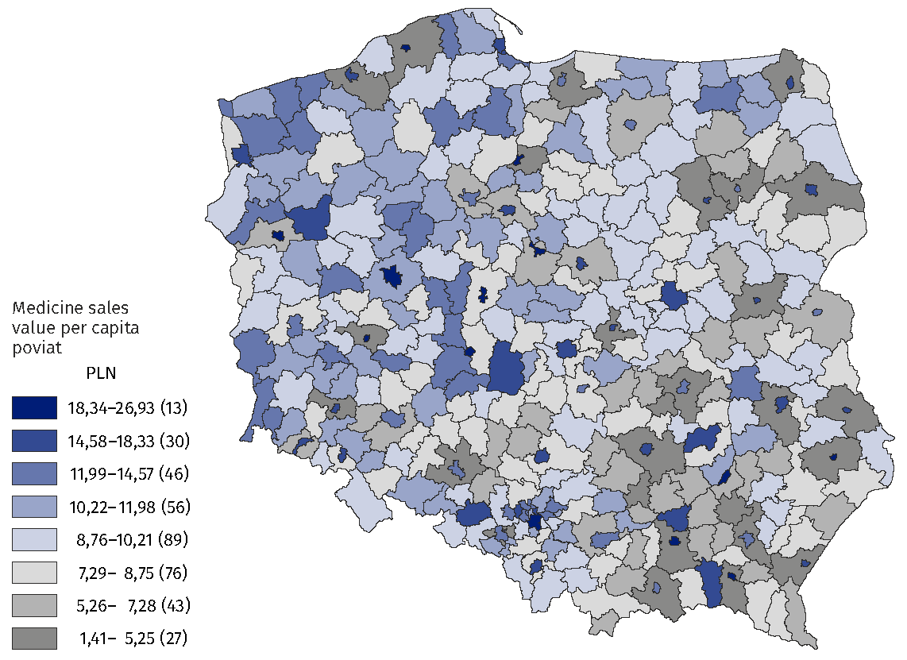
Map 3. Sales value of prescription medicines related to the cardiovascular system in 2022

The signal information was based on two data sources:
- reports from pharmacies and pharmacy outlets – ZD-5 submitted to the Statistics Poland in accordance with the Statistical Survey Program of Official Statistics
for 2022;
- data from the Medical Information System of the Ministry of Health regarding
the implementation of prescriptions (including, among others, the number
of prescriptions, the number of packages, the value of sales, reimbursement
and patient subsidies for medicines according to the ATC classification).

Prepared by:  Social Surveys and Labour Market Department  Director Piotr Łysoń, Ph.D.  Phone: (+48 22) 449 40 27 | Issued by:  The Spokesperson for the President  of Statistics Poland  Karolina Banaszek  Phone: (+48) 695 255 011
Press Office  Phone: (+48 22) 608 38 04  e-mail: obslugaprasowa@stat.gov.pl |   stat.gov.pl/en/

@StatPoland

@GlownyUrzadStatystyczny

gus_stat

glownyurzadstatystycznygus

glownyurzadstatystyczny
Related information
Health and health care in 2021
Methodological report. Health and health care statistics − Statistics Poland’s reports
Terms used in official statistics
Pharmacy
Pharmaceutical outlet

According to the address of the pharmacy or pharmacy where the prescription was completed.

