Social integration centres, social integration clubs, vocational activity establishments, occupational therapy workshops in 2022.
28 November 2023

In 2022, 1263 social and professional reintegration units: social integration centres (CIS), social integration clubs (KIS), vocational activity establishments (ZAZ), occupational therapy workshops (WTZ) were active, i.e. 2 less than in 2021. Compared to 2015, the number of these units increased by 74.
3.7%
increase year-on-year in the recipients number of services provided by CIS, ZAZ and WTZ
During 2022, almost 48.0 thousand people at risk of social exclusion benefited from social and professional reintegration services provided by CIS, ZAZ and WTZ, i.e. 3.7% more than in the previous year. In 2015-2021 there was an increase in this area by 23.0%.

Active social and professional reintegration units
There were 1263 social and professional reintegration units active in total in 2022. This number has decreased by 2 units compared to 2021. As was the case in previous years, in 2022 these were mainly facilities aimed at activating people with disabilities – 729 occupational therapy workshops (WTZ) and 135 vocational activity establishments (ZAZ). Among units providing services also for people from other groups at risk of social exclusion, 208 social integration centres (CIS) and 191 social integration clubs (KIS) were active.
Graph 1. Number of active social and professional reintegration units in 2015–2022
Compared to 2015, the number of socio-professional reintegration units increased by 6.2%.

Between 2015 and 2022, the total number of CIS, ZAZ, WTZ and KIS establishments increased by 74 units, i.e. by 6.2%. During this period, the number of individual active reintegration units changed as follows: social integration centers increased by 48.6%, vocational activity establishments increased by 39.2%, occupational therapy workshops increased by 4.3%, and social integration clubs decreased by 24.5%. The number of CIS, ZAZ and WTZ was increasing throughout the analyzed period year-on-year, while the number of KIS fluctuated, reaching the highest value in 2019 (260 units) and the lowest in 2022 (191 units).
As in previous years, social and professional reintegration units were most often organised by non-profit sector entities, i.e. associations, foundations and faith-based charities – they created 68.3% of the total number of CIS, KIS, ZAZ and WTZ establishments.
Most CIS, KIS, ZAZ and WTZ establishments were located in the following voivodships: Wielkopolskie (11.6% of total number establishments ), Śląskie (10.5%), Małopolskie (9.8%) and Mazowieckie (9.7%). The number of reintegration units in the Wielkopolskie voivodeship has remained at a similar level for 3 years, as well as the Wielkopolskie voivodship had the largest number of units in the country.
When relating the number of social and professional reintegration units to the population, there were 3.3 such units per 100 thousand inhabitants in 2022. As was the case in previous year, this indicator had the highest value in the Warmińsko-Mazurskie voivodship – 6.0 units per 100 thousand inhabitants. However, the Mazowieckie voivodship, similarly to previous year, achieved the lowest value of this indicator – 2.2 establishments per 100 thousand inhabitants.
Similarly to 2021, the largest number of units providing social and professional integration services in the country were the Olsztyński (40) and Chełmsko-Zamojski (36) subregions, followed by the Kielecki subregion (35). In comparison to 2021, the number of institutions has not changed in 38 out of 73 subregions, increased in 15 subregions (usually by one unit, whereas in the Częstochowski subregion were formed 4 units) and decreased in 20 subregions (mostly by one unit).

Map 1. Social and professional reintegration units by subregion in 2022.
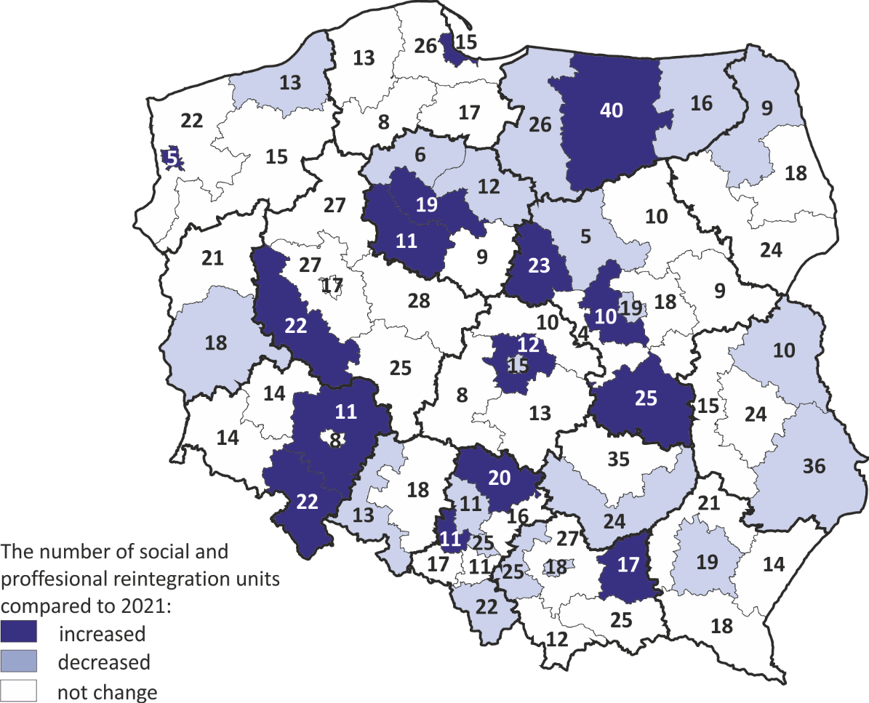
Between 2021 and 2022, the number of recipients of social and professional integration services provided by CIS, WTZ and ZAZ increased by 2.2 thousand people.
There were 48.0 thousand beneficiaries of integration services provided in 2022 by CIS, ZAZ and WTZ. Since 2021, the number of customers for the services provided by these establishments has increased by 3.7%, i.e. by 1.7 thousand people. Taking into account the type of unit where social and professional integration was carried out, the largest group of beneficiaries were the participants of the WTZ (59.7%), followed by the participants of CIS classes (26.6%), and the smallest group were persons with severe or moderate disability status employed by the ZAZ (13.7%).

Social integration centres
There were 191 social integration centres active in Poland in 2022. Compared to 2021, this number increased by 7, whereas the largest increase in the number of centres were in the Śląskie (from 30 to 34). In 4 voivodships their number increased by 1 (Dolnośląskie, Mazowieckie, Świętokrzyskie, Wielkopolskie). One unit was closed - in the Podlaskie. In 2022, more than two thirds of social integration centres were run by non-profit organizations (139 units). Local government units, mainly gminas, operated 59 social integration centres, and there were 9 active CIS establishments operating within social cooperatives. One social integration centre was run by a company.
Similarly to previous year, most CIS establishments had their seats in the following voivodships: Śląskie (16.3%), Wielkopolskie (13.0%) and Pomorskie (9.6%). The highest saturation with CIS facilities in relation to the number of inhabitants living in a given voivodship was - similarly to 2021 - recorded in the Lubuskie voivodship, where per 100,000 inhabitants there were 1.7 units of this kind, while the national average was 0.6 units.

Map 2. Social integration centres by voivodship and region in 2022.
In 2022, there were 208 active CIS that provided social and professional integration services to 12.7 thousand participants.

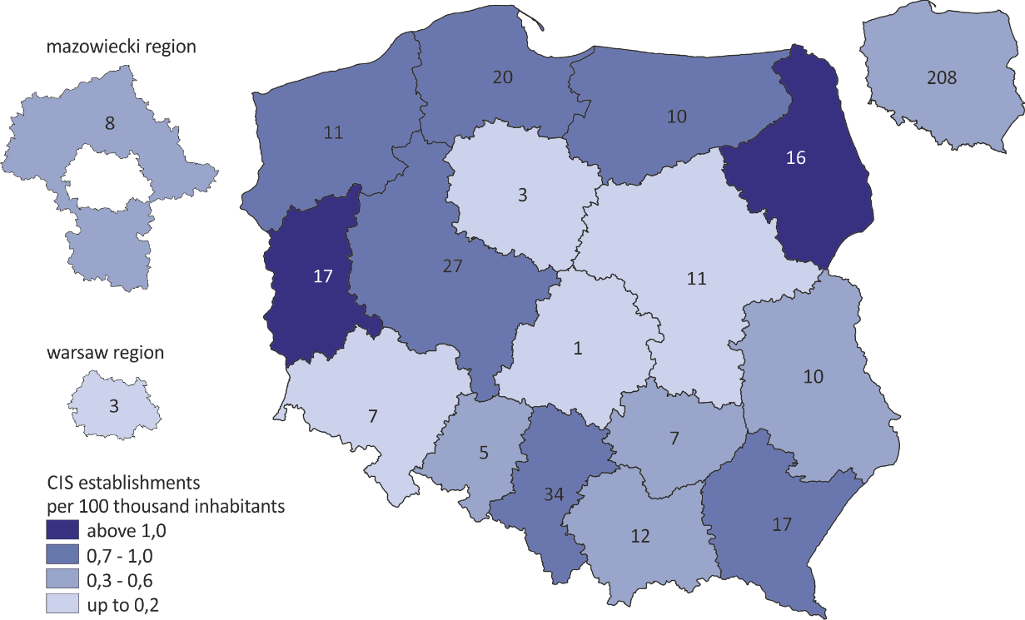

In 2022, 12.8 thousand people from groups at risk of social exclusion participated in CIS classes. Compared to 2021, the number of participants increased by 9.7% (in 2021 it was 11.6 thousand people). In 2022, on average, there were 61 participants per CIS, whereas in 2021 there were 58.
According to the CIS statements, the most frequent participants in classes related to social and professional integration were the long-term unemployed persons – they constituted 32.1% of all recipients of services provided by CIS. The share of this group has decreased by 5.4 p.p. compared to 2021. CIS support was also provided to persons dependent on alcohol or psychoactive substances (13.9%) and persons with disabilities (10.4%). On the other hand, persons for whom the main reason for exclusion was homelessness (5.1%) or mental illness (2.3%) had a small share among CIS beneficiaries.
The total cost of running social integration centres in 2022 amounted to over 272 million PLN. The average cost of activity per 1 unit were 1.309 thousand PLN.

Social integration clubs
There were 191 active KIS establishments in 2022. More than three fourths of them were operated by local government units.
In 2022, there were 191 social integration clubs operating in Poland. The number of active KIS establishments decreased by 11 units (5.4%) compared to 2021. In 2022, there were 0.5 units of this kind per 100 thousand inhabitants.
Social integration clubs, as the only type among the social and professional reintegration units, were predominantly (75.9%) operated by local government units or their subordinate organisational units, such as e.g. social assistance centres. Other social integration clubs were operated by non-profit organizations (23.6%) and social cooperatives (0.5%).
The largest number of KIS establishments were located in the following voivodships: Małopolskie (16.2%), Warmińsko-Mazurskie (14.7%) and Śląskie (13.6%). Compared to 2021, there were changes in 12 out of 16 voivodeships in the number of KIS. Between 2021 and 2022, in 9 voivodships the number of KIS decreased -in the Śląskie Voivodship- by 3 units, in the Lubelskie, Małopolskie and Świętokrzyskie - by 2 units in each voivodship. The number of KIS increased only in 3 voivodships - Dolnośląskie, Mazowieckie and Pomorskie - by 1 units in each voivodship.
In 2022, 9.1 thous. people started classes n KIS and 6.6 thous. people completed them.
Map 3. Social integration clubs by voivodship and region in 2022.
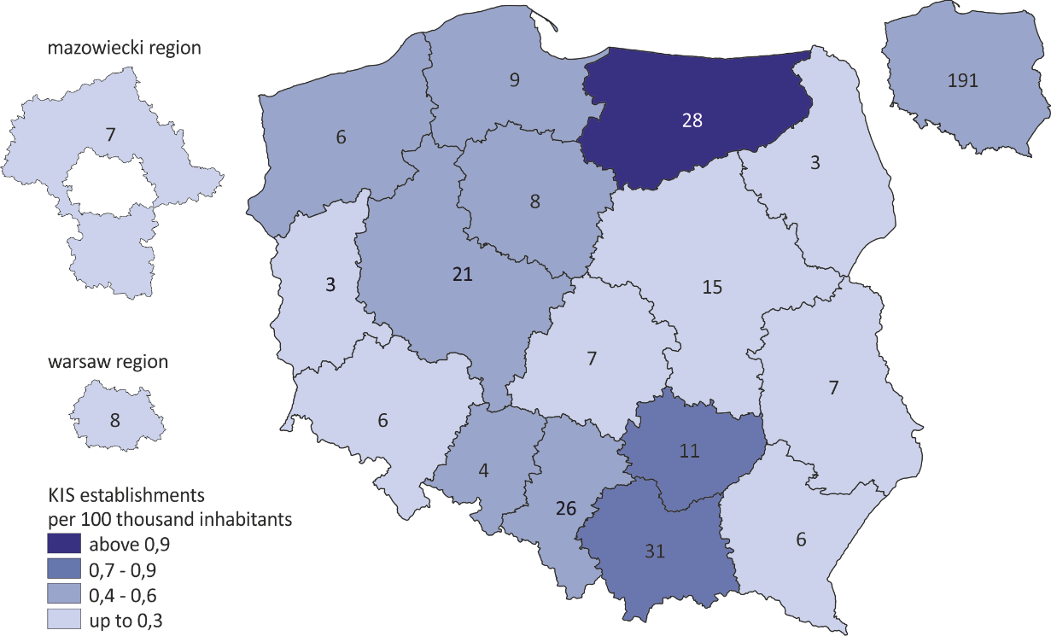
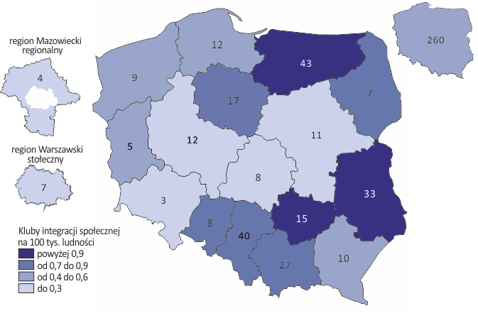
Vocational activity establishments
At the end of 2022, there were 135 vocational activity establishments in Poland. There were 0.4 units per 100 thousand inhabitants. The number of ZAZ establishments increased by 2 units compared to 2021.
Map 4. Vocational activity establishments by voivodship and region in 2022.
In 2022, there were 135 active ZAZ establishments, which employed a total of 6.6 thousand people with severe or moderate degree of disability.
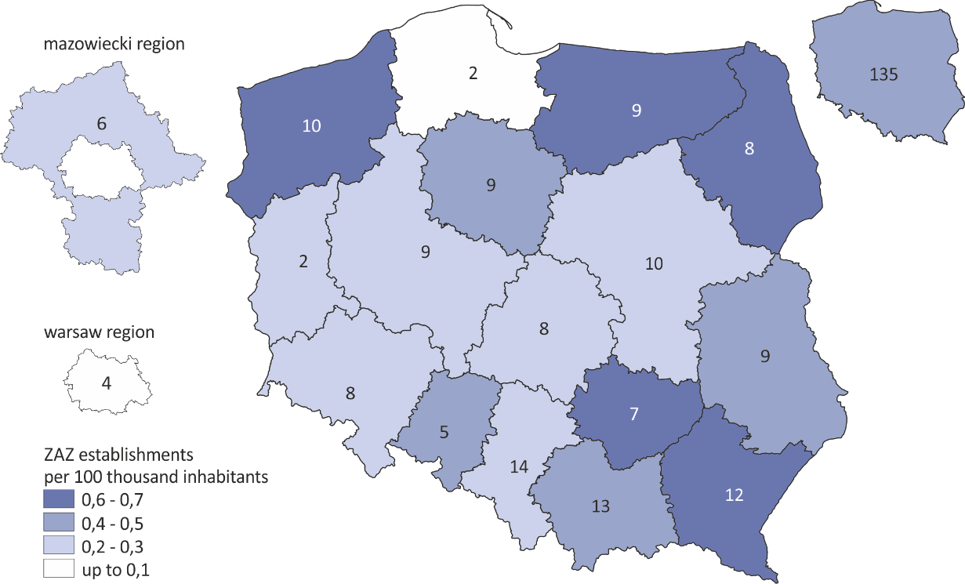

Most of ZAZ were run by non-profit organizations (63.7%). Another part was operated by local government units or their subordinate organisational units, such as e.g. social assistance centres (33.3%). The remaining 3% of ZAZ were created by social cooperatives or companies.
The largest number of ZAZ establishments were located in Śląskie (10.4%), Małopolskie (9.6%) and Podkarpackie (8.9%), followed by voivodship. The number of establishments increased in Podlaskie voivodship – by 2 entities and in Malopolskie – by 1 unit. One of the units existing in 2021 lost its ZAZ status.
At the end of 2022, more than 8.7 thousand people were employed in all the vocational activity establishments. Compared to 2021, total employment in ZAZ establishments increased by 5.4%.
The reintegration activities of ZAZ are legally directed to people with severe or moderate degree of disability, who have been diagnosed with autism, intellectual disability or mental illness. At the end of 2021, the number of reintegrated employees at ZAZ establishments was 6.6 thousand. The number of people with a severe or moderate degree of disability in the total number of employees amounted to 76.2%. In 2022, one ZAZ employed, on average, 49 workers with disabilities for reintegration purposes.

Occupational therapy workshops
At the end of 2022, there were 729 active occupational therapy workshops - exactly the same as in the previous year. There were 1.9 units of this kind per 100 thousand inhabitants. Compared to other types of social and professional reintegration units, WTZ establishments were most often operated by non-profit organizations (81.2%). Another 16.9% of the WTZ establishments operated within local government units and institutions subordinate to them, and 1.9% were run by other entities.
The total cost of occupational therapy workshops in 2022 amounted to PLN 836 million PLN. The vast majority of expenses were covered by funds from PFRON (88.7%). The average cost of maintaining WTZ was PLN 1.147 thousand PLN annually.

Map 5. Occupational therapy workshops by voivodship and region in 2022.
There were 729 WTZ establishments active in 2022, and their services were used by 28.7 thousand people with a disability.

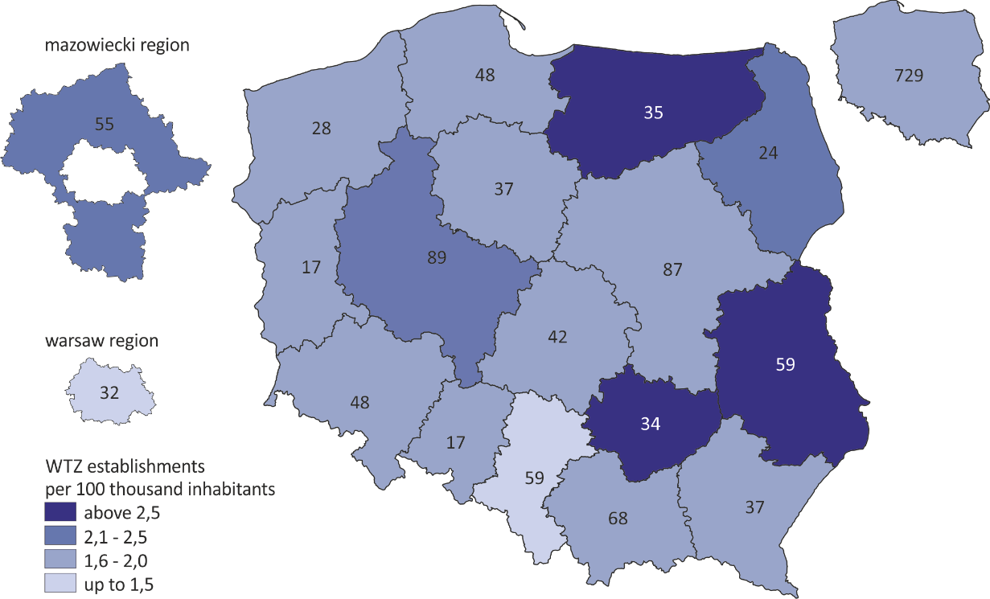

In 2022, the largest number of occupational therapy workshops were located in the Wielkopolskie (12.2%), Mazowieckie (11.9%) and Malopolskie (9.3%) voivodships. Compared to 2021, no changes were recorded within individual voivodeships. During this period, the number of WTZ establishments decreased in two voivodships - by 2 units in Lubuskie and by 1 unit in Podlaskie voivodship. In three voivodships the number of WTZ increased – Kujawsko-Pomorskie, Łódzkie and Małopolskie – by 1 unit in each voivodship.
In 2022, 28.7 thousand people with certified disabilities benefited from classes in occupational therapy workshops, i.e. 0.3 thousand more than a year before. On average, there were 39 persons participating in workshops in one WTZ (similar to the previous year).
When comparing the average number of participants, the highest rate was recorded in the following voivodships: Śląskie (50 participants ), Podkarpackie (49 participants) and Świętokrzyskie (48 participants). The smallest values were recorded in Pomorskie (32 participants) and Opolskie voivodship (31 participants).
Methodological information
Presented data includes only active WTZ and ZAZ as of December 31, 2022, and CIS and KIS that submitted the activity report for 2022 and showed the participants of the classes.
The release was prepared based on data from administrative sources obtained under the Public Statistics Statistical Research Programme for 2022:

- from information systems of voivodship offices concerning CIS, KIS and ZAZ establishments (as regards registers and establishment records);
- from information systems of the Ministry of Family and Social Policy (MRiPS) (as regards CIS and KIS operations);
- from information systems of the State Fund for the Rehabilitation of Disabled People (PFRON) (as regards the number of WTZ establishments and their operations).
Data from different sources were collated and verified by public statistics staff, and inconsistencies and shortcomings identified were clarified and then corrected.

In case of quoting Statistics Poland data, please provide information: “Source of data: Statistics Poland”, and in case of publishing calculations made on data published by Statistics Poland, please include the following disclaimer: “Own study based on figures from Statistics Poland”.

Prepared by:  Social Surveys and Labour Market Department  Director: Piotr Łysoń, Ph.D.  Tel: +48 22 449 40 27  Statistical Office in Kraków  Director Agnieszka Szlubowska  Tel: +48 12 420 40 50 | Issued by:  The Spokesperson for the President  of Statistics Poland  Karolina Banaszek  Tel: 695 255 011  e-mail: rzecznik@stat.gov.pl
Press Office  Tel: +48 22 608 38 04  e-mail: obslugaprasowa@stat.gov.pl |  |  | www.stat.gov.pl
 |  |  | @GUS_STAT
 |  |  | @GlownyUrzadStatystyczny
 | gus_stat
 | glownyurzadstatystycznygus
 | glownyurzadstatystyczny
Related publications
Non-profit sector in 2020. Associations, foundations, faith-based charities, business and professional associations
Cooperation of non-profit organizations with other entities in 2021

The number and structure of CIS participants calculated only for those CIS establishments that have submitted a report on their operations.
Act of 27 August 1997 on Professional and Social Rehabilitation and Employment of Disabled Persons (consolidated text: Journal of Laws 2020, item 426).

