ICT usage by public administration units in 2022
In 2022, all marshal offices had a website adapted to mobile devices. Almost 40% of public administration units prepared a website for foreigners.
95.5%
of public administration units had a website adapted to mobile devices

Remote access
In 2022, more than two-thirds of public administration units conducted an information
system security audit
In 2022, remote access to the resources of the unit, dedicated to public administration
employees, was provided by 95.9% of public administration units, including all government administration units. Among local self-government administration units, this type of access was declared by all marshal offices.
Chart 1. Public administration units with remote access to the unit's resources in 2022
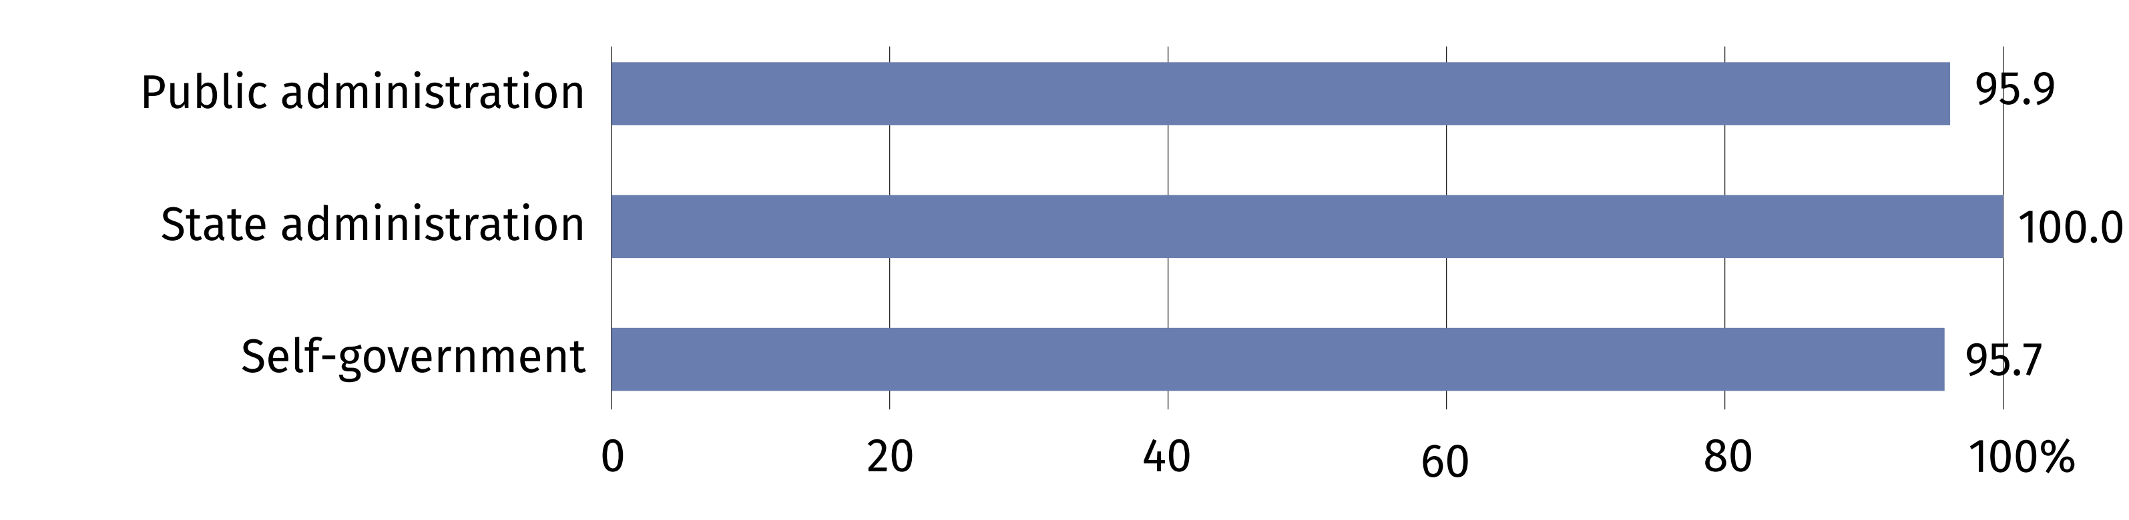

Training for employees in the field of information and communication technologies
The dynamic development of information and communication technologies makes it necessary to improve ICT skills of persons employed in public administration units. In 2022, 60.2% of offices provided appropriate training for employees for this purpose.

Supporting citizens' digital skills
The need to improve the quality of functioning of public administration in the field of
e-government services requires the implementation of new solutions dedicated to both
employees and citizens. In 2022, 43.2% of offices declared support for digital skills among
citizens, of which 95.6% was related to providing advice/instructions on the use of e-government services.

Use of the Electronic Document Management System (EDMS)
The large selection of functionalities, the ability to store, process and share documents
in a digital version – these are the main advantages of the Electronic Document Management System. In 2022, 85.0% of public administration units declared using EDMS, with 36.0% indicating this system as the primary way of documentation of handling and settling official matters.

Chart 2. Public administration units using the Electronic Document Management System (EDMS) in 2022
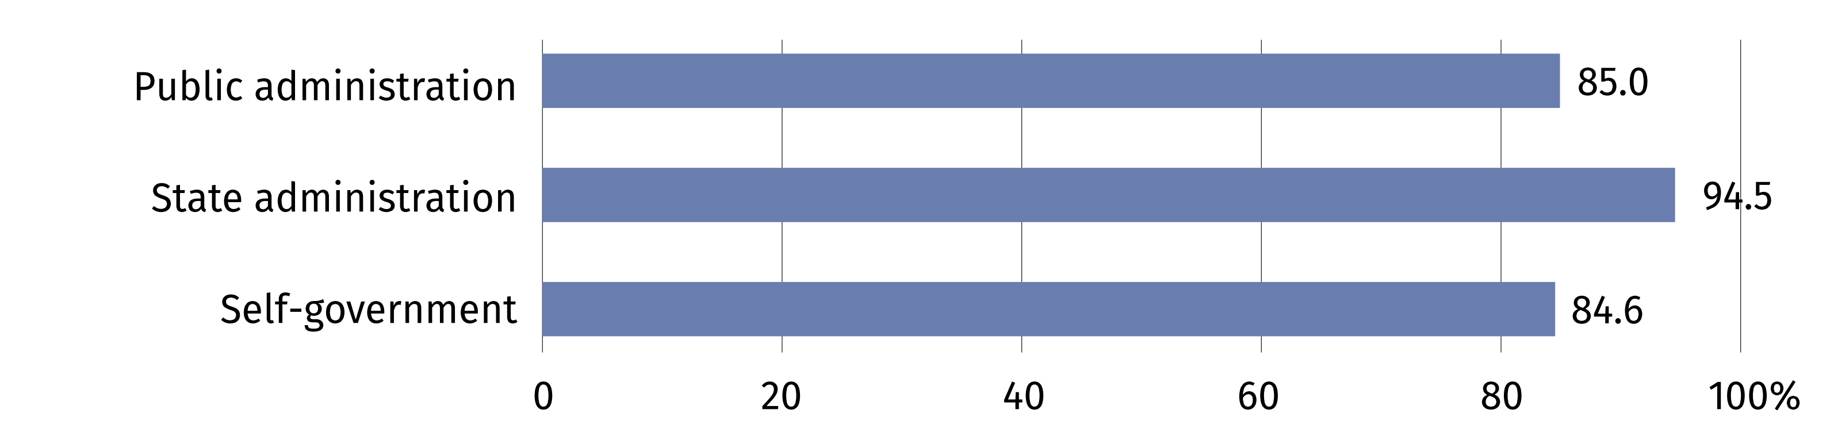

Cloud solutions
In 2022, almost a half of public administration units declared purchasing cloud computing services. Website hosting and e-mail services (87.3% and 80.2%, respectively) were the most frequently mentioned.

E-services
In 2022, 86.7% of public administration units used numerical maps
In the era of the uptake of digital technologies public administration units make efforts
to ensure that as many official matters as possible can be handled via the Internet. In 2022, electronic services were offered to citizens by 99.8% of public administration units, with 84.1% of them providing access to spatial data, most often concerning land and building
register and orthophotomaps (74.9% and 63.1% of units providing spatial data, respectively). 27.1% of offices enabled participation in online voting or social consultations. All local self-government administration units provided services via the Internet.
Chart 3. Public administration units providing electronic services to citizens in 2022
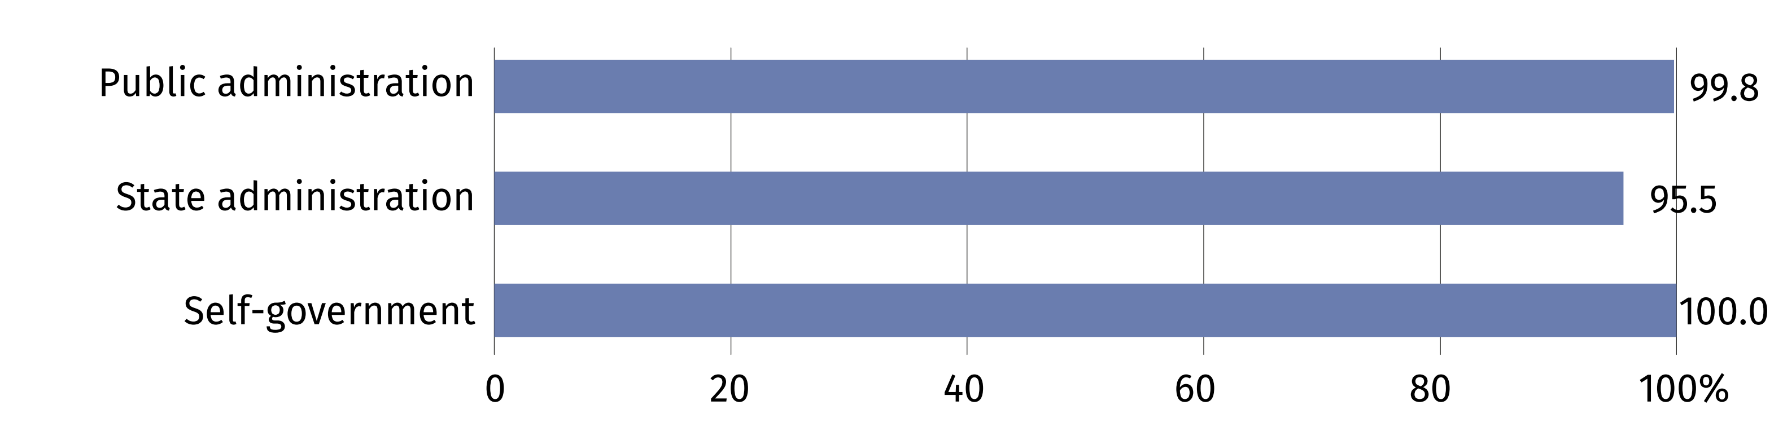

Providing access to mobile applications offering e-services
Almost every third public administration unit provided a downloadable application offering e-services
Downloadable applications for mobile devices serve the society by enabling handling official matters from anywhere at any time. In 2022, 31.1% of public administration units provided access to applications offering e-services.
Chart 4. Public administration units providing access to applications for mobile devices
in 2022
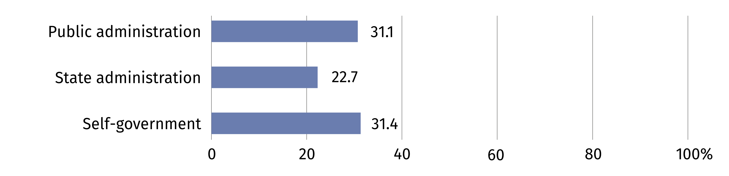
When quoting data from Statistics Poland, please include the following information: "Source of data from Statistics Poland", and in the case of publishing calculations made on the data published by Statistics Poland, please include the following information: "Own study based on Statistics Poland data".

Prepared by:  Statistical Office in Szczecin  Director Magdalena Wegner  Phone: (+48 91) 459 77 00 | Issued by:  The Spokesperson for the President  of Statistics Poland  Karolina Banaszek  Phone: (+48) 695 255 011
Press Office  Phone: (+48 22) 608 38 04  e-mail: obslugaprasowa@stat.gov.pl |   stat.gov.pl/en/

@StatPoland

@GlownyUrzadStatystyczny

gus_stat

glownyurzadstatystycznygus

glownyurzadstatystyczny
Related information
Information society in Poland in 2022
Terms used in official statistics
ICT specialist
Mobile device
Web Content Accessibility Guidelines (WCAG)
Geospatial data

