Information society in Poland 2023

INFORMATION AND COMMUNICATION TECHNOLOGIES USAGE IN HOUSEHOLDS
AND BY INDIVIDUALS
In 2023, the percentage
of individuals aged 16–74 using
e-government services in the last 12 months amounted to 58.5%, that is, 3.1 p.p. more than in the previous year.
3.1 p.p.
An increase in the percentage of individuals using e-government services compared to 2022

Over 93% of households
had access to the Internet
In 2023, as in the previous year, 93.3 percent of households had access to the Internet.
On an annual basis, the percentage of households with fixed-line broadband access to the Internet remained on the same level, while access via mobile broadband was indicated
by 3.1 p.p. more households.
Internet access and the type of Internet connection owned was varied by household type, domicile classes and degree of urbanisation. Households with children were more likely
to have Internet access than without them. Taking into account domicile classes, the percentage of households with Internet was greater in large cities than in smaller towns and in rural areas, and taking into account the degree of urbanisation – it was the highest
in densely populated areas.
Chart 1. Access to the Internet in households (in % of total households)
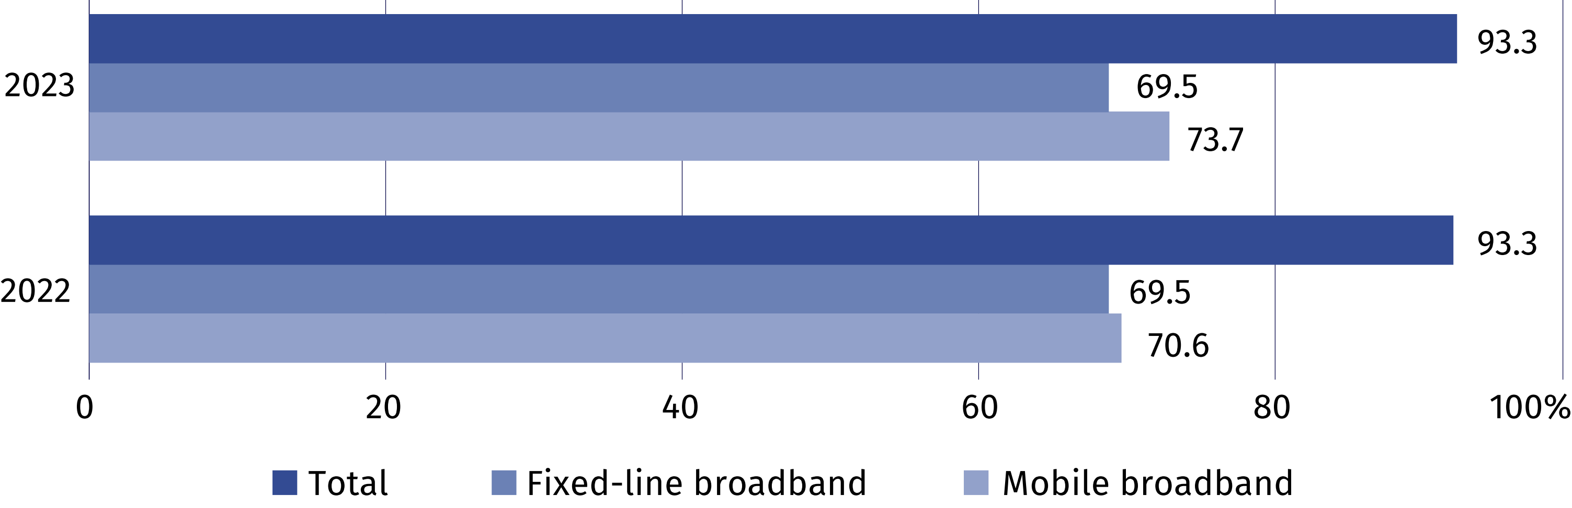
Chart 2. Households with Internet access at home (in % of total households)
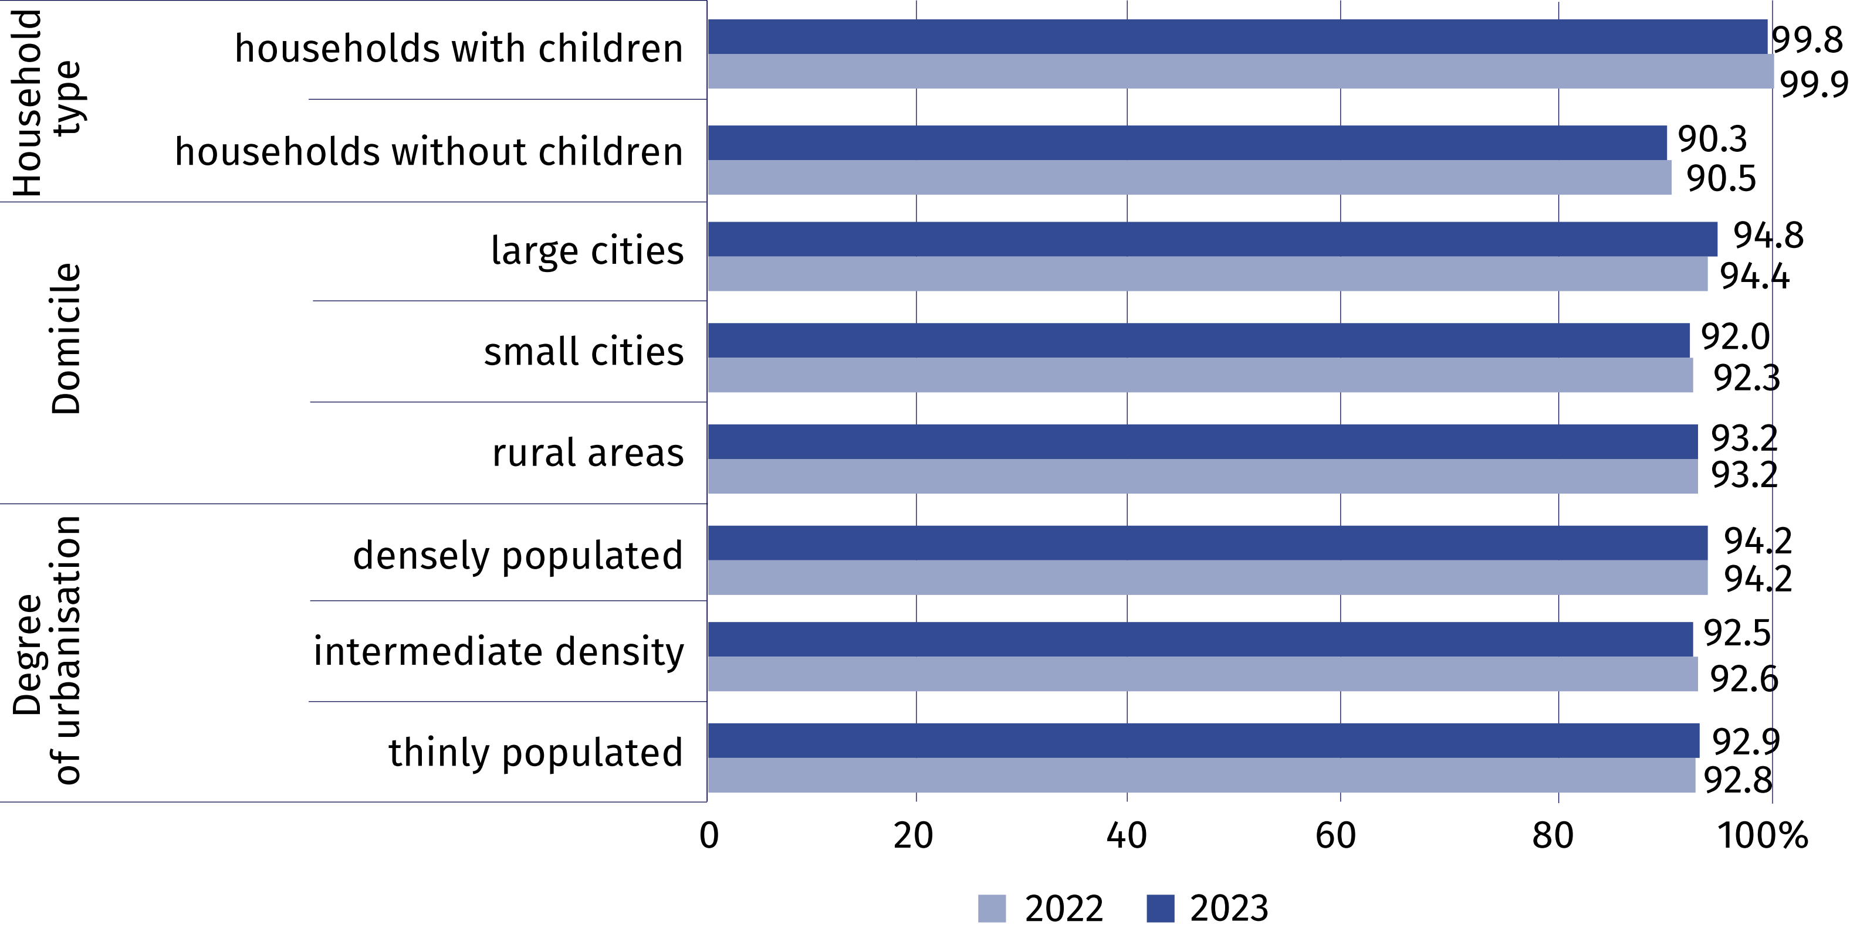
In 2023, individuals using public administration services online in the last 12 months accounted for more than 58% of the population aged 16–74. Use of e-government was indicated by 16.8 p.p. more residents of urban areas than rural areas. The most popular activities performed via the websites or applications of public administration included searching for information on websites of public authorities, sending completed tax declarations, downloading or printing official forms and gaining access to personal information stored by public authorities.
58.5% of individuals aged
16–74 contacted public administration through
a website or an app
Table 1. Individuals using e-government services in the last 12 months
Specification | Total | Urban areas | Rural areas
Specification | in % of total individuals
Individuals using e-government services  in the last 12 months | 58.5 | 65.2 | 48.4

in order to:
access personal information stored  by public authorities or public services | 29.0 | 36.2 | 18.1
access information from public databases or registers | 9.9 | 12.9 | 5.2
obtain information | 32.8 | 37.0 | 26.5
make an appointment or reservation | 18.3 | 23.3 | 10.6
receive any official communication/document by public authorities via account on a website  or app | 27.0 | 30.8 | 21.1
print or download official forms | 29.4 | 33.3 | 23.5
submit tax declaration | 32.6 | 38.5 | 23.6
request official documents or certificates | 6.6 | 8.3 | 4.0
request benefits or entitlements | 17.2 | 18.1 | 15.9

In 2023, 64.3% of individuals aged 16–74 ordered or purchased goods or services over the
Internet (compared to 64.6% in 2022). On an annual basis, the disparity between urban and rural areas increased (from 5.4 p.p. to 9.3 p.p.); the largest remained in Macroregion Mazowieckie Voivodship (20.4 p.p.), while the smallest in Macroregion South (2.1 p.p.).

Chart 3. Individuals ordering or purchasing goods or services over the Internet for private
use in the last 12 months by macroregions

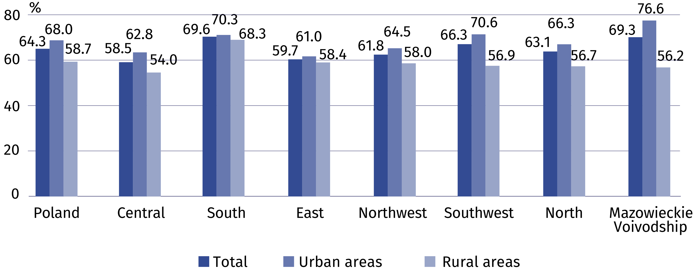

Taking into account the place of residence of individuals ordering or buying online, it can
be noted that the highest percentage of such individuals for urban areas occurred
in Macroregion Mazowieckie Voivodship and for rural areas in Macroregion South, whereas the lowest percentage of such individuals for urban areas occurred in Macroregion East and for rural areas in Macroregion Central.
Analysing data on activities performed to manage access to personal information, it can
be seen that the highest percentage of people refusing access to their geographical location occurred in the 16–24 age group. Limiting access to the profile was also the most common
in this group. The highest share of persons reading the privacy policy, refusing the use
of information for advertising purposes and checking whether the website is safe was noted among people aged 25–54.
Chart 4. Activities undertaken to manage access to personal information by age
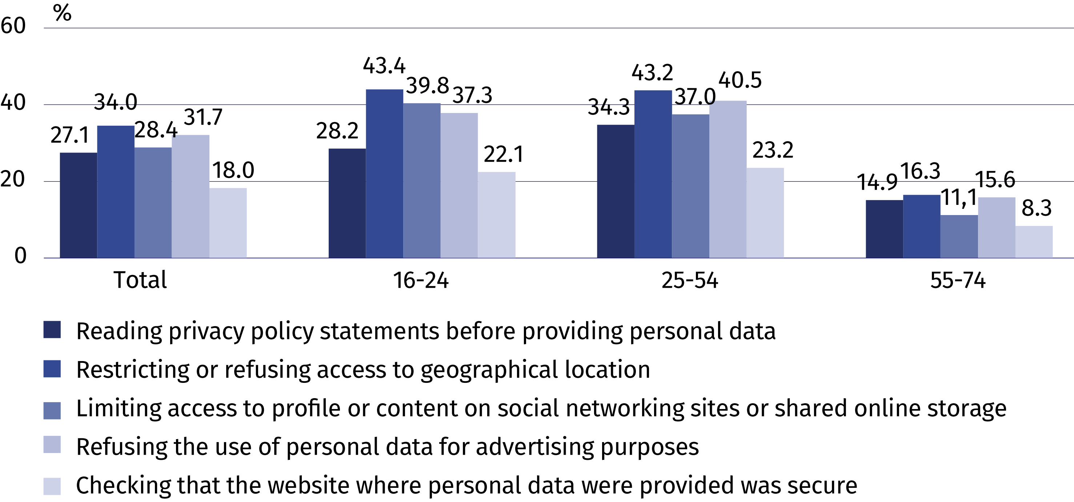

INFORMATION AND COMMUNICATION TECHNOLOGIES USAGE IN ENTERPRISES
In 2023, 47.6% of enterprises used social media and 14.6% used open data. Every fifth company paid for advertising
on the Internet. Compared
to 2021, the percentage of enterprises purchasing cloud services increased significantly (by 27.0 percentage points).
The share of entities with an Internet connection with a capacity of 500 Mbit/s increased over the year (by 2.0 p.p.).
27.0 p.p.
An increase in the percentage of enterprises purchasing cloud computing services compared to 2021.
z 2020 r.

In 2023, 3.7% of enterprises used artificial intelligence technologies
In 2023, over one third of enterprises (36.0%) used ERP software, slightly fewer used CRM programs (28.5%), while Business Intelligence solutions were used by one in ten enterprises (10.5%).
The percentage of enterprises conducting data analytics amounted to 18%. Transactions data were most frequently analysed (16.6%).
67.3% of enterprises had a website and 4.1% provided customers with applications which can be downloaded to a smartphone.
In 2023, 81.1% of enterprises employing more than 249 persons used social media
in their activities. Three quarters of them (75.5%) used social media for image creation
or product marketing, and over a half (57.7%) for employee recruitment. Social networks were used the most frequently.

Chart 5. Enterprises using social media (% of total enterprises)

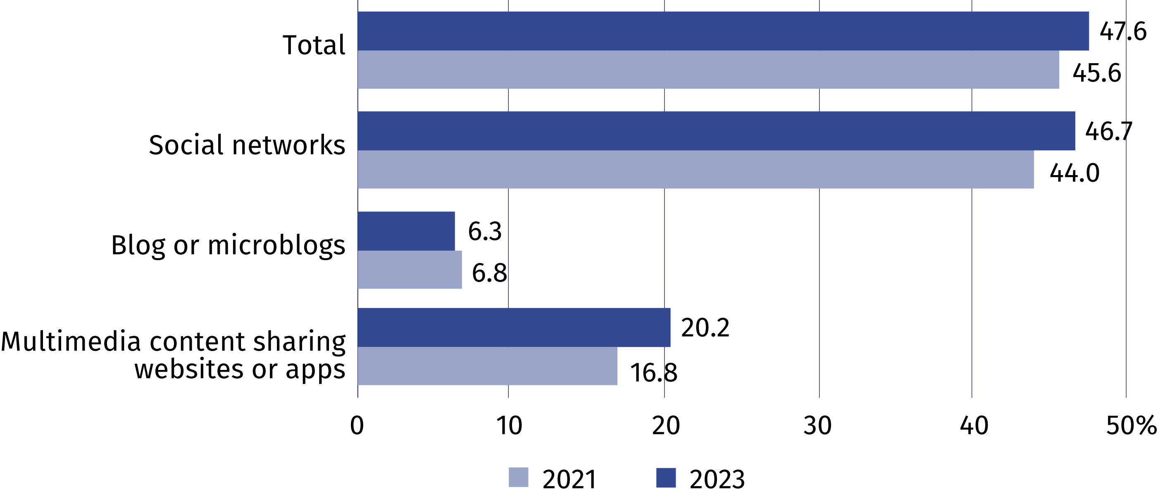
In 2022, every eighth company declared that it used open data. Large entities used this type of data most often (51.5%). Economy and finance were the most popular domain of open data.
In 2022, 72.8% of enterprises issued invoices in electronic form, including 14.8% of invoices suitable for automatic processing

Chart 6. Enterprises using open data (in % of total enterprises)

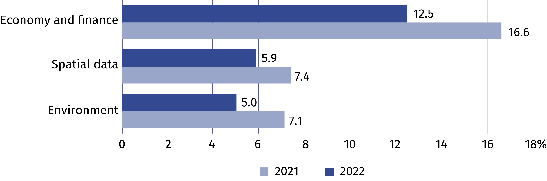
In 2023, one fifth of businesses paid for online advertising. The most frequently used advertising was based on the content of websites visited by Internet users or keywords entered by them in search engines.
Chart 7. Enterprises paying for advertising on the Internet (% of total enterprises)

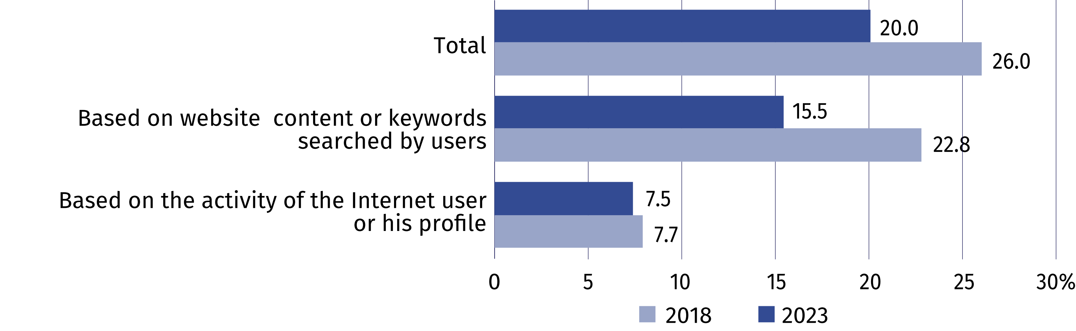
More than a half of enterprises used paid cloud computing services. The most popular cloud services were e-mail (37.8%) and office software (27.3%).
Chart 8. Enterprises purchasing cloud computing services (in % of total enterprises)

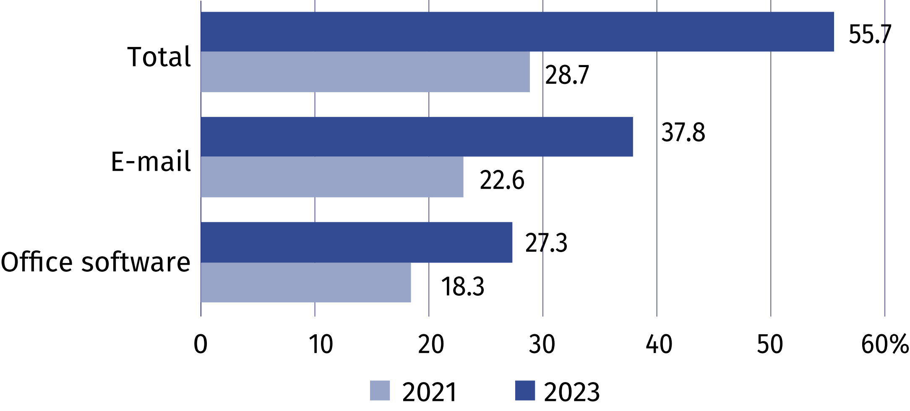
In 2022, 18.0% of enterprises conducted e-commerce; 12.5% of enterprises made sales through own website or application, 9.5% – through online e-commerce platforms, and 3.5% via EDI-type messages.
The percentage of enterprises with an Internet connection with a capcity of at least 500 Mbit/s increased annually by 2.0 p.p. and amounted to 25.3% in 2023. The largest increase occurred among large enterprises (by 5.6 p.p.).

Chart 9. Enterprises with an Internet connection with a capacity of at least 500 Mbit/s
(in % of all enterprises)

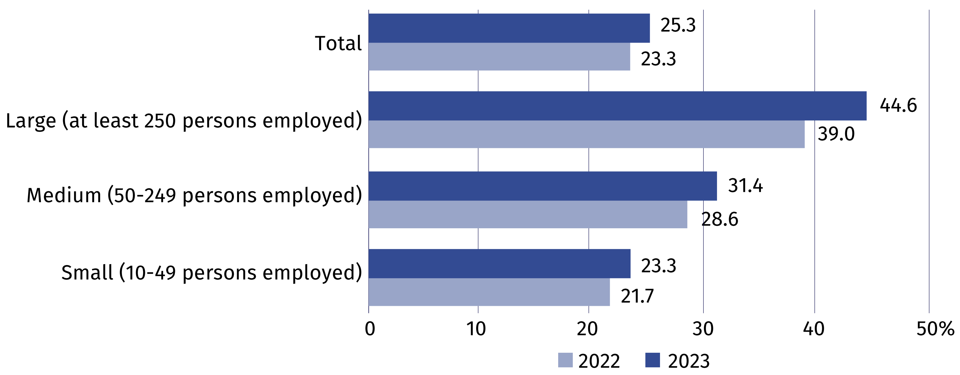

In case of quoting Statistics Poland data, please provide information: “Source of data: Statistics Poland”, and in case of publishing calculations made on data published
by Statistics Poland, please include the following disclaimer: “Own study based on figures from Statistics Poland”.
Prepared by:  Statistical Office in Szczecin  Director Magdalena Wegner  Phone: (+48 91) 459 77 00 | Issued by:  The Spokesperson for the President  of Statistics Poland  Karolina Banaszek  Phone: (+48) 695 255 011
Press Office  Phone: (+48 22) 608 38 04  e-mail: obslugaprasowa@stat.gov.pl |   stat.gov.pl/en/

@StatPoland

@GlownyUrzadStatystyczny

gus_stat

glownyurzadstatystycznygus

glownyurzadstatystyczny
Related information
Information society in Poland in 2022
Methodological report. Information society indicators. Surveys on the use of information and communication technologies
Data available in databases
Local Data Bank – Science and technology – Information society in Poland
Terms used inn official statistics
E-government
E-commerce
Internet
Broadband connection
Mobile connection to the Internet
Open data
Information society

Retrospective data according to the years in which the survey in a given domain was carried out.

