Maritime economy in Poland in 2022

Over the year, cargo traffic and the number of ship arrivals at Polish seaports increased. On the other hand the passenger traffic in seaports drecreased. The volume of international carriages of cargo by Polish operators decreased whereas the passenger carriages grew and passengers increased. As of the end of 2022, the number the maritime cargo-carrying fleet remained at the same level as in the previous year, whereas their total deadweight and gross tonnage increased as a result of re-classifications. The number of Polish marine fishing fleet increased by 1 vessel, the engine power grew
by 0.1%, however the gross tonnage remained at the same level as in the previous year.
23.1%
Increase in cargo traffic
compared to 2021

Seaports
Cargo traffic in seaports in 2022 was 23.1% higher than in the previous year
Cargo traffic in seaports in 2022 amounted to 119.0 million tonnes and was higher by 23.1%
in comparison to previous year. The largest increase of cargo traffic handled the port of: Gdańsk (by 40.3%), Świnoujście (by 16.5%), Szczecin (by 13.2%) and Gdynia (by 1.5%), while
a decrease was reported in Police (by 11.9%).
Chart 1. Cargo traffic in seaports
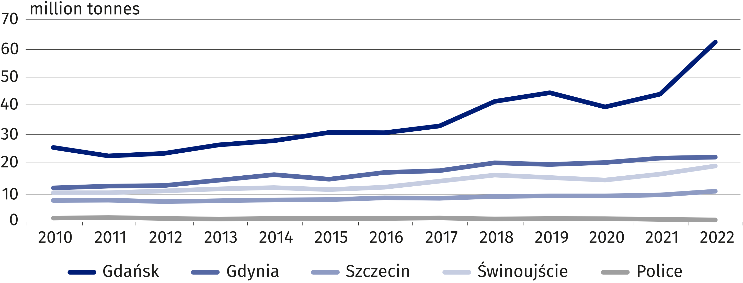

The share of seaports in the domestic cargo traffic in 2022 were as follows: Gdańsk (53.1%), Gdynia (19.4%), Świnoujście (16.8%), Szczecin (9.4%), Police (1.0%) and other ports (0.3%).
In the structure of cargo traffic in 2022, dry bulk prevailed (35.0%)

In the structure of cargo traffic in 2022, the largest share had dry bulk (35.0%, including coal and coke 18.9%), liquid bulk (32.6%, including crude oil and oil products 26.9%) and cargo
in large containers (19.1%).
In 2022, in comparison to the previous year, there was reported an increase in cargo traffic of dry bulk (by 46.2%, of which the traffic of coal and coke grew by more than 2.5 times),
liquid bulk (by 29.9%) and other general cargo (by 17.2%), while a decrease in ro-ro units
(by 3.1%) and large containers (by 1.6%).

Chart 2. Cargo traffic by seaports and cargo categories in 2022
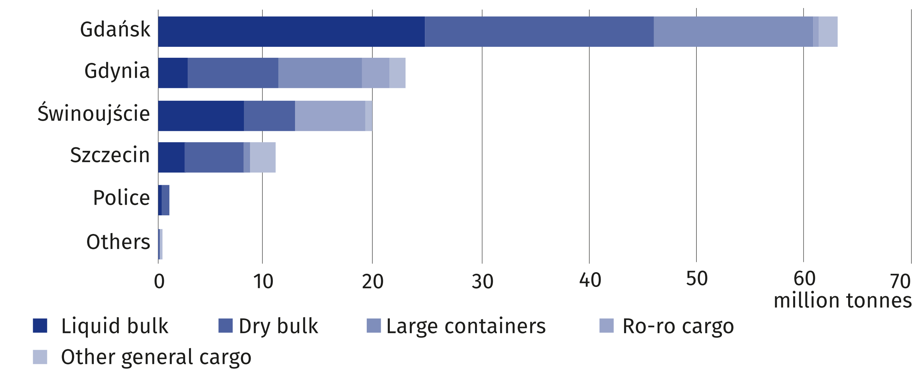

In 2022, domestic maritime traffic amounted to 5.1 million tonnes (by 23.7% more than in the previous year) and constituted 4.3% of the total cargo traffic. The international maritime traffic amounted to 113.9 million tonnes, i.e. by 23.1% more than in 2021.
In 2022, most of the international maritime traffic was made in relation to European ports (60.5%)
In 2022, cargo traffic on the routes to/from European ports accounted for 60.5% of the international maritime traffic in Polish seaports. The international maritime traffic with other continents amounted as follows: with Africa (14.5%), Asia (10.2%), North America (6.7%), Central and South America (5.2%), Australia and Oceania (2.5%).
Chart 3. International maritime traffic in seaports by country of loading and unloading of cargo
in 2022
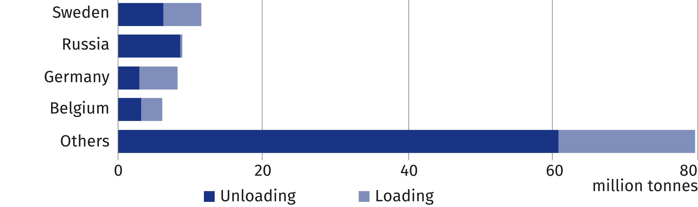
The main transit (land-to sea or sea-to-land) directions in 2022 were Germany (61.6%), Slovakia (16.2%), Czechia (8.7%) and Ukraine (7.4%)
In 2022, the volume of cargo transit amounted to 16.2 million tonnes and grew by 12.9% against the previous year. The largest weight of transit cargo handled the port of: Gdańsk (79.3%), followed by Szczecin (8.7%), Gdynia (6.2%), Świnoujście (5.8%). No transit cargo
traffic was carried out by the port of Elblag, in 2022 r. During the year, there was an increse in the weight of handled transit cargo in the following ports: Gdynia (by 46.4%), Szczecin
(by 11.8%), Gdańsk (by 11.3%), Świnoujście (by 9.0%). In comparison to the previous year,
the increase were reported both in the traffic outwards (by 27.0%) and inwards (by 48.1%).
Chart 4. Structure of transit cargo in seaports in 2022
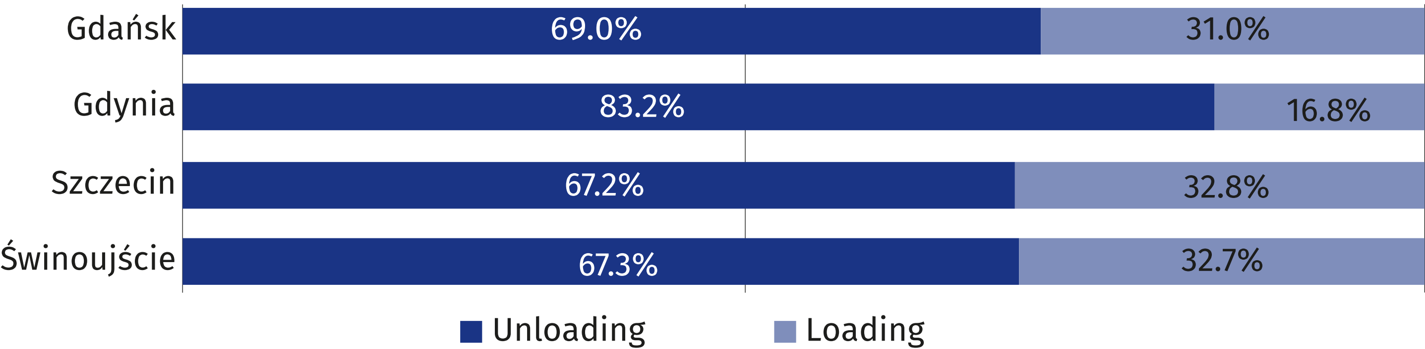

In 2022, there were 2008.0 thousand passengers started or finished their sea journey
(by 13.3% less than in 2021). The domestic passenger traffic amounted to 193.0 thousand persons (less by 65.0%) of the total passenger movements) and the international one – 1815.0 thousand persons (by 2.9% more).
Sweden was the country to which the largest number of passengers departed or arrived
at Polish seaports. The share in international passenger traffic amounted to 99.4%.
Chart 5. International passenger movements in seaports by country of embarkation
or disembarkation in 2022
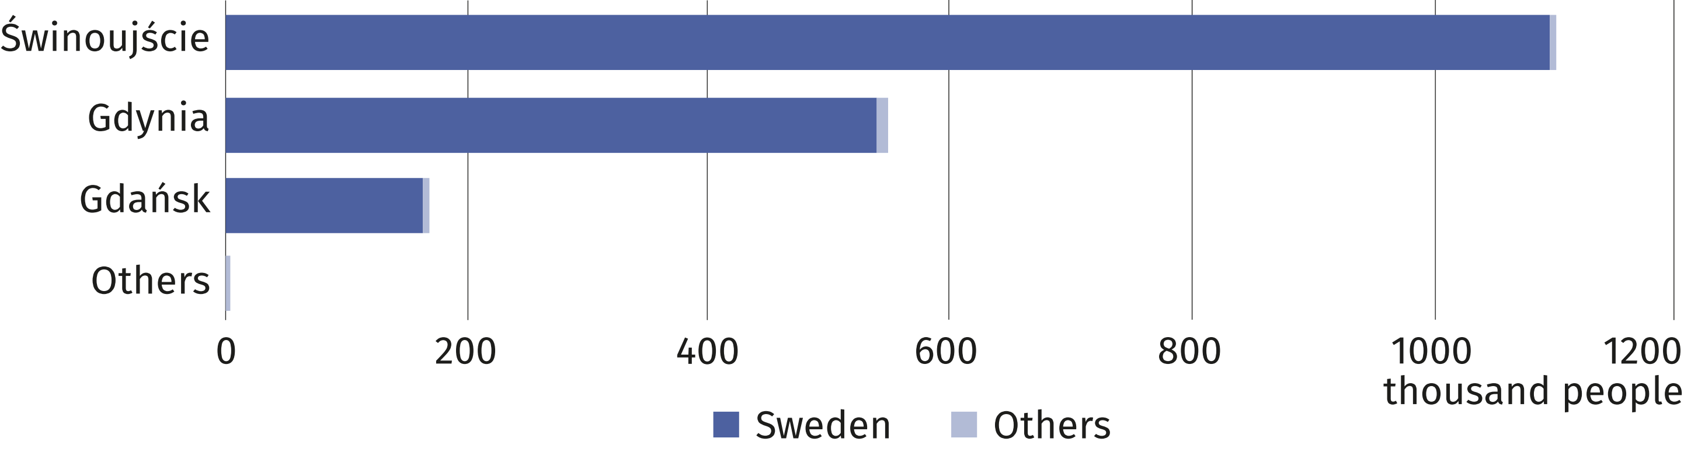
In 2022, 2.4% more ships called at Polish seaports than a year ago
In 2022, Polish seaports in 2022 were visited by 19.9 thousand ships (against 19.5 thousand ships reported in 2021) with a gross tonnage (GT) of 274.4 millions (by 11.3% higher in comparison to 2021) and deadweight (DWT) of 217.1 million tonnes (by 20.8% higher in comparison to the previous year).
Compared to 2021, all the basic ship sizes parameters increased as follows – deadweight
(by 18.0%), net tonnage (by 13.1%) and gross tonnage (by 8.7%).

Maritime and coastal shipping
In comparison to 2021, deadweight (DWT) of the fleet grew by 5.2% and gross tonnage (GT) – by 4.5%
At the end of 2022, the maritime fleet consisted of 88 ships (the same as the previous year), owned or co-owned by Polish shipowners and fleet operators. The total volume of deadweight (DWT) of the fleet amounted to 2728.0 thousand tonnes, whereas its gross tonnage (GT) was equal to 1960.1 thousands (against 2593.7 thousand tonnes and 1876.0 thousands in 2021, respectively).
Chart 6. Maritime cargo-carrying fleet in 2022
As of 31 December
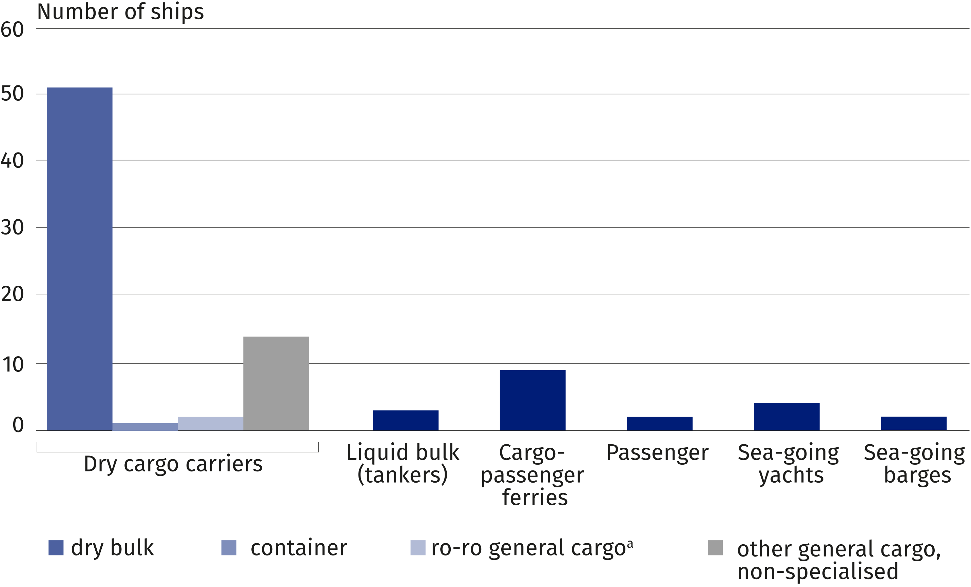
a Excluding ferries.
At the end of 2022 ships under the Polish flag represented 15.9% of the total number of maritime cargo-carrying fleet. The total deadweight (DWT) of the Polish flag ships (14 vessels) amounted to 18.1 thousand tonnes (0.7% of the total deadweight of maritime fleet), while the gross tonnage (GT) – 13.9 thousands (0.7% of the total gross tonnage).
Using the maritime cargo-carrying fleet, Polish shipping operators transferred by 12.0% goods less than in 2021

A maritime cargo-carrying ship was 19.0 years old on average (in case of the Polish flag ships that age was 41.9 years whereas foreign flags ships were 14.6 years old on average). The maritime cargo-carrying fleet companies shipped 8441.7 thousand tonnes of goods.
Chart 7. Structure of goods shipped by maritime cargo-carrying fleet by categories in 2022
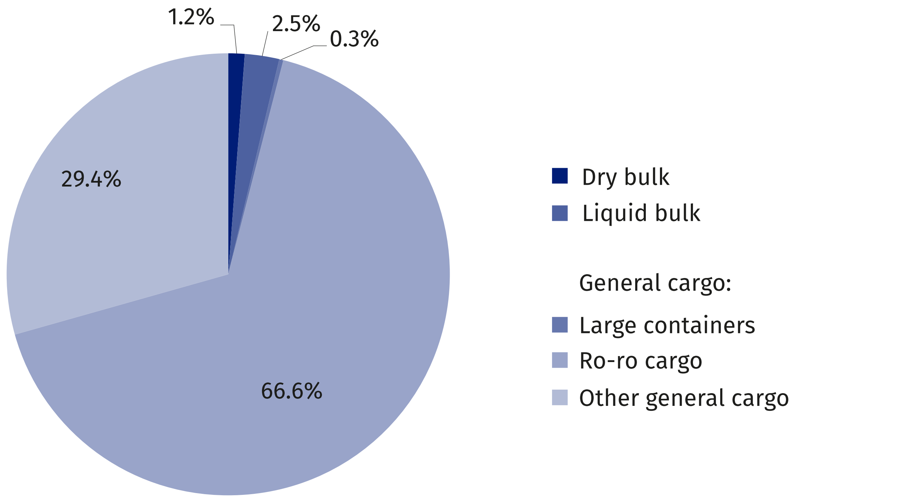

On the routes to/from Polish seaports there were 7615.1 thousand tonnes of cargo carried
(less by 6.9% than in 2021), of which the goods shipped abroad from Polish ports represented 52.1% (by 4.4% less than the previous year), whereas the goods shipped inwards
– 47.9% (9.5% less).
The weight of goods carried between foreign ports amounted to 619.2 thousand tonnes (i.e. by 0.4% more in comparison to the previous year), between Polish ports – 200.1 thousand tonnes (by 73.6% less). Intra-ports transfers of goods represented 0.1% of the total cargo shipped by maritime cargo-carrying fleet, and amounted to 7.2 thousand tonnes.
Chart 8. Transport of goods and transportation volume performed by type of shipping
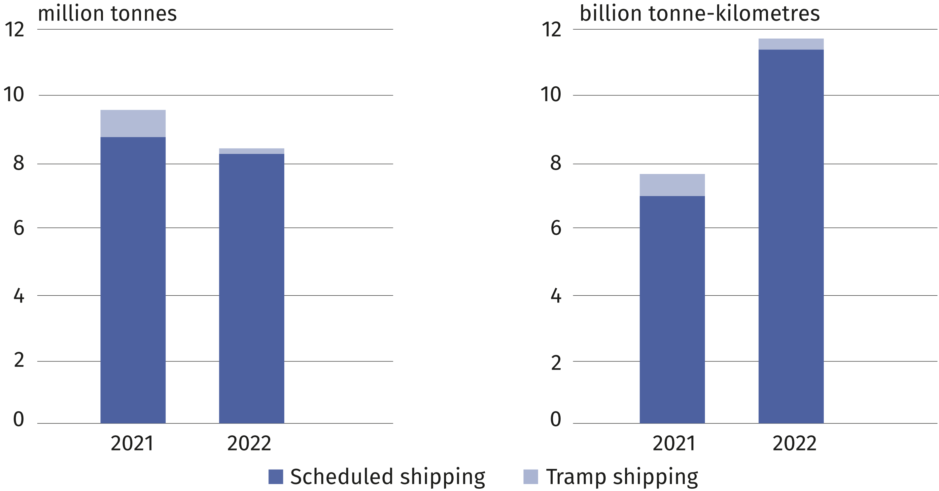

In 2022, the Polish fleet owners and operators transferred 611.4 thousand passengers on
international routes. In addition, 312.8 thousands truck drivers travelled onboard ferries
(by 6.8% less than the previous year).
The number of international passenger transfers increased by 5.1% as compared to 2021
Chart 9. Structure of passengers transferred onboard maritime and coastal fleets in 2022
(excluding truck drivers)
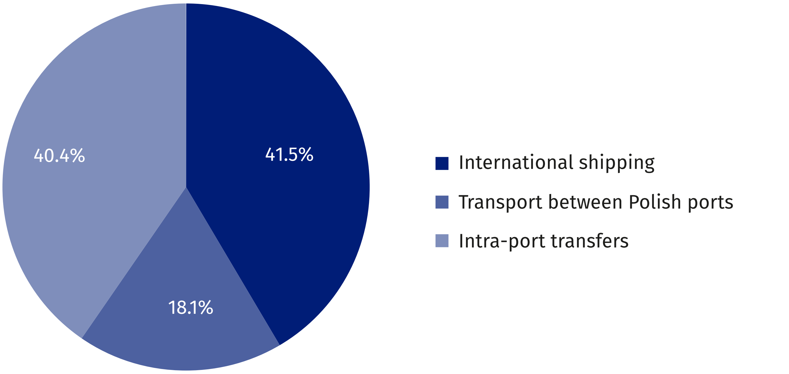
In comparison to 2021, the number of coastal ships, their deadweight and gross tonnage (GT) remained at the same level
At the end of 2022 coastal fleet consisted of 42 vessels with the total deadweight (DWT) of 12.4 thousand tonnes and gross tonnage (GT) of 10.5 thousands. All coastal vessels hoisted the flag of Poland. They were 47.4 years on average.
In 2022, 192.6 thousand persons travelled on routes between Polish ports, using coastal passenger fleet (by 7.0% less than in the previous year), with the transportation volume performed equal to 4231.9 thousand passenger-kilometers (7.6% less compared to 2021). In 2022, on intra-port routes there were travelled onboard coastal passenger fleet 547.4 thousand persons (a decrease of 9.8% on an annual basis), at an average distance per a single passenger journey of 7.8 km.
At the end of 2022 the number of crew of maritime and coastal fleet amounted to 1981 persons (38 persons more than 2021), including the maritime fleet – 1811 persons (38 persons more), and the coastal one – 170 persons (the same as the previous year).

Shipbuilding and ship repair industry¹
Similarly to the previous year, 4 new vessels were built, with gross tonnage (GT) of 2.5 thousands and compensated gross tonnage (CGT) measuring the yard’s productivity of 8.9 thousands (against 25.1 thousands and 42.8 thousands, in 2021, respectively).
On an annual basis the portfolio of order book has shrunk. At the end of 2021 it covered
8 vessels (10 vessels the previous year).
In 2022 Polish yards repaired 571 vessels with the total gross tonnage (GT) of 5516.0 thousands (against 455 ships with the total gross tonnage 1704.1 thousands in 2021).

1 On the basis of data from Maritime Advanced Research Centre (CTO S.A.) in Gdańsk and the Ministry of Infrastructure – Department of Maritime Economy.

Marine fisheries
As of the end of 2022, Polish marine fishing fleet consisted of 824 ships and small-scale fleet (1 vessel more than in 2021), with the total gross tonnage (GT) 35.2 thousands (the same
as in the previous year) and engine power 84.3 thousand kW (0.1% more).
The Polish marine fishing fleet consisted of 2 trawlers, 123 cutters and 699 small-scale boats. Gdynia continued to be the home port for the deep sea trawlers. A majority of the cutters (72.4%) moored in the Pomorskie, the rest of them – in Zachodniopomorskie Voivodship.
In addition, small – scale boats moored in all the Baltic voivodships: Pomorskie (46.5% of the total number of the Polish small-scale fleet), Zachodniopomorskie (43.3%) and Warmińsko-
-Mazurskie (10.2%).

When quoting data from the Statistics Poland, please include the following information: "Source of data from the Statistics Poland", and in the case of publishing calculations made on the data published by the Statistics Poland, please include the following information: "Own study based on Statistics Poland data".

Prepared by:  Statistical Office in Szczecin  Deputy director Katarzyna Dmitrowicz-Życka  Phone: (+48 91) 459 77 00 | Issued by:  The Spokesperson for the President  of Statistics Poland  Karolina Banaszek  Phone: (+48) 695 255 011
Press Office  Phone: (+48 22) 608 38 04  e-mail: obslugaprasowa@stat.gov.pl |   stat.gov.pl/en/

@StatPoland

@GlownyUrzadStatystyczny

gus_stat

glownyurzadstatystycznygus

glownyurzadstatystyczny
Related information
The maritime economy in Poland in years 2019 and 2020
Statistical Yearbook of Maritime Economy 2022
Terms used inn official statistics
Seaport
Seagoing vessels
Gross tonnage (GT)
Net tonnage (NT)
Cargo maritime transport in ton - kilometers
Coastal transport fleet
Cargo traffic at sea ports
Average distance of cargo transportation by sea and coastal fleet
Average transport distance of a passenger by sea and coastal transport fleet

